LifeLine — One-Page Product Brief v3 (FINAL)
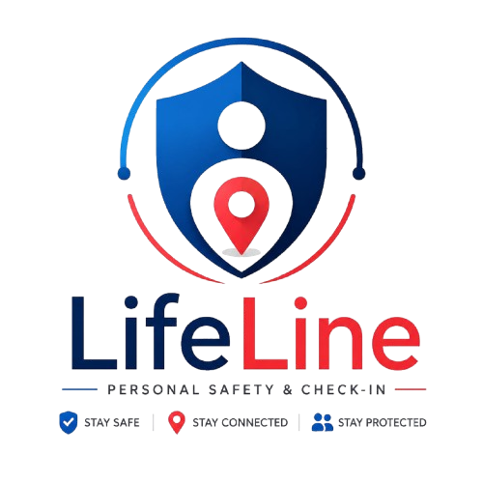
LifeLine Logo

LifeLine — Safety in one tap.
Personal Safety & Check-In · One-Page Product Brief Group 39 · Phoenix Cohort · TS Academy PM Capstone · May 2026 Version 3.0 (FINAL) · Status: Demo-ready

Problem
Female undergraduates on Nigerian campuses face a near-daily safety gap. Walking between hostels, libraries, and lecture halls — especially after 7pm — they have no fast, reliable way to confirm safe arrival to people who worry about them, and no simple way to escalate when something feels wrong. Existing options sit at two unhelpful extremes: WhatsApp messages that nobody is actively watching, or police hotlines that take minutes to connect and don’t share location. The gap between “text a friend” and “call the police” is where harm happens. Discovery interviews with 6 users (students, NYSC corpers, bankers, ride-hailing users, professionals) confirmed this pain is universal — and that users already create manual safety workarounds today.

Target user
Primary persona — Ada Umeh, 20, 300-level Biochemistry, UNN. Lectures end at 6pm; she sometimes stays in the library until 9pm; walks back to her hostel through dimly-lit paths; calls her boyfriend during the walk but knows that’s not a real safety net.
Future personas (validated in discovery, expanded in V2+): NYSC corpers, young urban professionals, ride-hailing users, lone workers, elderly individuals, parents and guardians.

Solution
LifeLine is a single-page web app delivering two core flows: a Safe Arrival trip with live tracking, a countdown timer, and an “I’ve arrived safely” check-in; and an SOS trigger with a 3-second hold-to-activate and 2:45 escalation timer that auto-alerts trusted contacts with the user’s live GPS location.
Core promise: Safety in one tap.

MVP scope (shipped)
In scope — demo-ready:
- Onboarding flow with OTP verification (demo OTP: 8484)
- Trusted contact management (up to 5 contacts with consent flow)
- Safe Arrival: pick destination, set ETA (15/30/60 min), share with contacts, live OpenStreetMap tracking, “I’ve arrived safely” confirmation
- SOS: 3-second hold-to-activate, 2:45 escalation timer, live GPS streaming, “I’m safe — cancel” override, contact view of active alert
- Three failure paths: wrong OTP, location permission denied, ETA overdue
- Two delighters: confetti on safe arrival, shake-to-SOS hint
- Demo navigation bar for jumping between flows
- Works on Nigerian 3G via embedded Leaflet (no CDN) and progressive OSM tile loading
Out of scope (deferred to V2+):
- Real backend persistence (currently in-memory; resets on refresh)
- Real SMS dispatch (currently simulated; planned for V2 via Termii)
- Push notifications (planned for V3 via Firebase Cloud Messaging)
- Police / responder integration
- Wearable triggers, voice activation, community crime mapping
Prioritisation method: MoSCoW. Rationale: safety-critical features must be cleanly separated from optional enhancements.

Success metrics
North Star metric (MVP): % of journeys ending in successful safe-arrival confirmation. Target ≥ 90%.
Note: As the product matures and accumulates usage data, the North Star will evolve to “Successful Safety Interactions Per Active User per week” — a more product-y measure capturing both safe-arrival sessions and meaningful SOS activations as healthy engagement. See Metrics & Tracking Plan for the staged evolution.
Supporting metrics:
- Activation — % of new users completing onboarding + ≥ 1 contact (target: 70%)
- Daily habit — Safe-arrival sessions per active user per week (target: ≥ 3)
- Emergency effectiveness — % of SOS alerts where contact responds within 2 min (target: 80%)
- False-positive rate — % of SOS triggers cancelled before escalation (target: < 15%)

Architecture (MVP, as-built)
Single-file vanilla HTML/CSS/JavaScript app, ~210 KB. Leaflet 1.9.4 embedded inline (no CDN). OpenStreetMap tiles. Browser-native APIs for geolocation, vibration, motion. Deployed to GitHub Pages. Zero backend in MVP — all state held in-memory. This is deliberate: demonstrates the user experience end-to-end without backend complexity and proves the app works on the worst Nigerian mobile networks.

Roadmap (high-level)
- MVP — May 2026 (shipped): Static HTML prototype, 12 screens, 3 flows
- V2 — Year 1 Q1: Supabase backend (auth, persistence, real-time sync) via Termii SMS
- V3 — Year 1 Q2–Q3: Edge Functions for SMS failover, offline-first PWA, USSD fail-safes
- V4 — Year 1 Q4: Public production launch; expanded personas
- V5 — Year 2: Public API for logistics; anonymised risk maps; wearables

Assumptions and risks
Top assumptions (validated in discovery):
- Users will actively configure trusted contacts (✓ already done manually)
- 3-second SOS hold reduces accidental triggers (test data: yes)
- Embedded library + progressive tiles work on Nigerian 3G (test data: yes on MTN 3G forced)
Top risks and mitigations:
- False alarms eroding trust → 5-second cancel window + cancel SMS follow-up
- Battery drain on long journeys → low-battery polling + V2 low-battery contact warning
- Trusted contacts not responding → multi-contact escalation; V3 community responder fallback

Brand & design system
Element | Value
Tagline | Safety in one tap
Primary colours | Navy #0A1E3F (background), Teal #2DD4BF (brand accent), Mint #86EFAC (secondary)
Emergency colours | Red #EF4444 (SOS), Green #10B981 (safe state)
Typography | Helvetica · 16pt title / 9pt body / 6pt label
Design language | Dark-first (navy bg) for night-safety use cases

What lives where
- Live demo: [GitHub Pages URL]
- Source: [Repo URL]
- Wireframes: lifeline-wireframes.html (12 screens, 3 flows)
- PRD: LifeLine_PRD_v3_FINAL.docx
- Metrics: LifeLine_Metrics_and_Tracking_Plan_v2.docx
- Discovery: LifeLine_Discovery_Evidence_FINAL.pdf
- GTM: LifeLine_GTM_Plan.pdf

One-page brief · Owner: Group 39 PM team · Last updated: 21 May 2026 · Submission deadline: 24 May 2026

