# Grazioso Salvare Animal Center Outcomes

## About the Project/Project Title

The purpose of this dashboard is to simplify the search of animal outcomes from the Austin Animal shelter.

## Motivation

The purpose of this dashboard is to simplify the search for dogs that are good candidates for search-and-rescue training and to create visuals to better understand the results.

## Getting Started

To get started with MongoDB CRUD, perform the following steps:

1. Startup the dashboard in the web.
2. Use the available filters to get the necessary data.

## Usage Examples

Search for animals older than two years with an outcome:

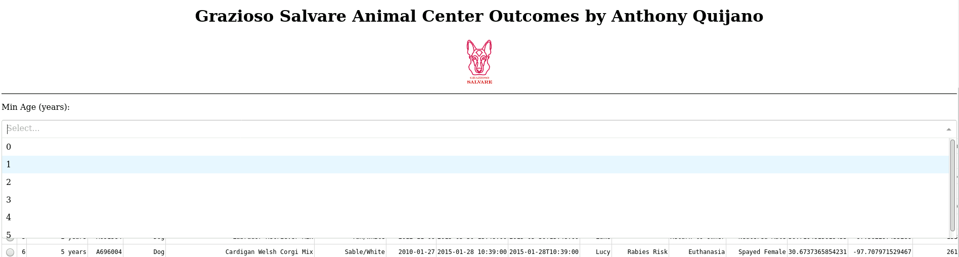

To view the location of an animal on the map, select a row from the data table:



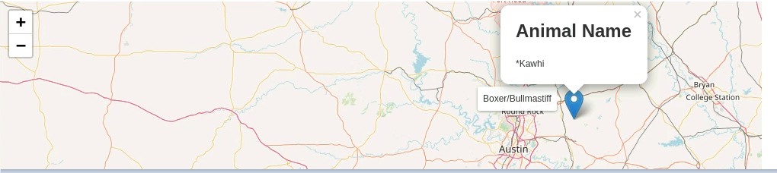

Breed distribution is displayed at the bottom of the dashboard in the pie chart:

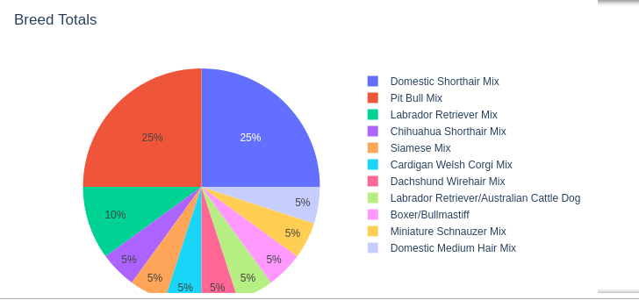

## Contact

Your name: Jesse Quijano jesse.quijano@snhu.edu