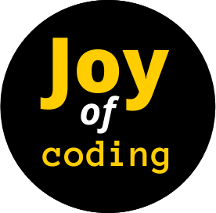**First Look: Lists & Strings**

20.code/lists_intro.py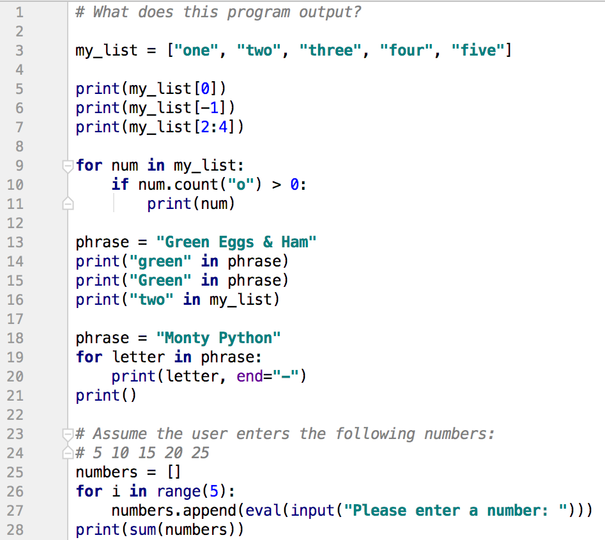

In the code above, identify the following:

1. Loop variables
2. List initializations
3. Function definitions
4. Function calls
5. Conditions
6. Boolean Expressions
7. String Literals