**Turtle Party!**

*Using loops, functions, & variables to draw shapes with python turtle.*

**Overview**

**Congratulations** on progressing to Day 5! In Day 4 we made our triangle DRYer using a function & introduced a square function. Today we’re integrating your newfound knowledge by creating general-purpose **polygon** and **spiral** functions.

**Video Introduction**

**Day 5: Turtle Party!** <https://youtu.be/kBq9oRYpwrI>

**Instructions**

1. If you don’t have your previous program open, **navigate to** [**trinket.io/turtle**](https://trinket.io/turtle) and replace any code with the code from Day 4’s activity:
2. Let’s generalize from our triangle & square functions to draw even more shapes. Create a **polygon** function that takes the **number of sides** and **length of each side** as parameters & draws the appropriate shape by turning 360 (the number of degrees in a circle) divided by the number of sides. **Challenge**: print an error message & draw nothing if there are less than 3 sides.

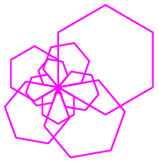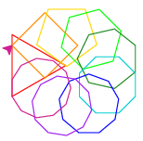

1. **Test** that your polygon function works   
   by using a **loop** to draw multiple   
   shapes. Some examples for inspiration:
2. 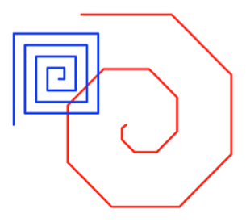**Challenge:** Create a **spiral** function that takes the **length of the longest side** and the **angle** of the spiral as parameters and draws a spiral shape where the side length shrinks (or grows) after every turn:

**Awesome job!** *After putting your newfound knowledge   
into practice, you’re ready for the next challenge!*

**Video Solution**

**Day 5: Turtle Party! Walk Thru** <https://youtu.be/f5dUg_0zauw>

**What’s next?**

*Are you ready to take your python programming to the next level?*

**Overview**

Have you enjoyed the learning process over the course of the 5 Day Beginning Python Challenge? Do you feel we have been laying a strong foundation for your future mastery? **Your learning journey need not end today!**

**Next Steps**

1. **Complimentary portfolio & learning review!** Ready to take your programming skills to the next level & land your dream job? Schedule a free consultation:  
   **>>>** [**calendly.com/joyofcoding/coding-chat**](http://calendly.com/joyofcoding/coding-chat) **<<<**
2. **Keep the conversation going!** Join the **Joy of Coding Facebook Group** to get daily feedback from the community on your learning as you progress from python beginner to programming master: [facebook.com/groups/joy.of.coding](http://facebook.com/groups/joy.of.coding)
3. **Stay up to date!** Follow the **Joy of Coding Facebook Page** to get the latest updates on new learning materials & course offerings: [fb.me/joyofcoding4all](http://fb.me/joyofcoding4all)
4. **Follow along!** Learn about new videos as they are released by subscribing to the **Joy of Coding YouTube Channel**: [bit.ly/joy-of-coding-youtube](http://bit.ly/joy-of-coding-youtube)
5. **Deepen your learning!** Think of how much you’ve learned in **5 days** with the Beginning Python Challenge, and imagine how much **more** you could learn with a full **6 week course**! Join the **Joy of Coding Python Project** to continue your mastery on the road from zero to hero: [joy-of-coding.thinkific.com](http://joy-of-coding.thinkific.com/courses/python-project)  
     
   The **Joy of Coding Python Project** goes **beyond** the **Challenge** by including:
   * **Deeper** coverage of **library** **functions**, **for loops**, writing **functions**, and professional **best practices** with **tons** of practice problems & solutions
   * **Full lessons** covering **if** conditions, **while** loops, as well as working with **strings,** **lists, dictionaries,** and **files**
   * **Bonus** modules introducing **data analysis** & **recursion**
   * A **dedicated discord channel** with real-time Q & A from a mentor who’s been there and can give feedback on your questions, work, & advice on everything from software development to computer science

**Don’t stop now! Let’s do this!** *Are you ready to stop   
being frustrated & start crafting programs like a pro?*