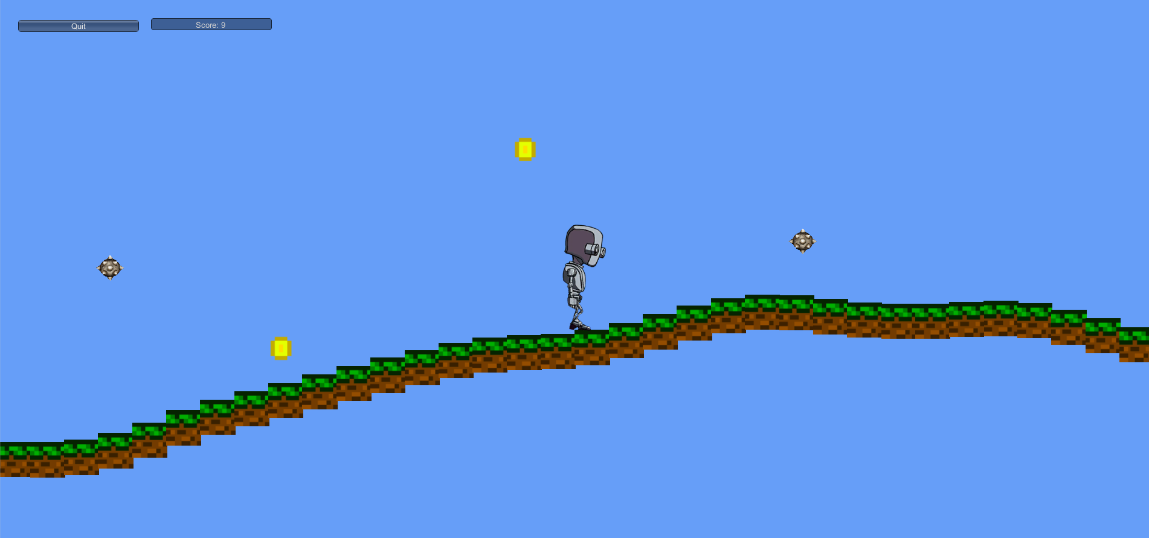

Roaming

A Game Created by:

Anthony Reese

Using the Unity Engine

Contents

Game Overview . . . . . . . . . . . . . . . . . . . . . . . . . . . . . . . . . . . . . . . . . . . . . . .

High Concept . . . . . . . . . . . . . . . . . . . . . . . . . . . . . . . . . . . . . . . . . . . . . . . . .

Unique Selling Points . . . . . . . . . . . . . . . . . . . . . . . . . . . . . . . . . . . . . . . . . .

Platform Minimum Requirements . . . . . . . . . . . . . . . . . . . . . . . . . . . . . .

Competence Titles . . . . . . . . . . . . . . . . . . . . . . . . . . . . . . . . . . . . . . . . . . . .

Synopsis . . . . . . . . . . . . . . . . . . . . . . . . . . . . . . . . . . . . . . . . . . . . . . . . . . . . .

Game Objectives . . . . . . . . . . . . . . . . . . . . . . . . . . . . . . . . . . . . . . . . . . . . .

Game Rules . . . . . . . . . . . . . . . . . . . . . . . . . . . . . . . . . . . . . . . . . . . . . . . . . .

Game Structure . . . . . . . . . . . . . . . . . . . . . . . . . . . . . . . . . . . . . . . . . . . . . .

Gameplay . . . . . . . . . . . . . . . . . . . . . . . . . . . . . . . . . . . . . . . . . . . . . . . . . . . .

Game Overview

Title: Roaming

Platform: Windows PC

Genre: 2D Objective Game

Rating: E for Everyone

Target: Casual gamer (aging from 10 - 30)

Release date: February 23, 2019

Publisher: Anthony Reese

*Roaming* is a survival, objective based game. It is a obstacle course, where the camera follows the user throughout the level. There will be coins that spawn as the player moves throughout the level, as well as dangerous spikes.

High Concept

*Roaming* sets the player high in the sky, where they must overcome obstacles in order to obtain an Epic Victory. Analyze each situation and determine the best route in order to overcome the obstacles ahead!

Unique Selling Points

* Unique Obstacles
* Rewarding
* Challenging

Platform Minimum Requirements

PC, MAC AND LINUX STANDALONE OS: Windows XP SP2+, Mac OS X 10.8+, Ubuntu 12.04+, SteamOS+ Graphics card: DX9 (shader model 2.0) capabilities; generally everything made since 2004 should work.

Competence Titles

2D Obstacle Game by Unity Technologies

Synopsis

Take the role of the Robo User, a robot stuck in the sky, who must gather as many coins as he can, while scaling the tough terrain and avoiding dangerous obstacles.

Game Objectives

The Objective of the game is to get as many coins as possible.

Game Rules

Stay alive by avoiding the spiky balls which will be generated as you move throughout the level in either direction. While doing so, gather as many coins as possible!

Game Structure

Level 1 -> Respawn

Gameplay

* A / Left arrow key : Run Left
* D / Right arrow key: Run Right
* Spacebar : Jump
* Ctrl : Crouch

Game Camera will follow the player in a fixed position as the player navigates each level.