
MISSION USA MINISTRY ASSESSMENTS
Bring Proven Assessments to Your Church
A partnership for your membership and growth classes

Dear Pastor,
Mission USA of the Congregational Holiness Church has built a growing library of ministry and personal assessments, and we would love for your church to use them. The assessments are biblically grounded, professionally built, and ready to serve your people. You can find them at assessments.chchurch.com.
We designed this especially with your classes in mind. When new members or growth-track students discover how God has wired and gifted them, they connect faster, serve sooner, and stay longer. Two assessments fit membership classes perfectly:
Spiritual Gifts  125 short statements rank all 25 gifts from Romans 12, 1 Corinthians 12, and Ephesians 4, so each member sees clearly where they are wired to serve. | Wired to Lead (DISC)  A simple, biblical DISC profile that shows each person's leadership wiring, paired with a biblical leader who shares it.

What your members receive
Every person gets a clean, shareable report, on screen and as a PDF, saved to their own profile. A sample of each:
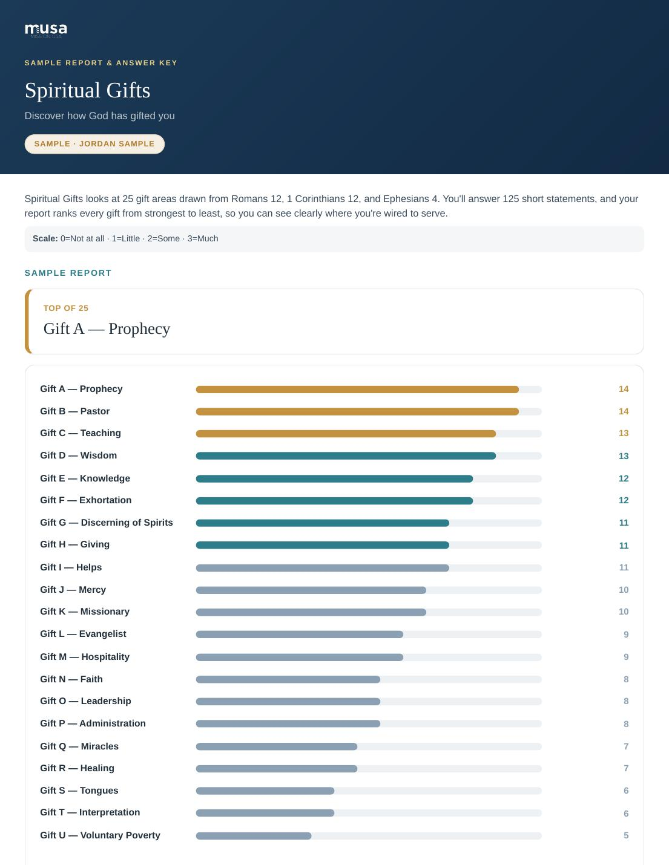 | 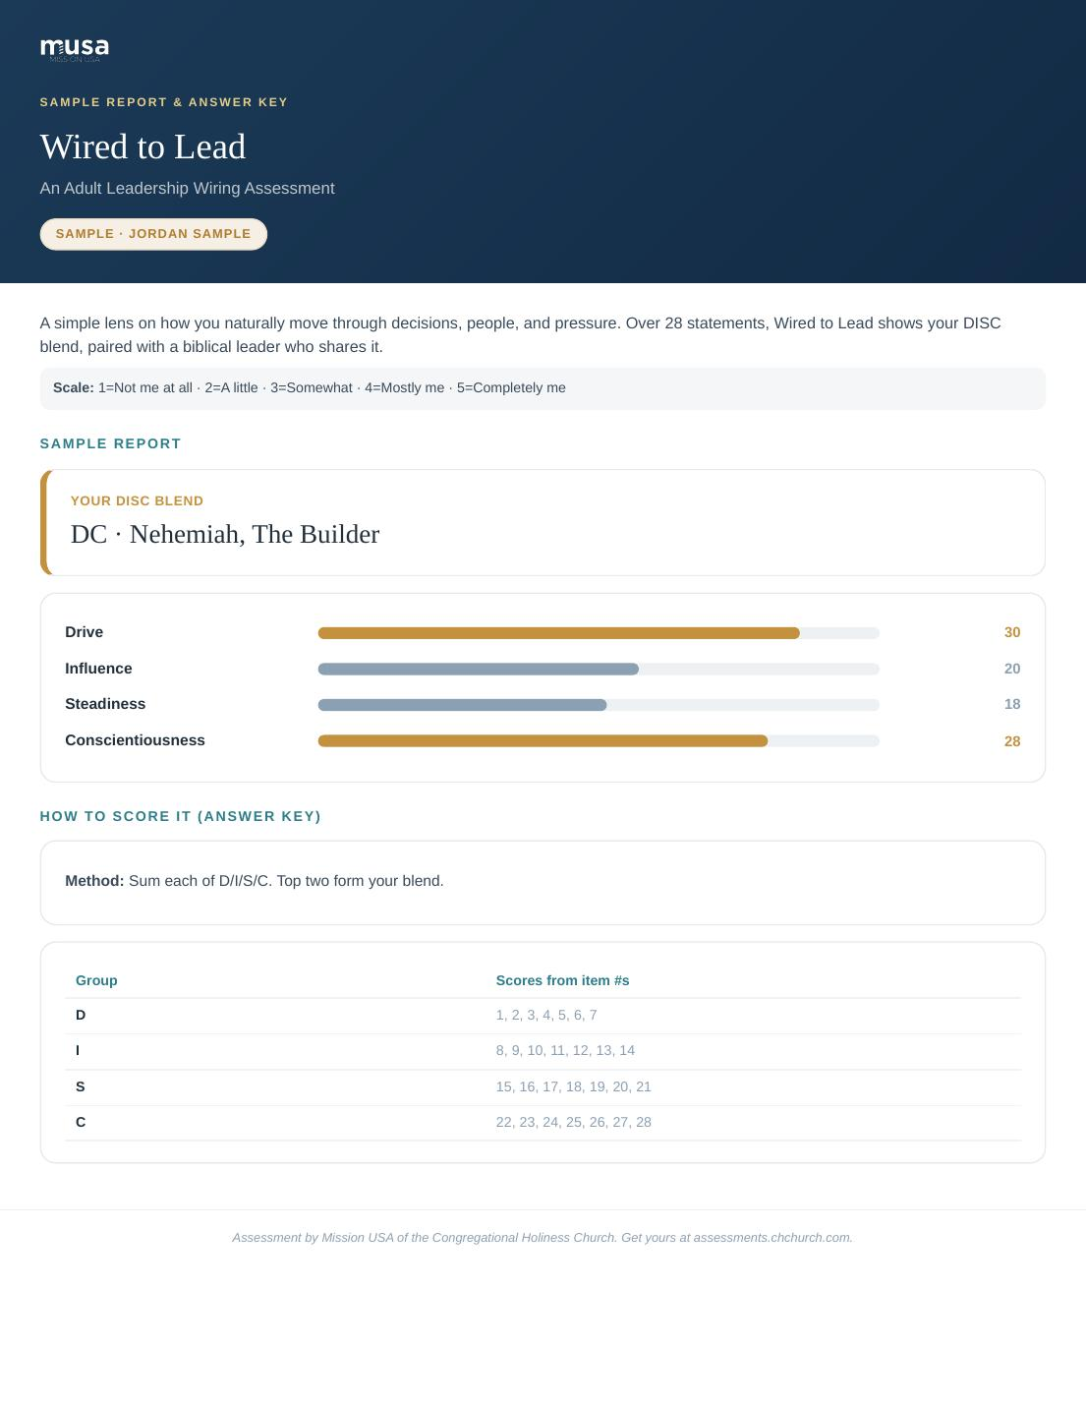

How the partnership works
1. We set up your church. We add your church and the email address where you want results sent. You choose which assessments your church receives (for classes, that's usually Spiritual Gifts and DISC).
2. Your people take it. When a member takes an assessment, they simply choose your church from the list. They see clearly that a copy of their results will be shared with the church.
3. You get notified. The moment a member finishes, your church contact receives an email letting you know.
4. You see everything in one place. Your church gets its own private dashboard showing every member's results for the assessments assigned to you, and nothing else.
5. You hand out one simple link. We give you a direct link for each class assessment. It pre-fills your church, so every result routes to you automatically. Share it in class, in an email, or on a card.
Two ways to make it yours
• Reveal results in person.If you would rather your members not see their own results on their own, we can hold their results back so that you reveal and walk through them together, in person. It keeps the moment pastoral, and puts you in the room when it matters.
• Your logo on the reports.We can put your church's logo on your members' reports, right alongside ours, so what they receive feels like it came from their church home.
Why churches love it
• It's practical:turns a one-time class into a lasting picture of your people's gifts and wiring.
• It's personal:members feel known and find their place to serve faster.
• It's useful:you see your whole class's gifts at a glance, and can build teams around them.
• It's simple:most assessments are free to take, and we handle the setup.
There's more we can do together
Beyond classes, we can add assessments your church specifically needs, and even build custom assessments for you. The library keeps growing. If your church has a need, let's talk about it.
Ready to get your church set up?
Reply to this note or reach us through assessments.chchurch.com, and we'll have you ready before your next class.

Assessment by Mission USA of the Congregational Holiness Church · assessments.chchurch.com

