
MISSION USA · CONGREGATIONAL HOLINESS CHURCH
Mission USA Ministry Assessments
An introduction, and the case for our denomination

Assessments platform: assessments.chchurch.com
In one page
We have built a professional assessment platform for our churches and our people. It is live, biblically grounded, and ours. It helps believers discover their spiritual gifts, understand how they are wired to lead, take an honest look at their walk with God, and much more. It helps pastors and churches see their own health clearly. And it gives us, as a denomination, something we have never had before: real data about our people, our leaders, and our churches.
This document explains what the platform does, shows what people receive, and makes the case for why this is worth leaning into. It also shows how the platform can serve us financially and strategically for years to come.
The short version: this is a tool that serves people, strengthens churches, informs our leadership, and can grow with us without limit. We can add assessments whenever we want, partner with churches, license respected instruments, and even generate income, all from one platform we control.
What it is, and how it works
The platform is a website where a person takes a short assessment and immediately receives a clear, encouraging, personal report. There is no software to install and nothing to score by hand. The experience is simple on purpose.
1. They choose an assessment. From spiritual gifts to leadership wiring to church health, each one is short and focused.
2. They answer honestly. Most take ten to twenty minutes. There is no score to pass or fail.
3. They get their report right away. On screen, saved to their profile, and emailed as a link. They can print it or save it as a PDF.
Every report carries our name: "Assessment by Mission USA of the Congregational Holiness Church." Every person who takes one sees who stands behind it.
What people receive
The reports are the heart of it. They are clear, warm, and genuinely useful, not a page of numbers. Here are real samples:
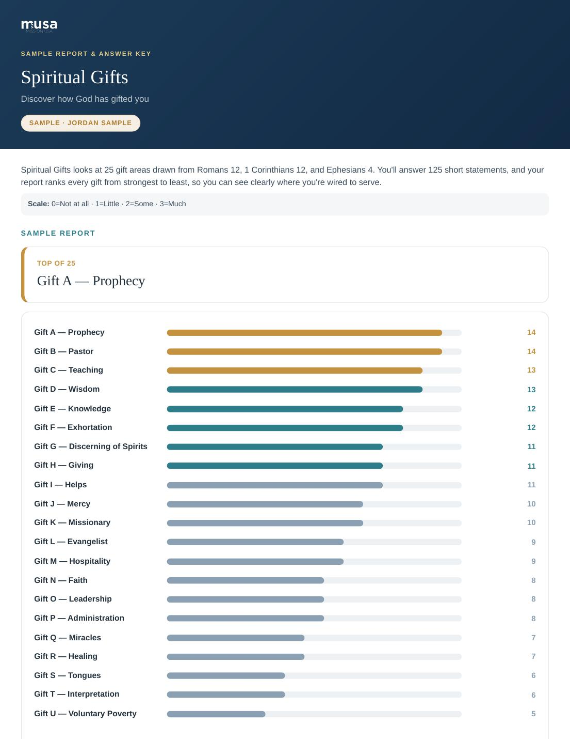  Spiritual Gifts, ranked across all 25 gifts | 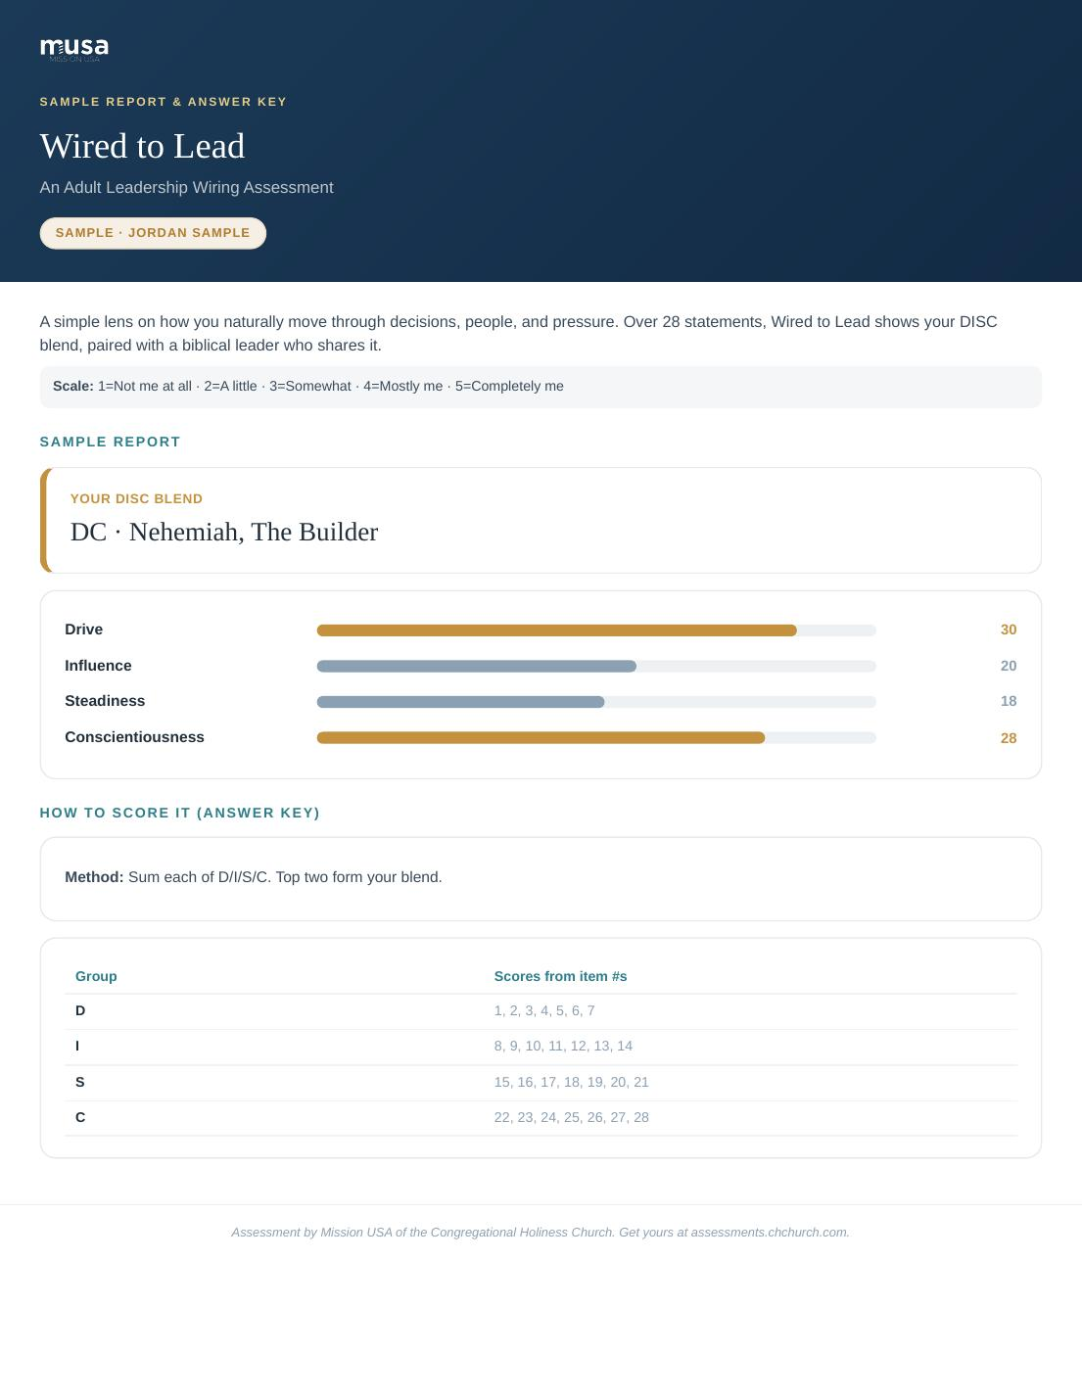  Wired to Lead, a DISC profile with a biblical parallel

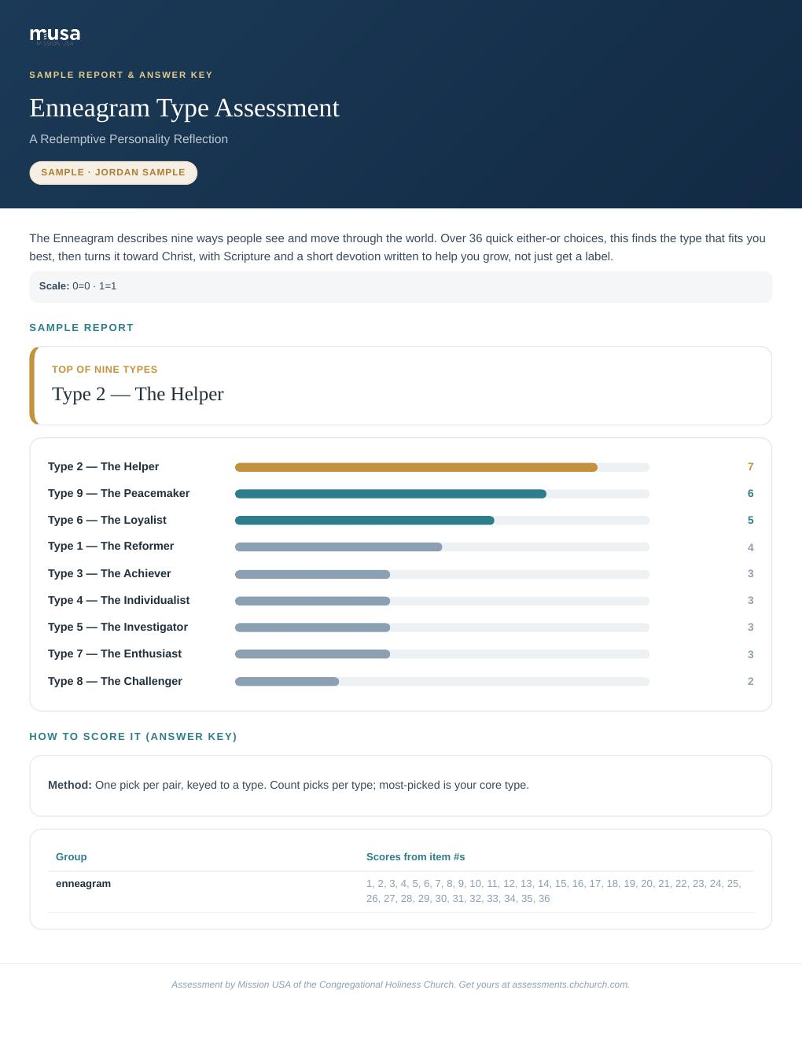  The Enneagram, turned toward Christ with a devotion | 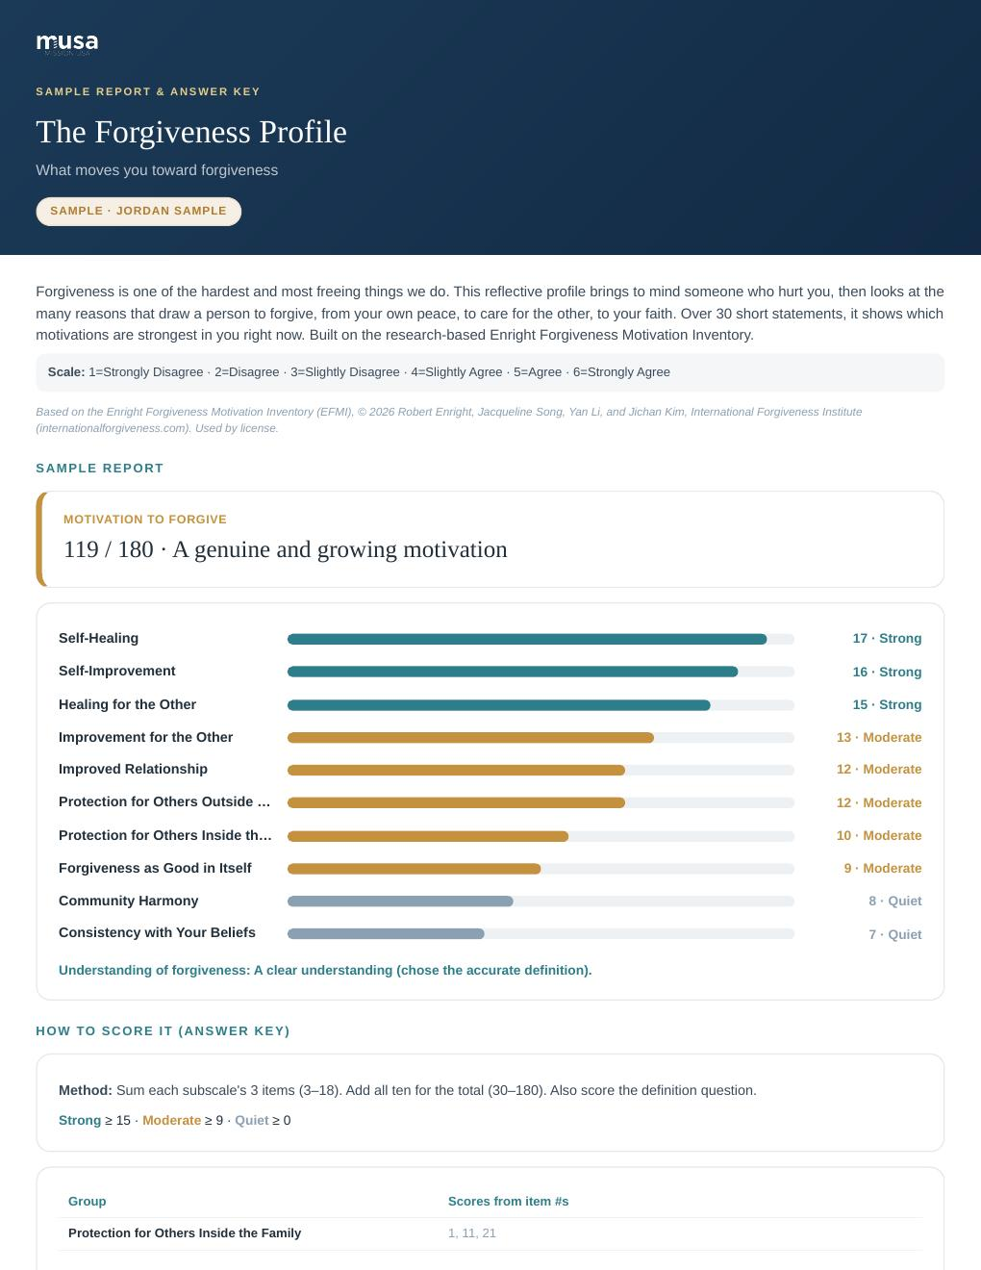  The Forgiveness Profile, a licensed clinical instrument

The assessments we offer today
We currently offer thirteen public assessments, with three more that work behind the scenes as team or spouse input. We can add more at any time. Here is the current library:
For every believer
Spiritual Gifts. Ranks all 25 gifts from Romans 12, 1 Corinthians 12, and Ephesians 4.
Fivefold Calling. Finds a person's primary Ephesians 4 calling.
Wired to Lead. A biblical DISC profile of how a person is wired to lead.
Rooted. An honest look at eight markers of spiritual maturity.
Spiritual Growth Assessment. A Discipleship Wheel across six spiritual disciplines. Based on LifeWay's assessment.
Enneagram Type Assessment. The nine Enneagram types, turned toward Christ with Scripture and a devotion.
The Forgiveness Profile. What moves a person toward forgiveness. A licensed clinical instrument (EFMI).
For ministers and planters
Church Planter. A church planting readiness picture across thirteen characteristics.
Pastor Profile. A pastoral health and calling assessment, with a private wellbeing check.
Called Together. A marriage and ministry assessment taken by both spouses.
For churches and teams
Leadership Health. A leader's health across eight domains, with optional peer input.
Church Growth. An honest read on a church's stage, from decline to multiplication.
Church Health. A whole leadership team's honest read on their church's health.
We can license other respected instruments and add them here, as we already did with the Forgiveness Profile. There is no ceiling on how many assessments this platform can hold.
How it serves our denomination
It helps our people
A believer who knows their gifts serves sooner and stays longer. A leader who understands their wiring leads with less friction. A pastor who takes an honest look at their own life is a healthier shepherd. This platform puts that self-understanding in reach of everyone, for free.
It strengthens our churches
Church Health and Church Growth give a congregation an honest mirror. Called Together supports our ministry marriages. Church Planter helps us assess readiness before we send. These are tools our churches need and rarely have.
It informs our leadership
For the first time, we can see patterns across our movement. That is the part leadership should not miss, so it has its own section next.
The data advantage
Every assessment taken teaches us something. Held together, and always with care for privacy, this becomes a picture of our people and our churches that we have never had before.
• Gifts across the movement. Which spiritual gifts are most and least common across our churches, so we know where we are strong and where we need to develop people.
• Planter readiness. Who is showing readiness to plant, and where, so we can identify and develop planters intentionally instead of by accident.
• Church health. An honest, aggregate read on the health and stage of our churches.
• Who we are reaching. Who is taking assessments, their roles, ages, and regions, so we understand our audience and our reach.
• Pastoral care. A confidential wellbeing signal that lets us reach out to pastors who are carrying a heavy load, gently and early.
The admin dashboard turns all of this into simple charts: completions over time, breakdowns by assessment and by church, the most common gifts, planter readiness, and more. Analytics is not a side feature here. It is one of the biggest reasons to lean in.
Church partnerships
Any church can partner with us. We set them up, they choose which assessments they want for their classes, and their members simply pick that church when they take one. The church receives an email and sees every result in its own private dashboard. We hand them a single link that pre-fills their church, so it is effortless to use in a membership or growth class.
We can also tailor the experience to each church:
• Reveal in person. a church can ask us to hold results back from the member, so a leader reveals and walks through them in person. It keeps the moment pastoral.
• Church-branded reports. we can place a church's own logo on its members' reports, alongside ours, so the report feels like it came from their church home.
This is a natural on-ramp. A church that uses our Spiritual Gifts and DISC assessments in its classes is a church connected to Mission USA, month after month.

The opportunity
This platform is built to grow, and it can serve us strategically and financially at the same time.
• Unlimited assessments. We can add as many assessments as we want, on any topic our churches need. The platform does not limit us.
• Partner and custom work. We can build assessments for a specific church or ministry and host them here.
• Revenue. Most assessments are free, but we can charge for premium ones, sell them in bundles, and offer churches discounted seats. The commerce is already built in.
• Licensing. We can license respected instruments, as we did with the Forgiveness Profile, and offer them under our name.
• Reach. Every report, email, and page carries our name and points people back to us.
In other words, a tool that serves our people can also help fund the mission and extend our reach. That is a rare combination.
Our commitments, and important notes
We take stewardship of people's trust seriously. A few commitments and clarifications matter here.
• Privacy. We tell people plainly what we collect and why, we ask for consent, and we never sell or give away their data. Confidential items, such as a pastor's wellbeing check or a spouse's safety response, are held separately and never shared in reports.
• Not professional advice. These assessments are ministry and self-development tools. They are for insight, encouragement, and growth. They are not medical, psychological, or professional advice, and they are not a diagnosis. Where an instrument is clinical in origin, we use it with permission and present it as a reflective tool, not as treatment. People with real needs are encouraged to seek qualified help.
• Not a verdict. Results describe tendencies and gifts. They are a starting point for conversation and prayer, not a verdict on anyone's worth, calling, or future.
• Credit where due. Licensed instruments are credited to their authors and used under license. We honor those agreements.
This page is written in plain language for leadership. Before we publish formal terms of use and a privacy policy, we should have them reviewed by qualified counsel so our commitments are stated properly and our liability is limited appropriately.
Where this can go
We have the platform. It works, it looks professional, and it is ours. The question in front of us is simple: how far do we want to take it?
We can make these assessments a normal part of membership classes, leadership development, church planting, and pastoral care across the denomination. We can partner with our churches, add the assessments they ask for, and learn from the data as we go. And we can do all of it while pointing people, again and again, back to Christ and to their place in His church.
That is the invitation. We would value your support in taking the next step.

Mission USA of the Congregational Holiness Church · assessments.chchurch.com

