PROJECT IN AUTOMATA AND LANGUAGE THEORY

GENDER NEUTRAL LANGUAGE RECOGNIZER

Submitted by:
ANTHONY P. SIBARRE
CHARLEEN E. AMPER
JEREMIAH KARL S. ALERIA
DARL C. DESTRIZA
BSCS 3A

Submitted to:

ALMA MAE B. AUXTERO
Instructor

Date submitted: November 4, 2026

1 Project overview
The Gender Neutral Language Recognizer is a web application that reads a plain text (.txt) file and finds predefined gender-specific words and phrases, such as “chairman” or “policeman”. It shows each detected term, how many times it appears, and one or more gender-neutral alternatives in a simple results table, and it highlights the terms inside the text so the user can review them in context. It also shows clear messages for files with no detected terms, empty files, and unsupported file formats. The suggestions are for review only; the application never rewrites the user’s file.

2 Tools and recognition approach
The application is written in HTML, CSS, and plain JavaScript, with no frameworks or installation, and runs in any modern web browser. Node.js was used only to run the test script. The recognition approach is regular expressions.
All 28 terms are combined into one regular expression. The pattern below is generated directly from the term list in recognizer.js and is used with the flags g and i:
/\b(?:ladies\s+and\s+gentlemen|businessman|congressman|forefathers|stewardess|headmaster|his\s+or\s+her|policeman|policemen|spokesman|cameraman|craftsman|housewife|he\s+or\s+she|chairman|chairmen|salesman|manpower|man-made|waitress|freshman|fireman|firemen|mankind|mailman|foreman|actress|layman)\b/gi
Part of the pattern | What it does
\b … \b | Word boundary at the start and end. A match must begin and end at the edge of a word, so “he” is never found inside “the”, and “chairman” is not found inside “chairmanship”.
(?: a | b | c … ) | A group of alternatives separated by |. The pattern matches if any one of the 28 terms appears. Terms are sorted longest first.
\s+ (inside phrases) | One or more whitespace characters between the words of a phrase, so “he or she” and “ladies and gentlemen” are still found across extra spaces or a line break.
i flag | Ignores capitalization, so chairman, Chairman, and CHAIRMAN are all detected. Each match is converted to lowercase before counting, so all three are counted in one row.
g flag | Finds every occurrence instead of stopping at the first, which makes it possible to count how many times each term appears.

Sample trace: for the text “The Chairman spoke.”, the matcher looks for a word boundary followed by one of the listed terms. It rejects “The” and “spoke” because neither is a listed term, and accepts “Chairman” because it equals “chairman” when capitalization is ignored and has a word boundary on both sides. The app then records one occurrence of “chairman” and suggests “chairperson” or “chair”.
The predefined terms and their suggested alternatives (28 terms):
Term | Suggested alternatives | Term | Suggested alternatives
chairman | chairperson, chair | cameraman | camera operator
chairmen | chairpersons, chairs | layman | layperson
policeman | police officer | craftsman | artisan, craftsperson
policemen | police officers | forefathers | ancestors
fireman | firefighter | manpower | workforce, personnel
firemen | firefighters | man-made | artificial, synthetic
stewardess | flight attendant | waitress | server
mankind | humankind, humanity | actress | actor
businessman | businessperson | headmaster | principal, head teacher
salesman | salesperson, sales representative | housewife | homemaker
mailman | mail carrier | freshman | first-year student
spokesman | spokesperson | ladies and gentlemen | everyone, honored guests
congressman | legislator, member of Congress | he or she | they
foreman | supervisor | his or her | their

3 Application screenshots
Source code and instructions:
[Insert your public GitHub repository link here]
To run the application, open index.html in a web browser and choose or drop a .txt file (sample.txt is included). Screenshots below were taken from the running application.
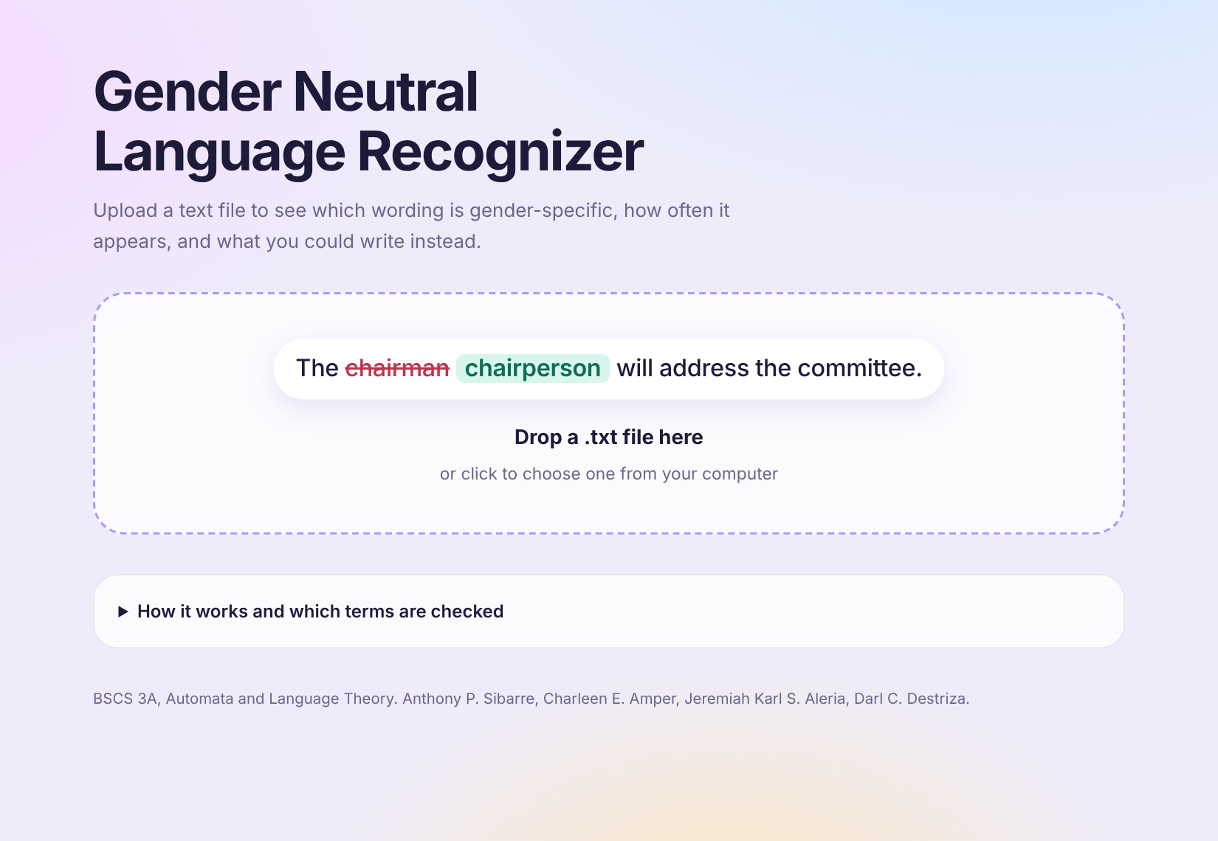
Figure 1. File selection: the user drops a .txt file here or clicks to choose one.
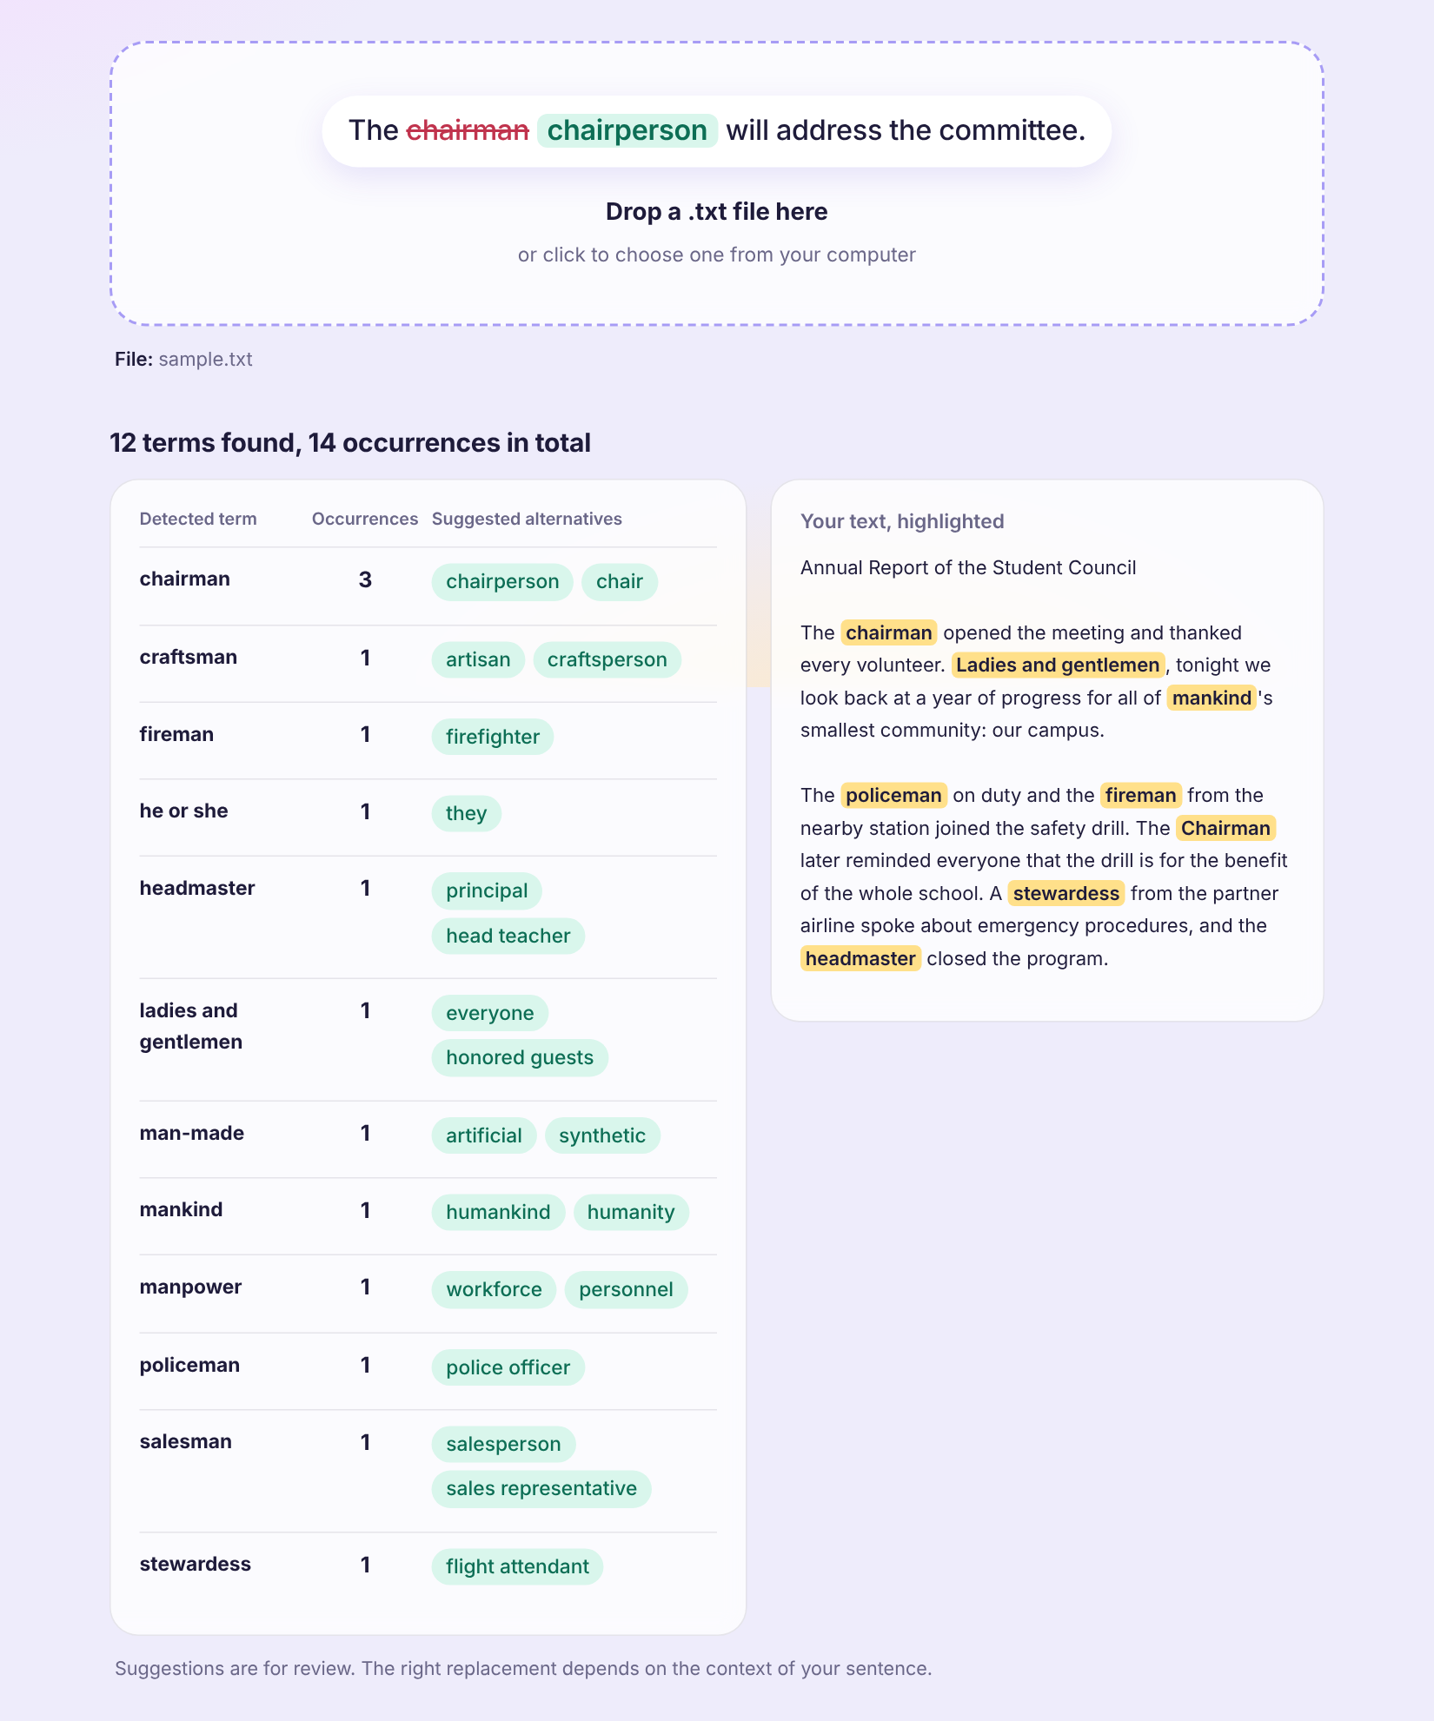
Figure 2. Detected terms with occurrence counts and suggested alternatives for sample.txt (12 terms, 14 occurrences), with the terms highlighted in the text.
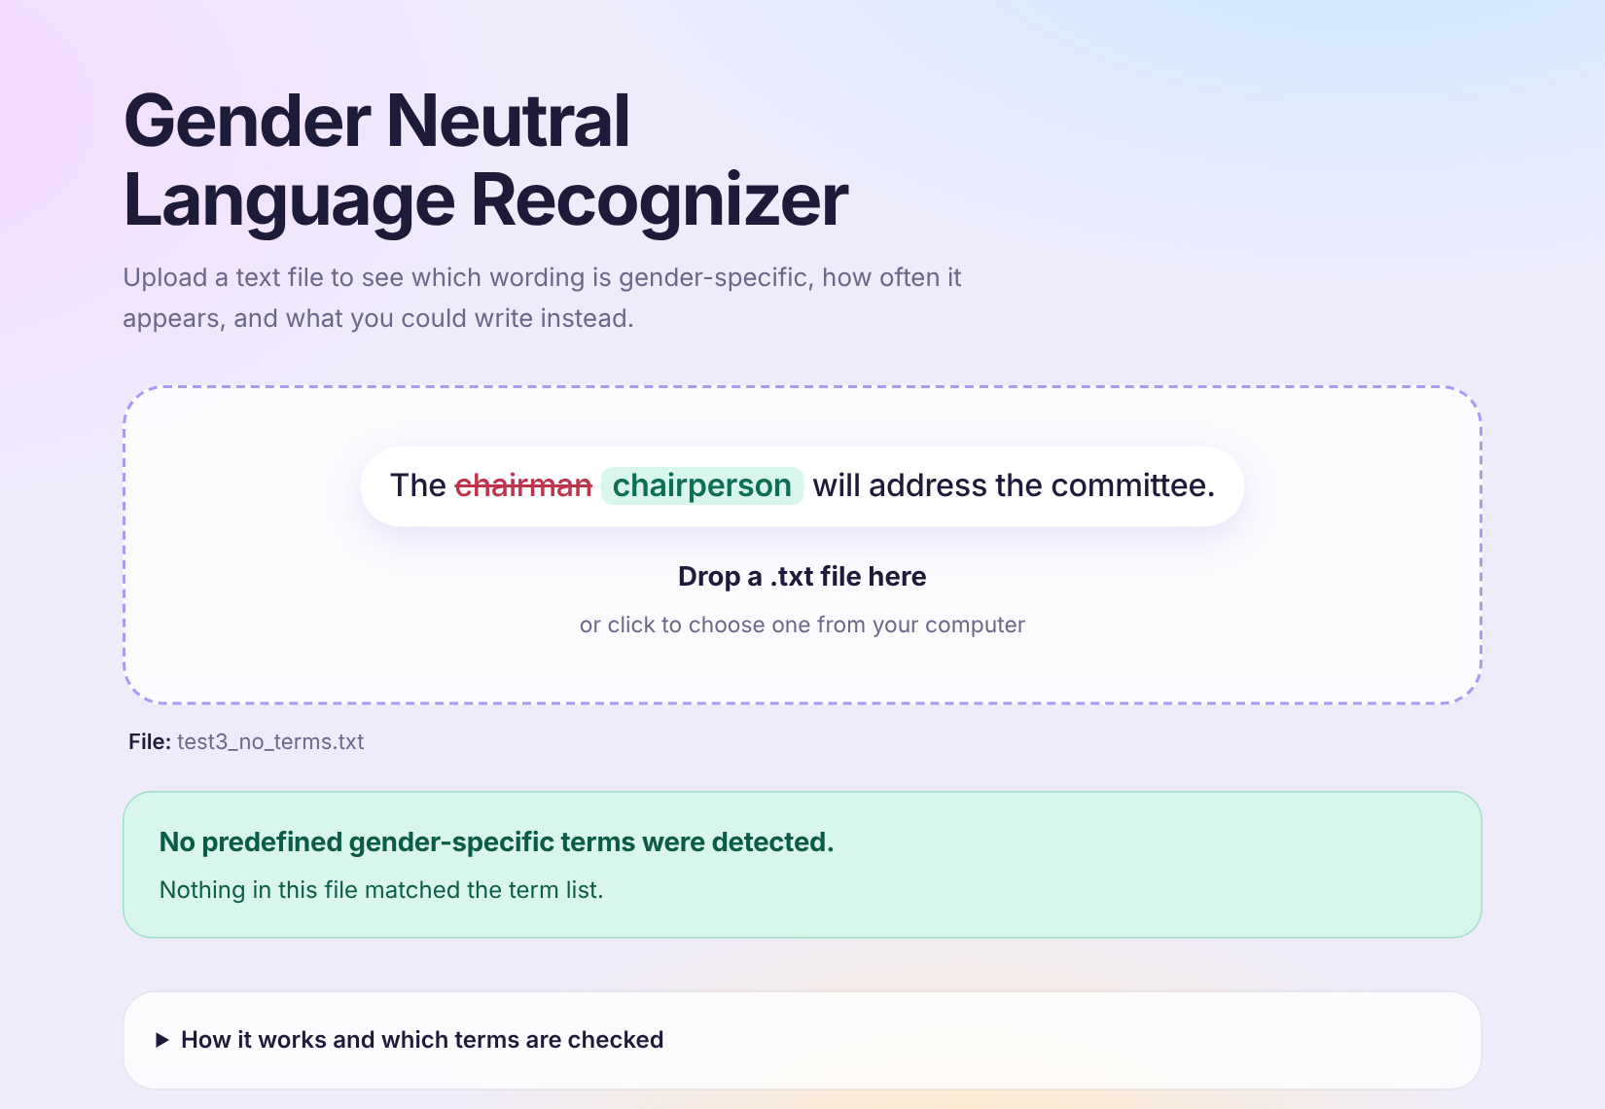
Figure 3. A document with no detected terms shows “No predefined gender-specific terms were detected.”

4 Testing
Five situations were tested with the running application. The test files are in the tests folder, and the same results can be reproduced with node tests/test.js.
# | Test situation | Expected result | Actual result | Passed?
1 | A document containing listed terms (test1_listed_terms.txt): policeman, fireman, stewardess, chairman, mankind. | Each term is detected once with its suggested alternatives. | “5 terms found, 5 occurrences in total.” chairman 1, fireman 1, mankind 1, policeman 1, stewardess 1, each with its alternatives. | Yes
2 | The same term repeated with different capitalization (test2_repeated_mixed_case.txt): Chairman, chairman, CHAIRMAN, chAiRmAn; policeman, POLICEMAN. | Case is ignored. chairman is counted 5 times and policeman 2 times. | “2 terms found, 7 occurrences in total.” chairman 5, policeman 2. | Yes
3 | A document with no listed terms (test3_no_terms.txt), containing “the”, “them”, “there”, “theme”, “She”. | Nothing is detected; “the” does not trigger “he”. | Message shown: “No predefined gender-specific terms were detected.” | Yes
4 | An empty .txt file (test4_empty.txt). | A clear message that the file is empty. | “This file is empty. There is no text to check. Choose a .txt file that contains some writing.” | Yes
5 | A file in an unsupported format (test5_unsupported.pdf). | A clear message that the format is not supported. | “Unsupported file format. Only plain text (.txt) files can be checked. Please choose a .txt file.” | Yes

5 Conclusion
We built a working web application that recognizes 28 gender-specific terms in a .txt file using a single regular expression, reports how often each term appears with suggested alternatives, and passed all five planned tests. Through this project we learned how regular expressions describe a set of words, how the word boundary and the ignore-case flag solve the “he” inside “the” problem, and how to test a recognizer against empty, mixed-case, and unsupported inputs. Known limitations: only .txt files are supported (not .docx or .pdf); only the 28 listed terms and their listed forms are detected; the program cannot tell when a term is acceptable in context, such as a proper name or a quotation; and it does not replace any text automatically.

6 Sources and contributions
References and tools: JavaScript regular expressions (MDN Web Docs); the Inter typeface from Google Fonts; Node.js to run the test script. No external code libraries or borrowed code were used.
AI assistance: Claude, an AI assistant made by Anthropic, was used to help write the application code, the test files, and the first draft of this document.
Member contributions:
- Anthony P. Sibarre: [describe this member’s contribution]
- Charleen E. Amper: [describe this member’s contribution]
- Jeremiah Karl S. Aleria: [describe this member’s contribution]
- Darl C. Destriza: [describe this member’s contribution]

