

  - Weekly Infrastructure Update

15-07-2026

Standard Report

Reputation and Delivery 3
Gmail Delivery issues 6

Reputation and Delivery

Totals | 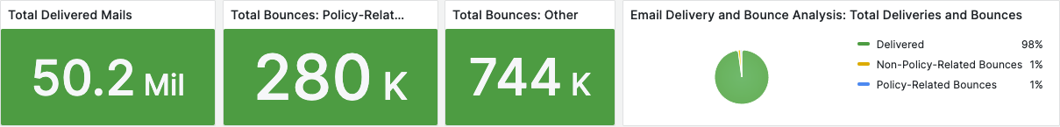

MTA Delivery Times | 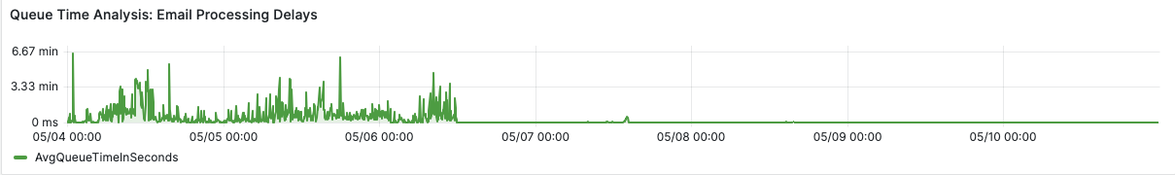

MTA Queue | 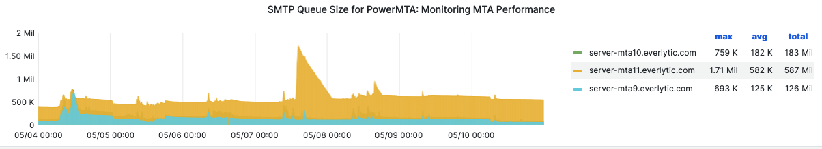

Bounce Reasons | 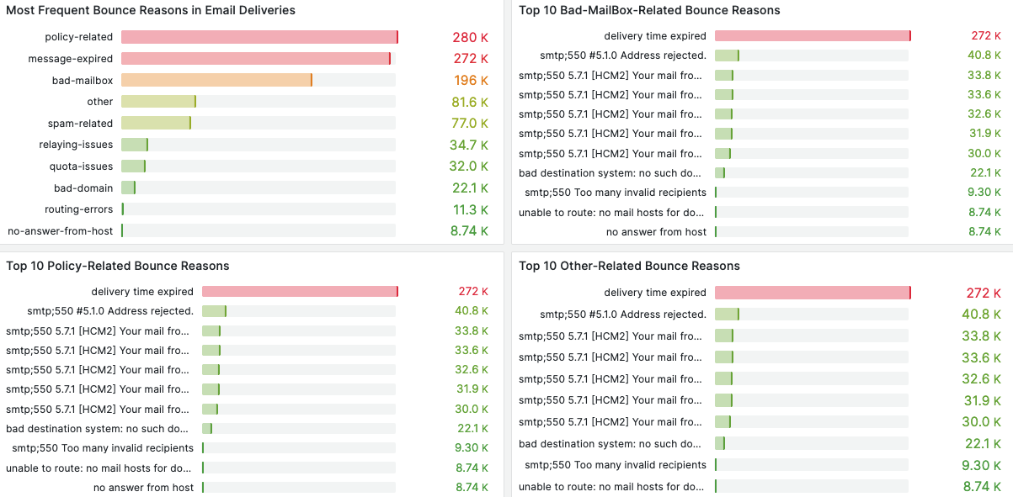

Delivery Issues | 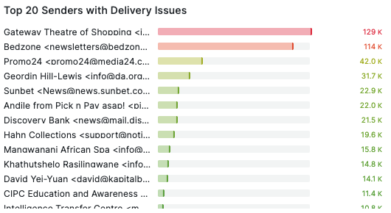 | 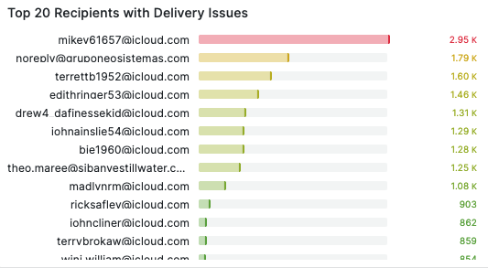

Email Sizing | 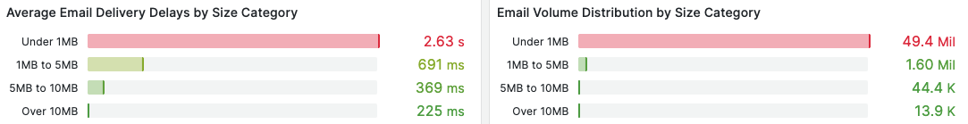

Gmail Delivery issues

Error Types | 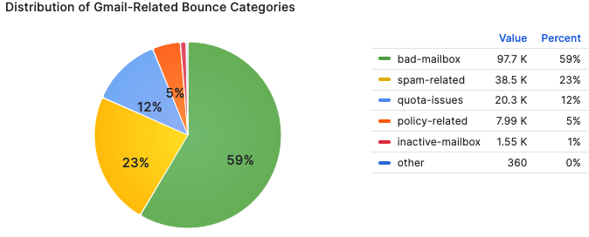

Errors by Sender | 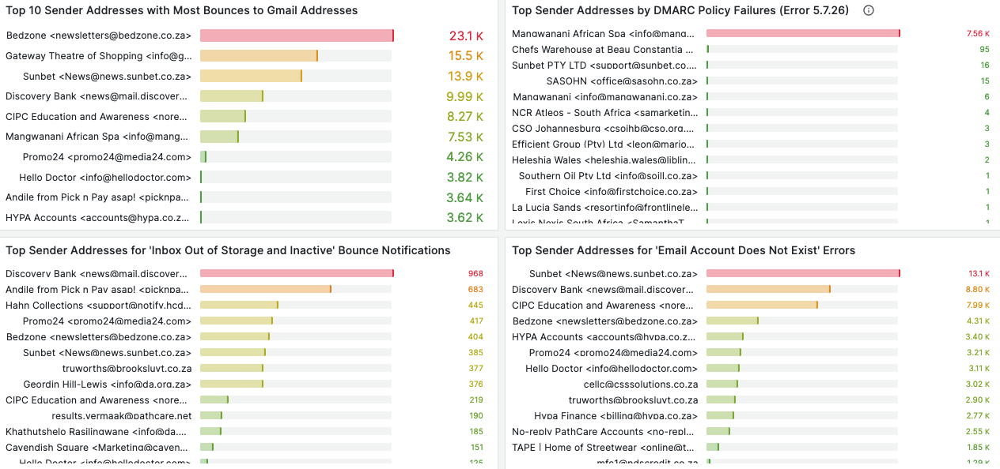

Document Version Control
Department | Last Edited by | Version | Date of Update | Nature of changes
Infrastructure | Anthony Smillie | 1.0 | 12/05/2026 | Weekly report

