Phase III: Final Report

This report outlines the functionality of the current system. Though the framework is designed to be extensible, so as to encourage future development, we will discuss first the contributions made by the two original developers (Pierce and Theocharis), at the time of submission (December 2008).

Framework Overview
The 3AD Framework is conceptually divided into a number of modules, each tasked with its own, well-defined functionality. A block diagram of the system is shown below:

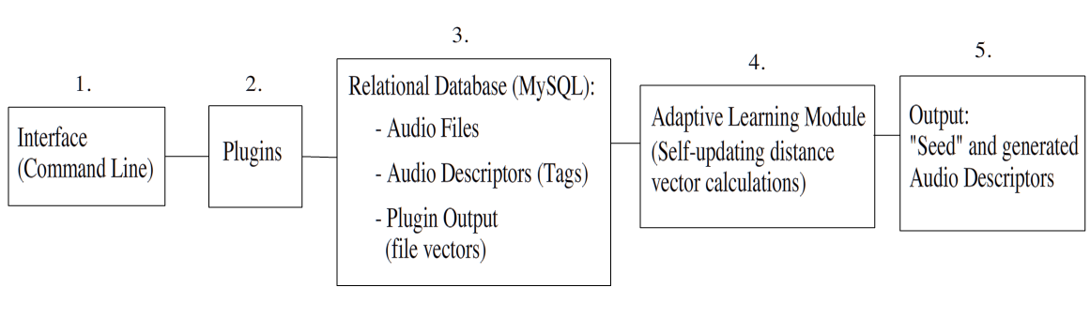
- Currently, the 3AD Framework can be run on the command line via a number of Python scripts (detailed below). The interface provides a way to:
  - create the database tables (init_database.py)
  - initialize the starting plug-ins, audio files and tags (init_database.py)
  - input single files to be processed and/or given descriptors (add_file.py)
  - calculate (and print to the terminal) generated tags for one or all files within a user-defined tolerance zone (generate_tags.py)

- Plugins are used to generate vectors for audio files in the framework’s database. A plugin’s calculations are intended to be based on a single audio processing function, but, by specification, a plugin need only provide a createVector() method that returns a list of floats. The final vector of an audio file is a concatenation of all plugin vectors for that file.
The current version of 3AD has three plugins:
  - charlotte(), a timbral feature extractor based on “In the Mood”, a Rhythm Box plugin developed by Charlotte Curtis
  - centroid_plugin(), a centroid calculation plugin which takes the average over the entire piece of audio
  - bextract_plugin(), which extracts both timbral and textural features.

- The MySQL database stores the filenames of all audio files and the audio descriptors and the current mappings between them. The database also stores the most recent output vectors for all audio files.

- The 3AD Framework calculates audio descriptor vectors by taking the mean vector of all audio files tagged with that descriptor. These values are updated every time a new file vector is generated, so that a distance calculation between the file and the updated audio descriptor vectors can be made.
As new descriptors and new file vectors are added into the system (by the addition of plugins or by the addition of new files) the descriptor vector calculation becomes more and more accurate, thereby adaptively improving the framework.

- The framework generates audio descriptors for a given audio file by calculating the Euclidean distance between the audio file vector and each tag vector. If the difference is within a given tolerance range for a descriptor, then that file is “tagged” with that descriptor. The output of the 3AD Framework displays the “seed” (user provided) audio descriptors, as well as the generated audio descriptors for all processed files.

Files
The 3AD Framework was written in Python (2.5) and uses SQLAlchemy (0.4) for interacting with the database. All three of the current plugins use the Marsyas SWIG Python bindings.

The current distribution package contains the following files structure:
- controller.py: all of the main controller methods (used by the interface scripts)
- init_database.py: database initialization script
- init_vectors.py: database vector initialization script
- generate_tags.py: tag generation/regeneration script for single or multiple files that allows for filename (–f), pre-defined tag (-t), and classification tolerance value (-r) command-line flags
- model.py: model classes for interacting with the database as a collection of objects
- plugins/charlotte.py: timbral feature extraction plugin
- plugins/centroid_plugin.py: average centroid calculation plugin
- plugins/bextract.py: timbral and textural feature extraction

