Central Market data ERD
Dataset: qwiklabs-gcp-04-029c15637557.a4i_econ (BigQuery location US). This diagram describes the loaded tables and logical joins. PK denotes an intended unique identifier, including inline property-graph keys; FK denotes a logical reference. These labels do not imply enforced BigQuery relational constraints. Types below follow notebook construction; they are not a fresh live schema inspection. Row counts are from the previously recorded project reads.

Core dataset relationships
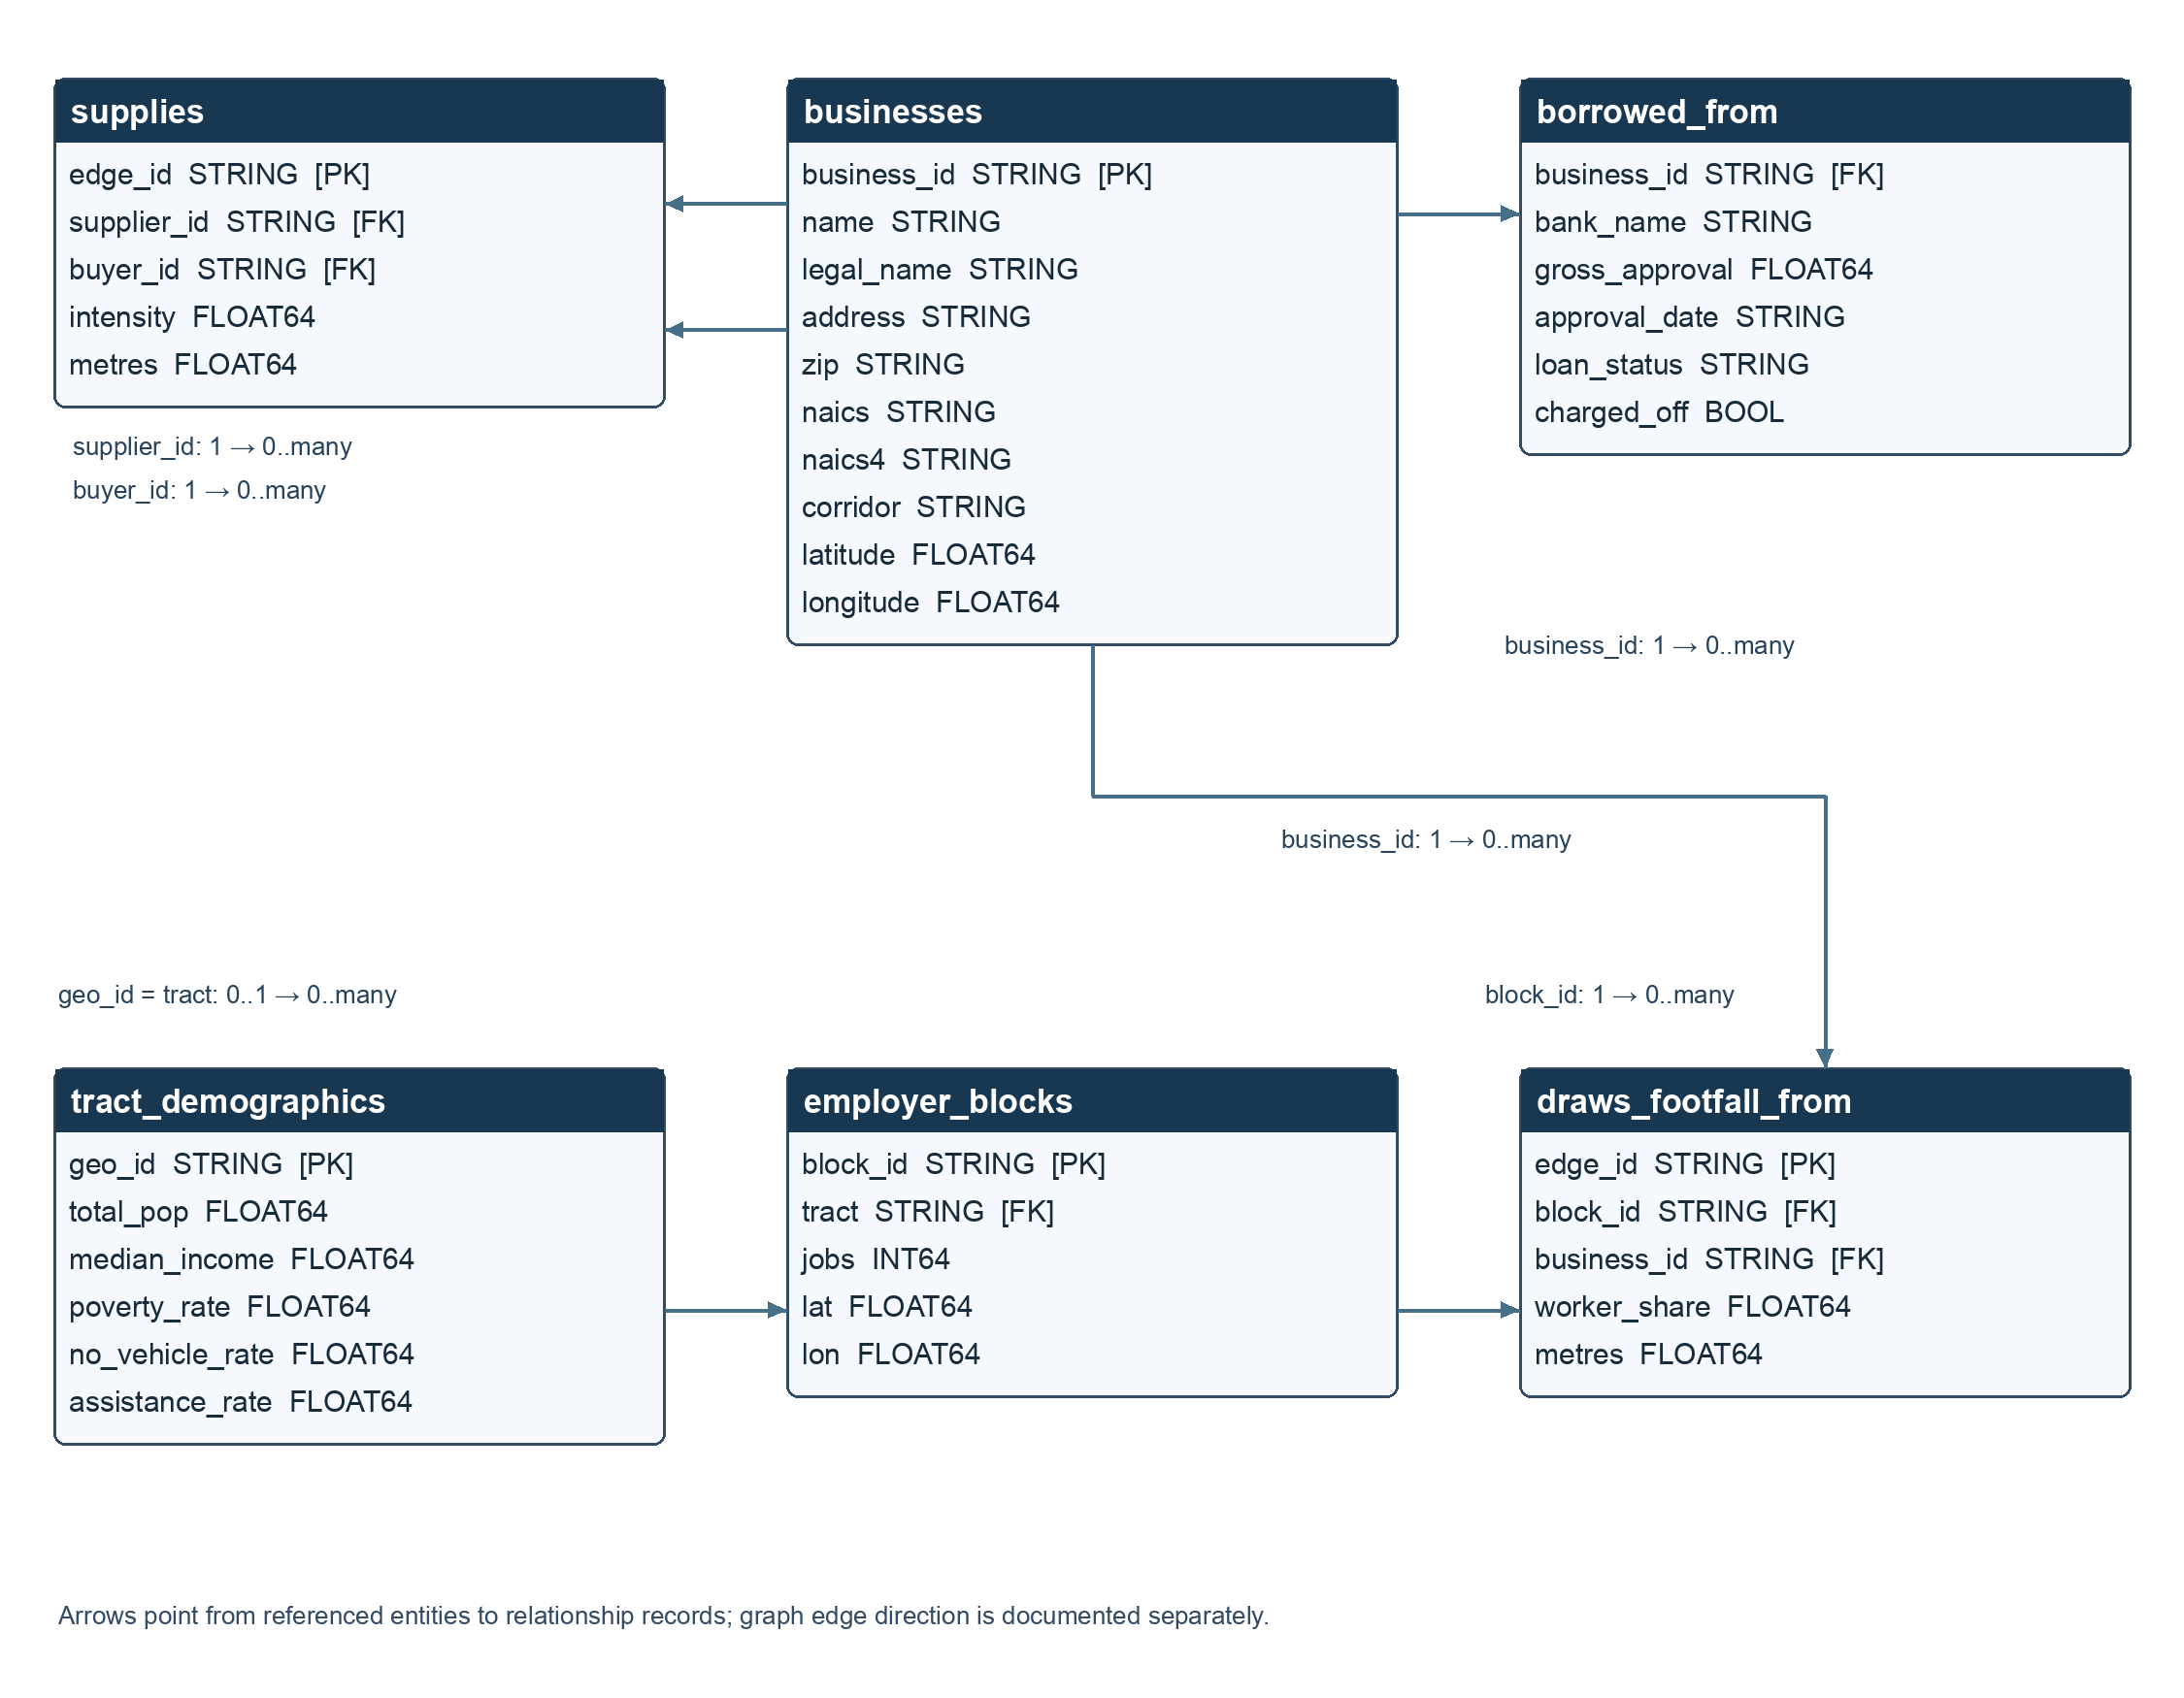

Table inventory and meaning
Table | Recorded rows | Source and interpretation
businesses | 232 | Real San Francisco registry locations; business_id comes from stable ttxid. ZIP can represent a mailing address.
supplies | 994 | Modeled supplier → buyer edges using BEA input requirements, industry prefixes and proximity; not observed purchases.
employer_blocks | 122 | Real LEHD workplace job totals; coordinates approximate each block using its tract's internal point.
draws_footfall_from | 1,024 | Modeled employer-block → consumer-business connections; worker_share allocates block jobs among nearby consumer businesses.
borrowed_from | 4 | Real SBA source records matched to registry names/legal names within the city's ZIP prefix; linkage is not independently verified. All four recorded rows had loan_status=EXEMPT, charged_off=False.
tract_demographics | 7 | Real ACS tract estimates. Rates are fractions, not percent values; total_pop is stored as a float by notebook SQL.
A business can have zero or many supplier, buyer, footfall and loan records. Each supply edge references exactly one supplier and buyer; each footfall edge references one block and business. The tract relationship allows missing demographic matches rather than assuming complete coverage. Normalize tract identifiers to 11-digit strings with leading zeros when joining.
borrowed_from has no loan_id, edge_id, or declared unique composite key in the loader. Do not assume (business_id, bank_name) uniquely identifies a loan. Lender names are attributes in this table; there is no separately loaded banks entity.
There is no tract foreign key on businesses. A block's tract describes workplace context, not a business's customer demographics. A direct business-to-tract mapping would require a separate spatial join. There is also no corridor table: corridor is a business attribute.
Block jobs total 44,847 in the recorded load. These are not employment counts at the 232 businesses. worker_share is an allocated worker count, not a probability or a share of business revenue. Loan approval amounts do not establish current cash gaps or grant needs.

Property graph overlay
The implemented CascadeEconomy graph uses businesses as Business nodes and supplies as directed Supplies edges: supplier_id → buyer_id. Its keys are business_id and edge_id. The graph is metadata over these tables, not another copy of their rows.
The notebook's LocalEconomy example additionally shows employer_blocks nodes and DrawsFootfall edges from blocks to businesses. That DDL is a proposed example, not evidence that this expanded graph was deployed. Footfall and demographic queries can use the underlying tables independently of the graph. No lender node graph has been implemented in this ERD.

Separate illustrative data
These tables are fictional teaching examples, with no joins to the real corridor tables.

Illustrative toy relationships
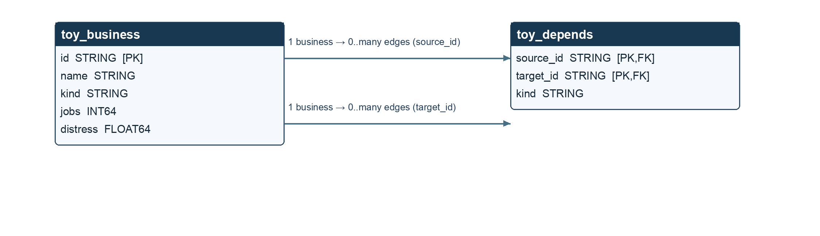

Recorded counts: 12 toy businesses and 11 toy edges. ToyBlock declares the composite edge key (source_id, target_id) and direction source → target. The kind field labels supply or footfall connections; it does not make these fictional links observations.

Sources
- Loader notebook (../notebooks/c3_01_load_explore.ipynb): normalized business columns, supply/footfall construction, SBA matching, ACS projection, load steps, and toy graph DDL.
- Implemented graph DDL (../agent/cascade_analyst/queries.py).
- Recorded deployment/data verification (../agent/VERIFICATION.md).
- Project data notes (../data/README.md).
Applicant budgets, requested grants, cash gaps, operating horizons, and evidence provenance are agent inputs. They are not additional persisted tables in the loaded dataset.

Field dictionary

businesses
Field | Type | Logical key
business_id | STRING | PK
name | STRING
legal_name | STRING
address | STRING
zip | STRING
naics | STRING
naics4 | STRING
corridor | STRING
latitude | FLOAT64
longitude | FLOAT64

supplies
Field | Type | Logical key
edge_id | STRING | PK
supplier_id | STRING | FK
buyer_id | STRING | FK
intensity | FLOAT64
metres | FLOAT64

employer_blocks
Field | Type | Logical key
block_id | STRING | PK
tract | STRING | FK
jobs | INT64
lat | FLOAT64
lon | FLOAT64

draws_footfall_from
Field | Type | Logical key
edge_id | STRING | PK
block_id | STRING | FK
business_id | STRING | FK
worker_share | FLOAT64
metres | FLOAT64

borrowed_from
Field | Type | Logical key
business_id | STRING | FK
bank_name | STRING
gross_approval | FLOAT64
approval_date | STRING
loan_status | STRING
charged_off | BOOL

tract_demographics
Field | Type | Logical key
geo_id | STRING | PK
total_pop | FLOAT64
median_income | FLOAT64
poverty_rate | FLOAT64
no_vehicle_rate | FLOAT64
assistance_rate | FLOAT64

toy_business
Field | Type | Logical key
id | STRING | PK
name | STRING
kind | STRING
jobs | INT64
distress | FLOAT64

toy_depends
Field | Type | Logical key
source_id | STRING | PK,FK
target_id | STRING | PK,FK
kind | STRING

