ReliefIQ — Technical Blueprint
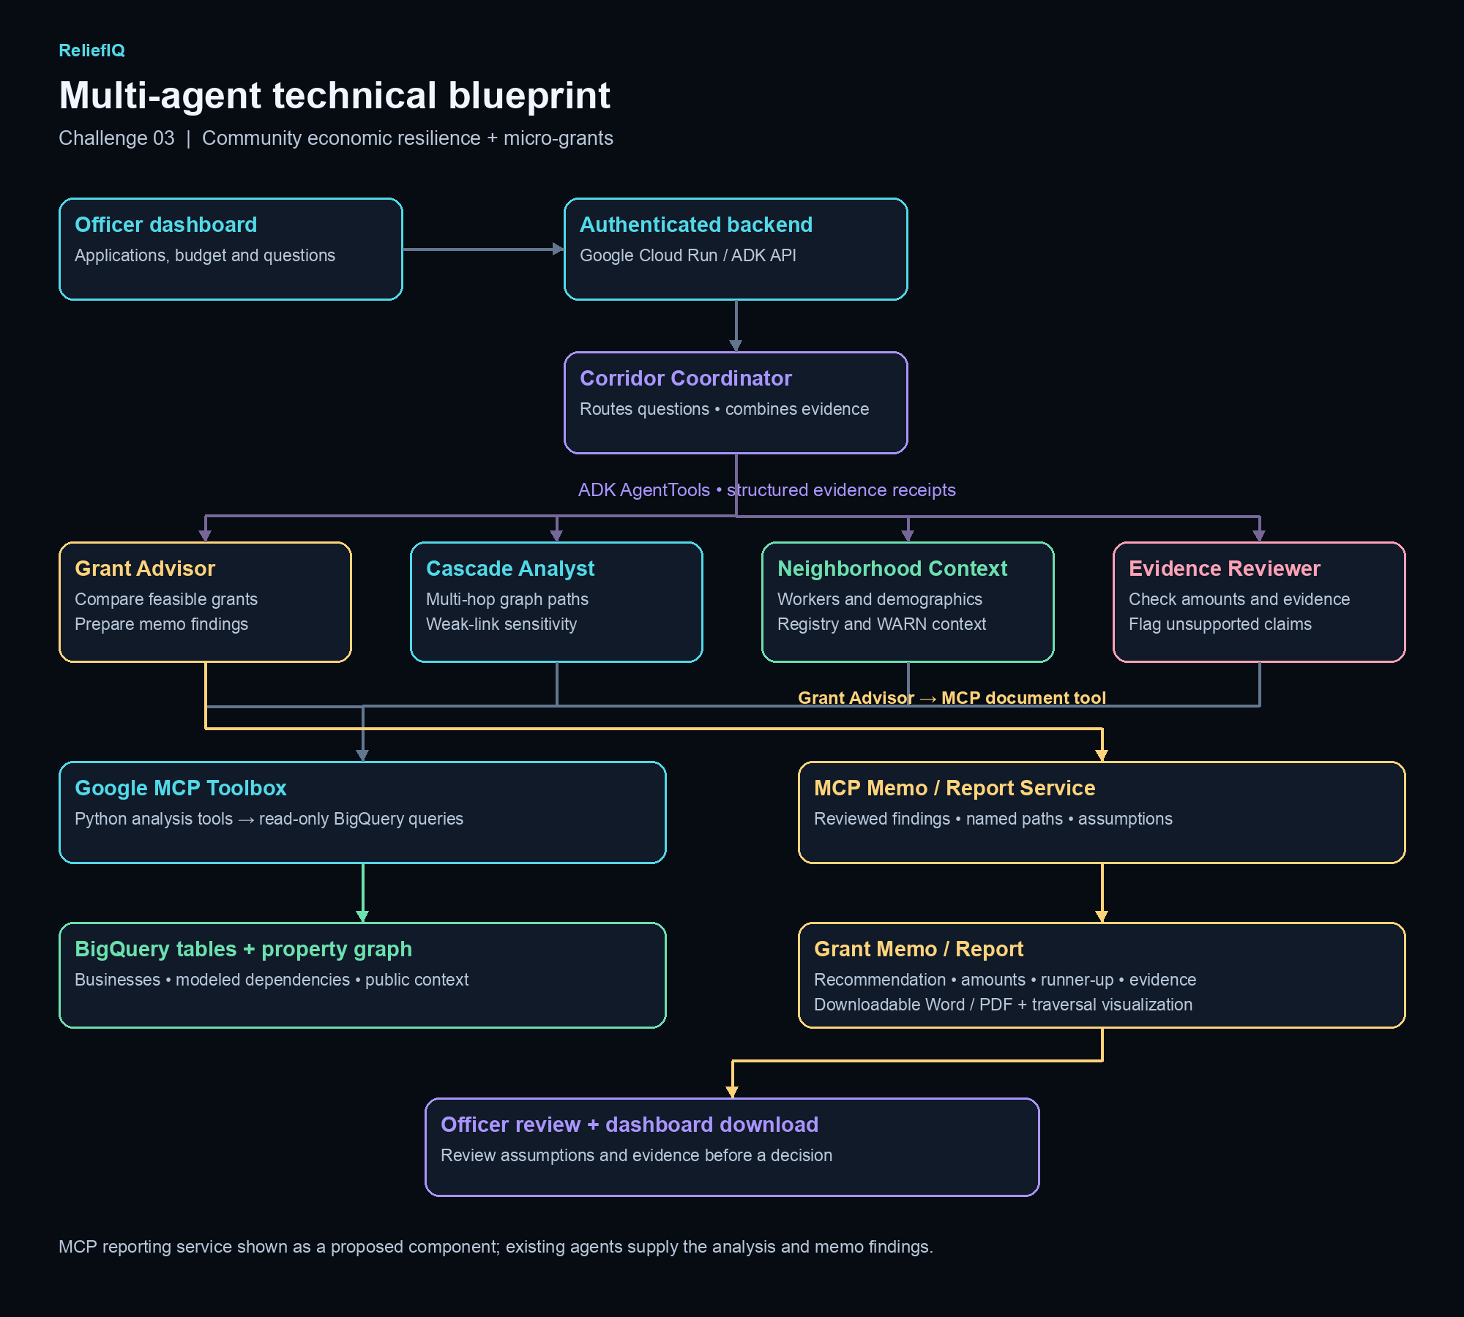
ADK AgentTools coordinate four specialists. Python tools access BigQuery through Google MCP Toolbox. The MCP Memo / Report Service is a proposed extension for Word/PDF export; it is not currently deployed.

