FIGURE FOR QUESTION 1D

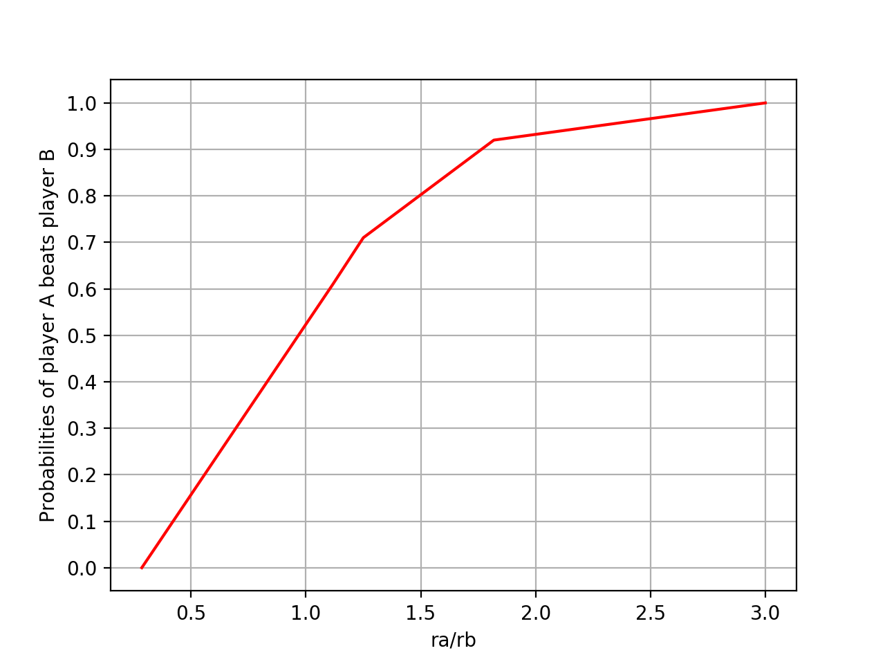

SIMULATION FOR QUESTION 1E

**import** random

**import** math

***def*** one_e():

p**=**winProbability(60,40,100000)

**if** p**>**0.90:

**return** 1

**else**:

**for** n **in** range(2,100):

pl**=**0

**for** i **in** range(0,(2**\***n**-**1)):

**if** i**==**0:

pl**+=**(p**\*\***n)**\***((1**-**p)**\*\***(i))

**else**:

pl**+=**(p**\*\***n)**\***((1**-**p)**\*\***(i))**\***(math.factorial(n)**/**(math.factorial(n**-**1)**\***math.factorial(n**-**(n**-**1))))

print(***f***"n ->{n} == probability: {pl}")

**if** pl**>=**0.9:

**return** n

The above code shows the implementation of how many rallies the players with abilities 60,40 need to play so that the probability the player a wins is at least 0.9. The result is 2 rallies.