# Squash scoring methods

Problem

The problem is which one of the Squash scoring methods English or PARS is better to be used for games. Another question is which method takes more time to finish, because shorter matches are usually preferable from the public. It is expected to be seen that the PARS scoring method is more equitable and takes less time to finish, because the player can win a point regardless if they are the server or the returner.

Method

To investigate the problem, a program with a function for each scoring method will be used to compute the probabilities of the player A to win based on each player's ability, each game's score and how many games they play. Each player’s ability will be read from a csv file with random numbers and the number of games will be a sufficient number so that the probability will be more accurate. Therefore, another function will be used to compute the average of how many rallies will be played by each method, based also on players abilities to see which one takes more time. Then, a graph with the probabilities that were computed and a graph with the average rallies of each method, which are both against the division of player's A and player's B abilities, will be plotted. With this method the graphs will be compared and conclude to which scoring method is fairer and takes less time to finish.

Assumptions

1. The term “better” is assumed to be which scoring method makes the player with the highest ability to win.
2. It is assumed by the coursework that each rally takes equal time.
3. It is assumed by the coursework that player A’s ability is represented by an integer value ra such that is between 0 and 100.
4. It is assumed that with the English scoring method when the score of the game reaches 8-8 the decision of the player who scored first 8 points is chosen randomly by the program between 9 and 10.

Results

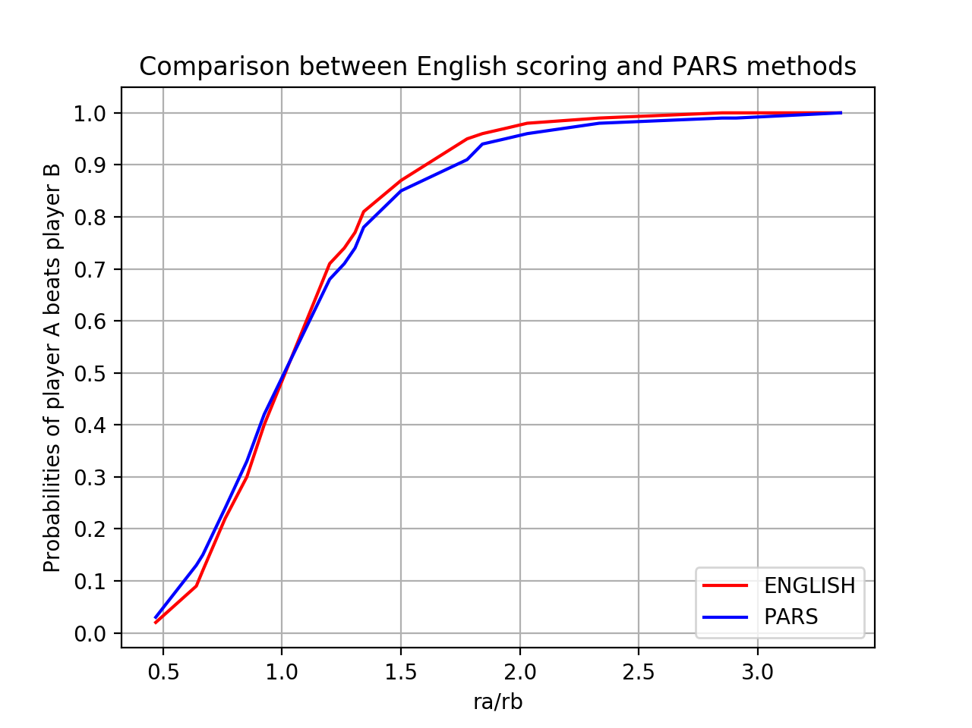

Figure 1

Figure 1 shows the results of the probabilities of player A beats player B against the division of player’s A ability and player’s B ability for 1000 rallies. The line with the blue colour is the results of the PARS method and the line with the red colour is the results of the English scoring method.

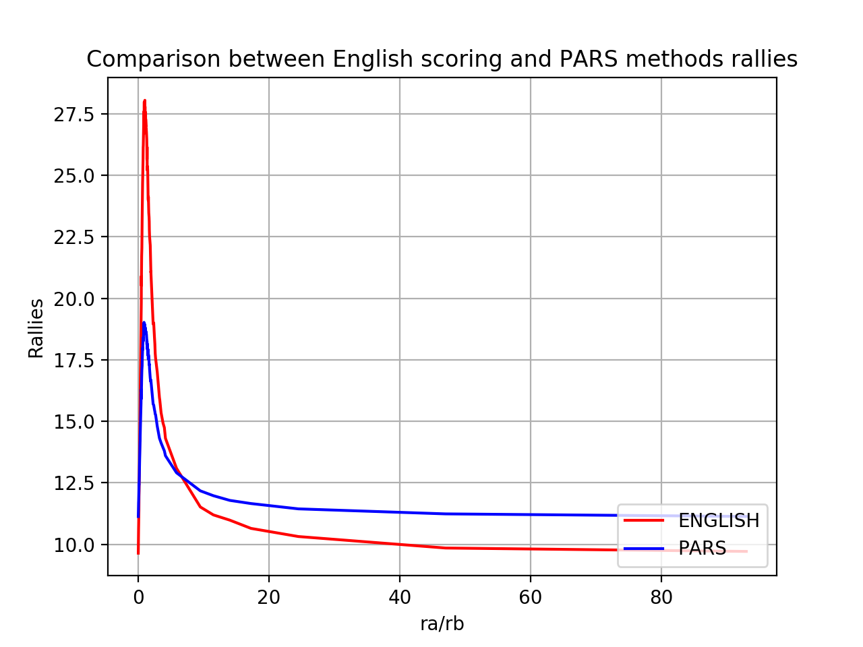

Figure 2

Figure 2 shows the results of the average rallies of each scoring method against the division of player’s A ability and player’s B ability. The line with the blue colour is the results of the PARS method and the line with the red colour is the results of the English scoring method.

Conclusions

In conclusion, according to the results we got from figure 1, we notice that English scoring and PARS methods do not have many differences of the values of probabilities, therefore both methods are fair. Moreover, from figure 2 results we can deduce that the English scoring method takes more time to finish.