**Manage Themes**

This is the functionality to manage Themes. A “Theme” is a different Look & Feel (Logos, Colors) that can be associated with 1 or more Domains, there is a “Theme” drop-down already in the Manage Domain that need to be updated to pick the values from this functionality. When a user login, the Theme associated with their domain automatically display the Logos/Colors stored in the database, all the users in this domain will see this Look & Feel. (see screenshot below):

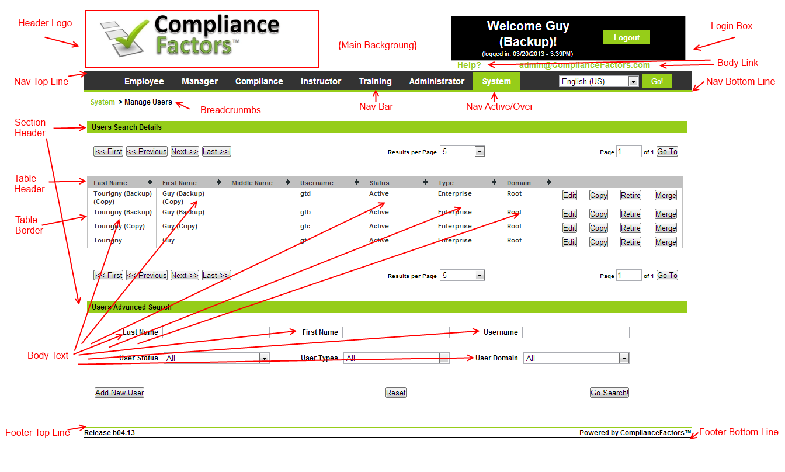

The system will display the Theme if associated with the Domain; if not, it will display the Default Theme (Root). This is based on dynamically controlling the CSS with HEX# for the Colors (i.e. background, navigation top line, navigation bottom line, navigation bar, navigation active section/mouse over, links, text, etc.) and uploading a Logo for each of the following: Header, Reports. (See screenshot below for example of items to be controlled); this should not be a problem as all of these should already be controlled by the CSS so we just need to make the CSS values dynamic coming from the database based on Domain.

To manage the Theme for the user selects “System -> Manage Configuration” from the navigation.

The user clicks the “Manage Themes” link from the Manage Configuration main page.

The system display the main Manage Themes page (samtmp-01.aspx) which already shows the first 10 records (or up to 10 records) and also provide a search functionality at the bottom of the page (see the screenshot below and mockup “samtmp-01.html”):

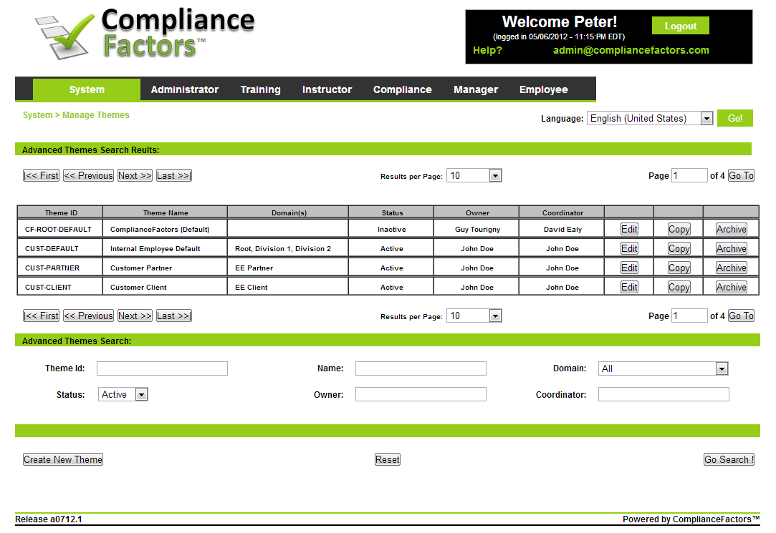

***Note: The system must at least always have an “Active” Them for the Root Domain.***

The user then can click the “Edit” or “Copy” or “Archive” or “Create New Theme” buttons.

If the user clicks the “Create New Theme” button, the system then goes to the “Create New Theme” page to enter information (see the screenshot below and mockup “saantp-01.html”). The create New Theme always starts with all the CF default values and logos:

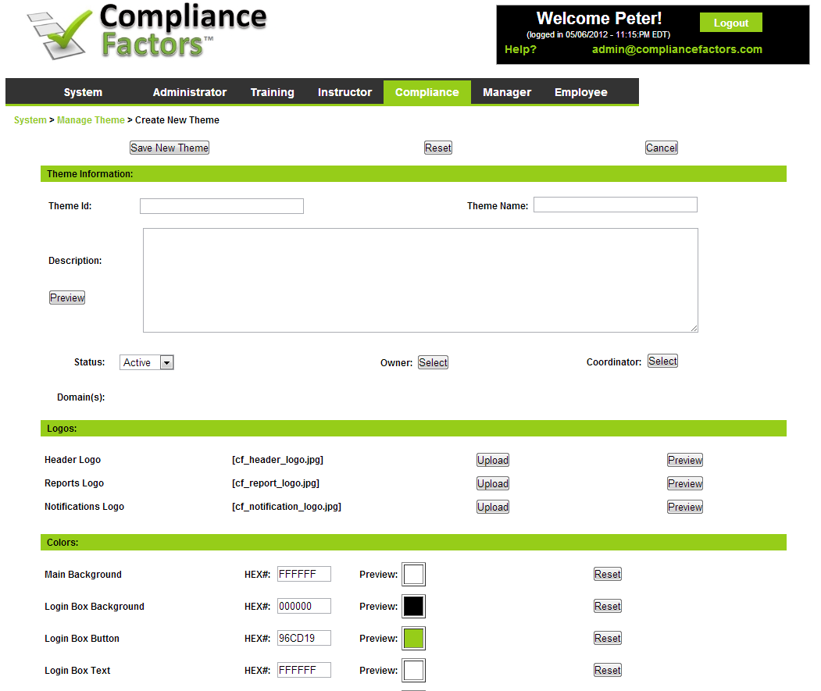

Note that in the “Domain” fields, the system will display only the domain(s) that associated with this Theme currently (so when creating a new one, it will be empty). There can be only 1 Theme per domain. However, multiple Domains can use the same theme. If a domain does not have a Theme, the system will display the “Root” domain Theme if active.

To support all that, we will need a new table in the database for the Themes as follow:

CREATE TABLE [dbo].[s_tb_themes](

[s_theme_system_id_pk] [identifier] NOT NULL,

[s_theme_id_pk] [varchar](50) NOT NULL,

[s_theme_name] [varchar](50) NOT NULL,

[s_theme_description] [longtext] NOT NULL,

[s_theme_status_id_fk] [bit] NOT NULL,

[s_theme_owner_id_fk] [varchar](50) NULL

[s_theme_coordinator_id_fk] [varchar](50) NULL

[s_theme_head_logo_file_name] [nvarchar](255) NOT NULL,

[s_theme_report_logo_file_name] [nvarchar](255) NOT NULL,

[s_theme_notification_logo_file_name] [nvarchar](255) NOT NULL,

[s_theme_css_tag_main_background_hex_value] [char](6) NOT NULL

[s_theme_css_tag_login_background_hex_value] [char](6) NOT NULL

[s_theme_css_tag_login_button_hex_value] [char](6) NOT NULL

[s_theme_css_tag_login_text_hex_value] [char](6) NOT NULL

[s_theme_css_tag_login_link_hex_value] [char](6) NOT NULL

[s_theme_css_tag_nav_top_line_hex_value] [char](6) NOT NULL

[s_theme_css_tag_nav_bar_hex_value] [char](6) NOT NULL

[s_theme_css_tag_nav_bar_text_hex_value] [char](6) NOT NULL

[s_theme_css_tag_nav_bot_line_hex_value] [char](6) NOT NULL

[s_theme_css_tag_nav_active_hex_value] [char](6) NOT NULL

[s_theme_css_tag_nav_active_text_hex_value] [char](6) NOT NULL

[s_theme_css_tag_foot_top_line_hex_value] [char](6) NOT NULL

[s_theme_css_tag_foot_bot_line_hex_value] [char](6) NOT NULL

[s_theme_css_tag_section_head_hex_value] [char](6) NOT NULL

[s_theme_css_tag_section_head_text_hex_value] [char](6) NOT NULL

[s_theme_css_tag_section_head_border_hex_value] [char](6) NOT NULL

[s_theme_css_tag_table_head_hex_value] [char](6) NOT NULL

[s_theme_css_tag_table_head_text_hex_value] [char](6) NOT NULL

[s_theme_css_tag_table_border_hex_value] [char](6) NOT NULL

[s_theme_css_tag_bread_link_hex_value] [char](6) NOT NULL

[s_theme_css_tag_bread_text_hex_value] [char](6) NOT NULL

[s_theme_css_tag_body_text_hex_value] [char](6) NOT NULL

[s_theme_css_tag_body_link_hex_value] [char](6) NOT NULL

) ON [PRIMARY]

Then the user clicks the “Save” button and the Theme is saved and they are now in “Edit” mode which is the same as Create New Theme just with the new Logos and Colors (saetp-01.aspx).

The “Preview” button under Description brings up a pop-up Preview of the Theme (Logos/Colors):

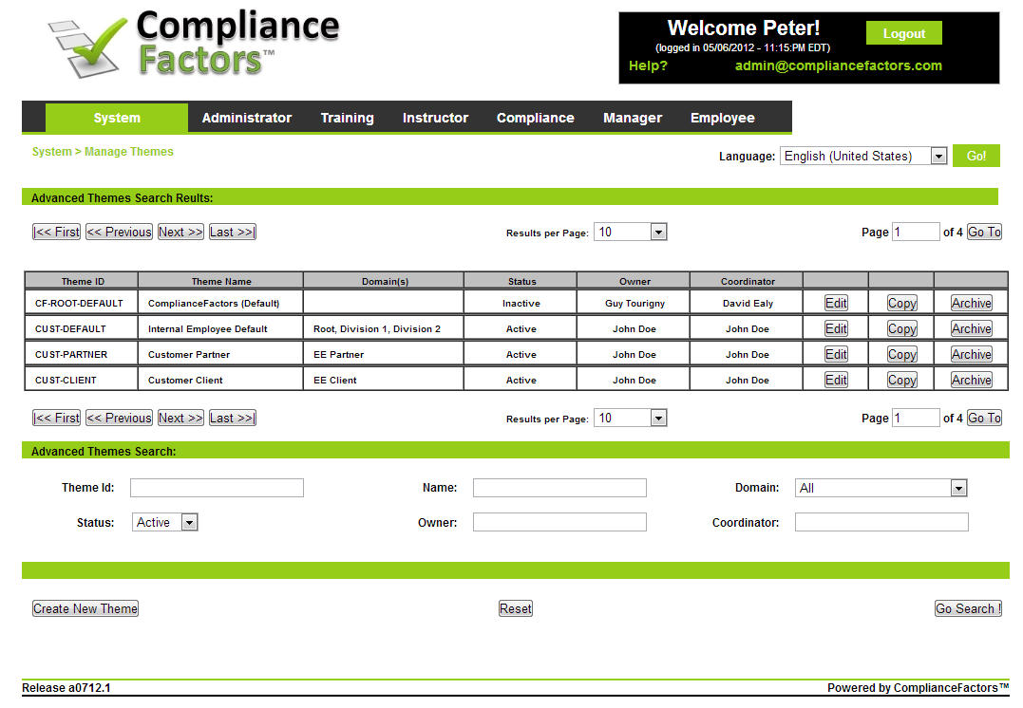

The “Preview” button beside the Logos brings up a pop-up Preview of that specific Logo (Image).

If the user clicks the “Edit” button, the system goes to the Edit Theme page. “Edit” mode which is the same as Create New Theme just with the new Logos and Colors.

If the user clicks the “Copy” button, the system then make a copy of that Theme information and goes to the “Edit” page for them to review the information and save it (works just like the user copy and add “(Copy) to the Theme Name).

If the user clicks the “Archive” button, a “pop-up” appears asking them to confirm and if they click yes, it change the status to “Inactive” and save it to the database (it is just a shortcut instead of having to do “Edit”-Change Status-Save”).

Finally, the Theme is linked to the Domain in the Manage Domain (see screenshot below):

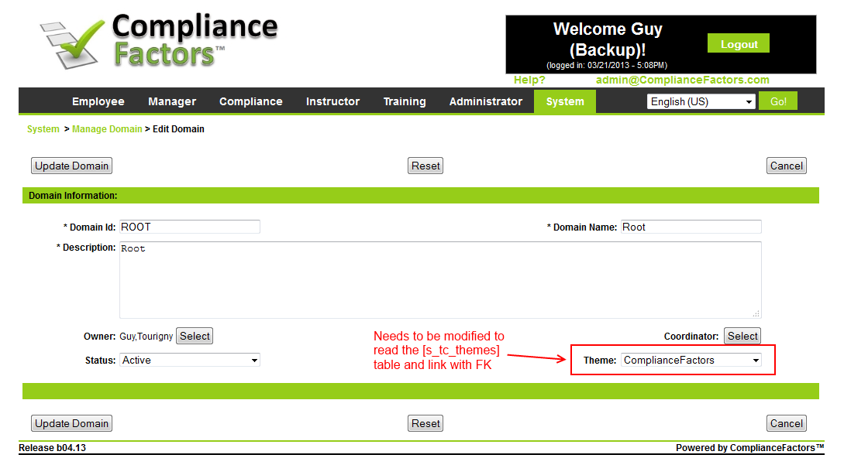

Link to FK:

CREATE TABLE [dbo].[s_tb_domains](

[u_domain_system_id_pk] [uniqueidentifier] NOT NULL,

[u_domain_id_pk] [varchar](50) NOT NULL,

[u_domain_name] [varchar](50) NOT NULL,

[u_domain_desc] [varchar](max) NULL,

[u_domain_branding_id_fk] [varchar](50) NULL,

[u_domain_parent_id_fk] [varchar](50) NULL,

[u_domain_status_id_fk] [nvarchar](255) NULL,

[u_domain_owner_id_fk] [uniqueidentifier] NULL,

[u_domain_coordinator_id_fk] [uniqueidentifier] NULL,

**[u_domain_theme_id_fk] [uniqueidentifier] NULL, ***Linked to [s_tb_themes] s_theme_system_id_pk**

CONSTRAINT [PK_s_tb_domains] PRIMARY KEY CLUSTERED