Project Paragon
Functional Specification & UI Blueprint
Version 1.0 · Solo Founder Edition




Platform Flutter (Web + Android + Desktop)
Backend Firebase (Firestore, Auth, Hosting, Analytics)
State Riverpod 3.3.1 · GoRouter v17
Design Figma → Google Stitch → Flutte

Document Information
Document Title: Project Paragon — Functional Specification & UI Blueprint
Version: 1.0 (Draft)
Last Updated: May 2026
Author: Darren Ohiomoba

How to use this document:
- Read Part 1 (Global Standards) before writing any Flutter code. These rules apply everywhere.
- Use Part 3 (Screen Specs) as the source of truth when generating widget code with Claude Code or Google Stitch.
- Insert your Figma design screenshots into every placeholder marked [ SCREEN_NAME_PICTURE ].
- Fill in every line marked with underscores — these are decisions only you can make.
- Yellow dashed boxes are image placeholders. Replace them with actual screenshots or Figma exports.
- Blue boxes are section labels inside each screen spec — they are for your navigation, not for the document reader.

Table of Contents

Note: Right-click the table of contents and select 'Update Field' in Word to refresh page numbers after editing.

Part 1 — Global Architecture & Standards
These rules apply to every screen and every widget in the app.

1.1 Brand Identity
NOTE TO READER
This section is a condensed typography reference for the Project Paragon design spec. It covers the essential decisions for day-to-day design and development work. For the complete specification including all component rules, contrast matrix, truncation rules, OpenType features, and Do/Don't examples, see the linked full type specimen.
Typography
Font: Space Grotesk · Geometric sans-serif · Google Fonts · 5 weights (300–700) · pubspec: google_fonts: ^6.2.1

**TYPE SCALE — 8 STYLES (quick reference · see §1.2 for complete table including btnLabel and navLabel)**
TYPE SCALE — see §1.2 for the complete authoritative table, including btnLabel and
navLabel tokens. §1.2 is the source of truth; this section is a condensed visual
reference only. If any value here conflicts with §1.2, §1.2 wins.

RESPONSIVE SCALE
Style | 360px | 700px | 1100px
Display Large (Display LG) | 32sp | 44sp | 56sp
Heading 1 | 24sp | 30sp | 36sp
Heading 2 | 20sp | 24sp | 28sp
Heading 3 | 18sp | 20sp | 22sp
Body + below | fixed | fixed | fixed — frozen

TOKENS
LETTER-SPACING | SPACING
  Token | Value | Applied to
  ls-tight | −0.5sp | Display Large (Display LG)
  ls-snug | −0.3sp | H1, H2
  ls-normal | 0sp | H3, Body
  ls-wide | +0.5sp | Label, Caption, chips
  Token | Value | Use
  space-xs | 4px | Icon↔label
  space-sm | 8px | Option gap
  space-base | 12px | Head→body
  space-md | 16px | Card pad, Q→opts
  space-lg | 24px | Sections, math pad
  space-xl | 32px | Page padding

5 RULES EVERY DEVELOPER MUST KNOW
# | Rule
1 | Question text NEVER truncates — always wraps, scroll the container
2 | Only #0D1117 dark text on orange (#FF7700) — light text fails WCAG
3 | Tabular figures (tnum) on all score, streak, and stat displays
4 | Off-grid spacing is prohibited — only use spacing token values
5 | Input fields fixed at 16sp across all breakpoints (iOS zoom rule)

Full type specimen: paragon-type-specimen.html (open in browser · Cmd+P → Save as PDF to import to Figma)

Token | Value | Usage
Background | #0D1117 | Page/scaffold background on all screens
Surface | #161B22 | Cards, bottom sheets, modals, nav bar
Border | #30363D | Card borders, dividers, input outlines
Primary (Orange) | #FF7700 | CTAs, streak flame, active tab indicator, accent highlights
Secondary (Violet) | #8B5CF6 | Learn buttons · Year badges · XP & achievements · Info chips · Links · Secondary actions · Primary CTA focus rings · Selected state borders · Active card borders · Onboarding CTAs
Text Primary | #E6EDF3 | All body text, headings on dark background
Text Secondary | #8B949E | Subtitles, metadata, placeholder text
Success Green | #3FB950 | Correct answer feedback, streak active, Correct label text, right-aligned indicators.
Error Red | #F85149 | Wrong answer feedback, error states, error text.
Overlay | #000000 at 70% | Modal and bottom sheet scrims
Success Overlay | rgba(35,134,54,0.20) | Safe background overlay for correct states.

1.2 Typography
**Font Family: **Space Grotesk (via google_fonts package). Fallback: Arial.
**SOURCE OF TRUTH:** This section (§1.2) is the authoritative type scale reference. §1.1 carries a condensed quick-reference version for day-to-day use. If the two tables ever conflict, §1.2 wins. The type specimen (paragon-type-specimen.html) is the master; §1.2 must match it exactly.

Style Name | Weight | Size | Line Height | Letter Spacing | Usage
Display Large | Bold 700 | 32sp | 1.2 | -0.5sp (ls-tight) | Score results, achievement unlocked, results hero, Scores display,
Heading 1 | Bold 700 | 24sp | 1.25 | -0.3sp (ls-snug) | Screen titles
Heading 2 | SemiBold 600 | 20sp | 1.3 | -0.3sp (ls-snug) | Section headings, card titles. Cards. App bar
Heading 3 | SemiBold 600 | 18sp | 1.35 | 0sp (ls-normal) | Unit/topic names, Unit headers
Body Large | Regular 400 | 16sp | 1.6 | +0.1sp (ls-normal) | Question text, article body, notes
Body Medium | Regular 400 | 14sp | 1.6 | +0.1sp (ls-normal) | Options A–D, supporting text
Label | Medium 500 | 12sp | 1.4 | +0.5sp (ls-wide) | Tags, metadata, timestamps, chip labels, nav, badges
Caption | Regular 400 | 11sp | 1.4 | +0.5sp (ls-wide) | Footnotes, year badges, version text, timestamps.

Style Name | Weight | Size | Letter Spacing | Usage
btnLabel | SemiBold 600 | 14sp | 0sp (ls-normal) | Primary text for Large (48dp) and Medium (40dp) buttons.
navLabel (Active) | SemiBold 600 | 10sp | — | Active bottom navigation text (frozen across all breakpoints).
navLabel (Inactive) | Regular 400 | 10sp | — | Inactive bottom navigation text (frozen across all breakpoints).

1.3 Layout Grid
The 8px Spacing System

All margins, padding, gaps, and UI element dimensions must be multiples of 8 (e.g., 8, 16, 24, 32, 48, 64). Off-grid values are strictly prohibited. This ensures a consistent vertical and horizontal rhythm across all screen sizes and translates cleanly to const EdgeInsets.all() in Flutter.

Responsive Breakpoints & Grid Rules
All UI design originates at the Desktop/Web breakpoint (≥1100px). Figma frames are drawn at 1280px or 1440px width. Flutter code is written with desktop as the default layout; mobile is a responsive degradation applied via LayoutBuilder breakpoints. The type specimen's responsive scale table scales up from 360px — that reflects font size behaviour only, not layout direction. Layout direction is desktop-first.
Performance baseline remains budget Android (360px, ~4GB RAM). Desktop-first layout does not change query limits, image compression targets, or shimmer/spinner decisions — those are always made for the weakest target device. Test layout on desktop; test performance on mobile.

- Desktop / Large Web (Base Concept)
  - Breakpoint: ≥ 1100px width
  - Layout Behavior: Dual column (Persistent navigation rail/sidebar on the left, widened content area on the right).
  - Figma Grid: 12 columns
  - Max-Width: 1200px for the central content area to prevent infinite stretching on ultrawide monitors.
  - Margin (Horizontal Padding): 32px minimum
  - Gutter: 24px
- Tablet / Small Web
  - Breakpoint: 700px to 1099px
  - Layout Behavior: Dual column or fluid single column depending on content density. Navigation rail may collapse to icons only.
  - Figma Grid: 8 columns
  - Margin (Horizontal Padding): 24px
  - Gutter: 24px
- Mobile (Collapsed Layout)
  - Breakpoint: < 700px (Targeting 360px as the baseline for budget Android devices)
  - Layout Behavior: Single column. Sidebar navigation moves to a Bottom Navigation Bar or a hidden Drawer.
  - Figma Grid: 4 columns
  - Margin (Horizontal Padding): 16px
  - Gutter: 16px
  - Safe Areas: Account for the bottom navigation bar on all scrollable content, and leave adequate padding at the top for the mobile system status bar.

[ LAYOUT_GRID_DIAGRAM ]
Insert your Figma grid layout diagram here showing all three breakpoints side by side.

1.4 Navigation Architecture
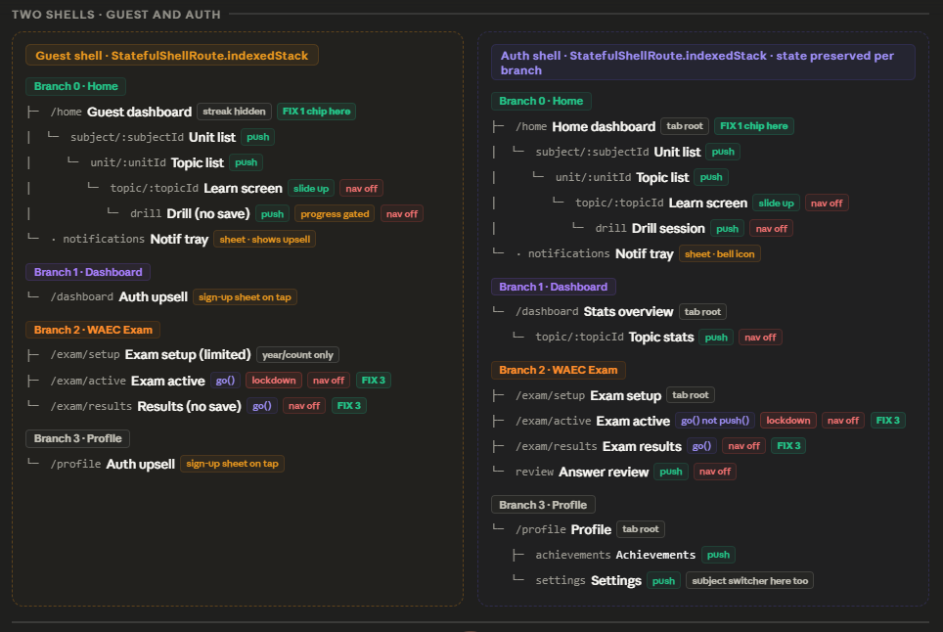
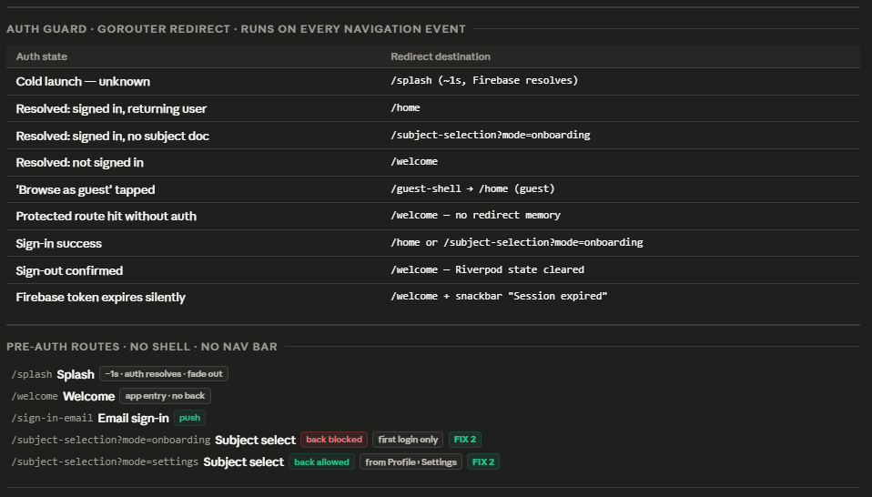
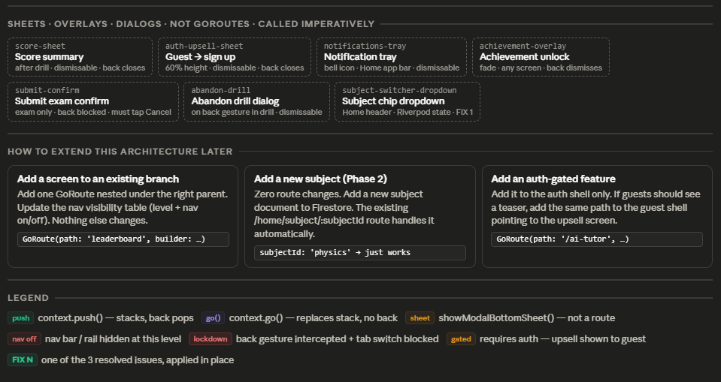
Insert your navigation flow diagram here (GoRouter route tree). You can draw this in Figma or use FigJam.

Router: go_router v17
Bottom Navigation (mobile): 4 tabs — Home, Dashboard, WAEC Exam, Profile
Navigation Rail (desktop/web): Same 4 destinations, displayed as left-side rail with labels

Core Engine & Web-First Strategy
Navigation is strictly governed by go_router (v17+) and state is monitored via Riverpod (v3.3.1). To support a seamless web-first experience alongside mobile, the architecture relies on clean, shareable URL paths and a robust redirection engine. The UI adapts via a StatefulShellRoute.indexedStack, rendering a persistent left-hand NavigationRail on web/desktop viewports (≥700px) and a BottomNavigationBar on mobile (<700px).

Dual Shell Architecture
To elegantly handle unauthenticated users without duplicating logic, the app utilizes a Two-Shell strategy:
- Guest Shell: Allows exploration of the topic catalog (/home branch) and limited access to WAEC exams. Attempts to save progress, view the dashboard, or access profile settings will trigger an imperative auth-upsell-sheet.
- Auth Shell: The full application experience with state preserved across all four navigation branches.

Auth Guard & Redirect Logic
A Riverpod-powered auth guard evaluates every navigation event to prevent unauthorized access and handle deep-link resolutions.

Auth StateS | Redirect Destination
Cold Launch (unknown) | /splash (~1 s, awaiting Firebase resolution)
Resolved: Signed in, returning user | /home
Resolved: Signed in, incomplete profile | /onboarding/username (first incomplete step — see checkOnboardingStep())
Resolved: Not signed in | /welcome
‘Browse as Guest’ selected’ | /guest-shell -> /home GoRouter's redirect logic detects isAnonymous == true and mounts the Guest Shell automatically. There is no /guest-shell route. The Guest Shell is a layout wrapper (StatefulShellRoute), not a navigable path. context.go("/home") is the correct call, matching 2_1.docx §2.1.3.
Protected Route hit without auth | /welcome — return URL stored in GoRouter extra and restored after sign-in. Unauthenticated deep links (e.g. WhatsApp shared drill) resolve to the original destination once auth completes. See §2.1.12.
Sign-in success | /home OR /onboarding/username (first incomplete step)
Sign out confirmed | /welcome (Riverpod state cleared)
Firebase token expires silently | /welcome + Snackbar “Session expired”

Pre-Auth & No-Shell Routes
These routes sit outside the StatefulShellRoute. The navigation rail/bottom bar is never visible here.

Path | Screen | Behaviour & Navigation
/splash | Splash | Fades out after auth resolves
/welcome | Welcome | App entry point. Back gesture blocked.
/sign-in-email | Email Sign-In | Back gesture allowed. Top app bar shows back arrow (←); tap or swipe routes to /welcome. User may return to choose Google Sign-In instead.
/onboarding/subjects | Subject Select | First Login only. Back gesture blocked. User has authenticated — must complete profile before accessing the app.
/profile/subjects | Subject Select | Reached from Profile. Back gesture allowed.

Auth Shell: Route Branches
The core application state is preserved per branch using StatefulShellRoute.indexedStack.
Branch 0: Home & Learn (Khan Academy Style)
- /home: Home dashboard (Tab Root).
- /units/:subjectIdpush).
- /topics/:subjectId/:unitId: Topic list (push).
- /learn/:topicId: Learn screen (Video + Notes). UI slides up, Nav Bar hidden (nav off).
- /drill/:topicId: Drill session. Immediate feedback practice (push, nav off).
- /drill/:topicId: Drill session. Immediate feedback practice (push, nav off).
- /drill/:topicId/results: Score Summary. context.go() ONLY — replaces the drill
- screen in the navigation stack. Back gesture → /topics/:subjectId/:unitId (never
- back to the drill). Nav off. Route must be declared as a child GoRoute under
- /drill/:topicId in the GoRouter configuration.

Branch 1: Dashboard
- /dashboard: Stats overview (Tab Root).
- - /dashboard/topic/:topicId: Topic stats detail (push, nav off).
- - /exam/history: Exam History screen (push from Dashboard). Full chronological exam list with per-subject filter chips. Back → /dashboard.
Branch 2: WAEC Exam (Strict Separation from Drill)
- /exam/setup: Exam setup parameters (Tab Root).
- /exam/active: Exam active lockdown mode. Must use context.go(). Back gesture intercepted, tab switching blocked (lockdown, nav off).
- /exam/results/:examId: Exam results summary. Must use context.go() (nav off).
- - /exam/review/:examId: Answer review interface (push, nav off).
- - /exam/history: See Branch 1 (Dashboard) and Branch 3 (Profile). This route is reachable from both; GoRouter resolves back destination from the originating branch using GoRouter's parentNavigatorKey. Do not declare it as a Branch 2 child — it does not belong to the exam flow.
Branch 3: Profile
- /profile: Profile and settings (Tab Root).
- /profile/achievements: Achievements grid (push).
- - /profile/settings: Account settings and subject switcher (push).
- - /exam/history: Exam History screen (push from Profile). Same screen as Branch 1 push — shared route, distinct entry points. Back → /profile.

Note on GoRouter implementation: /exam/history must be declared as a push route under both Branch 1 and Branch 3 using separate GoRoute definitions with the same path and widget but different parentNavigatorKey assignments so the back gesture resolves correctly. A single toplevel GoRoute for /exam/history will not preserve the correct back stack.

Guest Shell: Route Branches
The Guest Shell mirrors the structure of the Auth Shell to preserve the UI layout but strictly limits data writing and access to premium features.

Branch 0: Home & Learn (Guest)
- /home: Guest dashboard. The active streak tracker is strictly hidden. The subject switcher dropdown (FIX 1) is active here.
- /units/:subjectId → /topics/:subjectId/:unitId → /learn/:topicId: Full read-only access to the Learn screen (Video + Notes). Nav Bar hidden (nav off).
- /drill/:topicId: Drill session. Scores are saved to Firestore via anonymous UID. Auth Upsell Sheet appears after Score Summary to prompt account linking — not to gate the save. (nav off)
- .notifications: Notification tray triggers auth-upsell-sheet on tap.
Branch 1: Dashboard (Guest)
- /dashboard: Tab root. Automatically triggers the auth-upsell-sheet upon tab selection.
Branch 2: WAEC Exam (Guest)
- /exam/setup: Exam setup screen. Functionality is artificially limited (e.g., year and question count only).
- /exam/active: Exam active lockdown mode. Uses context.go() (FIX 3). Back gesture intercepted (lockdown, nav off).
- - /exam/results/:examId: Exam results summary. Results are saved to Firestore via anonymous UID. Auth Upsell Sheet appears to prompt account linking. Uses context.go() (FIX 3). Nav bar IS visible on this screen — "nav off" in the route table refers to the navigation method (context.go() replaces the stack), not the nav bar. The student must be able to navigate away after reviewing results.

Branch 3: Profile (Guest)
- /profile: Tab root. Automatically triggers the auth-upsell-sheet upon tab selection.

Imperative Overlays & Dialogs
These elements exist outside the declarative go_router tree and are invoked imperatively (e.g., showModalBottomSheet, showDialog). They do not change the URL path.

Overlay Name | Trigger Context | Behaviour
Score Summary Screen | End of Drill/ Practice/ Exercise Session | NOT an overlay. Full-screen route at /drill/:topicId/results, navigated via context.go() (replaces drill stack). Back gesture routes to /units/:subjectId — never back into the drill session. See §2.2.8 for full spec.
Auth Upsell Sheet | Guest hits gated feature | 60% height. Dismissible. Routes to /welcome on accept
Notification Tray | Bell icon (or some other icon to be decided later) tap on home | Standard dismissible sheet
Achievement Unlock | Triggered globally on XP gain | Fades over current screen. Back button dismisses.
Submit Exam Confirm | Tapping “Submit” in Exam | Back gesture blocked. User mist explicitly tap Cancel or Submit.
Abandon Drill Dialog | Back Gesture. | Dismissible confirmation dialog
Subject Switcher Dropdown / Course dropdown | Tapping Subject/Courses chip | Drops down from Home header via Riverpod state.

Implementation Resolutions (Architecture Fixes)
Based on the routing logic, the following critical state fixes must be enforced during development:
- FIX 1 (Subject Switcher): Ensure the Subject Chip Dropdown is globally accessible in the Home header via Riverpod state, regardless of guest or auth shell status.
- FIX 2 (Subject Select Modes): The /onboarding/subjects route (onboarding) and /profile/subjects route (settings) use the same Subject Selection widget but are distinct routes with distinct back-gesture behaviour. On /onboarding/subjects the back gesture is strictly blocked. On /profile/subjects the back gesture is allowed.
- FIX 3 (Exam Navigation): Routes moving into /exam/active and /exam/results/:examId must strictly use context.go() (which replaces the stack) rather than context.push(). This prevents the user from using a back swipe to return to a live exam timer.

1.5 Technical Stack Rules
These are hard constraints. Never deviate from them when writing Flutter code. These constraints are the bedrock of the Paragon codebase. They are mandatory. Deviation from these rules requires an architectural review.

Constraint | Rule | Reason
State Management | Riverpod 3.3.1 only. Use .asData?.value not .valueOrNull. No setState except inside animations. | Consistency — one pattern everywhere
Routing | GoRouter v17 only. All navigation via go()/push() context extensions. | Prevents back-stack corruption
LaTeX | flutter_math_fork only. Never re-add flutter_tex. | flutter_tex crashes on web
LaTeX Format | \(...\) for inline, \[...\] for display block. | Firestore data is stored this way
Answer Options | Stored WITHOUT A/B/C/D prefix. The UI widget adds the label. | Avoids data duplication
Google Sign-In (Web) | signInWithPopup via firebase_auth web SDK. | signInWithRedirect breaks on Web
Google Sign-In (Android) | google_sign_in package separately configured. | firebase_auth alone won't work on Android
Images | cached_network_image for all network images. Never Image.network(). | Prevents repeated downloads on 3G
Loading States | shimmer package for skeleton loaders. Never show empty white space. | Perceived performance on slow networks

I have integrated your technical stack constraints directly into the expanded Section 1.5. This version now blends your hard constraints with the optimized Riverpod architecture patterns we discussed, creating a comprehensive "developer's bible" for the codebase.

Technical Constraints (Hard Rules)
Constraint | Rule | Reason
State Management | Riverpod 3.3.1 only. Use .asData?.value (not .valueOrNull). No setState except for local animations | Consistency, so there’s one predictable pattern for me
Routing | GoRouter v17 only. All navigation strictly via context.go() or context.push() | Prevents navigation stack corruption and back-button breaking
LaTeX Rendering | Flutter_math_fork only. Never use flutter.tex | Flutter_tex has known critical failure modes on Web
LaTeX Format | Use \(...\) for inline, \[...\] for display block | Matches the source formatting in Firestore
Answer Options | Stored in DB without A/B/C/D prefixes. UI adds labels (allows for option randomization) | Avoids redundant data; simplifies dynamic layout.
Google Sign-In (Android) | Google_sign_in package (configured separately) | Required for native token handshake on Android.
Image loading | Cached_network_image only. Never image.network() | Improved perceived performance on unreliable 3G networks.

Architectural Data Flow
The application follows a strict Unidirectional Data Flow (UDF). UI components watch Riverpod providers; providers manage the async lifecycle of Firestore data.
- Caching Strategy: To optimize Firestore reads, data-fetching Providers (FutureProvider) must cache results in memory. Once a Subject list is loaded, Riverpod retains that state. Subsequent UI navigation to the same page triggers a zero-read, instantaneous render.
- The .when() Standard: Every async UI component must utilize the .when() pattern to ensure the shimmer skeleton loaders are always displayed during the loading state, preventing layout shifts or "empty white space" flash.

Authentication & Redirection Pattern
To prevent the "Back-Stack Corruption" described in your constraints, the GoRouter configuration uses a centralized redirection engine:
- Auth State Change: When authProvider changes (e.g., login success/failure), the GoRouter re-evaluates all routes.
- Redirect Enforcement: No logic inside the UI screens handles auth checks. The GoRouter base configuration prevents navigation into protected routes (Dashboard, Subjects, Profile) unless the authProvider confirms a valid session.
- Imperative Navigation: All triggered overlays (e.g., showModalBottomSheet) are managed imperatively, keeping them outside the URL routing tree, which prevents them from being added to the browser's history back-stack.

Firestore & Asset Integration
- LaTeX Rendering: All math content fetched from Firestore is passed directly into flutter_math_fork.
  - Example: Math.tex(data.questionText, delimiters: [...]).
- Question Bank Logic: When rendering drills, the drillSessionProvider maps over the raw options array. The QuestionWidget injects the index (0, 1, 2, 3) to generate the UI labels ("A", "B", "C", "D") dynamically, ensuring the data source remains clean and unpolluted by display-layer logic.
This version is now complete. You can copy this entire block directly into your design document to ensure that whenever you generate code (using AI or writing it yourself), you have these hard-coded constraints as a reference to keep the project clean and maintainable.

1.6 Firestore Data Architecture
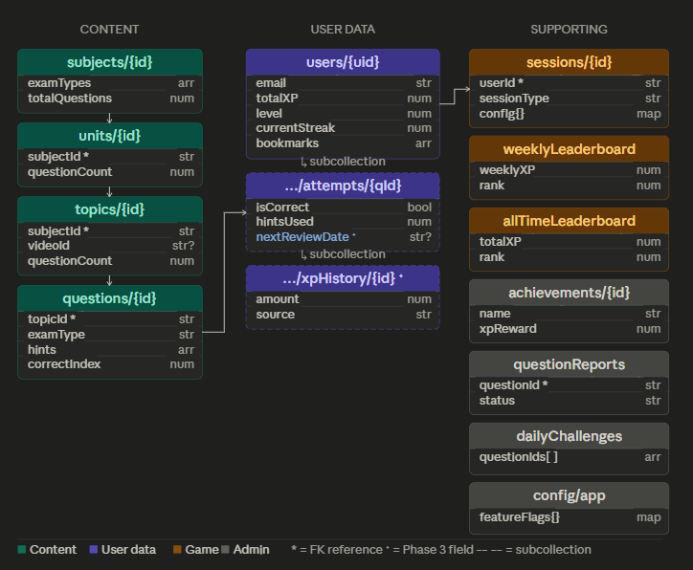
Insert your Firestore collection structure diagram here. You can screenshot this from Firestore console or draw it in Figma/FigJam.

Collection structure:
- subjects/{subjectId} → Mathematics, Physics, Further Mathematics
- units/{unitId} → Algebra, Geometry, Statistics…
- topics/{topicId} → Completing the Square, Circle Theorems…
- questions/{questionId} → Individual WAEC questions
- users/{uid} → Profile, streak, XP, subject selections
- attempts/{uid}_{questionId} → Every question attempt recorded

Key question fields:
- questionText: string (LaTeX via \(...\) syntax)
- options: string[] (4 items, no A/B/C/D prefix)
- correctIndex: number (0=A, 1=B, 2=C, 3=D. Currently -1 for all — run 4_scrape_answers.js before launch)
- year: number (WAEC exam year, e.g. 2022)
- subject, unit, topic: string IDs for cross-referencing
- imageUrl: string | null (for questions with diagrams — Phase 2)

Answer Options: Stored in Firestore as a List<String> of exactly 4 items, index 0–3. No A/B/C/D prefix is stored. The QuestionWidget maps index → label at render time: ['A','B','C','D'][index]. The correctIndex field (0–3) maps to this same array. A correctIndex of -1 means unverified — never show this question in production.

Part 2 — Core User Flows

2.1 Onboarding Flow

Insert your onboarding flow diagram here. Draw in FigJam or Figma. Show every decision branch: new user vs returning user.
Refer to full Document.
- App launches → Firebase Auth state check fires before any UI renders. Splash shows minimum 800 ms.
- Not signed in → /welcome.
- Signed in, profile complete (username + subjects present) → /home directly. No onboarding shown.
- Signed in, profile incomplete → resume funnel from first missing step: /onboarding/username or /onboarding/subjects.
- New user after auth → /onboarding/username → /onboarding/displayname → /onboarding/subjects → /onboarding/profile (optional) → /home.
- Guest: tap Browse as Guest on Welcome → signInAnonymously() → context.go("/home") (Guest Shell). Full topic catalogue accessible. Sign-up nudge (Auth Upsell Sheet) appears when: completing a drill session, accessing the Dashboard tab, accessing the Profile tab, or tapping the notification icon. Dismissal stored in sessionStorage (web) or in-memory (mobile); nudge reappears on next trigger or next session. See §2.1.10 for full guest behaviour spec.

Identity setup — new signed-in users
- Step 1 — Username (/onboarding/username): unique @handle, 4–20 chars. Letters, numbers, underscores, periods. Periods are cosmetic and stripped during normalisation (bright.kofi = brightkofi). Real-time Firestore availability check, debounced 300 ms.
- Step 2 — Display name (/onboarding/displayname): what the app calls the student. 2–30 chars, any characters, not unique. Pre-filled from Google display name if applicable.
- Step 3 — Subject selection (/onboarding/subjects): card grid, 2-col mobile. Minimum 3 subjects. Launch: Mathematics, Physics, Further Mathematics (selectable). Others shown as Coming Soon (greyed, not tappable). Toggle is a Firestore config flag — no code deploy needed.
- Step 4 — Profile (/onboarding/profile): optional. Fields: school name, class/year, age, gender, country, state. Skip link prominent. Partial saves on skip. All fields editable from Settings.

Firestore writes summary
- usernames/{normalised}: { uid, raw } — on username submit.
- users/{uid}.username, .usernameKey, .displayName — on each step submit.
- users/{uid}.selectedSubjects: string[] — on subject selection submit.
- users/{uid}.profile: { school, classYear, age, gender, country, state } — on profile submit or skip.

2.2 Learn Mode Flow
[ LEARN_MODE_FLOW_DIAGRAM ]
Insert your Learn Mode user journey diagram here.
Refer to Full Document.

Learn Mode is the primary daily-use flow. Design principle: understand before you drill.

Content hierarchy
- Subject (e.g. Mathematics) → Units (e.g. Algebra) → Topics (e.g. Completing the Square) → Questions + Video + Notes.
- Students can enter any topic drill directly via Quick Practice or a shared link, without visiting the Learn screen first.

Step-by-step flow
Step 1 — Home (/home)
- Subject cards with progress bars (X of Y topics completed). Streak banner. Quick Practice shortcut. Tap subject → /units/:subjectId. Tap Quick Practice → /drill/:topicId directly, bypassing list screens.
Step 2 — Unit List (/units/:subjectId)
- Units ordered by order field. Each card: unit name, topic count, progress bar. Tap → /topics/:subjectId/:unitId.
Step 3 — Topic List (/topics/:subjectId/:unitId)
- Each row: topic name, WAEC frequency badge, question count, accuracy (% once attempted; — if never). Two actions: Learn button (→ /learn/:topicId) and Practice button (→ /drill/:topicId).
Step 4 — Learn Screen (/learn/:topicId)
- Three sections: Video (YouTube embed 16:9), Topic Notes (markdown + LaTeX), Worked Examples (accordion, collapsed by default). Sticky footer: Practice this topic button. No video set: placeholder card shown, notes still display.
Step 5 — Drill Screen (/drill/:topicId)
- One MCQ at a time (A–D). Submit → immediate feedback (correct = green, wrong = red + correct shown). Collapsible Worked Solution panel below each reveal. Watch video link at bottom of each question. Progress bar top. Last question → navigate to Score Summary screen (/drill/:topicId/results).
Step 6 — Score Summary Screen (/drill/:topicId/results)
- Score (X/N), accuracy %, streak update if daily 5-question minimum reached. Three exits: Try again, Back to topics, Next topic.
- Writes: See §2.2.8 for the full and authoritative write specification. Summary: client writes users/{uid}.topicStats[topicId] (via onSessionComplete Cloud Function — see field ownership rules), currentStreak (client increment only), lastStreakDate, questionsAttemptedToday, questionDateLastReset, lastStudiedTopicId. totalXP and level are written by the onAttemptWrite Cloud Function only — never client-side. topicAccuracy does not exist as a field name anywhere in this codebase.

Shortcut and deep-link paths
- Quick Practice (Home → /drill/:lastTopicId): primary returning-user path, bypasses all list screens.
- Direct topic link (WhatsApp / leaderboard): unauthenticated users redirect to /welcome with return URL stored and restored after sign-in.

2.3 WAEC Exam Mode Flow
[ EXAM_MODE_FLOW_DIAGRAM ]
Insert your WAEC Exam Mode user journey diagram here. Mark the 'lockdown' state clearly.
Refer to Document

WAEC Exam Mode simulates timed exam conditions. No answer feedback until submission. The lockdown state is the feature that distinguishes this from Drill Mode.

Lockdown: the defining constraint
- Once the exam begins: no answer feedback, no worked solutions, no exit without a confirmation prompt, bottom nav hidden. Do not soften these constraints.

Step-by-step flow
Step 1 — Exam Setup (/exam/setup)
- Entry: WAEC Exam tab or Home shortcut. Config: Subject (user’s subjects, default Mathematics), Year range (1990–2024, default 2015–2024), Question count (slider 10–60 step 5, default 40), Timer (toggle; slider 10–180 min step 10, default 60 min), Shuffle (default on).
- Estimated time label updates dynamically. Availability warning chip if fewer questions than requested. Zero questions: inline error, Start Exam disabled. Tap Start Exam → fetch questions → push to /exam/active with config as route state.
Step 2 — Exam Active (/exam/active) — lockdown state
- Full-screen. Bottom nav hidden. Back intercepted: Exit exam? Your progress will be lost.
- Top bar: Q [X] of [N], countdown (MM:SS), flag icon. Question strip: scrollable numbered bubbles (answered = violet fill, current = outlined violet 2px, flagged = red dot, unanswered = dark). Tap any bubble → jump to that question.
- MCQ options (A–D), changeable until submit. Previous/Next arrows. Next on last question becomes Submit Exam button. Timer: turns red + vibration at 5 min remaining. Auto-submit at 0:00 with toast.
Step 3 — Submit confirmation modal
- Shows answered/unanswered/flagged counts. Review flagged (return to exam) or Submit anyway. All answered + none flagged: simplified modal. On confirm → write to Firestore → /exam/results/:examId.
Step 4 — Exam Results (/exam/results/:examId)
- Score ring: animated clockwise fill, colour-coded (green >=70%, amber 50-69%, red <50%), centre text [X]/[N]. Metadata: time taken, date, subject, year range. Topic breakdown: tap a row → /learn/:topicId. CTAs: Review answers and Start new exam.
Step 5 — Answer Review (/exam/review/:examId)
- Scrollable list. Each item: student answer (red/green) + correct answer + expandable Worked Solution accordion. Filter chips: All, Correct, Wrong, Flagged. No re-answering.

Firestore writes
- - sessions/{sessionId}: { uid, sessionType: "exam_simulation", subject, yearRange, config: { questionCount, timeLimitSeconds, shuffled }, questionIds[], answeredIndices[], correct, incorrect, skipped, total, score, accuracy, timeTakenSeconds, topicBreakdown[], submittedAt: serverTimestamp() }. See §2.3.6 for the complete field list. The sessions/ collection is the only write path for exam results — there is no exams/ collection.
- - users/{uid}.lastExamDate ← today's date. users/{uid}.examCount += 1. These are written in a separate update() call at the same moment as the session document. Exam mode does NOT update users/{uid}.topicStats — that map is owned exclusively by Drill Mode. Exam topic results are stored only in sessions/{sessionId}.topicBreakdown[] and are used for the Results and Review screens only.

Edge cases
- Tab/browser close mid-exam (auth users): exam state persisted locally via SharedPreferences (mobile) and localStorage (web) under exam_ prefixed keys. On relaunch: resume dialog shown with subject, question count, and time remaining. Timer resumes from persisted elapsed time. Guests: exam state is persisted via exam_ keys identically to authenticated users (anonymous UID stored in exam_uid). Resume flow functions as normal on relaunch.
- Network loss mid-exam: questions already loaded. Submit write retries on reconnect via Firestore offline persistence.

2.4 Auth Decision Tree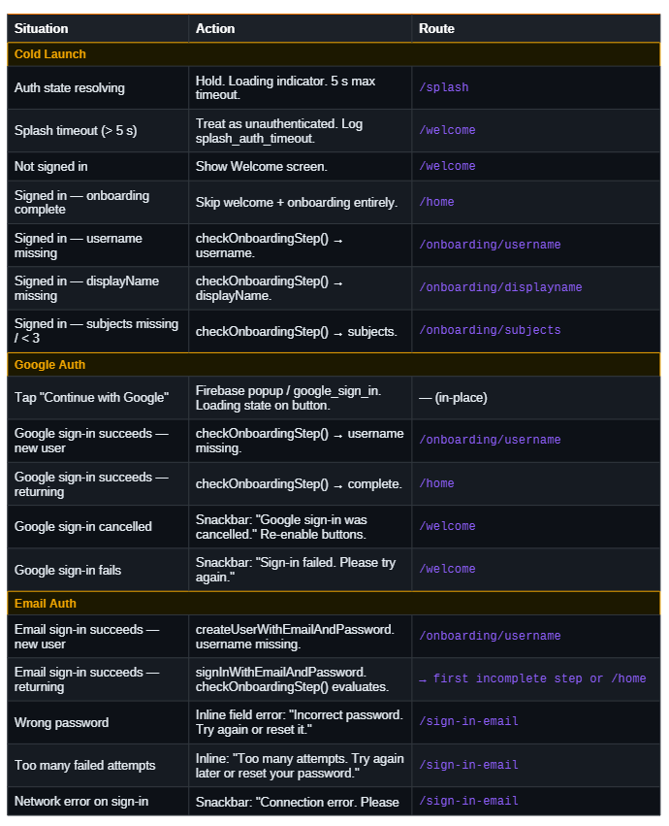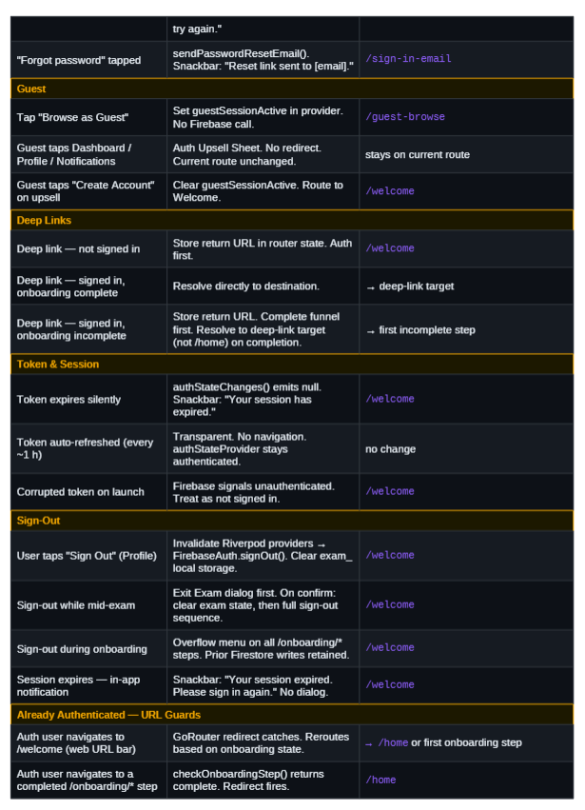
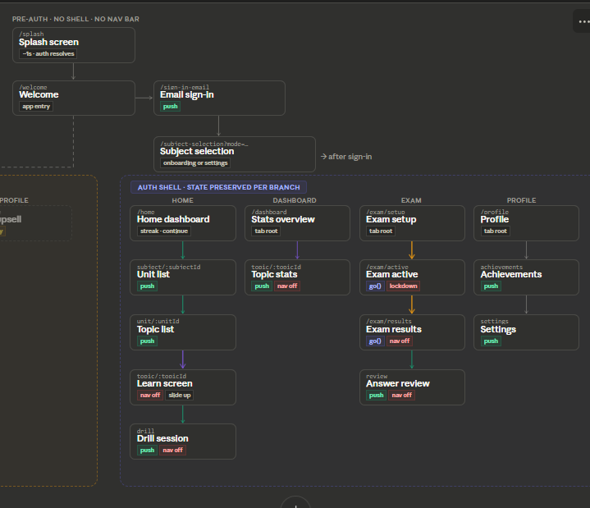
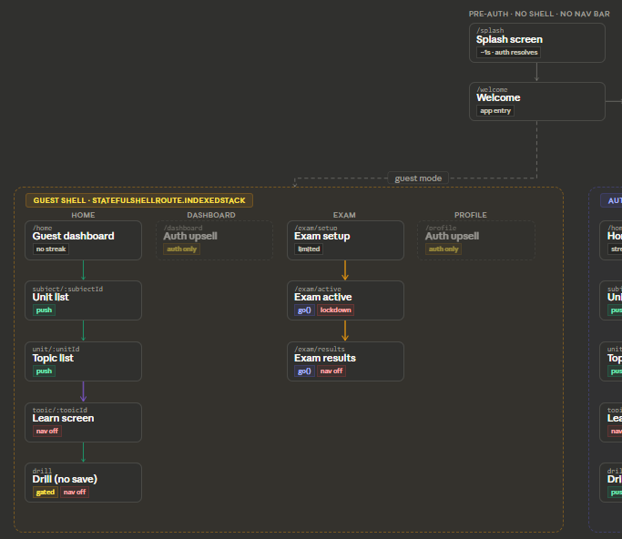

Sheets · not routes · showModalBottomSheet()

auth-upsell-sheet
Guest → sign up
notifications-tray
Notification tray
achievement-overlay
Achievement unlock
submit-confirm
Submit exam confirm
abandon-drill
Abandon drill dialog

Reading it top to bottom: Pre-auth screens sit above both shells. The dashed line from Welcome shows where guest mode branches off into the left shell. Everything else flows down through sign-in into the right (auth) shell.
Reading each branch vertically: Each column is one tab. Arrows show navigation direction and type — green for standard push, purple for the slide-up session transition (Learn screen and Drill), amber for go() calls that replace the stack (Exam active and Exam results). No arrow means the screen is standalone in that branch.
The gated (dimmed, dashed-border) nodes in the guest shell show Dashboard and Profile are visible tabs but deliver an upsell sheet instead of real content.
The sheets row at the bottom shows every showModalBottomSheet() call — none of these are routes, all are imperative calls from within their parent screens.
Guest scores: Written to Firestore under the anonymous UID — identical write path to authenticated users. Anonymous Auth provides a real UID; all writes succeed. Auth Upsell Sheet appears after Score Summary to prompt account linking, not to gate the save. On account link, the UID is preserved and all data carries over. Canonical authority: §2.1.10 and Firestore_Schema_Final (Guest Mode section).

