DESIGN AND ANALYSIS OF ALGORITHMS
LAB 2 18th January, 2017

C Code

#include <stdio.h>
#include <stdlib.h>
#include <math.h>
#include <time.h>

#define MAX_DIGITS 50
#define MAX_FLIPS 1000

void generateNumber(int *arr, int maxLen);
void printArray(int *arr, int len);
int calcDecVal(int *arr, int len);
void simulateNFlips(int *flipNumber, int noOfBits, int noOfFlips, int *flips, int max);
float calcProb(int *arr, int len,int n);

int main(){

int max,noOfBits;
int flipNumber[MAX_DIGITS];
int flips[MAX_FLIPS];
float noProbs[MAX_DIGITS];
printf(" Enter the max value of coin i.e. n : ");
scanf("%d",&max);
noOfBits = ceil(log(max)/log(2));
simulateNFlips(flipNumber,noOfBits,MAX_FLIPS,flips,max);

// printArray(flips,MAX_FLIPS);

for(int i = 0;i<max;i++){
printf("\n Probablity of %d: %1.3f",i+1,calcProb(flips,MAX_FLIPS,i+1));
}
printf("\n");

}

void simulateNFlips(int *flipNumber, int noOfBits, int noOfFlips, int *flips, int max){
int tempStore;
srand(time(NULL));
for(int i=0;i<noOfFlips;i++){
// printf("%4d) ",i+1);
generateNumber(flipNumber,noOfBits);
// printArray(flipNumber,noOfBits);
// printf(" : ");
tempStore = calcDecVal(flipNumber,noOfBits);
if(tempStore > max || tempStore < 1){
// printf("INVALID \n");
i-- ;
continue;
}
else{
flips[i] = tempStore ;
// printf("%d\n",tempStore);
}
}
}

void generateNumber(int *arr, int maxLen){
for(int i = 0; i < maxLen; i++){
arr[i] = (rand())%2;
}
}

void printArray(int *arr, int len){
for(int i = 0;i < len ;i++)
printf("%d\t",arr[i]);
}

int calcDecVal(int *arr, int len){
int i,j,sum = 0;
for(i=len-1,j=0;i>=0,j<len;i--,j++){
sum += arr[i]*pow(2,j);
}
return sum;
}

float calcProb(int *arr, int len,int n){
int count=0;
for(int i=0; i<len; i++){
if(arr[i] == n){
count++;
}
}
return (double)count/(double)len;
}
Result Table

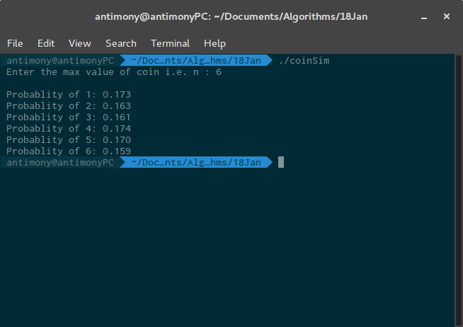

Analysis

Did the result meet the expectation?
Yes, the result met the expectation of around 0.16 which every number is around.

If no, can you think of an improvement?
No, I don’t think any scope of improvement is there. It’s almost close to the ideal value.

