**Data Analysis Case Study:**

**Changes in Fine Particle Air Pollution in the U.S.**

Pragya Chaturvedi Ishan Tyagi Sushant Bansal

1410110289 1410110164 1410110454

**Introduction**

Air pollution is a leading cause of many health problems across the globe, contributing to stroke, heart disease, lung cancer, and other respiratory diseases. The goal of this analysis is to explore the changes in fine particle air pollution in USA.

The datasets in the analysis cover the daily data between year 2000 – 2016, downloaded from EPA website <http://www3.epa.gov/airdata/ad_data.html>. EPA measures the air quality with respect to five major pollutants regulated by the Clean Air Act: Ozone, PM (Particle pollution or particulate matter), CO (carbon monoxide), SO2 (sulphur dioxide) and NO2 (nitrogen dioxide). Therefore, in our data and visualization analysis we will use these pollutants.

**State Wise Analysis:**

Here we answer, is air quality in USA getting better or worse?

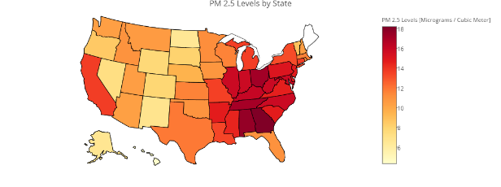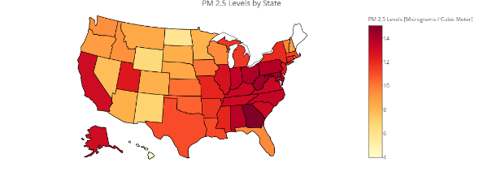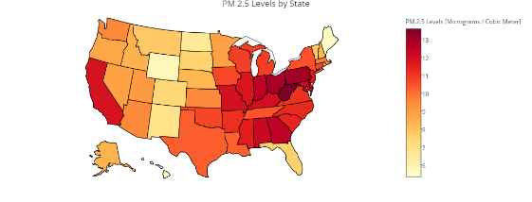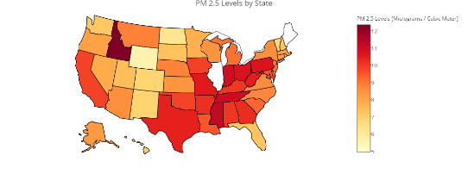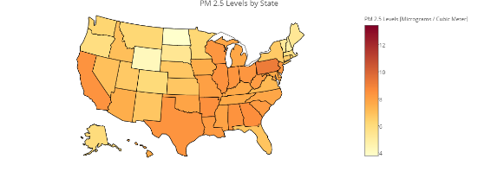

State wise Pollutants [2000-16]

* The mean concentration of the pollutants has been decreasing which means that the air quality is getting better since 2000s.
* The credit can be given to the Clean Air Act, which has imposed various regulations to help reduce the air pollution, and hence achieving the same.

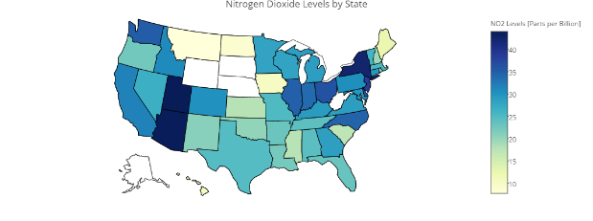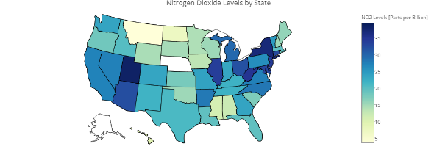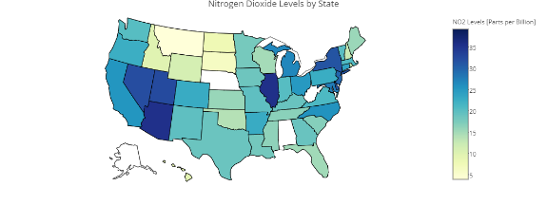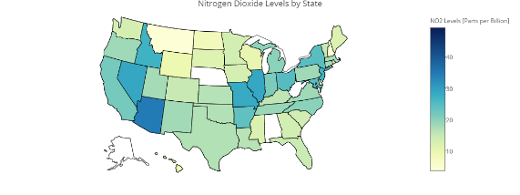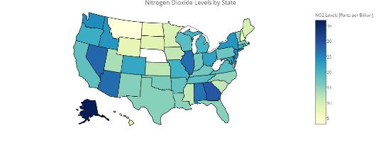

NO2 Levels [2000-2016]

* Although the overall pollution levels have been decreasing over the years, but we see NO2 as an **outlier**. NO2 levels are decreasing from 2000 to 2012 but there is an increase noticed in 2016.

**Main Pollutants Analysis:**

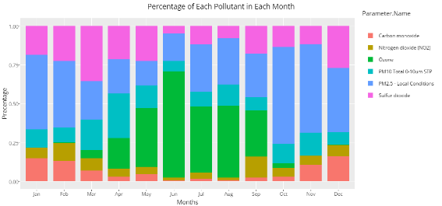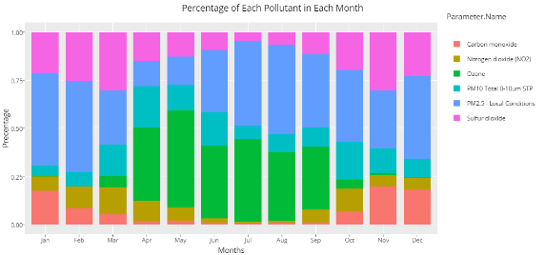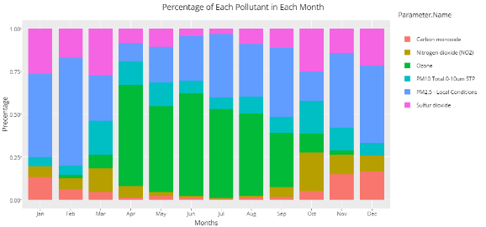

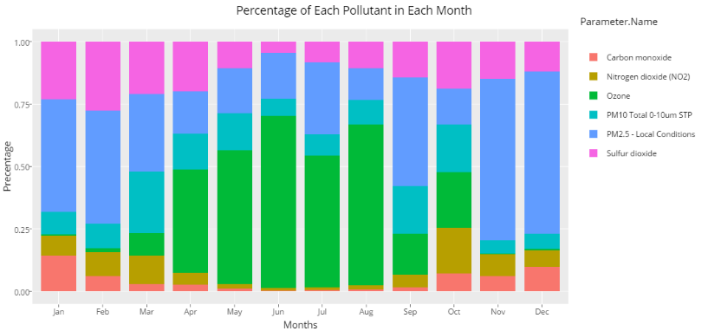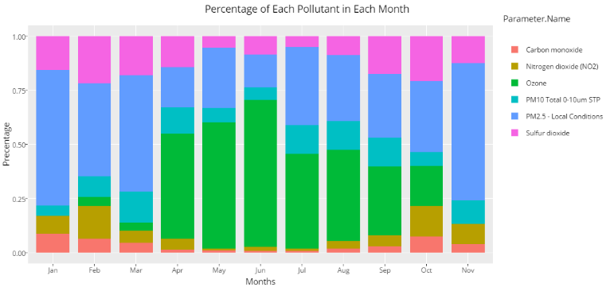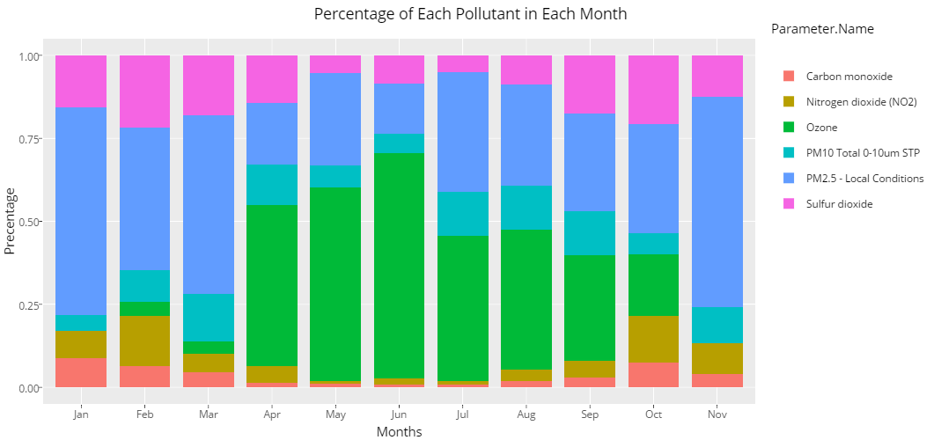

Proportions of Pollutants [2000-16]

* Looking at the stack bar plots we observe the concentration of Ozone increases during the summer months and PM 2.5 increases during winter months. CO and SO2 levels are relatively low in proportion to the other major pollutants.
* The main reason of higher proportions of Ozone and PM2.5 can be related to high number of factories, vehicles, etc.

**Monthly View of Air Quality**:

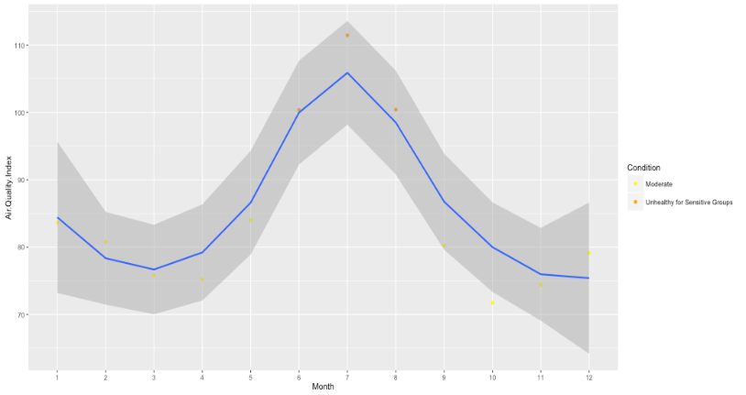Another question can be answered is in which months the air quality is good in USA. As the graph tells us, in general air quality conditions are bad during summers. Especially from June to August, probably because more people are driving and more ACs are used during summers.

Air Quality across a Year [2000-16]

**Conclusion**

Overall air quality in the USA has been improving as the concentrations of pollutants is decreasing over the years i.e. 2000 to 2016 but pollutants such as Ozone, NO2, PM 2.5 still have high occurrences. This improving quality is a good trend but as the concentrations of the **outlier** NO2 have increased from 2012 to 2016, we need to find the cause of the sudden increase and take measures to reduce it.