Palestinian User Protection Platform from Digital Fraud — Methodology & Design

Palestinian User Protection Platform from Digital Fraud
Methodology & System Design Document — how the platform detects suspicious links, measures their spread, and protects users without surveilling them
Graduation Project · July 2026 · Prepared by: [student names] · Supervisor: [supervisor name]
Contents
- Introduction
- Background & Related Work
- The Idea
- System Architecture
- Methodology
- Q1 — How do we determine that a link is suspicious?
- Q2 — How do we know how many people visited a link?
- Q3 — How do we “monitor” users who visited links?
- Message (SMS/WhatsApp) Analysis
- Data Model
- Evaluation Plan
- Implementation Timeline
- References

1.Introduction
Digital fraud against Palestinian users was relatively limited before the war on Gaza, but it has grown sharply during and since it: fake prize draws impersonating telecom operators (Jawwal, Ooredoo), phishing pages imitating local banks and e-wallets (Bank of Palestine, PalPay, Jawwal Pay, Reflect), fake delivery-fee requests, fraudulent job offers, and fake donation campaigns exploiting the humanitarian situation. Victims lose money, credentials, and accounts — and today there is no local, Arabic-first tool where a Palestinian user can check a suspicious link or message before acting on it, or look up whether a phone number or page has already been reported as a scam.
This project builds that tool: a web + mobile platform that (a) analyzes suspicious links and messages and returns an explained risk verdict, (b) hosts a community database of reported scam numbers, links, and accounts, (c) publishes a live feed of flagged links, and (d) provides localized awareness content and quizzes. The platform is Arabic-first with full English support.

2.Background & Related Work
Link-safety checking is a mature research and industry area. The main families of prior work:

2.1 Industrial blocklist services
Google Safe Browsing [1] maintains blocklists of phishing/malware URLs and serves them to browsers via a privacy-preserving API (clients query hashed URL prefixes, so Google never sees the full browsing history — a design we borrow in §8). PhishTank [2] is a community platform where users submit and vote on phishing URLs — the closest existing model to our community-reporting feature. VirusTotal [3] aggregates ~90 scanning engines for URLs/files. ScamAdviser [4] computes a website trust score from domain age, hosting, and reviews.

2.2 Academic work on URL classification
Ma et al. [5] showed that malicious URLs can be detected from lexical and host-based features alone (length, tokens, TLD, IP-literal hosts, WHOIS age) — the scientific basis for our heuristic engine. Whittaker et al. [6] describe Google's large-scale phishing page classifier. Sahingoz et al. [7] and Mohammad et al. [8] demonstrate machine-learning phishing detection from URL features with F1 scores above 0.95 on public datasets — the path our platform follows in future work, once our community database has accumulated labeled local data. The APWG Phishing Activity Trends Reports [9] document the global growth of phishing campaigns, and 7amleh [10] documents the Palestinian digital-safety context.

2.3 The gap
Capability | Safe Browsing [1] | PhishTank [2] | VirusTotal [3] | ScamAdviser [4] | This project
URL risk checking | ✓ | ✓ | ✓ | ✓ | ✓
Community reporting | ✗ | ✓ | partial | ✓ | ✓
Arabic-first interface | ✗ | ✗ | ✗ | ✗ | ✓
Palestinian brand lookalike detection | ✗ | ✗ | ✗ | ✗ | ✓
Scam message (SMS/WhatsApp) analysis in Arabic | ✗ | ✗ | ✗ | ✗ | ✓
Local phone-number scam registry | ✗ | ✗ | ✗ | ✗ | ✓
Localized awareness & quizzes | ✗ | ✗ | ✗ | partial | ✓
Table 1 — Feature comparison with existing platforms. No existing tool combines link checking with Arabic message analysis and a local community registry.

3.The Idea
One platform, four protective functions, available as a website and a mobile app:

1 · URL Checker
Paste any link → multi-signal analysis → verdict (safe / suspicious / dangerous) with human-readable reasons in Arabic and English.

2 · Message Analyzer
Paste an SMS/WhatsApp text → bilingual scam-pattern engine detects prize, delivery, job, OTP and bank-phishing scams; embedded links are auto-extracted and checked.

3 · Community Reports
Users report scam phone numbers, links, and social accounts. Everyone can search the registry before trusting a contact. Reports feed back into URL scoring.

4 · Awareness Hub + Flagged Feed
Localized articles and quizzes, plus a public live feed of links the platform has recently flagged — “what scams are active right now.”
The system creates a feedback loop: every check and every report makes the next check smarter — community reports raise the risk score of matching URLs, and unusually frequent checks of the same URL signal an active campaign.

4.System Architecture
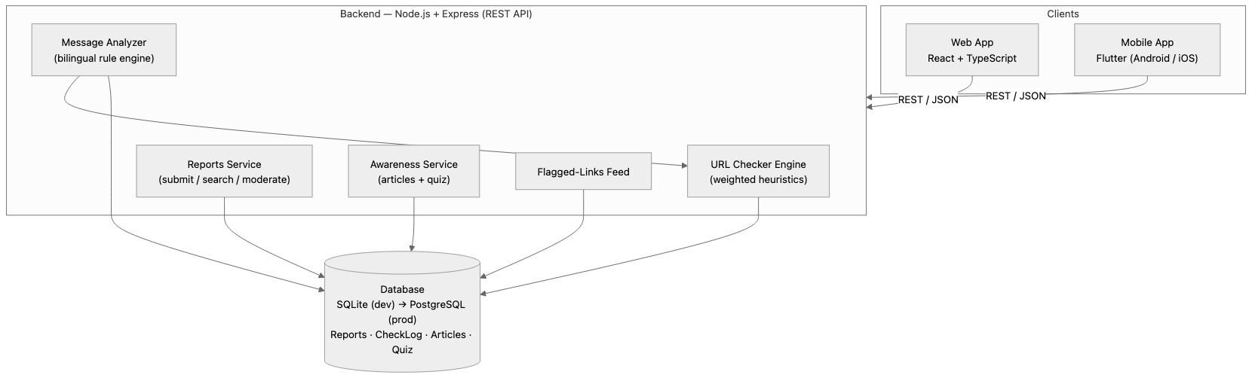
Figure 1 — System architecture. Both clients consume the same REST API; the message analyzer reuses the URL engine for links found inside messages.
Layer | Technology | Why
Web frontend | React + Vite + TypeScript | Fast development, type safety, easy RTL/i18n
Mobile | Flutter | One codebase for Android + iOS, strong RTL support
Backend | Node.js + Express + TypeScript | Same language as frontend, large ecosystem
ORM / DB | Prisma + SQLite → PostgreSQL | Zero-setup development, drop-in production upgrade
Validation | Zod schemas | Every API input validated server-side

5.Methodology
We follow a design-science / incremental development methodology: build the artifact in small verified increments, evaluate it against a labeled dataset and real users, and iterate.
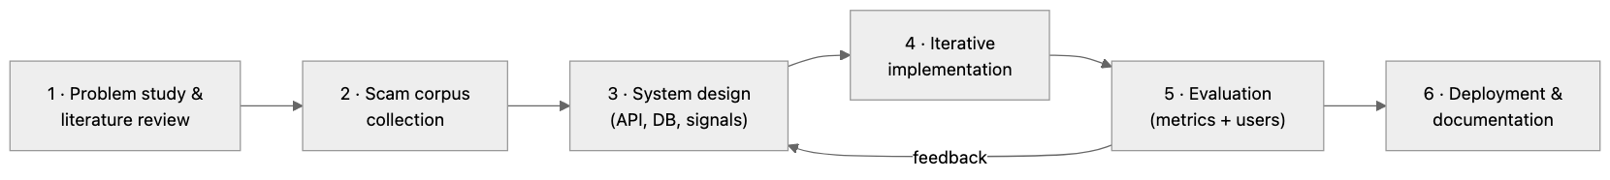
Figure 2 — Methodology phases. Evaluation feeds back into design: misclassified samples become new rules or adjusted weights.
Phase | Activities | Output
1 · Problem study | Review academic work [5–8] and industrial systems [1–4]; document local fraud patterns | Requirements + this document
2 · Corpus collection | Collect real scam SMS/WhatsApp messages and phishing links circulating in Palestine (community submissions, public reports); collect an equal set of benign samples | Labeled bilingual dataset
3 · System design | Define detection signals and weights, REST API contract, database schema | Architecture (§4), signals table (§6)
4 · Implementation | Backend engines → web app → mobile app, with unit tests per engine rule | Working platform
5 · Evaluation | Precision / recall / F1 on the held-out labeled set; usability testing (SUS questionnaire) with local users | Results chapter
6 · Deployment | Dockerized deployment, PostgreSQL, monitoring | Public pilot

6.Q1 — How do we determine that a link is suspicious?
Professor's question
“How will you decide whether a link is suspicious?”
A URL is never judged by one signal. The engine evaluates independent weighted signals from three families — lexical (the URL text itself), transport (encryption), and community (our own database) — and combines them into a 0–100 risk score. This mirrors the feature families proven effective in the literature [5][7], implemented as transparent rules so every verdict can be explained to the user.

6.1 Detection signals and weights
# | Signal | Family | Example trigger | Weight
S1 | Palestinian brand lookalike — registrable domain within Levenshtein distance ≤ 2 of a protected brand (jawwal, ooredoo, bankofpalestine, palpay, reflect…) or brand name embedded in a non-official domain | Lexical | jawwal-prize.win | +35
S2 | IP-literal host | Lexical | http://185.12.4.9/login | +30
S3 | Punycode / IDN homograph | Lexical | xn--jwwl-… | +30
S4 | user@host credential trick | Lexical | http://bop.ps@evil.com | +30
S5 | High-abuse TLD (.win .top .xyz .icu .buzz…) | Lexical | prize-draw.top | +20
S6 | URL shortener hiding the destination | Lexical | bit.ly/3xY… | +20
S7 | Scam keywords in domain/path (prize, win, free, gift, verify…) | Lexical | /claim-prize | +15
S8 | No HTTPS — the link is unencrypted, so any submitted data travels in clear text | Transport | http://… | +15
S9 | Excessive subdomain nesting (≥ 3) | Lexical | login.bop.secure.evil.com | +10
S10 | Community reports — each approved report matching this URL | Community | 3 reports → +15 | +5 each (max +20)
S11 | Check-frequency spike — same URL checked unusually often recently (§7) | Community | campaign in progress | +10
Table 2 — Signal catalog. Weights were set from the relative severity reported in the literature [5][8] and will be tuned in the evaluation phase (§11).

6.2 Scoring and verdict
Score(u) = min(100, Σ wᵢ·xᵢ(u) + min(20, 5·R(u)) + 10·F(u))
xᵢ(u) ∈ {0,1} — signal i triggered · R(u) — approved community reports · F(u) — frequency-spike flag
✓ SAFE 0–29
⚠ SUSPICIOUS 30–59
✕ DANGEROUS 60–100
03060100
Figure 3 — Verdict thresholds. “Safe” means no risk signals found, and the UI says so honestly — absence of signals is not a guarantee.

6.3 Worked example
Checking http://jawwal-prize.win/claim (a typical fake-prize campaign link):
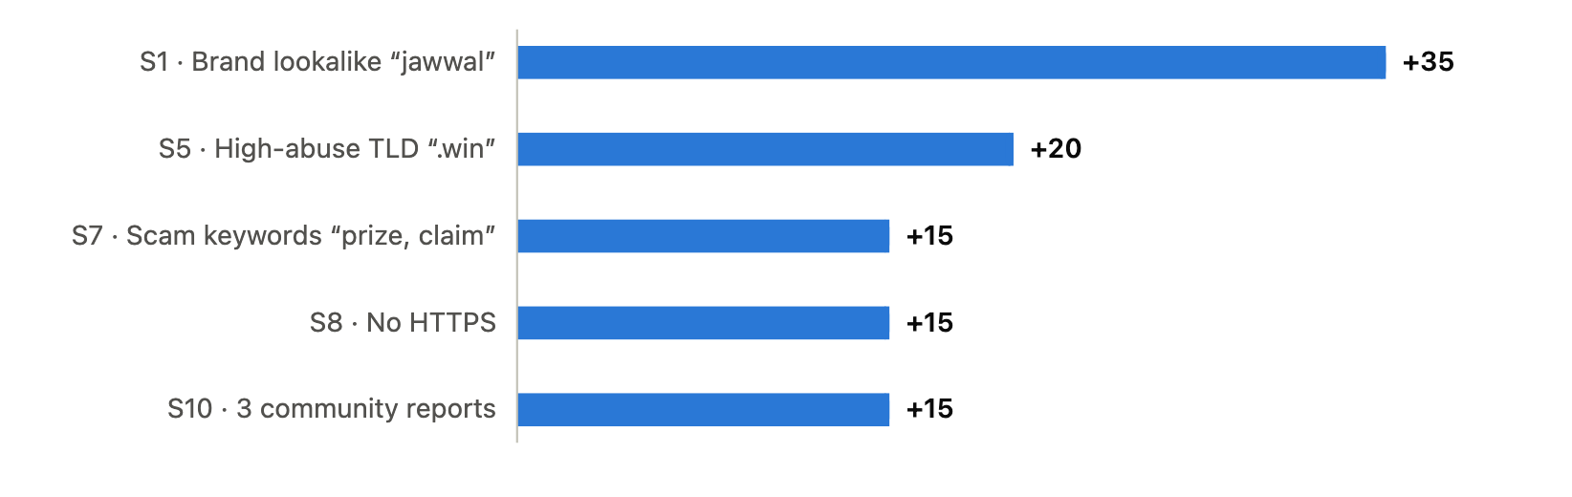

6.4 Check pipeline
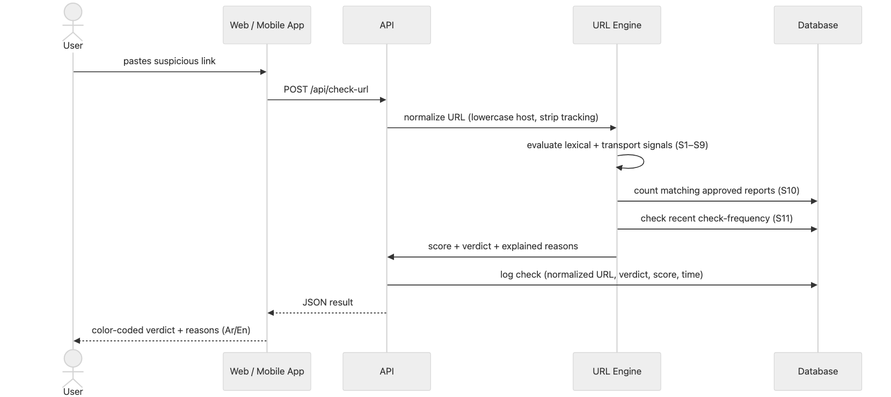
Figure 5 — URL check sequence. Every check is logged (anonymously) — the log powers the visit-proxy metrics in §7 and the flagged-links feed.

7.Q2 — How do we know how many people visited a link?
Professor's question
“How will you know the number of people who visited a specific link?”
Honest scientific answer first: no third party can measure the true global visit count of an arbitrary external URL — only the site's owner (or its DNS/hosting provider) has that data. None of the established systems [1–4] rely on such a number either. What we can measure, rigorously, is the link's observed spread through channels we instrument — and that is a proven proxy for campaign activity. We present this limitation explicitly rather than over-claiming.
The platform measures link exposure at four tiers, from already-implemented to future work:
Tier | Mechanism | What it counts | Status
A | Check frequency. Every URL check is logged with the normalized URL and timestamp. Many different people checking the same link in a short window ⇒ the link is circulating widely right now. | How many times the link was checked on our platform | Implemented
B | Report count. Approved community reports naming the URL. | How many people reported it | Implemented
C | Protective warning links (interstitial redirector). When a link is flagged, the platform issues a shareable warning URL (e.g. platform.ps/w/abc123). People share the warning link instead of the scam link; every open is counted and the visitor sees a warning page before deciding to proceed. | True visit count of the warning page — a direct measure of how many people encountered the link | Planned (v2)
D | Opt-in browser extension. Checks visited URLs against our blocklist using hashed URL prefixes (k-anonymity, the Safe Browsing model [1]) — counts encounters in the wild without ever transmitting a user's browsing history. | Anonymous encounter count across consenting users | Future work
Table 3 — Visit-measurement tiers. Tiers A+B feed signals S10/S11 in the scoring engine, closing the feedback loop.
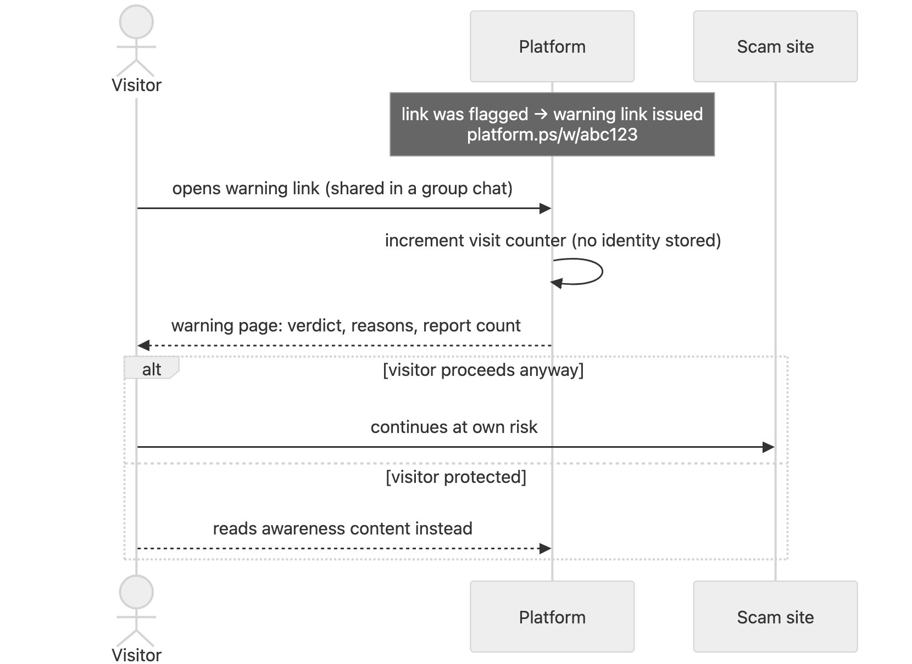
Figure 6 — Tier C: the protective warning link both counts exposure and interrupts the scam at the moment of the click.

8.Q3 — How do we “monitor” users who visited links?
Professor's question
“How will you monitor the users who visited the links?”
We deliberately do not monitor individuals — the platform is designed so that it cannot. Tracking what specific people visit would itself be surveillance: it would violate the privacy of the very users we protect, and unauthorized interception/monitoring is prohibited under the Palestinian Cybercrime Law by Decree No. 10 of 2018 [11]. It would also destroy user trust, which a community-reporting platform depends on. Instead, all metrics in §7 are anonymous and aggregate by construction:
We store (per event) | We never store
Normalized URL that was checked  Verdict + score  Timestamp  Report text (submitted voluntarily) | User identity, account, or phone number of the checker  IP addresses (beyond transient rate-limiting)  Device identifiers  Any browsing history
Table 4 — Privacy-by-design data policy. No login is required to check a link or search reports; reporters may optionally leave a display name.
For the future browser extension (Tier D), the Safe Browsing k-anonymity model [1] applies: the extension hashes each visited URL locally and sends only a short hash prefix; the server returns candidate matches and the final comparison happens on the device. The server therefore learns that someone encountered a flagged link — never who, and never the rest of their browsing.

9.Message (SMS/WhatsApp) Analysis
Scams reach Palestinians mostly as messages, not bare links. The message analyzer applies a weighted bilingual rule engine over the text, then extracts any embedded URLs and runs each through the URL engine (§6), folding the results into one verdict.
Category | Arabic patterns (examples) | English patterns (examples)
PRIZE_SCAM | مبروك · ربحت · جائزة · سحب | congratulations · you won · claim your prize
DELIVERY_SCAM | رسوم توصيل · شحنة معلقة | delivery fee · package on hold
BANK_PHISHING | تحديث حسابك · بطاقتك موقوفة | verify your account · card suspended
OTP_THEFT | رمز التحقق · أرسل الكود | verification code · send the OTP
JOB_SCAM | وظيفة براتب مغري · اعمل من البيت | easy salary · work from home
CHARITY_SCAM | تبرع عاجل · حملة إغاثة | urgent donation · relief campaign
Table 5 — Category pattern examples (abbreviated). Urgency markers (عاجل, فوراً, urgent) and payment requests add cross-category weight.

10.Data Model
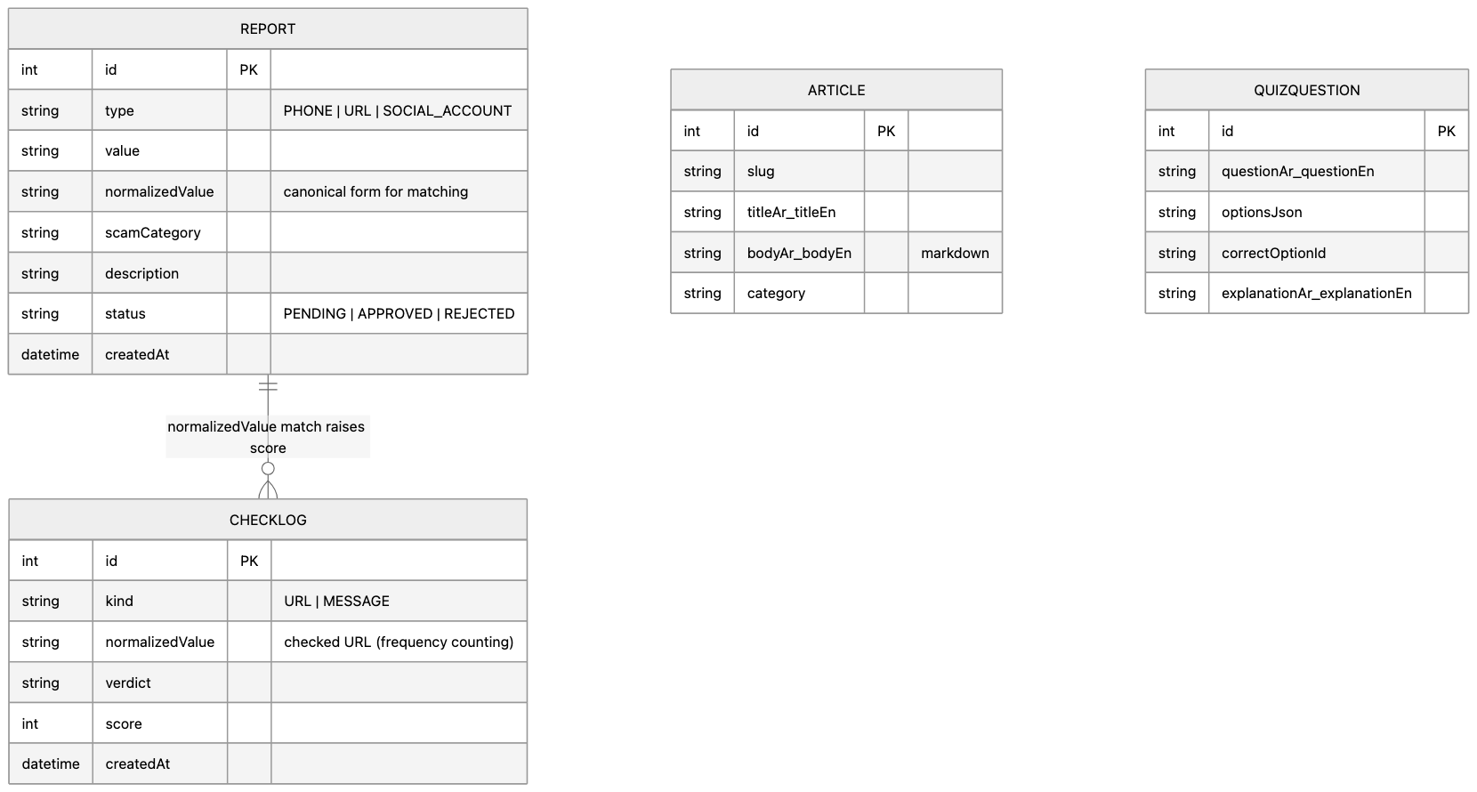
Figure 7 — Core entities. normalizedValue is the join key between community reports and check logs — it powers signals S10/S11 and the flagged-links feed.

11.Evaluation Plan
The detection engines are evaluated like classifiers, on a held-out labeled dataset (phase 2 corpus):
Metric | Definition | Target
Precision | Of links/messages we flag, how many are truly scams (controls false alarms) | ≥ 0.90
Recall | Of true scams, how many we catch | ≥ 0.85
F1 score | Harmonic mean of the two | ≥ 0.87
False-positive rate on benign set | Legitimate Palestinian sites (banks, telecoms, news) wrongly flagged | ≤ 0.05
Usability (SUS) | System Usability Scale questionnaire with ≥ 15 local users | ≥ 70
Table 6 — Evaluation metrics. Misclassified samples from each round feed back into rule weights (Figure 2 feedback edge).

12.Implementation Timeline
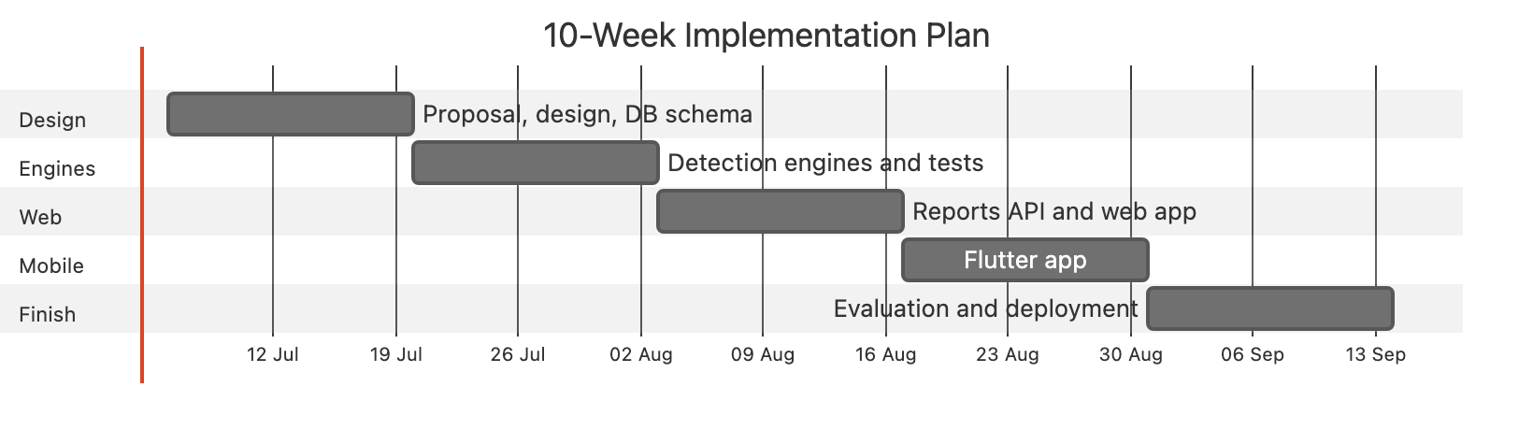
Figure 8 — Ten-week plan mapped to the methodology phases of §5.

13.References
- Google. Google Safe Browsing. https://safebrowsing.google.com/ — and the Safe Browsing Update API (v4) documentation on hash-prefix k-anonymity, https://developers.google.com/safe-browsing
- Cisco / OpenDNS. PhishTank — community phishing verification. https://phishtank.org/
- Google (Chronicle). VirusTotal. https://www.virustotal.com/
- ScamAdviser. Website trust-score checker. https://www.scamadviser.com/
- Ma, J., Saul, L. K., Savage, S., & Voelker, G. M. (2009). Beyond Blacklists: Learning to Detect Malicious Web Sites from Suspicious URLs. Proceedings of ACM SIGKDD (KDD '09), 1245–1254.
- Whittaker, C., Ryner, B., & Nazif, M. (2010). Large-Scale Automatic Classification of Phishing Pages. Network and Distributed System Security Symposium (NDSS '10).
- Sahingoz, O. K., Buber, E., Demir, O., & Diri, B. (2019). Machine learning based phishing detection from URLs. Expert Systems with Applications, 117, 345–357.
- Mohammad, R. M., Thabtah, F., & McCluskey, L. (2014). Predicting phishing websites based on self-structuring neural network. Neural Computing and Applications, 25(2), 443–458.
- Anti-Phishing Working Group. Phishing Activity Trends Reports. https://apwg.org/trendsreports/
- 7amleh — The Arab Center for the Advancement of Social Media. Reports on Palestinian digital rights and safety. https://7amleh.org/
- Palestinian Authority. Law by Decree No. 10 of 2018 on Cybercrime. Official Gazette of Palestine, 2018.
This document is self-contained (diagram library embedded) and prints cleanly — use the browser's Print → Save as PDF to produce a submission copy.

