1. Features implemented

* Fixed tasked (Completed)
* SCO : Power ups
* Respawn : Will render text onto screen telling player to respawn

1. How features are implemented

* Power ups: I created a singleton called Powerup_Generator
  + Every t amount of time, will start spawning random power ups
  + Located in Server

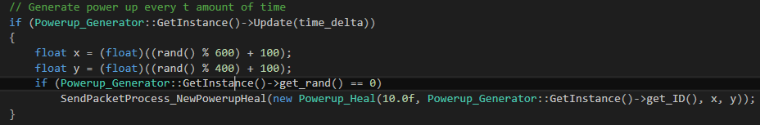

Inside main.cpp [server], I am updating the timer, when it reaches 0 it should randomize a number (but since I only have 1 power up, rand (int variable) can be a constant 0)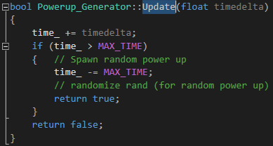

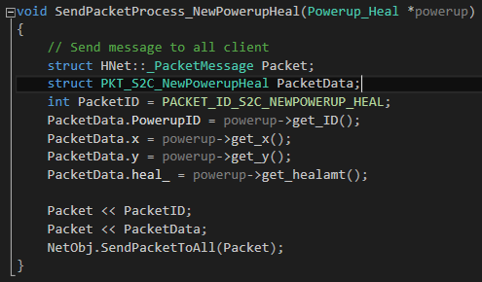

This part of the code is sending over to the client. Located in send_packet.cpp [server]

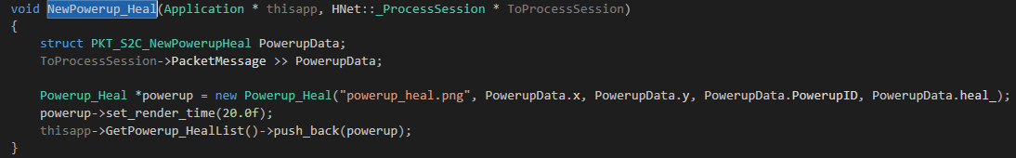

Where it will be processed inside the client itself and get pushed into a vector. Located in process_packet.cpp [client’s]

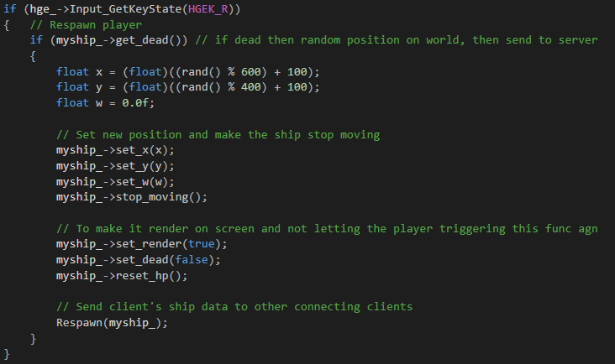

By pressing the ‘R’ key when the player is dead, it will respawn. Located in application.cpp [client’s]

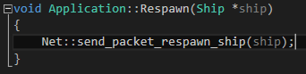

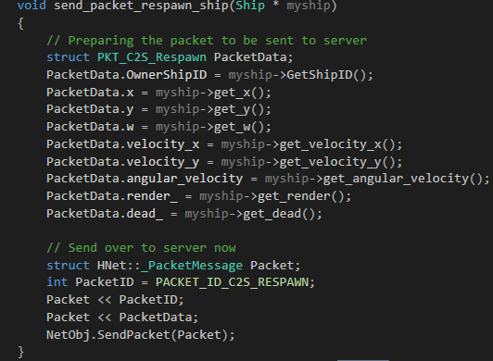

Sending over to server where it will be sent to all other client.

1. For power-ups

* Server will spawn it every t amount of time, the power up will last through x amount of time.
* Any connected client just have to collide with it.

Respawn:

Press ‘R’ when dead to respawn

Will have text printed onto screen prompting the player to press R to respawn