Assignment 3: EDA Report + Standards Normalization on MIMIC-IV
Dataset: MIMIC-IV Clinical Database Demo v2.2 (100 patients). All numbers and figures below are produced by the analysis code.

Cohort and method notes
Cohort: ALL ICU stays in icustays: 140 stays, 128 hospital admissions, 100 patients. Vitals come from chartevents (HR 220045, RR 220210, SpO2 220277, NIBP systolic 220179, NIBP mean 220181, Temp °C 223762 and Temp °F 223761 converted to °C). Labs come from labevents for the stay's hadm_id with charttime between ICU intime and outtime (creatinine 50912, BUN 51006, potassium 50971, sodium 50983, bicarbonate 50882, glucose 50931, hemoglobin 51222, WBC 51301, platelets 51265, lactate 50813).
Two things to be upfront about:
1. The physiologic range table is the one from Slide 55 (Outlier Detection: Physiologically Impossible Values): HR 20–250 bpm (flag <20 or >250), SpO2 60–100 % (flag >100 or =0), temperature 30–43 °C (flag <30 or >43). For SpO2 the slide’s valid range (60–100) and its flag condition (>100 or =0) are not the same rule, so I report both counts and say which is which. The rules are in one dictionary (SLIDE) in the A3 code.
2. The d_labitems.csv.gz in this demo has only the columns itemid, label, fluid, category. There is no loinc_code column, so the LOINC coverage answer in Part B is 0 % (see B3).

Part A: Exploratory Data Analysis

A1. Distributions (10 pts): heart rate and creatinine
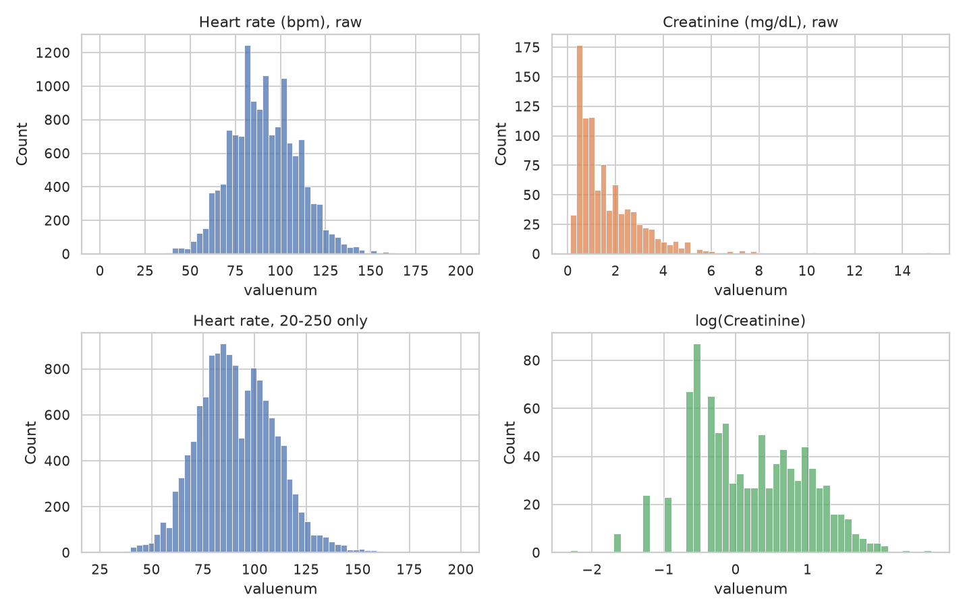
Heart rate (n=13,913 charted values): mean 91.1, median 90, SD 18.7, skew 0.23, range 0–200. It is unimodal and close to symmetric with a slightly longer right tail; the only odd feature is a handful of zeros (artefact, see A3). Creatinine (n=923 values): median 1.2 mg/dL (IQR 0.7–2.3), max 15.2, skew 2.43, excess kurtosis 11.6. It is strongly right-skewed with a heavy tail (patients in renal failure); after a log transform the skew falls to 0.09, so it is roughly log-normal and a log transform is appropriate before using it in a linear or distance-based model. On the log scale the creatinine histogram has a main mode near 0.6 mg/dL and a weaker second hump around 1.5–2.7 mg/dL (a shoulder rather than a clean second peak). That pattern is consistent with a mixture of patients with normal kidney function and patients with impaired function, but I did not test this. The gaps on the left of the log histogram come from creatinine being reported to 0.1 mg/dL. The comb-like bars in the heart-rate histogram come from integer values meeting the bin width, not from round-number rounding: 21.4% of heart rates are multiples of 5, against 20% expected with no digit preference. Note that the values are repeated measurements within stays, so they are not independent samples.

A2. Missingness (10 pts)
Heatmap of 16 variables (6 vitals, 10 labs) across the 140 ICU stays. A cell is red if the variable was never measured during that stay (stay-level missingness, rows sorted by first care unit then length of stay), plus the percentage missing per variable.
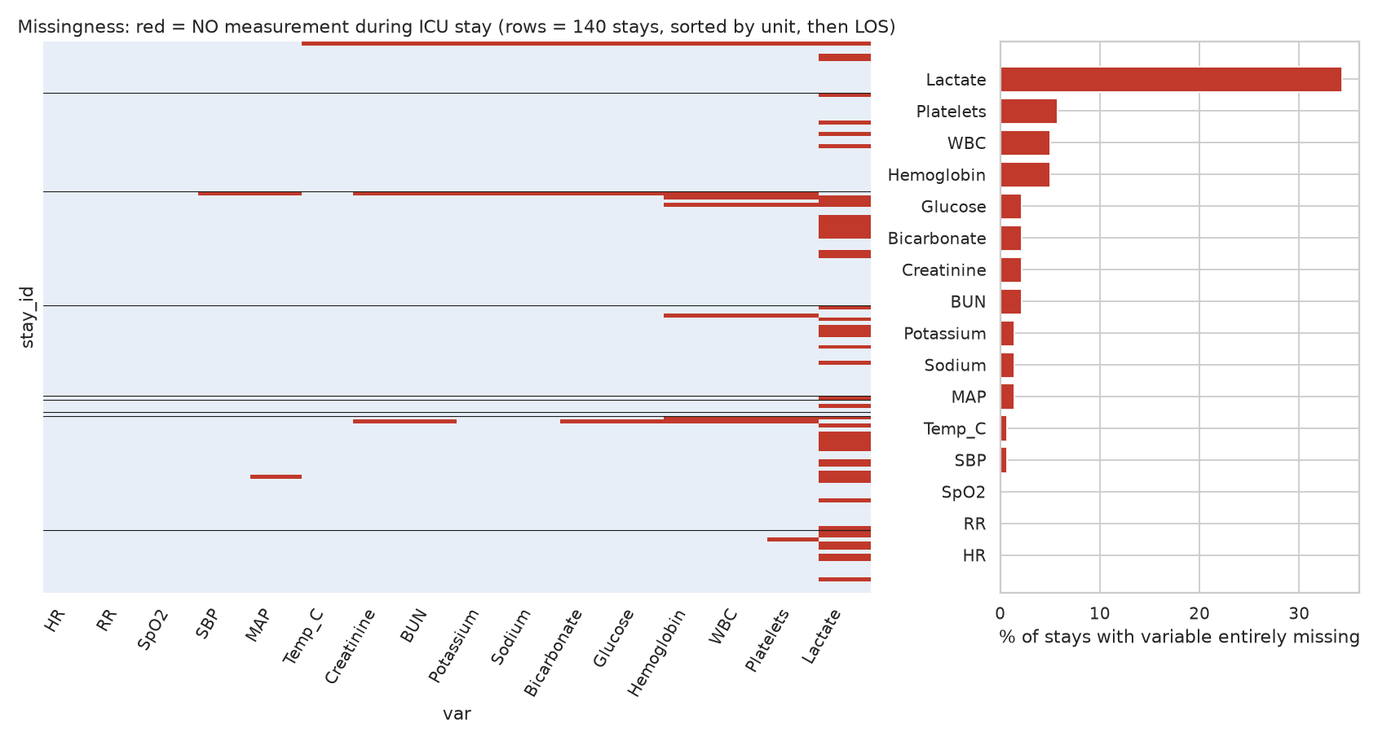
Missing % by variable: lactate 34.3%, platelets 5.7%, WBC and hemoglobin 5.0%, chemistry panel (creatinine/BUN/glucose/bicarbonate) 2.1%, K/Na 1.4%, MAP 1.4%, SBP and temperature 0.7%, HR/RR/SpO2 0%.
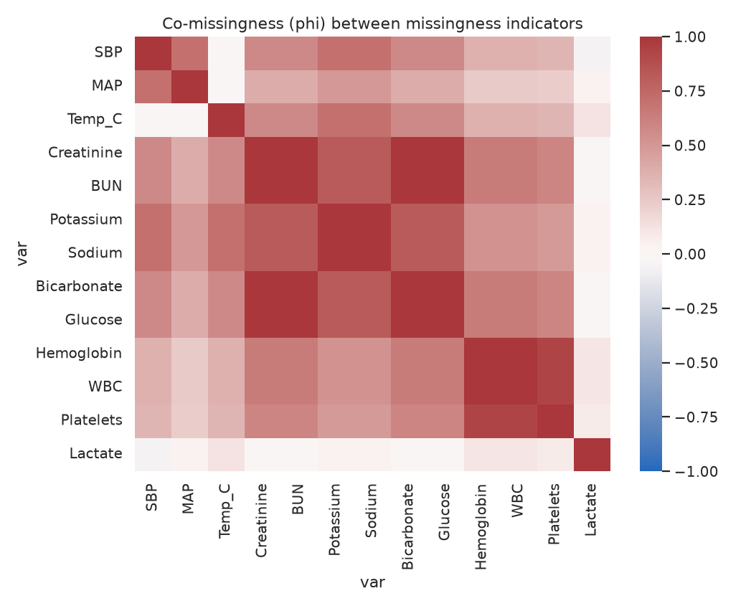
Interpretation: this is not MCAR. (i) The missingness shows horizontal stripes: the same stays are missing whole groups of variables together (creatinine, BUN, glucose, bicarbonate have phi = 1.0 co-missingness; hemoglobin and WBC are missing in exactly the same stays, with platelets nearly so). That is a panel/ordering mechanism (a lab panel was either drawn or not), not independent random loss. (ii) Lactate is missing in 34 % of stays, far more than any other lab. Lactate is ordered when clinicians suspect shock or sepsis, so whether it is observed depends on the patient's (unobserved) severity, which is MNAR-like. (iii) The 3 stays with no chemistry panel in the ICU window are all very short (LOS 0.02–0.6 days, versus a median of about 2.2 days) and all ended in in-hospital death, so missingness is tied to outcome and stay length (MAR on LOS or MNAR); Fisher's exact test of chemistry-missing vs. death gives p = 0.0025, but with only 3 events this is suggestive, not conclusive. (iv) By contrast, missingness differs little by care unit (chi-square p > 0.1 for every variable, but most unit cells are tiny, so this test is weak). Vitals (HR, RR, SpO2) are essentially complete as they are charted continuously by monitors. Caveat: this is stay-level presence/absence; within-stay sampling frequency (e.g., labs drawn every 6 h vs. daily) is also informative and is a separate form of missingness.

A3. Outliers (10 pts)
variable | unit | slide valid range | slide flag condition | n values | n flagged (flag condition) | % flagged | n outside valid range | % outside valid range | min | max
HR | bpm | 20-250 | <20 or >250 | 13913 | 3 | 0.0216 | 3 | 0.0216 | 0.0 | 200.0
SpO2 | % | 60-100 | >100 or =0 | 13540 | 0 | 0.0 | 5 | 0.0369 | 29.0 | 100.0
Temp_C | degC | 30-43 | <30 or >43 | 3770 | 3 | 0.0796 | 3 | 0.0796 | 31.1 | 99.0

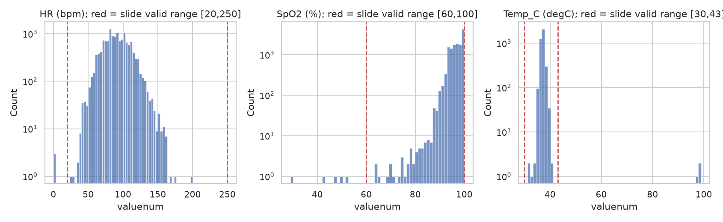
Rule table applied (Slide 55): heart rate 20–250 bpm (flag <20 or >250); SpO2 60–100 % (flag >100 or =0); temperature 30–43 °C (flag <30 or >43), with Fahrenheit readings converted to °C first. Heart rate: 3 of 13,913 values flagged (0.022%), all exactly 0 (sensor/monitor artefact). Temperature: 3 of 3,770 flagged (0.080%): [97.2, 98.9, 99.0] charted in the Celsius item, which are Fahrenheit values entered as °C, exactly the unit mismatch the slide lists as the likely cause. SpO2: using the slide’s flag condition (>100 or =0) 0 of 13,540 values are flagged (0.000%); the maximum is exactly 100 and there are no zeros. If instead the stated valid range 60–100 is used, 5 values are out of range (0.037%): [29.0, 43.0, 47.0, 50.0, 52.0]. These are low but not physically impossible (severe hypoxemia, or a poor probe signal), so they are suspicious rather than certainly wrong, and I would review them rather than silently delete them. In all three variables the rate of impossible values is far below 1 %, i.e. these monitors are clean, and most of the problems are unit and sensor artefacts. In A5 I removed values outside the slide’s valid ranges (HR 20–250, SpO2 60–100, Temp 30–43).

A4. Temporal pattern (10 pts)
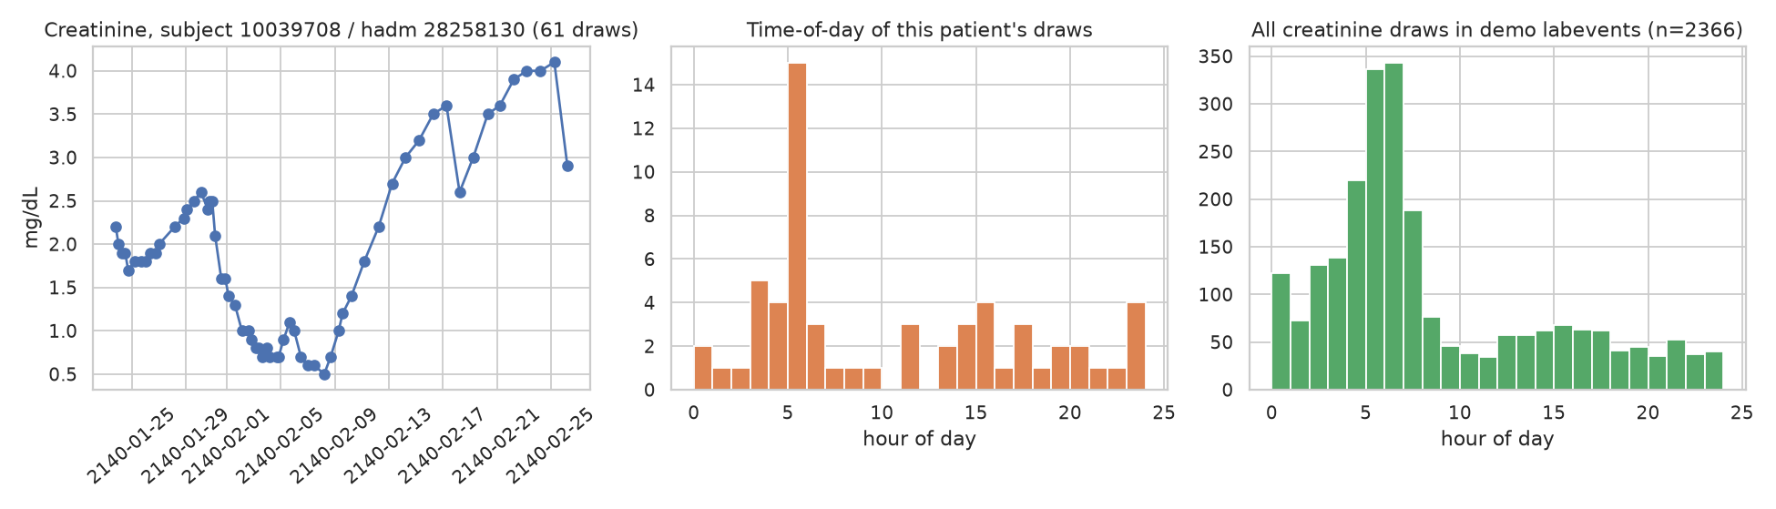
Patient chosen: subject_id 10039708, admission 28258130, the admission with the most creatinine draws in the dataset (61 draws over 33.4 days). In the first ~2 weeks draws are every ~6–12 h (median gap over the whole stay 11.9 h, IQR 6.5–22.8 h); from about 10 February onward there is one draw a day at 04:15–07:35. Across all creatinine draws in the demo, 43.9% fall between 03:00 and 06:59 (about 17 % would be expected if draws were uniform over 24 h), and this patient shows the same pattern (44.3%). Interpretation: the sampling times look workflow-driven (a routine morning “AM labs” round) rather than driven by clinical events; the value trajectory itself (falling to 0.5 then rising to 4.1 mg/dL) is clinical, but when it is observed is set by hospital routine. The extra off-schedule draws early in the stay do reflect clinical attention. Practical consequence: timestamps/“time since last lab” features can leak workflow information, and time-aware models should account for the irregular, schedule-driven sampling. (Draws here include the whole hospital admission, not just ICU time.)

A5. Correlation (10 pts)
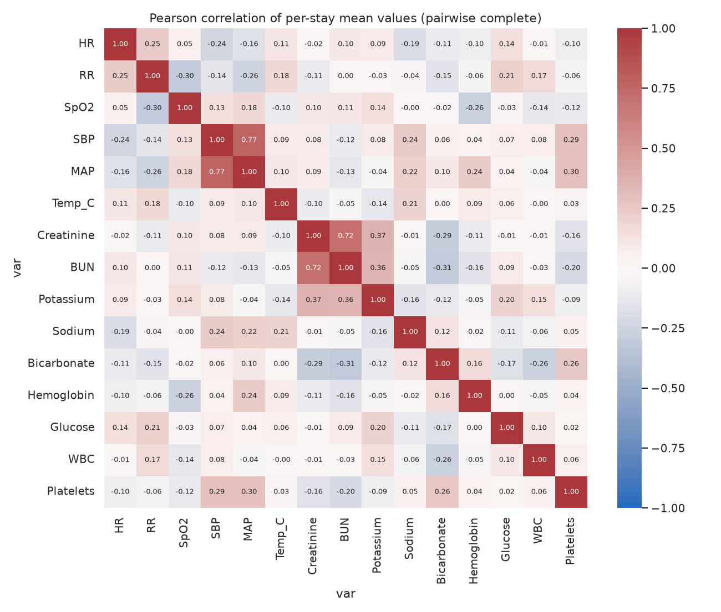
Heatmap of per-stay mean values for 15 numeric features (pairwise-complete Pearson, outliers from A3 removed). Two pairs exceed |r| > 0.6: SBP–MAP r = 0.768 (n = 138 stays); Creatinine–BUN r = 0.716 (n = 137 stays). Creatinine–BUN (r = 0.72): both are renal-clearance markers that rise together when glomerular filtration falls (acute kidney injury/chronic kidney disease); BUN is additionally raised by dehydration, GI bleeding and catabolism. SBP–MAP (r = 0.77): mean arterial pressure is computed from systolic and diastolic pressure (MAP ≈ DBP + (SBP − DBP)/3), so the two are mechanically related. No other pair reaches 0.6, so redundancy is limited to these. These are stay-level correlations on a small sample (about 140), so they are descriptive, not causal.

A6. Subgroup shift (10 pts): creatinine by gender
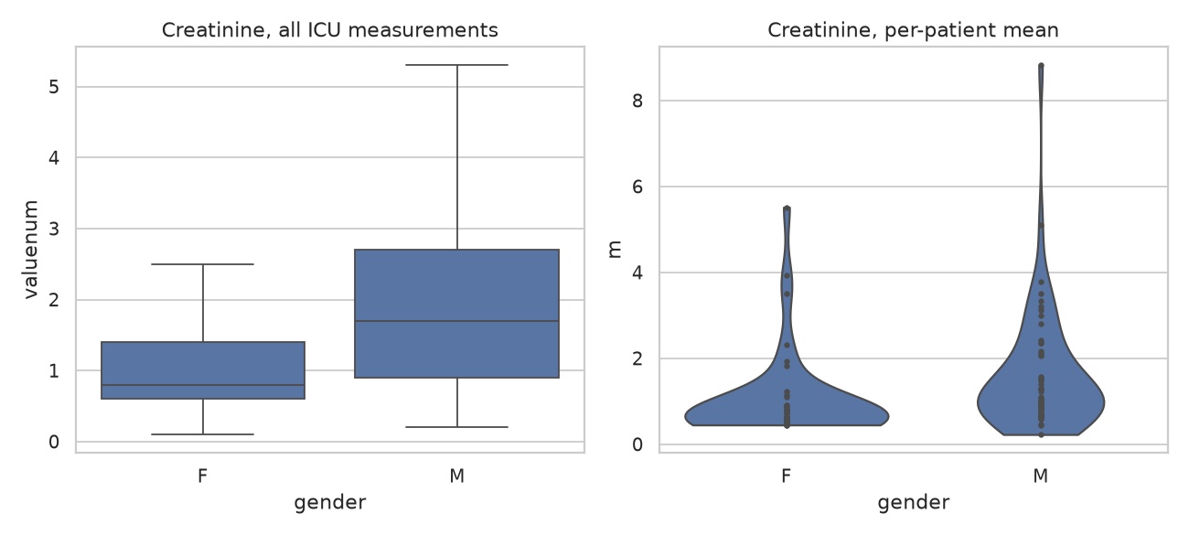
All ICU creatinine measurements: women n = 394, median 0.8 mg/dL (mean 1.28); men n = 529, median 1.7 (mean 2.0); Mann–Whitney p = 5.0e-29. Because measurements are clustered within patients, I repeated the test on per-patient means: women n = 43, median 0.6; men n = 56, median 1.05; p = 1.9e-05. Men have clearly higher creatinine under both analyses. Part of this is physiological (higher muscle mass and creatinine production in men, so reference ranges differ by sex), and part may be case-mix (age, kidney disease, severity) that I did not adjust for. The practical point is that a model using raw creatinine sees a different distribution by sex, so a sex-specific reference or a fairness check is warranted. The small sample (100 patients) limits how far this generalizes.

A7. Label distribution (10 pts)
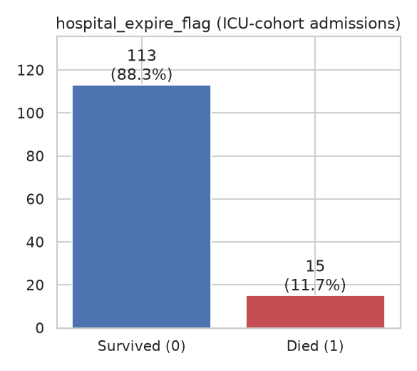
hospital_expire_flag among the 128 admissions with an ICU stay: 113 survived (0) and 15 died (1), a mortality of 11.7% (imbalance ≈ 7.53:1). At the stay level (a stay inherits its admission's flag) it is 120 vs 20; I report admission-level numbers because stays from the same admission share a label. For all 275 admissions in the demo it is 260 vs 15 (the 15 deaths all occur in ICU admissions). The classes are imbalanced, so plain accuracy is misleading (always predicting survival gives 88 %); use AUROC/AUPRC, class weights or resampling, stratified splits, and note that with only 15 positives any model estimate will have very wide uncertainty. Patient-level (not row-level) splits are needed to avoid leakage.

Part B: Standards Normalization

B1. Raw ICD codes vs. codes in ≥1 % of admissions (10 pts)
I used all 275 admissions that have diagnoses (4,506 diagnosis rows; requirement was 200+). Every code was found in d_icd_diagnoses (joined on icd_code + icd_version). ICD-9 and ICD-10 codes coexist in MIMIC-IV, so a code is identified as version:code.
Metric | Value
Unique raw ICD codes (version + code) | 1474
(ignoring version, for reference) | 1472
Unique codes in ≥1% of admissions (≥3 of 275, since 1% of 275 = 2.75) | 401
Share of unique codes that reach 1% | 27.2%

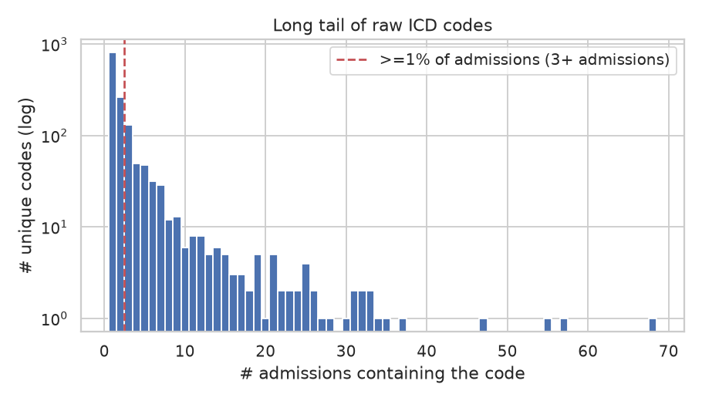
Most-prevalent codes (note that the same concept appears under both ICD versions, e.g. hypertension 4019 vs I10, hyperlipidemia 2724 vs E785):
code | admissions | % | description
9:4019 | 68 | 24.7 | Unspecified essential hypertension
10:E785 | 57 | 20.7 | Hyperlipidemia, unspecified
9:2724 | 55 | 20.0 | Other and unspecified hyperlipidemia
10:E039 | 47 | 17.1 | Hypothyroidism, unspecified
10:Z794 | 37 | 13.5 | Long term (current) use of insulin
10:Z87891 | 35 | 12.7 | Personal history of nicotine dependence
9:42731 | 34 | 12.4 | Atrial fibrillation
10:I2510 | 33 | 12.0 | Atherosclerotic heart disease of native coronary artery without angina
9:25000 | 33 | 12.0 | Diabetes mellitus without mention of complication, type II or unspecif
10:I10 | 32 | 11.6 | Essential (primary) hypertension
10:F329 | 32 | 11.6 | Major depressive disorder, single episode, unspecified
9:V1582 | 31 | 11.3 | Personal history of tobacco use
10:N179 | 31 | 11.3 | Acute kidney failure, unspecified
9:311 | 30 | 10.9 | Depressive disorder, not elsewhere classified
9:41401 | 28 | 10.2 | Coronary atherosclerosis of native coronary artery

Interpretation: the vocabulary is a long tail: 1474 distinct codes but only 401 appear in at least 1% of admissions, and the most common code covers only 24.7% of admissions. Most codes occur in one or two admissions, which is too few to learn from, motivating rollup and frequency thresholds. (In this 100-patient demo the 1% cut-off is only 3 admissions, so the count would be much smaller in full MIMIC-IV.)

B2. Roll-up to 3-character ICD families (5 pts)
raw code (version:code) | 3-char family
9:4019 | 9:401
10:E785 | 10:E78
9:2724 | 9:272
10:E039 | 10:E03
10:Z794 | 10:Z79
10:Z87891 | 10:Z87
9:42731 | 9:427
9:25000 | 9:250
10:I2510 | 10:I25
10:F329 | 10:F32
10:I10 | 10:I10
10:N179 | 10:N17
9:V1582 | 9:V15
9:311 | 9:311
9:41401 | 9:414
9:40390 | 9:403
10:E119 | 10:E11
10:F419 | 10:F41
9:5849 | 9:584
9:V5867 | 9:V58

The 20 most frequent codes above map to 20 distinct families (none collapse because these frequent codes already belong to different families). Applied to ALL 1474 unique raw codes, the roll-up leaves 688 unique categories, a 53.3% reduction; 337 of these families occur in ≥1% of admissions (versus 401 raw codes), and 313 families merge two or more raw codes. Caveats: (1) the roll-up is done within each ICD version, so equivalent ICD-9 and ICD-10 concepts (9:401 vs 10:I10) stay separate until a cross-version map (e.g., GEMs) is applied; (2) ICD-9 E-codes properly have a 4-character family, and a plain 3-character cut is coarser for them; (3) MIMIC stores codes without the dot, so J18.9 appears as J189 and rolls up to J18.

B3. LOINC coverage of lab itemids (5 pts)
The dataset has 498 distinct itemids in labevents, all present in d_labitems. The d_labitems table in this download has the columns itemid, label, fluid, category, with no loinc_code column. Therefore the fraction of itemids with a non-null LOINC code is 0/498 = 0%. I found no LOINC codes anywhere else in the download (a text search of the package for “loinc” returned nothing). This is expected: according to the MIMIC-IV change log, the loinc_code column was removed from d_labitems in MIMIC-IV v2.0 because the mapped values contained errors, and the demo v2.2 follows that schema. Earlier releases carried it. The analysis code still checks for the column and would compute the true non-null fraction if it were present.
For scale: the itemids split into fluid Blood 289, Urine 86 and others, and categories Hematology 238, Chemistry 227, Blood Gas 33. The top 25 itemids account for 58% of lab events and the top 50 for 79%, so manual curation of the head is cheap and covers most of the data. 46 lower-cased labels are shared by more than one itemid, so the label text alone is not a unique key (fluid has to be considered too).

B4. Fallback strategy for itemids without a LOINC code (10 pts)
1. Curate the head by hand. Rank itemids by event count and have a clinician or informatician map the top ~50–100 to LOINC (this covers about 79–94% of events here). Store the result as a reviewed crosswalk table (itemid → LOINC, mapping method, confidence, reviewer).
2. Normalize label strings for the tail. Lower-case, strip punctuation and extra whitespace, expand abbreviations (e.g., “Urea Nitrogen” = BUN, “WBC” = white blood cell count, “Hct” = hematocrit), and remove assay modifiers. Then exact-match against LOINC long common names and the LOINC “component” field.
3. Use more than the name. A LOINC code is defined by component, property, time, system (specimen), scale and method, so build the query from several fields: label → component; the fluid column (Blood, Urine, CSF, Pleural...) → system; valueuom (mg/dL, mEq/L, %, #/uL) → property type and unit; category (Chemistry/Hematology/Blood Gas) as a sanity check; and the reference range (ref_range_lower/upper) as a plausibility check. Two itemids with the same label but different fluid must not map to the same code.
4. Fuzzy and embedding matching with human review. For labels without an exact match, rank LOINC candidates by token-set or character n-gram similarity (e.g., TF-IDF cosine, Jaro-Winkler) and optionally by embeddings from a biomedical language model (SapBERT or similar); accept automatically only above a high threshold and when fluid and unit agree, and queue the rest for review.
5. Use value-distribution evidence. Compare the itemid's observed unit and value distribution with that of a confidently mapped item (for example, a sodium-like range around 135–145 mmol/L supports a sodium mapping) to detect and fix wrong matches.
6. Fail safe. Items that remain unmatched keep their local itemid as a namespaced code (e.g., MIMIC:51234) rather than being dropped, are flagged “unmapped”, and are excluded from or handled separately in cross-site models. Validate the pipeline by measuring precision on a held-out, hand-labelled sample of mapped items, and version the crosswalk so the mapping is reproducible.

Reproducibility
Run: python assignment3_mimic_eda.py <path to mimic-iv-clinical-database-demo-2.2>. Requires pandas, numpy, scipy, matplotlib, seaborn. All figures in this report are generated by that script.

