CST 2309 HW2

Refer to Tutorial 1: Getting Started with HTML

Session 1.3 pages HTML 46 to 70

Add a screenshot of the **ct_menu.html** file displayed in a browser after completing Step 6 on page HTML 52. See Figure 1-33 for reference. Include addressbar

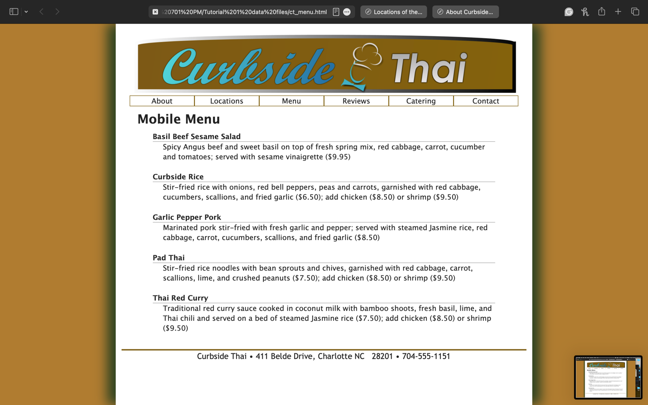

Add a screenshot of the **ct_location.html** file displayed in a browser after completing Step 7 on page HTML 54. See Figure 1-35 for reference. Include address bar

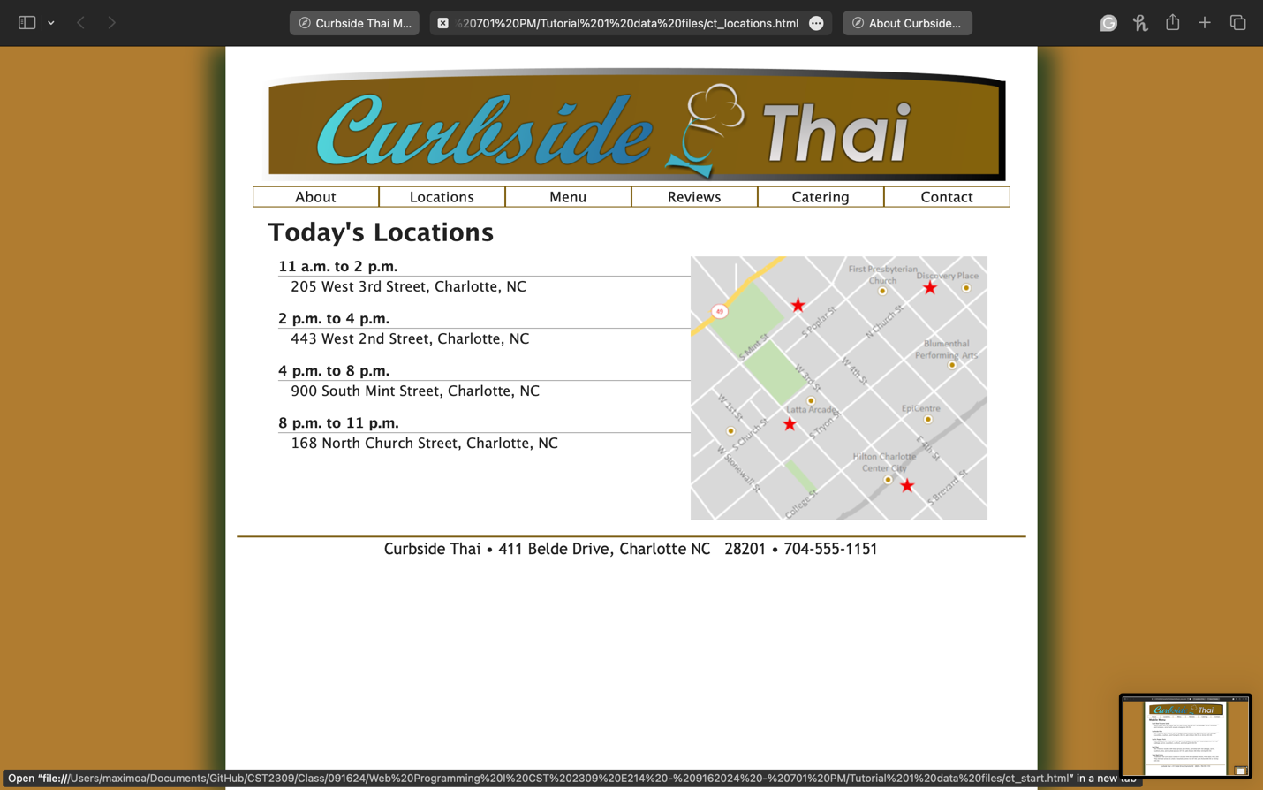

Add a screenshot of the **ct_about.html** file displayed in a browser after completing Step 3 on page HTML 56. See Figure 1-35 for reference. Include address bar

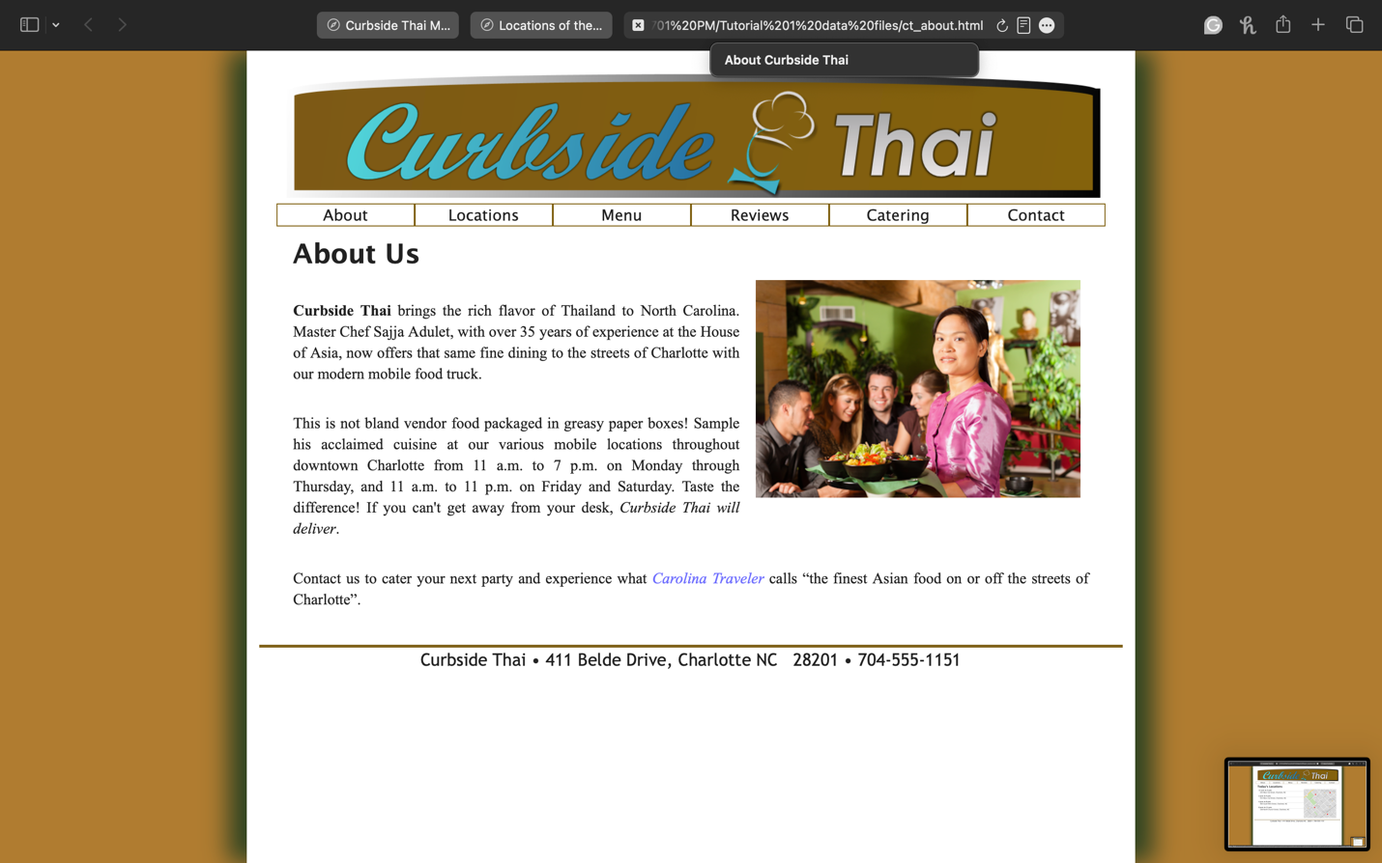

Add a screenshot of the validation report for ct**_about.html** file displayed in a browser after completing Step 4 on page HTML 70. See Figure 1-45 for reference. Include address bar

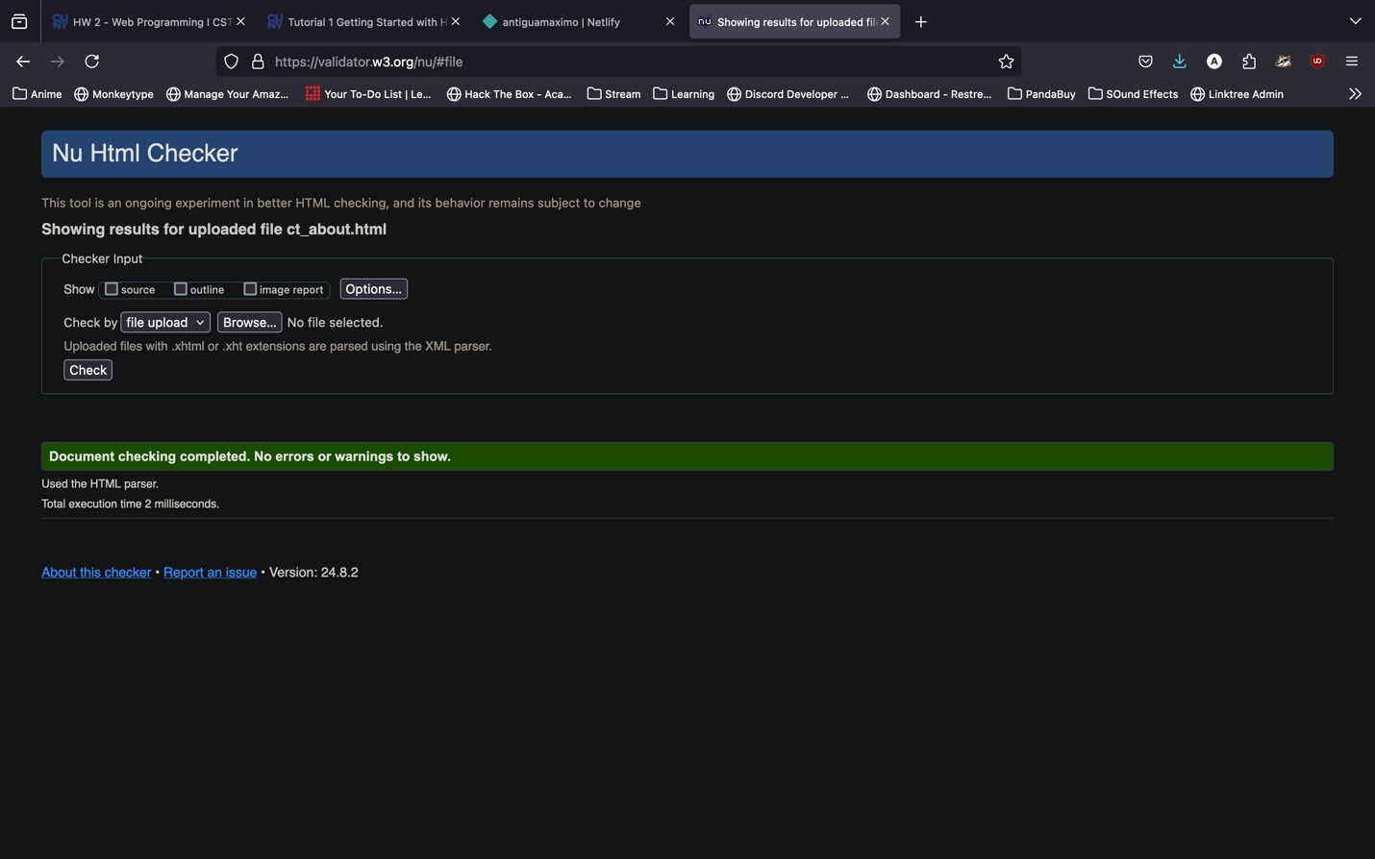

Complete Session 1.3 Quick Check

Completed