Lab 10.1 – Maximo Antigua

Refer to Chapter 1: Introduction to JavaScript

Add a screenshot of the js01.html file displayed in a browser after completing Step 4 on page 14. Include the browser address bar in the screenshot

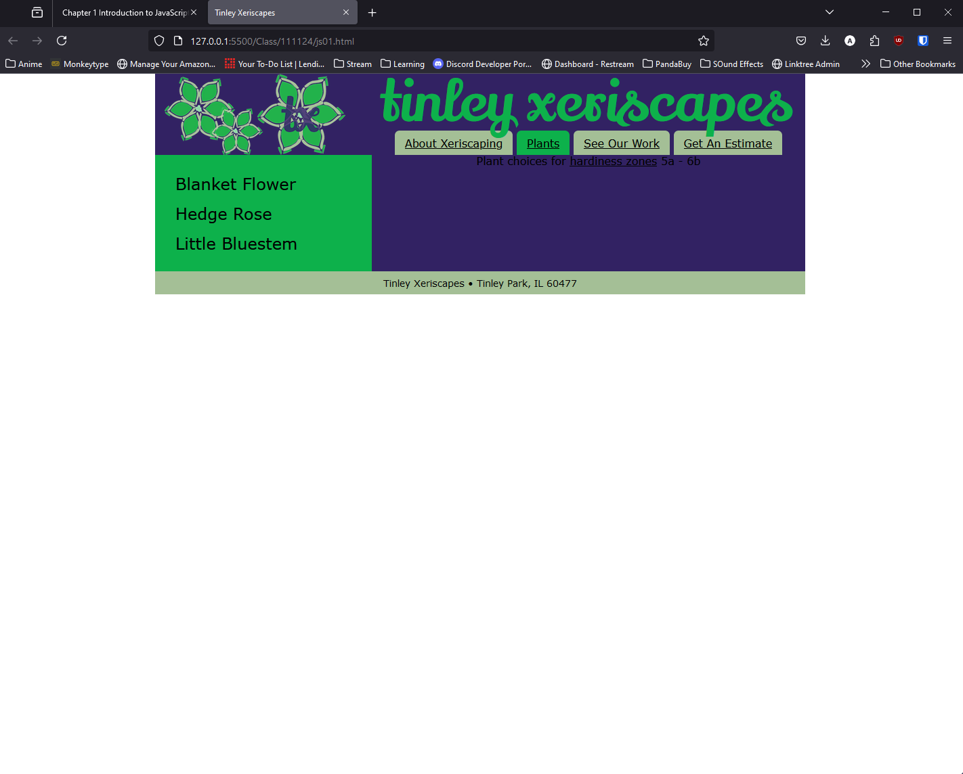

Answer the following questions: Refer to pages 1 - 14

1. How does a scripting language like JavaScript differ from a programming language like c#?

Scripting languages do not require compiling since they are run from the program or script. While programming language the instructions need to be translated into machine code so they can be understood by a machine.

1. What are the three core foundations upon which JavaScript is built?

ECMAScript, Document Object Model (DOM) and Browser Object Model (BOM)

1. In client/server architecture, what is a client? What is a server?

A client is the presentation of the interface to the user, the client gathers information from the user. While the server is a device or application from which a client requests information.

1. What HTML element is used to embed JavaScript code within an HTML file?

<script></script>

1. Provide the JavaScript command to write the HTML content <h1>Plant Types</h1> to the web page document

<script>

document.write("<h1>Plant Types</h1>");

</script>

1. Provide the code to write the text, “Major page Heading” as JavaScript block comment.

/\*

Major page Heading

\*/

1. Provide the code to write the text, “Major page Heading” as a JavaScript line comment.

// Major page Heading