Lab 10.2 – Maximo Antigua

Refer to Chapter 1: Introduction to JavaScript page 26 Step 6

Add a screenshot of the js01b.html file displayed in a browser. Include the browser address bar in the screenshot.

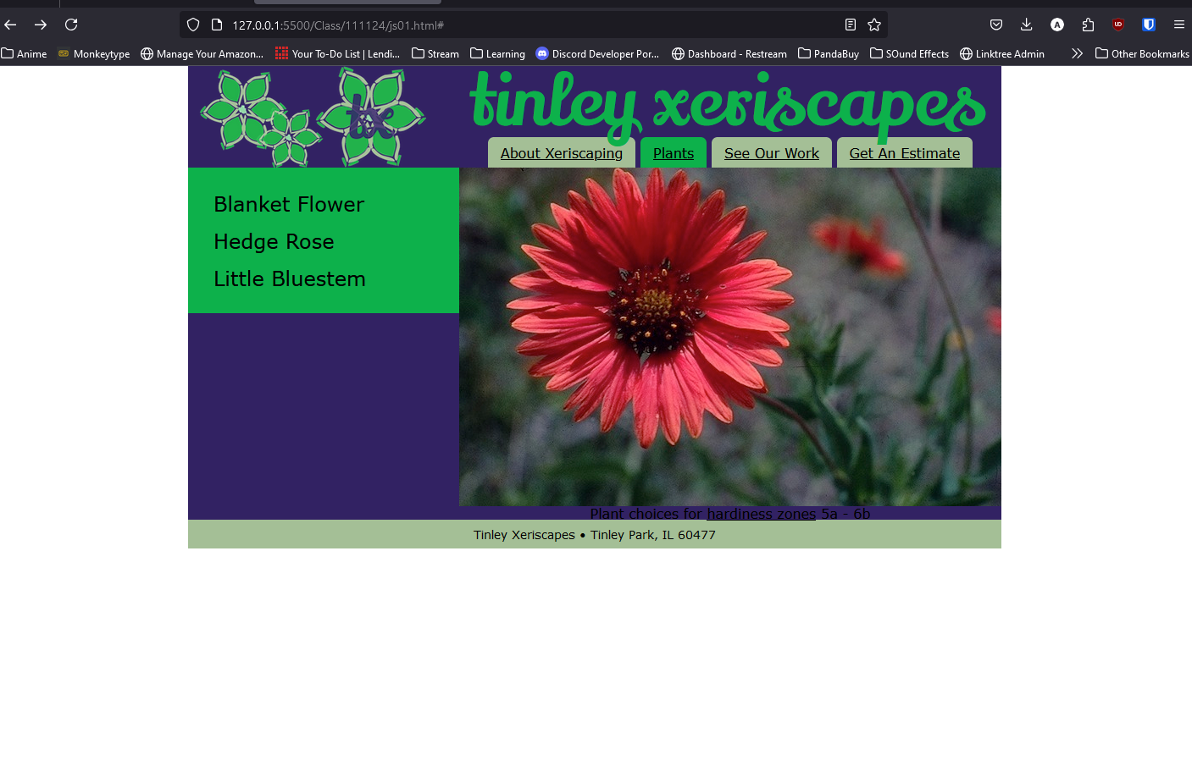

Add a screenshot of the 2023 USDA Plant Hardiness Zone Map obtain by clicking the Hardiness Zones link

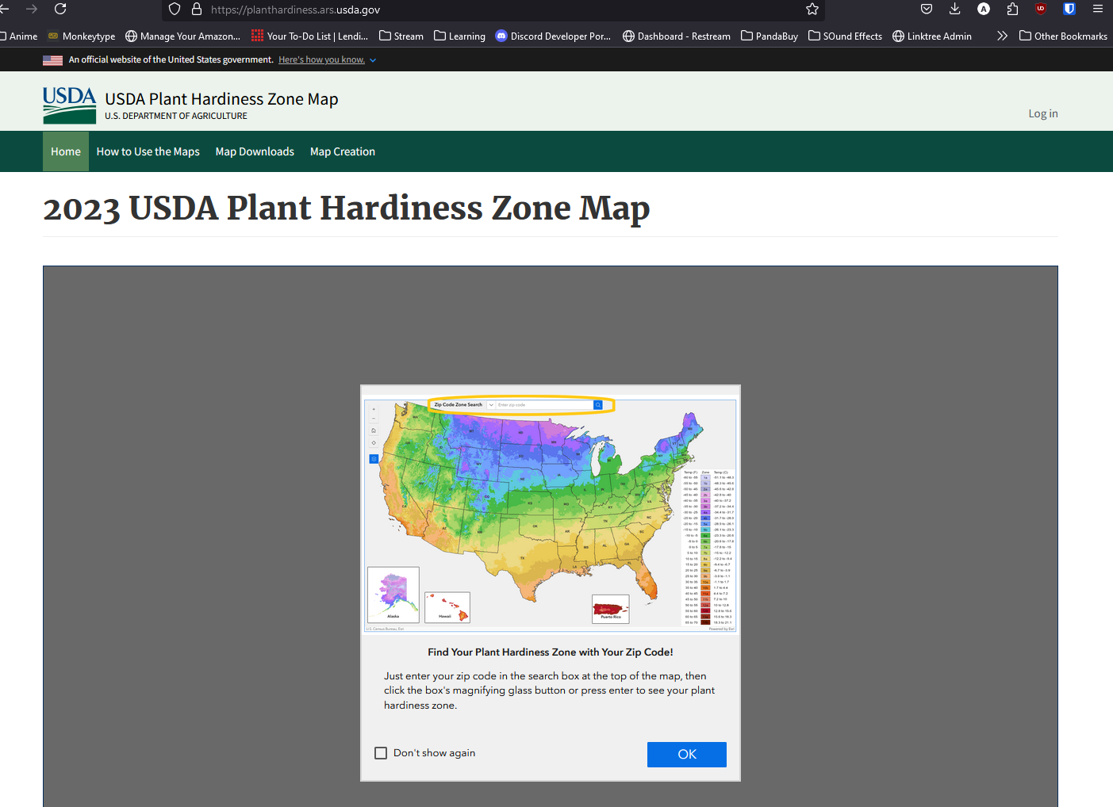

Answer the following questions:

1. What are the three JavaScript keywords for declaring a variable?

Let, var, const

1. What are the main differences between declaring and initializing a variable?

Declaring a variable creates a variable for storing data and objects, while initializing it assigns an initial value to it.

1. What is returned by expression “100” + 10?

10010

1. What is an event handler for?

An event handler reacts to an event made by either the browser or user on a specific element.

1. Why should you place script at the end of an HTML document’s body section?

Because if the script references part of the page that has not yet been loaded an error will occur.

1. How do you incorporate the contents of a JavaScript source file into an HTML document?

Using <script src=”url”> </script>