Schema visualization.xsd

schema location: | ..\..\..\courseware\documentation\visualization.xsd
attribute form default: | unqualified
element form default: | qualified

Attributes | Elements | Complex types
group | argument | collectable
index | collection | items
 | dvar
 | failed
 | focus
 | integer
 | other
 | sinteger
 | state
 | svar
 | tuple
 | visualization
 | visualizer
 | visualizer_state

attribute group
type | xs:string
used by
  elements | failed focus
source | <xs:attribute name="group" type="xs:string"/>

attribute index
type | xs:string
used by
  elements | argument collection dvar failed focus integer other sinteger svar tuple
source | <xs:attribute name="index" type="xs:string"/>

element argument
diagram | 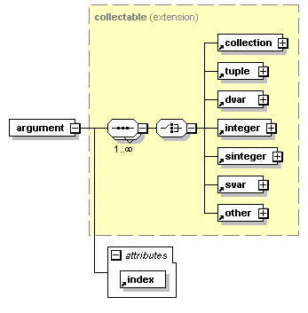
type | extension of collectable
properties
  content | complex
children | collection tuple dvar integer sinteger svar other
used by
  element | visualizer_state
attributes
  Name | Type | Use | Default | Fixed | annotation
  index |  | required
source | <xs:element name="argument">  <xs:complexType>  <xs:complexContent>  <xs:extension base="collectable">  <xs:attribute ref="index" use="required"/>  </xs:extension>  </xs:complexContent>  </xs:complexType>  </xs:element>

element collection
diagram | 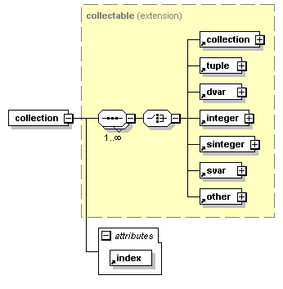
type | extension of collectable
properties
  content | complex
children | collection tuple dvar integer sinteger svar other
used by
  complexType | collectable
attributes
  Name | Type | Use | Default | Fixed | annotation
  index |  | required
source | <xs:element name="collection">  <xs:complexType>  <xs:complexContent>  <xs:extension base="collectable">  <xs:attribute ref="index" use="required"/>  </xs:extension>  </xs:complexContent>  </xs:complexType>  </xs:element>

element dvar
diagram | 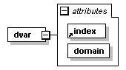
properties
  content | complex
used by
  element | visualizer_state
  complexTypes | collectable items
attributes
  Name | Type | Use | Default | Fixed | annotation
  index |  | required
  domain | xs:string | required
source | <xs:element name="dvar">  <xs:complexType>  <xs:attribute ref="index" use="required"/>  <xs:attribute name="domain" type="xs:string" use="required"/>  </xs:complexType>  </xs:element>

attribute dvar/@domain
type | xs:string
properties
  isRef | 0
  use | required
source | <xs:attribute name="domain" type="xs:string" use="required"/>

element failed
diagram | 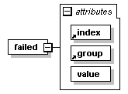
properties
  content | complex
used by
  element | visualizer_state
attributes
  Name | Type | Use | Default | Fixed | annotation
  index |  | required
  group |  | required
  value | xs:integer | required
source | <xs:element name="failed">  <xs:complexType>  <xs:attribute ref="index" use="required"/>  <xs:attribute ref="group" use="required"/>  <xs:attribute name="value" type="xs:integer" use="required"/>  </xs:complexType>  </xs:element>

attribute failed/@value
type | xs:integer
properties
  isRef | 0
  use | required
source | <xs:attribute name="value" type="xs:integer" use="required"/>

element focus
diagram | 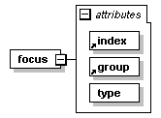
properties
  content | complex
used by
  element | visualizer_state
attributes
  Name | Type | Use | Default | Fixed | annotation
  index |  | required
  group |  | required
  type | xs:string | required
source | <xs:element name="focus">  <xs:complexType>  <xs:attribute ref="index" use="required"/>  <xs:attribute ref="group" use="required"/>  <xs:attribute name="type" type="xs:string" use="required"/>  </xs:complexType>  </xs:element>

attribute focus/@type
type | xs:string
properties
  isRef | 0
  use | required
source | <xs:attribute name="type" type="xs:string" use="required"/>

element integer
diagram | 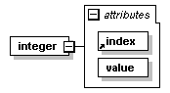
properties
  content | complex
used by
  element | visualizer_state
  complexTypes | collectable items
attributes
  Name | Type | Use | Default | Fixed | annotation
  index |  | required
  value | xs:integer | required
source | <xs:element name="integer">  <xs:complexType>  <xs:attribute ref="index" use="required"/>  <xs:attribute name="value" type="xs:integer" use="required"/>  </xs:complexType>  </xs:element>

attribute integer/@value
type | xs:integer
properties
  isRef | 0
  use | required
source | <xs:attribute name="value" type="xs:integer" use="required"/>

element other
diagram | 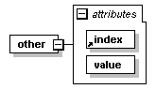
properties
  content | complex
used by
  element | visualizer_state
  complexTypes | collectable items
attributes
  Name | Type | Use | Default | Fixed | annotation
  index |  | required
  value | xs:string | required
source | <xs:element name="other">  <xs:complexType>  <xs:attribute ref="index" use="required"/>  <xs:attribute name="value" type="xs:string" use="required"/>  </xs:complexType>  </xs:element>

attribute other/@value
type | xs:string
properties
  isRef | 0
  use | required
source | <xs:attribute name="value" type="xs:string" use="required"/>

element sinteger
diagram | 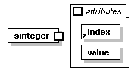
properties
  content | complex
used by
  element | visualizer_state
  complexTypes | collectable items
attributes
  Name | Type | Use | Default | Fixed | annotation
  index |  | required
  value | xs:string | required
source | <xs:element name="sinteger">  <xs:complexType>  <xs:attribute ref="index" use="required"/>  <xs:attribute name="value" type="xs:string" use="required"/>  </xs:complexType>  </xs:element>

attribute sinteger/@value
type | xs:string
properties
  isRef | 0
  use | required
source | <xs:attribute name="value" type="xs:string" use="required"/>

element state
diagram | 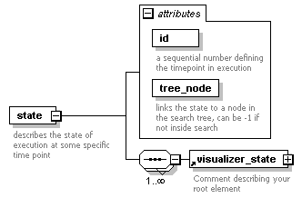
properties
  content | complex
children | visualizer_state
attributes
  Name | Type | Use | Default | Fixed | annotation
  id | xs:nonNegativeInteger | required
    documentation
    a sequential number defining the timepoint in execution
  tree_node | xs:integer | required
    documentation
    links the state to a node in the search tree, can be -1 if not inside search
annotation
  documentation
  describes the state of execution at some specific time point
source | <xs:element name="state">  <xs:annotation>  <xs:documentation>describes the state of execution at some specific time point</xs:documentation>  </xs:annotation>  <xs:complexType>  <xs:sequence maxOccurs="unbounded">  <xs:element ref="visualizer_state"/>  </xs:sequence>  <xs:attribute name="id" type="xs:nonNegativeInteger" use="required">  <xs:annotation>  <xs:documentation>a sequential number defining the timepoint in execution</xs:documentation>  </xs:annotation>  </xs:attribute>  <xs:attribute name="tree_node" type="xs:integer" use="required">  <xs:annotation>  <xs:documentation>links the state to a node in the search tree, can be -1 if not inside search</xs:documentation>  </xs:annotation>  </xs:attribute>  </xs:complexType>  </xs:element>

attribute state/@id
type | xs:nonNegativeInteger
properties
  isRef | 0
  use | required
annotation
  documentation
  a sequential number defining the timepoint in execution
source | <xs:attribute name="id" type="xs:nonNegativeInteger" use="required">  <xs:annotation>  <xs:documentation>a sequential number defining the timepoint in execution</xs:documentation>  </xs:annotation>  </xs:attribute>

attribute state/@tree_node
type | xs:integer
properties
  isRef | 0
  use | required
annotation
  documentation
  links the state to a node in the search tree, can be -1 if not inside search
source | <xs:attribute name="tree_node" type="xs:integer" use="required">  <xs:annotation>  <xs:documentation>links the state to a node in the search tree, can be -1 if not inside search</xs:documentation>  </xs:annotation>  </xs:attribute>

element svar
diagram | 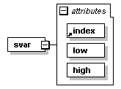
properties
  content | complex
used by
  element | visualizer_state
  complexTypes | collectable items
attributes
  Name | Type | Use | Default | Fixed | annotation
  index |  | required
  low | xs:string | required
  high | xs:string | required
source | <xs:element name="svar">  <xs:complexType>  <xs:attribute ref="index" use="required"/>  <xs:attribute name="low" type="xs:string" use="required"/>  <xs:attribute name="high" type="xs:string" use="required"/>  </xs:complexType>  </xs:element>

attribute svar/@low
type | xs:string
properties
  isRef | 0
  use | required
source | <xs:attribute name="low" type="xs:string" use="required"/>

attribute svar/@high
type | xs:string
properties
  isRef | 0
  use | required
source | <xs:attribute name="high" type="xs:string" use="required"/>

element tuple
diagram | 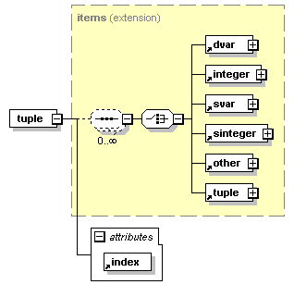
type | extension of items
properties
  content | complex
children | dvar integer svar sinteger other tuple
used by
  complexTypes | collectable items
attributes
  Name | Type | Use | Default | Fixed | annotation
  index |  | required
source | <xs:element name="tuple">  <xs:complexType>  <xs:complexContent>  <xs:extension base="items">  <xs:attribute ref="index" use="required"/>  </xs:extension>  </xs:complexContent>  </xs:complexType>  </xs:element>

element visualization
diagram | 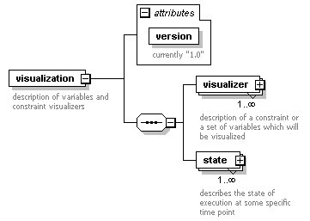
properties
  content | complex
children | visualizer state
attributes
  Name | Type | Use | Default | Fixed | annotation
  version | xs:string | required
    documentation
    currently "1.0"
annotation
  documentation
  description of variables and constraint visualizers
source | <xs:element name="visualization">  <xs:annotation>  <xs:documentation>description of variables and constraint visualizers</xs:documentation>  </xs:annotation>  <xs:complexType>  <xs:sequence>  <xs:element name="visualizer" maxOccurs="unbounded">  <xs:annotation>  <xs:documentation>description of a constraint or a set of variables which will be visualized</xs:documentation>  </xs:annotation>  <xs:complexType>  <xs:attribute name="id" type="xs:string" use="required">  <xs:annotation>  <xs:documentation>id is referred to by visualizer_state</xs:documentation>  </xs:annotation>  </xs:attribute>  <xs:attribute name="type" type="xs:string" use="required">  <xs:annotation>  <xs:documentation>type of visualizer; must be supported on both sizes</xs:documentation>  </xs:annotation>  </xs:attribute>  <xs:attribute name="display" type="xs:string" use="required">  <xs:annotation>  <xs:documentation>how to display the visualizer</xs:documentation>  </xs:annotation>  </xs:attribute>  <xs:attribute name="x" type="xs:integer" default="0">  <xs:annotation>  <xs:documentation>optional explicit placement of visualizer on canvas</xs:documentation>  </xs:annotation>  </xs:attribute>  <xs:attribute name="y" type="xs:integer" default="0"/>  <xs:attribute name="width" type="xs:integer" use="required"/>  <xs:attribute name="height" type="xs:integer" use="required"/>  <xs:attribute name="group" type="xs:string">  <xs:annotation>  <xs:documentation>optional parameter, allows grouping of multiple constraints</xs:documentation>  </xs:annotation>  </xs:attribute>  <xs:attribute name="min" type="xs:integer" default="0">  <xs:annotation>  <xs:documentation>expected minimal value of any of the domains</xs:documentation>  </xs:annotation>  </xs:attribute>  <xs:attribute name="max" type="xs:integer" default="0"/>  </xs:complexType>  </xs:element>  <xs:element name="state" maxOccurs="unbounded">  <xs:annotation>  <xs:documentation>describes the state of execution at some specific time point</xs:documentation>  </xs:annotation>  <xs:complexType>  <xs:sequence maxOccurs="unbounded">  <xs:element ref="visualizer_state"/>  </xs:sequence>  <xs:attribute name="id" type="xs:nonNegativeInteger" use="required">  <xs:annotation>  <xs:documentation>a sequential number defining the timepoint in execution</xs:documentation>  </xs:annotation>  </xs:attribute>  <xs:attribute name="tree_node" type="xs:integer" use="required">  <xs:annotation>  <xs:documentation>links the state to a node in the search tree, can be -1 if not inside search</xs:documentation>  </xs:annotation>  </xs:attribute>  </xs:complexType>  </xs:element>  </xs:sequence>  <xs:attribute name="version" type="xs:string" use="required">  <xs:annotation>  <xs:documentation>currently "1.0"</xs:documentation>  </xs:annotation>  </xs:attribute>  </xs:complexType>  </xs:element>

attribute visualization/@version
type | xs:string
properties
  isRef | 0
  use | required
annotation
  documentation
  currently "1.0"
source | <xs:attribute name="version" type="xs:string" use="required">  <xs:annotation>  <xs:documentation>currently "1.0"</xs:documentation>  </xs:annotation>  </xs:attribute>

element visualization/visualizer
diagram | 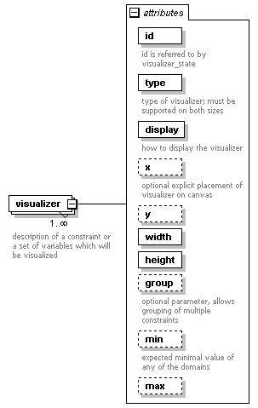
properties
  isRef | 0
  minOcc | 1
  maxOcc | unbounded
  content | complex
attributes
  Name | Type | Use | Default | Fixed | annotation
  id | xs:string | required
    documentation
    id is referred to by visualizer_state
  type | xs:string | required
    documentation
    type of visualizer; must be supported on both sizes
  display | xs:string | required
    documentation
    how to display the visualizer
  x | xs:integer |  | 0
    documentation
    optional explicit placement of visualizer on canvas
  y | xs:integer |  | 0
  width | xs:integer | required
  height | xs:integer | required
  group | xs:string
    documentation
    optional parameter, allows grouping of multiple constraints
  min | xs:integer |  | 0
    documentation
    expected minimal value of any of the domains
  max | xs:integer |  | 0
annotation
  documentation
  description of a constraint or a set of variables which will be visualized
source | <xs:element name="visualizer" maxOccurs="unbounded">  <xs:annotation>  <xs:documentation>description of a constraint or a set of variables which will be visualized</xs:documentation>  </xs:annotation>  <xs:complexType>  <xs:attribute name="id" type="xs:string" use="required">  <xs:annotation>  <xs:documentation>id is referred to by visualizer_state</xs:documentation>  </xs:annotation>  </xs:attribute>  <xs:attribute name="type" type="xs:string" use="required">  <xs:annotation>  <xs:documentation>type of visualizer; must be supported on both sizes</xs:documentation>  </xs:annotation>  </xs:attribute>  <xs:attribute name="display" type="xs:string" use="required">  <xs:annotation>  <xs:documentation>how to display the visualizer</xs:documentation>  </xs:annotation>  </xs:attribute>  <xs:attribute name="x" type="xs:integer" default="0">  <xs:annotation>  <xs:documentation>optional explicit placement of visualizer on canvas</xs:documentation>  </xs:annotation>  </xs:attribute>  <xs:attribute name="y" type="xs:integer" default="0"/>  <xs:attribute name="width" type="xs:integer" use="required"/>  <xs:attribute name="height" type="xs:integer" use="required"/>  <xs:attribute name="group" type="xs:string">  <xs:annotation>  <xs:documentation>optional parameter, allows grouping of multiple constraints</xs:documentation>  </xs:annotation>  </xs:attribute>  <xs:attribute name="min" type="xs:integer" default="0">  <xs:annotation>  <xs:documentation>expected minimal value of any of the domains</xs:documentation>  </xs:annotation>  </xs:attribute>  <xs:attribute name="max" type="xs:integer" default="0"/>  </xs:complexType>  </xs:element>

attribute visualization/visualizer/@id
type | xs:string
properties
  isRef | 0
  use | required
annotation
  documentation
  id is referred to by visualizer_state
source | <xs:attribute name="id" type="xs:string" use="required">  <xs:annotation>  <xs:documentation>id is referred to by visualizer_state</xs:documentation>  </xs:annotation>  </xs:attribute>

attribute visualization/visualizer/@type
type | xs:string
properties
  isRef | 0
  use | required
annotation
  documentation
  type of visualizer; must be supported on both sizes
source | <xs:attribute name="type" type="xs:string" use="required">  <xs:annotation>  <xs:documentation>type of visualizer; must be supported on both sizes</xs:documentation>  </xs:annotation>  </xs:attribute>

attribute visualization/visualizer/@display
type | xs:string
properties
  isRef | 0
  use | required
annotation
  documentation
  how to display the visualizer
source | <xs:attribute name="display" type="xs:string" use="required">  <xs:annotation>  <xs:documentation>how to display the visualizer</xs:documentation>  </xs:annotation>  </xs:attribute>

attribute visualization/visualizer/@x
type | xs:integer
properties
  isRef | 0
  default | 0
annotation
  documentation
  optional explicit placement of visualizer on canvas
source | <xs:attribute name="x" type="xs:integer" default="0">  <xs:annotation>  <xs:documentation>optional explicit placement of visualizer on canvas</xs:documentation>  </xs:annotation>  </xs:attribute>

attribute visualization/visualizer/@y
type | xs:integer
properties
  isRef | 0
  default | 0
source | <xs:attribute name="y" type="xs:integer" default="0"/>

attribute visualization/visualizer/@width
type | xs:integer
properties
  isRef | 0
  use | required
source | <xs:attribute name="width" type="xs:integer" use="required"/>

attribute visualization/visualizer/@height
type | xs:integer
properties
  isRef | 0
  use | required
source | <xs:attribute name="height" type="xs:integer" use="required"/>

attribute visualization/visualizer/@group
type | xs:string
properties
  isRef | 0
annotation
  documentation
  optional parameter, allows grouping of multiple constraints
source | <xs:attribute name="group" type="xs:string">  <xs:annotation>  <xs:documentation>optional parameter, allows grouping of multiple constraints</xs:documentation>  </xs:annotation>  </xs:attribute>

attribute visualization/visualizer/@min
type | xs:integer
properties
  isRef | 0
  default | 0
annotation
  documentation
  expected minimal value of any of the domains
source | <xs:attribute name="min" type="xs:integer" default="0">  <xs:annotation>  <xs:documentation>expected minimal value of any of the domains</xs:documentation>  </xs:annotation>  </xs:attribute>

attribute visualization/visualizer/@max
type | xs:integer
properties
  isRef | 0
  default | 0
source | <xs:attribute name="max" type="xs:integer" default="0"/>

element visualization/state
diagram | 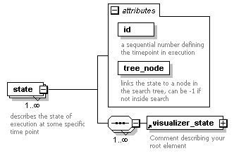
properties
  isRef | 0
  minOcc | 1
  maxOcc | unbounded
  content | complex
children | visualizer_state
attributes
  Name | Type | Use | Default | Fixed | annotation
  id | xs:nonNegativeInteger | required
    documentation
    a sequential number defining the timepoint in execution
  tree_node | xs:integer | required
    documentation
    links the state to a node in the search tree, can be -1 if not inside search
annotation
  documentation
  describes the state of execution at some specific time point
source | <xs:element name="state" maxOccurs="unbounded">  <xs:annotation>  <xs:documentation>describes the state of execution at some specific time point</xs:documentation>  </xs:annotation>  <xs:complexType>  <xs:sequence maxOccurs="unbounded">  <xs:element ref="visualizer_state"/>  </xs:sequence>  <xs:attribute name="id" type="xs:nonNegativeInteger" use="required">  <xs:annotation>  <xs:documentation>a sequential number defining the timepoint in execution</xs:documentation>  </xs:annotation>  </xs:attribute>  <xs:attribute name="tree_node" type="xs:integer" use="required">  <xs:annotation>  <xs:documentation>links the state to a node in the search tree, can be -1 if not inside search</xs:documentation>  </xs:annotation>  </xs:attribute>  </xs:complexType>  </xs:element>

attribute visualization/state/@id
type | xs:nonNegativeInteger
properties
  isRef | 0
  use | required
annotation
  documentation
  a sequential number defining the timepoint in execution
source | <xs:attribute name="id" type="xs:nonNegativeInteger" use="required">  <xs:annotation>  <xs:documentation>a sequential number defining the timepoint in execution</xs:documentation>  </xs:annotation>  </xs:attribute>

attribute visualization/state/@tree_node
type | xs:integer
properties
  isRef | 0
  use | required
annotation
  documentation
  links the state to a node in the search tree, can be -1 if not inside search
source | <xs:attribute name="tree_node" type="xs:integer" use="required">  <xs:annotation>  <xs:documentation>links the state to a node in the search tree, can be -1 if not inside search</xs:documentation>  </xs:annotation>  </xs:attribute>

element visualizer
diagram | 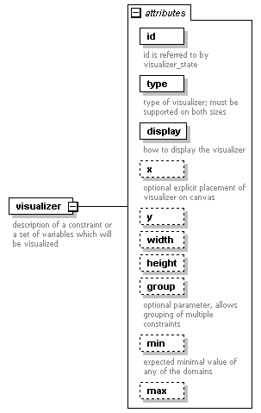
properties
  content | complex
attributes
  Name | Type | Use | Default | Fixed | annotation
  id | xs:string | required
    documentation
    id is referred to by visualizer_state
  type | xs:string | required
    documentation
    type of visualizer; must be supported on both sizes
  display | xs:string | required
    documentation
    how to display the visualizer
  x | xs:integer |  | 0
    documentation
    optional explicit placement of visualizer on canvas
  y | xs:integer |  | 0
  width | xs:integer |  | 0
  height | xs:integer |  | 0
  group | xs:string
    documentation
    optional parameter, allows grouping of multiple constraints
  min | xs:integer |  | 0
    documentation
    expected minimal value of any of the domains
  max | xs:integer |  | 0
annotation
  documentation
  description of a constraint or a set of variables which will be visualized
source | <xs:element name="visualizer">  <xs:annotation>  <xs:documentation>description of a constraint or a set of variables which will be visualized</xs:documentation>  </xs:annotation>  <xs:complexType>  <xs:attribute name="id" type="xs:string" use="required">  <xs:annotation>  <xs:documentation>id is referred to by visualizer_state</xs:documentation>  </xs:annotation>  </xs:attribute>  <xs:attribute name="type" type="xs:string" use="required">  <xs:annotation>  <xs:documentation>type of visualizer; must be supported on both sizes</xs:documentation>  </xs:annotation>  </xs:attribute>  <xs:attribute name="display" type="xs:string" use="required">  <xs:annotation>  <xs:documentation>how to display the visualizer</xs:documentation>  </xs:annotation>  </xs:attribute>  <xs:attribute name="x" type="xs:integer" default="0">  <xs:annotation>  <xs:documentation>optional explicit placement of visualizer on canvas</xs:documentation>  </xs:annotation>  </xs:attribute>  <xs:attribute name="y" type="xs:integer" default="0"/>  <xs:attribute name="width" type="xs:integer" default="0"/>  <xs:attribute name="height" type="xs:integer" default="0"/>  <xs:attribute name="group" type="xs:string">  <xs:annotation>  <xs:documentation>optional parameter, allows grouping of multiple constraints</xs:documentation>  </xs:annotation>  </xs:attribute>  <xs:attribute name="min" type="xs:integer" default="0">  <xs:annotation>  <xs:documentation>expected minimal value of any of the domains</xs:documentation>  </xs:annotation>  </xs:attribute>  <xs:attribute name="max" type="xs:integer" default="0"/>  </xs:complexType>  </xs:element>

attribute visualizer/@id
type | xs:string
properties
  isRef | 0
  use | required
annotation
  documentation
  id is referred to by visualizer_state
source | <xs:attribute name="id" type="xs:string" use="required">  <xs:annotation>  <xs:documentation>id is referred to by visualizer_state</xs:documentation>  </xs:annotation>  </xs:attribute>

attribute visualizer/@type
type | xs:string
properties
  isRef | 0
  use | required
annotation
  documentation
  type of visualizer; must be supported on both sizes
source | <xs:attribute name="type" type="xs:string" use="required">  <xs:annotation>  <xs:documentation>type of visualizer; must be supported on both sizes</xs:documentation>  </xs:annotation>  </xs:attribute>

attribute visualizer/@display
type | xs:string
properties
  isRef | 0
  use | required
annotation
  documentation
  how to display the visualizer
source | <xs:attribute name="display" type="xs:string" use="required">  <xs:annotation>  <xs:documentation>how to display the visualizer</xs:documentation>  </xs:annotation>  </xs:attribute>

attribute visualizer/@x
type | xs:integer
properties
  isRef | 0
  default | 0
annotation
  documentation
  optional explicit placement of visualizer on canvas
source | <xs:attribute name="x" type="xs:integer" default="0">  <xs:annotation>  <xs:documentation>optional explicit placement of visualizer on canvas</xs:documentation>  </xs:annotation>  </xs:attribute>

attribute visualizer/@y
type | xs:integer
properties
  isRef | 0
  default | 0
source | <xs:attribute name="y" type="xs:integer" default="0"/>

attribute visualizer/@width
type | xs:integer
properties
  isRef | 0
  default | 0
source | <xs:attribute name="width" type="xs:integer" default="0"/>

attribute visualizer/@height
type | xs:integer
properties
  isRef | 0
  default | 0
source | <xs:attribute name="height" type="xs:integer" default="0"/>

attribute visualizer/@group
type | xs:string
properties
  isRef | 0
annotation
  documentation
  optional parameter, allows grouping of multiple constraints
source | <xs:attribute name="group" type="xs:string">  <xs:annotation>  <xs:documentation>optional parameter, allows grouping of multiple constraints</xs:documentation>  </xs:annotation>  </xs:attribute>

attribute visualizer/@min
type | xs:integer
properties
  isRef | 0
  default | 0
annotation
  documentation
  expected minimal value of any of the domains
source | <xs:attribute name="min" type="xs:integer" default="0">  <xs:annotation>  <xs:documentation>expected minimal value of any of the domains</xs:documentation>  </xs:annotation>  </xs:attribute>

attribute visualizer/@max
type | xs:integer
properties
  isRef | 0
  default | 0
source | <xs:attribute name="max" type="xs:integer" default="0"/>

element visualizer_state
diagram | 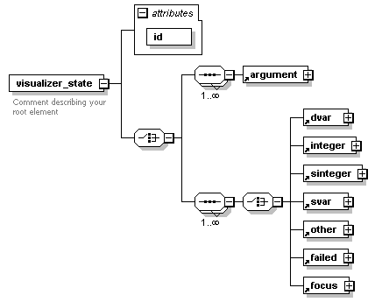
properties
  content | complex
children | argument dvar integer sinteger svar other failed focus
used by
  elements | visualization/state state
attributes
  Name | Type | Use | Default | Fixed | annotation
  id | xs:nonNegativeInteger | required
annotation
  documentation
  Comment describing your root element
source | <xs:element name="visualizer_state">  <xs:annotation>  <xs:documentation>Comment describing your root element</xs:documentation>  </xs:annotation>  <xs:complexType>  <xs:choice>  <xs:sequence maxOccurs="unbounded">  <xs:element ref="argument"/>  </xs:sequence>  <xs:sequence maxOccurs="unbounded">  <xs:choice>  <xs:element ref="dvar"/>  <xs:element ref="integer"/>  <xs:element ref="sinteger"/>  <xs:element ref="svar"/>  <xs:element ref="other"/>  <xs:element ref="failed"/>  <xs:element ref="focus"/>  </xs:choice>  </xs:sequence>  </xs:choice>  <xs:attribute name="id" type="xs:nonNegativeInteger" use="required"/>  </xs:complexType>  </xs:element>

attribute visualizer_state/@id
type | xs:nonNegativeInteger
properties
  isRef | 0
  use | required
source | <xs:attribute name="id" type="xs:nonNegativeInteger" use="required"/>

complexType collectable
diagram | 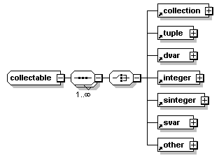
children | collection tuple dvar integer sinteger svar other
used by
  elements | argument collection
source | <xs:complexType name="collectable">  <xs:sequence maxOccurs="unbounded">  <xs:choice>  <xs:element ref="collection"/>  <xs:element ref="tuple"/>  <xs:element ref="dvar"/>  <xs:element ref="integer"/>  <xs:element ref="sinteger"/>  <xs:element ref="svar"/>  <xs:element ref="other"/>  </xs:choice>  </xs:sequence>  </xs:complexType>

complexType items
diagram | 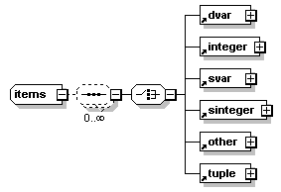
children | dvar integer svar sinteger other tuple
used by
  element | tuple
source | <xs:complexType name="items">  <xs:sequence minOccurs="0" maxOccurs="unbounded">  <xs:choice>  <xs:element ref="dvar"/>  <xs:element ref="integer"/>  <xs:element ref="svar"/>  <xs:element ref="sinteger"/>  <xs:element ref="other"/>  <xs:element ref="tuple"/>  </xs:choice>  </xs:sequence>  </xs:complexType>

XML Schema documentation generated by XMLSpy Schema Editor http://www.altova.com/xmlspy

