Gerson Ramirez | ← Download the most updated version following the link on the name.  preferred contact hours: M-F 1:00pm – 6:30pm PST, and weekends
Address | Sun Vista, Las Vegas, NV, 89104
Phone (s) | Cell: 7023218287
Email | antillgrp@gmail.com (preferred contact) |  |  | 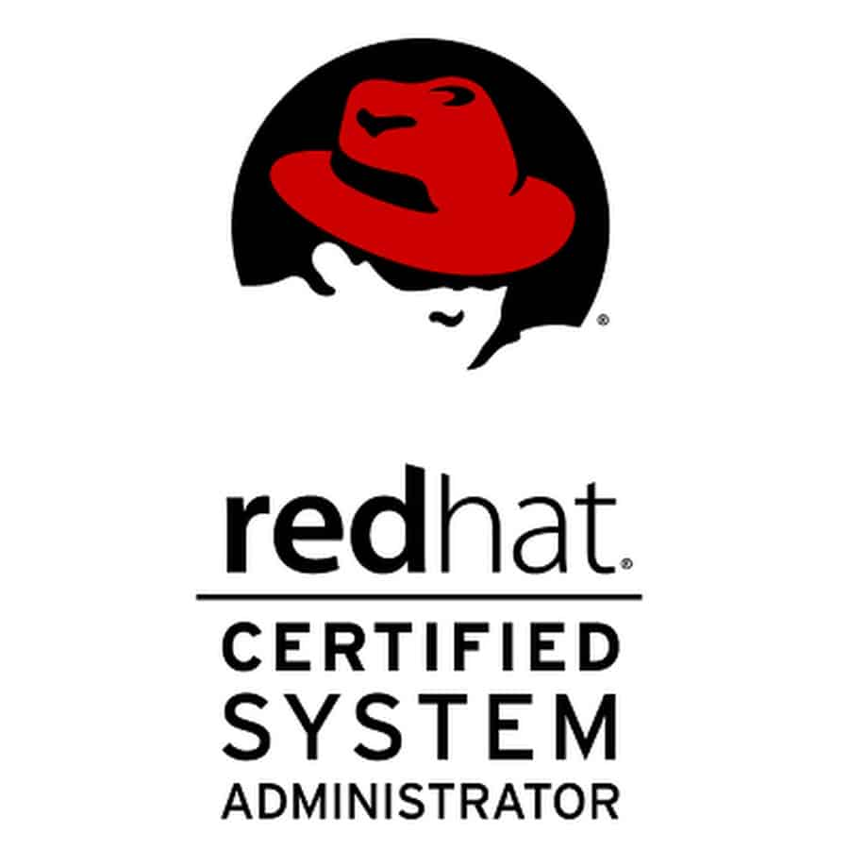 | 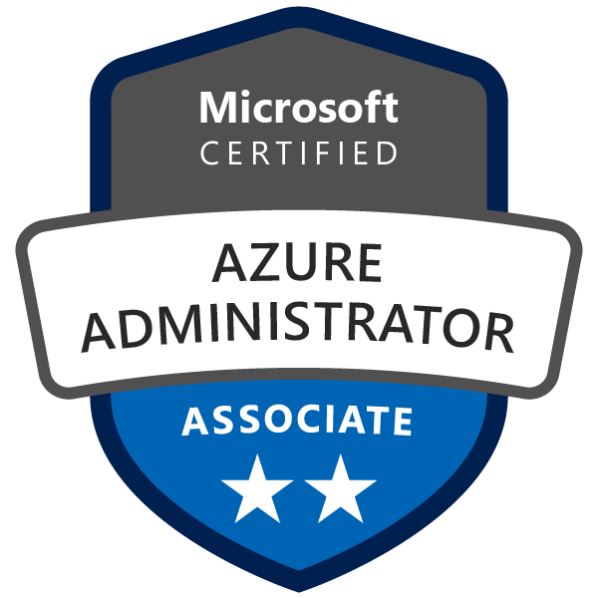 | 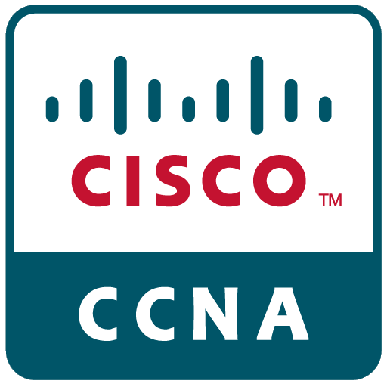
 | https://www.linkedin.com/in/bcs-gerson-ramirez
 | https://github.com/antillgrp
I am professional with more than ten years of experience in many different IT areas, such as software development, systems and networking.

!! Federal ACTIVE Department of Commerce (DoC) Moderate Background Investigation (MBI) Public Trust Clearance.
To inquire further regarding verification of clearance, please contact Census Investigative Services (CIS).

Education and Certifications
Majors | - Master of Science in Software Development at Maryville University of St. Louis.  (GPA: 4.0 (Gerson_Unofficial_Transcript_8_26_2020.pdf))  - Bachelor’s in Computer Science (07/2009)
Official Certifications:  - Oracle Certified Professional: Java SE 11 Developer  (Certification Number: 282095428OCPJSE11-J)  - Object Oriented Application Development in JAVA  (Certification Number: R073015600232)  - ReactJS with Redux Certification  (Certification Number: BT4Y8AVC)  - Cisco Certified Network Associate ( CCNA )  (Certificate Verification Number: Q58VEEDPF3RQQPG1)  - Microsoft Certified Azure Administrator Associate  (Certification Number: H524-5526)  - Red Hat® Certified System Administrator ( RHCSA )  (Certification Number: In progress …)  - NIIT Red Hat® Linux System Administration  (Certification Number: 07HO-MMS-0123)  - NIIT TCP/IP and Red Hat® Linux Essentials  (Certification Number: 07HO-MMS-0059) |  | Certificates and Trainings:  - Spring Boot and Microservices  - Docker & Kubernetes Workshop  - CDW application development cross-training (6 weeks)  (C#, ASP.NET Web API, SQL SERVER, JAVASCRIPT, JQUERY)  - ( Training ) AZ-104: Microsoft Azure Administrator  - ( Training ) Certificate CISCO CCNA Training (176 Hours)  - ( Training 290 hours) Helpdesk Agent  - Microsoft WS 2008 Network Services Administration Course  - Microsoft WS 2008 Active Directory Administration Course
Software development skills and competences:

- Expertise in OOP and Functional languages like Java (Spring Boot, Hibernate, JPA, etc.), NodeJS, Python, C#, TypeScript, …
- Advanced knowledge in Backend - Frontend integration with trends opensource libraries like ReactJS (JS, TS, Redux, React-Router, React-Bootstrap, React-Material-UI, etc.), Angular, VueJS. Knowledge of web services with solid understanding of the RESTful Architecture and SOAP. Knowledgeable in full stack development, platforms, frameworks and front-end libraries, Java frameworks, .Net Framework, ASP.NET, ADO.NET, Entity Framework, NodeJS (back-end libraries like express, sequelize and many others).
- Strong knowledge Object-Oriented Paradigm, SOLID adherence and GoF Design Patterns. Comprehensive experience with Databases design and administration and DB query languages, such as MS SQL Server and MySQL. High proficiency using IDEs and debugging tools, Microsoft Visual Studio, Visual Studio Code, Eclipse, NetBeans, etc.
- Accredited certifications for Docker & Kubernetes Workshop and Spring Boot and Microservices.
- (Cert) AZ-104: Microsoft Azure Administrator and (Training) AZ-104: Microsoft Azure Administrator
Infosys Education And Training:
FullStack Spring Microservices and ReactJS
Java (8/11) (Core, Spring, Microservices, Spring Boot, Spring Cloud (RestTemplate, Ribbon, Eureka, Hystrix, Zuul, Sleuth, Consul, etc.), Hibernate, JPA, etc.),

Project: EPortal Application: https://codesandbox.io/s/infy-eportal-angular-csbox-sxjoq
FullStack Project (Backend: JavaScript NodeJS/Express, MongoDriver, MongoDB. FrontEnd: TypeScript, Angular, RxJS)
https://github.com/antillgrp/infy-eportal-angular-csbox
Academic projects experience (01/2020 to current):

Project: https://github.com/antillgrp/swdv-620-web-apps-final-project
FullStack Project with 2 microservices (Java (SpringBoot, JPA, Hibernate) / NodeJS(Express, sequelize) ), MySql DB. FrontEnd: ReactJS, ReduxJS, Axios, material-ui, csvtojson, fakerest, react-admin, react-app-rewired, react-file-reader, react-markdown
Project: https://stackblitz.com/edit/react-ts-ms-mui-dev
ReactJS Mines Sweeper: ReactJS, Observable Design Pattern + OOP, Material-UI
Several coding projects with Java, Python, NodeJS, etc. (see https://github.com/antillgrp)
CDW in configuration center. (06/2016 – 05/2021)
IT Systems/Network/Hardware Technician level II Enterprise Area
Project: ConfingCentral/EnterpriseSolutions Module, Application development cross-training (6 month) (C#, ASP.NET Web API, SQL SERVER, JAVASCRIPT, JQUERY). Development o the enterprise module for the ConfigCentral Management System
Projects: Nordstrom Cloud, Sharp HealthCare RedHat Enterprise Migration Deploy, US Census, configure, automatize, scripting (bash, nodejs python, PowerShell), desktop, server OS (Linux (Red Hat, Centos, Ubuntu Server, etc.), Windows Server(2008, 2012, 2016)), and virtualization platforms (VMWare ESXi (6.5, 7.0), HyperV)

Freelance (01/2019 to 05/2021)
Upwork platform freelancing:
Frontend integration with trends opensource libraries like ReactJS (React Hooks, Redux, React-Router, React-Bootstrap, React-Material-UI, Axios, Testing(Jest), etc.)
Java (8/11) (Core, Spring, Spring Boot, Hibernate, JPA, etc.), JavaScript (NodeJS (back-end libraries like express, sequelize and many others), TypeScript, libraries and frameworks), Python, C# (ASP.NET, NET Core, Entity Framework, WebAPI, etc.).
Work experience
Occupation or position held | Specialist Programmer (06/2016 - current)
Functions and main responsibilities | - FullStack Spring Microservices and ReactJS/Angular  - Java (8/11) (Core, Spring, Microservices, Spring Boot, Spring Cloud (RestTemplate, Ribbon, Eureka, Hystrix, Zuul, Sleuth, Consul, etc.), Hibernate, JPA, etc.)  - MSSql, MySQL, MongoDB
Employer | Infosys
………………………………………………………………………………………………………………………………………………………………………………………… | ……………………………………………………………………………………………………………………………………………………………………………………………………………………………………………………………………………………………………………………………….………………………………………………………………………………………………………………………………………………………………………………………………………
Occupation or position held | IT Systems/Network/Hardware Technician level II Enterprise Area (06/2016 - current)
Functions and main responsibilities | - Application development cross-training (6 weeks) (C#, ASP.NET Web API, SQL SERVER, JAVASCRIPT, JQUERY)  - Install, configure troubleshoot and upgrade Server/Racks hardware, software, networks (routers/switches/wireless) and peripheral equipment.  Deploy, configure, automatize, scripting (bash, python, PowerShell), desktop, server OS (Linux (Red Hat EL, Centos, Ubuntu Server, etc.), Windows Server(2008, 2012, 2016)), and virtualization platforms (VMWare ESXi (6.5, 7.0), HyperV)
Employer | CDW in configuration center.
References | Annual Performance Review 2020
………………………………………………………………………………………………………………………………………………………………………………………… | ……………………………………………………………………………………………………………………………………………………………………………………………………………………………………………………………………………………………………………………………….………………………………………………………………………………………………………………………………………………………………………………………………………
Occupation or position held | Broadband Premises Installer (08/2015 to 06/2016) IES Residential, Inc. - Las Vegas, NV  Contact: Amaury Arencibia (Supervisor): +1-702-485-9266
………………………………………………………………………………………………………………………………………………………………………………………… | ……………………………………………………………………………………………………………………………………………………………………………………………………………………………………………………………………………………………………………………………….………………………………………………………………………………………………………………………………………………………………………………………………………
Occupation or position held | Non-IT (02/2015 to 07/2015)
………………………………………………………………………………………………………………………………………………………………………………………… | ……………………………………………………………………………………………………………………………………………………………………………………………………………………………………………………………………………………………………………………………….………………………………………………………………………………………………………………………………………………………………………………………………………
Occupation or position held | Non-IT (11/2014 to 07/2015) on-call
………………………………………………………………………………………………………………………………………………………………………………………… | ……………………………………………………………………………………………………………………………………………………………………………………………………………………………………………………………………………………………………………………………….………………………………………………………………………………………………………………………………………………………………………………………………………
Occupation or position held | Computer Technician/Web Developer (01/01/2013 to 09/30/2014)
Functions and main responsibilities | - Web applications development CMS based, joomla, drupal, wordpress.  - Systems Installation and Configuration, O.Systems Windows, Linux, MacOS, Unix (FreeBSD).  - Installation and configuration of wired and wireless networks, and network equipment.  - Repairing and maintaining all sort of computer equipment.  - Remote Assistance and Customer Support.  - Huge rollouts of memory installation/upgrade, peripheral equipment swapped out (monitors, keyboards, printers)
Employer | Freelance (customers references only)
………………………………………………………………………………………………………………………………………………………………………………………… | ……………………………………………………………………………………………………………………………………………………………………………………………………………………………………………………………………………………………………………………………….………………………………………………………………………………………………………………………………………………………………………………………………………
Occupation or position held | IT Systems and Hardware Technician/Web Developer (03/01/2011 to 12/31/2012)
Functions and main responsibilities | - Small web applications development CMS based, Joomla, Drupal, Wordpress.  - Systems Installation and Configuration, O.Systems Windows, Linux, MacOS, Unix (FreeBSD).  - Installation and configuration of wired and wireless networks, and network equipment.  - Repairing and maintaining all sort of computer equipment.  - Remote Assistance and Customer Support.  - Selling and post-sales support.
Employer | Informática Profesional de Canarias.
………………………………………………………………………………………………………………………………………………………………………………………… | ……………………………………………………………………………………………………………………………………………………………………………………………………………………………………………………………………………………………………………………………….………………………………………………………………………………………………………………………………………………………………………………………………………
Occupation or position held | System Technician and Final User Support (06/01/10 to 07/30/10)
Functions and main responsibilities | - Small web applications development CMS based, Joomla, Drupal, WordPress.  - Member of the team in charge of the migration and deploying of “Drago” System (Unified and centralized system of health information), Canary Islands Health Service.  - Also, giving technical onsite customer support.  - Huge rollouts of memory installation/upgrade, peripheral equipment swapped out (monitors, keyboards, printers)
Employer | Arcitel Ibérica, S.A, Tenerife (Spain)
………………………………………………………………………………………………………………………………………………………………………………………… | ……………………………………………………………………………………………………………………………………………………………………………………………………………………………………………………………………………………………………………………………….………………………………………………………………………………………………………………………………………………………………………………………………………
Occupation or position held | Dependent Technical of Cybercafe (retailer IT shop) (05/09 - 05/10)
Functions and main responsibilities | - Systems Installation and Configuration, O.Systems Windows.  - Installation and configuration of wired and wireless networks, and network equipment.  - Repairing and maintaining all sort of computer equipment.  - Remote Assistance and Customer Support.  - Huge rollouts of memory installation/upgrade, peripheral equipment swapped out (monitors, keyboards, printers)
Employer | Cybercafe Cybermar, Tenerife (Spain)
………………………………………………………………………………………………………………………………………………………………………………………… | ……………………………………………………………………………………………………………………………………………………………………………………………………………………………………………………………………………………………………………………………….………………………………………………………………………………………………………………………………………………………………………………………………………
Occupation or position held | Network and Systems Administrator and Management Computing (04/2008 - 04/2009)
Functions and main responsibilities | - Internet enterprises services management (email, web, others)  - Administration and maintenance physical (cable, routers, switches) and logical network (active directory, users, group policy, security, databases systems, others).  - Analysis and implementation of projects (see Degree Project (Spanish)))
Employer | ICM (Instituto Cubano de la Música), Ministerio de Cultura., Havana (Cuba)
………………………………………………………………………………………………………………………………………………………………………………………… | ……………………………………………………………………………………………………………………………………………………………………………………………………………………………………………………………………………………………………………………………….………………………………………………………………………………………………………………………………………………………………………………………………………
Occupation or position held | Network and Systems technician specialist (07/2007 to 03/2008)
Functions and main responsibilities | - Implementing, deploying and administration of mail, web and mailing list Unix servers (FreeBSD and Linux) in a dedicated Datacenter. (see Degree Project (Spanish)))  - Networking maintenance.  - Huge rollouts of memory installation/upgrade, peripheral equipment swapped out (monitors, keyboards, printers)
Employer | CUBARTE (Centro de Informática para la Cultura), Min. de Cultura, Habana (Cuba)

