Gerson Ramirez | ← Download the most updated version following the link on the name.  preferred contact hours: M-F 1:00pm – 6:30pm PST, and weekends
Address | Sun Vista, Las Vegas, NV, 89104
Phone (s) | Cell: 7023218287
Email | antillgrp@gmail.com (preferred contact) |  |  | 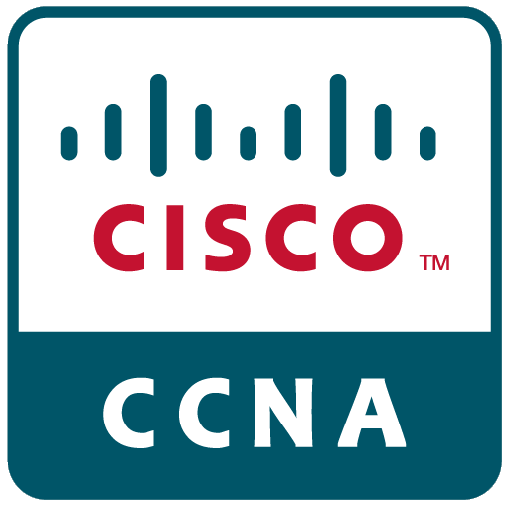 | 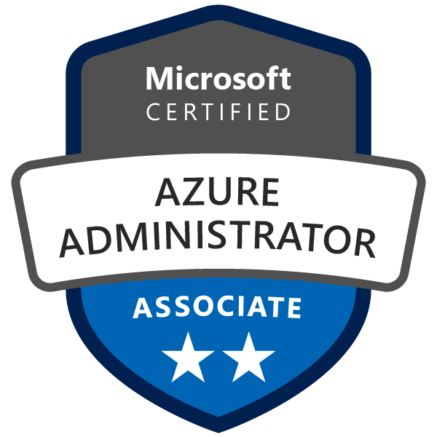 | 
 | https://www.linkedin.com/in/bcs-gerson-ramirez
 | https://github.com/antillgrp
I am professional with more than ten years of experience in many different IT areas, such as software development, systems and networking.

!! Federal ACTIVE Department of Commerce (DoC) Moderate Background Investigation (MBI) Public Trust Clearance.
To inquire further regarding verification of clearance, please contact Census Investigative Services (CIS).

Education and Certifications
Majors | - Master of Science in Software Development at Maryville University of St. Louis.  (GPA: 4.0 (Gerson_Unofficial_Transcript_8_26_2020.pdf))  - Bachelor’s in Computer Science (07/2009)
Official Certifications:  - Object Oriented Application Development in JAVA  (Certification Number: R073015600232)  - ReactJS with Redux Certification  (Certification Number: BT4Y8AVC)  - Cisco Certified Network Associate ( CCNA )  (Certificate Verification Number: Q58VEEDPF3RQQPG1)  - Microsoft Certified Azure Administrator Associate  (Certification Number: H524-5526)  - NIIT Red Had Linux System Administration  (Certification Number: 07HO-MMS-0123)  - NIIT TCP/IP and Red Had Linux Essentials  (Certification Number: 07HO-MMS-0059)  - 98-366: MTA: Networking Fundamentals |  | Certificates and Trainings:  - CDW application development cross-training (6 weeks)  (C#, ASP.NET Web API, SQL SERVER, JAVASCRIPT, JQUERY)  - ( Training ) AZ-104: Microsoft Azure Administrator  - ( Training ) Certificate CISCO CCNA Training (176 Hours)  - ( Training 290 hours) Helpdesk Agent  - Microsoft WS 2008 Network Services Administration Course  - Microsoft WS 2008 Active Directory Administration Course
Software development skills and competences:

- Expertise in OOP and Functional languages like Java (Spring Boot, Hibernate, JPA, etc.), NodeJS, Python, C#, TypeScript, …
- Advanced knowledge in Backend - Frontend integration with trends opensource libraries like ReactJS (JS, TS, Redux, React-Router, React-Bootstrap, React-Material-UI, etc.), VueJS. Knowledge of web services with solid understanding of the RESTful Architecture and SOAP. Knowledgeable in full stack development, platforms, frameworks and front-end libraries, Java frameworks, .Net Framework, ASP.NET, ADO.NET, Entity Framework, NodeJS (back-end libraries like express, sequelize and many others).
- Strong knowledge Object-Oriented Paradigm, SOLID adherence and GoF Design Patterns. Comprehensive experience with Databases design and administration and DB query languages, such as MS SQL Server and MySQL. High proficiency using IDEs and debugging tools, Microsoft Visual Studio, Visual Studio Code, Eclipse, NetBeans, etc.
- Accredited certifications for Docker & Kubernetes Workshop and Spring Boot and Microservices.
- (Cert) AZ-104: Microsoft Azure Administrator and (Training) AZ-104: Microsoft Azure Administrator

IT Software/Hardware/Networking Technician skills and competences:

- Extensive experience as Server-Racks/Network-Rack Technician (Hardware, Software), computer service, technical support.
- Extensive experience as a Computer Support Technician. Network and Systems Administrator. Operating Systems, Cisco, IOS, Windows Servers OS, Linux, Unix, BSD, others.
- Network Services configuration and deployment such as Email (SMTP, POP3, IMAP), Web IIS, (LAMP STACK), NODE.JS,
- FTP Servers. Network design and Security, Firewalling. Virtualization and Cloud VmWare (esxi,VSphere), HyperV and others.

Work experience
Occupation or position held | IT Systems/Network/Hardware Technician level II Enterprise Area (06/2016 - current)
Functions and main responsibilities | - Application development cross-training (6 weeks) (C#, ASP.NET Web API, SQL SERVER, JAVASCRIPT, JQUERY)  - Install, configure troubleshoot and upgrade Server/Racks hardware, software, networks (routers/switches/wireless) and peripheral equipment.  - Deploy, configure, automatize, scripting (bash, python, PowerShell), desktop, server OS (Linux, Windows Server), and virtualization platforms (VMWare ESXi, HyperV)
Employer | CDW in configuration center.
References | Annual Performance Review 2020
…………………………………………………………………………………………………………………………………………………………………………………………………………………………… | ……………………………………………………………………………………………………………………………………………………………………………………………………………………………………………………………………………………………………………………………….………………………………………………………………………………………………………………………………………………………………………………………………………
Occupation or position held | Broadband Premises Installer (08/2015 to 06/2016) IES Residential, Inc. - Las Vegas, NV  Contact: Amaury Arencibia (Supervisor): +1-702-485-9266
……………………………………………………………………………………………………………………………………………………………………………………………………………………………… | ……………………………………………………………………………………………………………………………………………………………………………………………………………………………………………………………………………………………………………………………….………………………………………………………………………………………………………………………………………………………………………………………………………
Occupation or position held | Non-IT (02/2015 to 07/2015)
……………………………………………………………………………………………………………………………………………………………………………………………………………………………… | ……………………………………………………………………………………………………………………………………………………………………………………………………………………………………………………………………………………………………………………………….………………………………………………………………………………………………………………………………………………………………………………………………………
Occupation or position held | Non-IT (11/2014 to 07/2015) on-call
……………………………………………………………………………………………………………………………………………………………………………………………………………………………… | ……………………………………………………………………………………………………………………………………………………………………………………………………………………………………………………………………………………………………………………………….………………………………………………………………………………………………………………………………………………………………………………………………………
Occupation or position held | Computer Technician/Web Developer (01/01/2013 to 09/30/2014)
Functions and main responsibilities | - Web applications development CMS based, joomla, drupal, wordpress.  - Systems Installation and Configuration, O.Systems Windows, Linux, MacOS, Unix (FreeBSD).  - Installation and configuration of wired and wireless networks, and network equipment.  - Repairing and maintaining all sort of computer equipment.  - Remote Assistance and Customer Support.  - Huge rollouts of memory installation/upgrade, peripheral equipment swapped out (monitors, keyboards, printers)
Employer | Freelance (customers references only)
……………………………………………………………………………………………………………………………………………………………………………………………………………………………… | ……………………………………………………………………………………………………………………………………………………………………………………………………………………………………………………………………………………………………………………………….………………………………………………………………………………………………………………………………………………………………………………………………………
Occupation or position held | IT Systems and Hardware Technician/Web Developer (03/01/2011 to 12/31/2012)
Functions and main responsibilities | - Small web applications development CMS based, Joomla, Drupal, Wordpress.  - Systems Installation and Configuration, O.Systems Windows, Linux, MacOS, Unix (FreeBSD).  - Installation and configuration of wired and wireless networks, and network equipment.  - Repairing and maintaining all sort of computer equipment.  - Remote Assistance and Customer Support.  - Selling and post-sales support.
Employer | Informática Profesional de Canarias.
……………………………………………………………………………………………………………………………………………………………………………………………………………………………… | ……………………………………………………………………………………………………………………………………………………………………………………………………………………………………………………………………………………………………………………………….………………………………………………………………………………………………………………………………………………………………………………………………………
Occupation or position held | System Technician and Final User Support (06/01/10 to 07/30/10)
Functions and main responsibilities | - Small web applications development CMS based, Joomla, Drupal, WordPress.  - Member of the team in charge of the migration and deploying of “Drago” System (Unified and centralized system of health information), Canary Islands Health Service.  - Also, giving technical onsite customer support.  - Huge rollouts of memory installation/upgrade, peripheral equipment swapped out (monitors, keyboards, printers)
Employer | Arcitel Ibérica, S.A, Tenerife (Spain)
……………………………………………………………………………………………………………………………………………………………………………………………………………………………… | ……………………………………………………………………………………………………………………………………………………………………………………………………………………………………………………………………………………………………………………………….………………………………………………………………………………………………………………………………………………………………………………………………………
Occupation or position held | Dependent Technical of Cybercafe (retailer IT shop) (05/09 - 05/10)
Functions and main responsibilities | - Selling and Customer attention.  - Systems Installation and Configuration, O.Systems Windows.  - Installation and configuration of wired and wireless networks, and network equipment.  - Repairing and maintaining all sort of computer equipment.  - Remote Assistance and Customer Support.  - Huge rollouts of memory installation/upgrade, peripheral equipment swapped out (monitors, keyboards, printers)
Employer | Cybercafe Cybermar, Tenerife (Spain)
……………………………………………………………………………………………………………………………………………………………………………………………………………………………… | ……………………………………………………………………………………………………………………………………………………………………………………………………………………………………………………………………………………………………………………………….………………………………………………………………………………………………………………………………………………………………………………………………………
Occupation or position held | Network and Systems Administrator and Management Computing (04/2008 - 04/2009)
Functions and main responsibilities | - Internet enterprises services management (email, web, others)  - Administration and maintenance physical (cable, routers, switches) and logical network (active directory, users, group policy, security, databases systems, others).  - Analysis and implementation of projects (see Degree Project (Spanish)))
Employer | ICM (Instituto Cubano de la Música), Ministerio de Cultura., Havana (Cuba)
……………………………………………………………………………………………………………………………………………………………………………………………………………………………… | ……………………………………………………………………………………………………………………………………………………………………………………………………………………………………………………………………………………………………………………………….………………………………………………………………………………………………………………………………………………………………………………………………………
Occupation or position held | Network and Systems technician specialist (07/2007 to 03/2008)
Functions and main responsibilities | - Implementing, deploying and administration of mail, web and mailing list Unix servers (FreeBSD and Linux) in a dedicated Datacenter. (see Degree Project (Spanish)))  - Networking maintenance.  - Huge rollouts of memory installation/upgrade, peripheral equipment swapped out (monitors, keyboards, printers)
Employer | CUBARTE (Centro de Informática para la Cultura), Min. de Cultura, Habana (Cuba)
Communication skills | - Excellent verbal and written communication in Spanish skills both in an office environment and with external stakeholders.  - Advanced (still learning) verbal and written communication in English skills both in an office environment and with external stakeholders.  - Teamwork: I have worked many times in multidisciplinary teams, even leading, with good results.  - Good telephone manner.  - Effective time management, prioritizing skills and abilities to concurrently work with restricted deadlines.  - Self-motivated, team worker, problem-solving, can-do attitude, and excellent communication skills. Active and fast learner and researcher.  - High adaptability to new processes, latest technologies, trends.

