ANTI-PATTERN: WRONG CUTS
STATUS: ABSENT
SUMMARY (1–2 lines):
- The artifacts show multiple deployable services (e.g., adminservice, configservice, portal), but they are not decomposed solely by technical layers (presentation/business/data-access) nor by UI-page microservices as in the example.
repo_scan
RATIONALE (max 4 bullets):
- The repository’s deployable units are named and packaged around distinct system roles (e.g., apollo-configservice, apollo-adminservice, apollo-portal) rather than “presentation layer service”, “business layer service”, or “data access layer service”.
repo_scan
- Deployment descriptors explicitly treat apollo-configservice and apollo-adminservice as separate backend services with different ports/images, and apollo-portal as its own service—this does not, by itself, evidence a layer-based decomposition “following technical aspects” per the definition.
repo_scan
- The provided artifacts do not show microservices split by UI components/pages (e.g., separate services for “index”, “login”, “namespace”, “config history”), which is the concrete example pattern.
repo_scan
- Missing for a PRESENT determination: explicit evidence that the system’s microservice boundaries were created only to mirror technical layers (presentation/business/data-access) or UI pages/components, such as service naming, separate deployables per layer/page, or routing/gateway configs mapping pages to distinct services.
repo_scan
SERVICES / COMPONENTS INVOLVED:
- None identified.
ANTI-PATTERN: NANO-SERVICE
STATUS: ABSENT
SUMMARY (1–2 lines):
The provided artifacts do not show any business microservice that is “too fine-grained” with only a few operations (e.g., one operation per service as in the calculator example). The main deployable services contain many controllers/methods, while the smallest modules appear to be non-business packaging/demo/mock components.
RATIONALE (max 4 bullets):
- The main business-facing services have substantial API surface area and logic (e.g., many controllers and hundreds/thousands of methods), which contradicts “only a few operations.”
loc
- No evidence in the repository structure indicates services split along single operations (e.g., add/subtract/multiply/divide-style microservices); instead, services are grouped by broader capabilities (admin/config/portal).
repo_scan
- The smallest modules (e.g., assembly/buildtools/demo/mockserver) do not show controller-driven business APIs in the provided scan, so they cannot be verified as nanoservices implementing isolated business operations.
- To classify PRESENT, we would need explicit artifacts proving a deployable business service with only a few operations/endpoints; such evidence is not present in the provided inputs.
SERVICES / COMPONENTS INVOLVED:
- None identified.
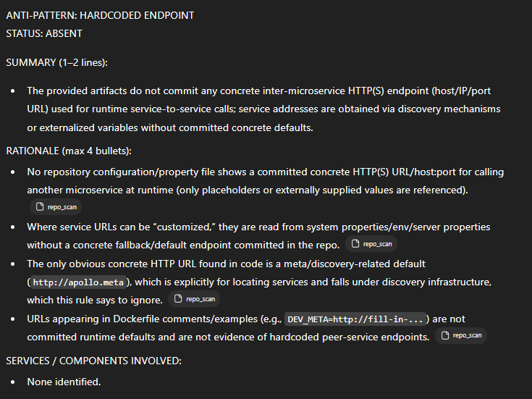

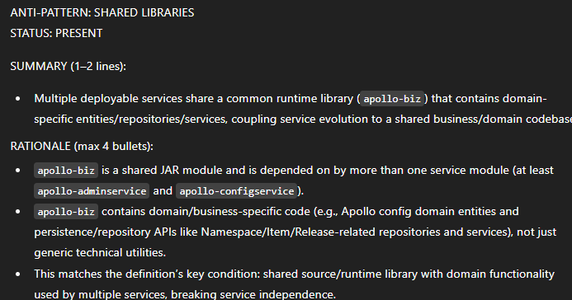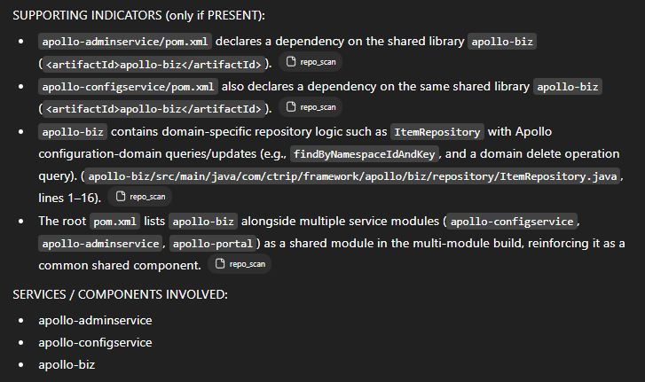
ANTI-PATTERN: MEGA-SERVICE
STATUS: ABSENT
SUMMARY (1–2 lines):
The provided artifacts show multiple separate Maven modules/services rather than a single monolithic service handling “all functionality.” While some modules are large, the required “high fan-in” evidence is not present in the inputs.
repo_scan
loc
RATIONALE (max 4 bullets):
- The definition requires both a “high number of lines/modules/files” and “high fan-in”; the artifacts include LOC/files counts but provide no verifiable fan-in (e.g., call graph, inbound dependency map, service-to-service routing, API gateway routes, or client/service consumption evidence).
loc
- The repository is structured into multiple distinct modules (e.g., apollo-adminservice, apollo-configservice, apollo-portal, etc.), which does not match the example of a single monolithic service attempting to handle all business logic in one codebase.
repo_scan
- Large size alone (e.g., apollo-portal with many files/LOC) is insufficient under the provided definition without demonstrable high fan-in and clear evidence it combines multiple functionalities that should be split into multiple services.
loc
- Missing/ambiguous for strict detection: any artifacts that quantify or demonstrate fan-in (who calls which service, number of consumers per service, gateway configs, service mesh telemetry, dependency graphs, or inter-service client usage).
repo_scan
SERVICES / COMPONENTS INVOLVED:
- None identified.

ANTI-PATTERN: SHARED PERSISTENCY
STATUS: PRESENT
SUMMARY (1–2 lines):
- apollo-adminservice and apollo-configservice are both configured to connect to the same database schema (ApolloConfigDB), meaning two services access the same persistency layer and (by implication of shared JPA repositories/entities) the same tables/entities.
RATIONALE (max 4 bullets):
- Two distinct services (AdminService and ConfigService) are explicitly instructed/configured to use the same JDBC database name/schema ApolloConfigDB.
repo_scan
- The build/deployment scripts wire both services to the same datasource URL/credentials for the “config db,” indicating shared persistency rather than per-service databases.
repo_scan
- The repository includes a dedicated schema SQL for ApolloConfigDB, reinforcing that this is a single shared schema intended to be used by more than one service.
repo_scan
SUPPORTING INDICATORS (only if PRESENT):
- apollo-adminservice/src/main/docker/Dockerfile:4 shows running apollo-adminservice with SPRING_DATASOURCE_URL=".../ApolloConfigDB...".
repo_scan
- apollo-configservice/src/main/docker/Dockerfile:4 shows running apollo-configservice with SPRING_DATASOURCE_URL=".../ApolloConfigDB...".
repo_scan
- scripts/build.sh:15 builds apollo-configservice,apollo-adminservice together while passing the same -Dspring_datasource_url=$apollo_config_db_url (same config DB datasource parameters) to both.
repo_scan
- scripts/sql/apolloconfigdb.sql:10–11 defines CREATE DATABASE ... ApolloConfigDB; Use ApolloConfigDB;, matching the shared datasource target used by both services.
repo_scan
SERVICES / COMPONENTS INVOLVED:
- apollo-adminservice
- apollo-configservice

ANTI-PATTERN: NO API VERSIONING
STATUS: PRESENT
SUMMARY (1–2 lines):
- One or more services expose REST endpoints on unversioned paths (e.g., /apps/..., /configfiles, /envs) with no visible path/header/query-based versioning in the provided artifacts.
repo_scan
RATIONALE (max 4 bullets):
- The definition is satisfied if any service exposes REST APIs to clients without versioning; multiple controllers define endpoints directly under non-versioned base paths.
- Apollo Admin Service exposes endpoints like GET /apps/.../commit and POST/GET /apps/{appId}/accesskeys (no /v1 or other version marker).
- Apollo Config Service exposes endpoints under @RequestMapping("/configfiles") (no version marker).
repo_scan
- Apollo Portal exposes unversioned REST endpoints such as @RequestMapping("/envs") (even though a separate OpenAPI surface is versioned under /openapi/v1).
SUPPORTING INDICATORS (only if PRESENT):
- apollo-adminservice: CommitController defines @GetMapping("/apps/{appId}/clusters/{clusterName}/namespaces/{namespaceName}/commit") (unversioned path).
repo_scan
- apollo-adminservice: AccessKeyController defines endpoints like @PostMapping("/apps/{appId}/accesskeys") and @GetMapping("/apps/{appId}/accesskeys") (unversioned path).
repo_scan
- apollo-configservice: ConfigFileController uses @RequestMapping("/configfiles") as its base path (unversioned).
repo_scan
- apollo-portal: EnvController uses @RequestMapping("/envs") (unversioned), while OpenAPI controllers explicitly show a versioned base path (/openapi/v1/...).
SERVICES / COMPONENTS INVOLVED:
- apollo-adminservice
- apollo-configservice
- apollo-portal

ANTI-PATTERN: NO HEALTH CHECK
STATUS: ABSENT
SUMMARY (1–2 lines):
The repository explicitly implements and uses health-check mechanisms (Spring Boot HealthIndicator and /health calls), so it does not match the “none of the microservices implement health checks” condition in the definition/example.
repo_scan
RATIONALE (max 4 bullets):
- The Admin and Config services implement Spring Boot Actuator HealthIndicator, which is direct evidence of health-check support.
repo_scan
repo_scan
- The Portal exposes logic that calls .../health on discovered service instances, indicating health endpoints exist and are expected to be reachable.
repo_scan
- Deployment descriptors include Kubernetes readiness/liveness probes (including an HTTP readiness probe hitting /health for the portal), showing operational health checking is configured.
repo_scan
repo_scan
- The definition/example requires absence of health checks across microservices; these artifacts demonstrate the opposite, so the anti-pattern is not satisfied.
repo_scan
SERVICES / COMPONENTS INVOLVED:
- None identified.

ANTI-PATTERN: INSUFFICIENT MONITORING
STATUS: ABSENT
SUMMARY (1–2 lines):
The artifacts show explicit, centralized observability support (health/metrics endpoints and Prometheus/Micrometer integration, plus tracing), so the system does not match the “only simple logging and no centralized monitoring” example.
repo_scan
RATIONALE (max 4 bullets):
- The repository includes Spring Boot Actuator and exposes monitoring endpoints (health/metrics/prometheus), which directly contradicts “performance and failure … are not tracked.”
repo_scan
- Prometheus/Micrometer dependencies are present (micrometer-core and micrometer-registry-prometheus), indicating a global metrics pipeline is intended/available.
repo_scan
- Tracing-style instrumentation is used (e.g., Tracer.logEvent, Tracer.logError, and transaction-style wrapping), indicating more than “simple logging statements within each service.”
- Multiple services are configured with health endpoints (e.g., Eureka health-check URL path and management health settings), supporting service health insights.
repo_scan
SERVICES / COMPONENTS INVOLVED:
- None identified.

ANTI-PATTERN: CYCLIC DEPENDENCY
STATUS: ABSENT
SUMMARY (1–2 lines):
The provided artifacts show several one-way inter-service calls, but no cyclic chain where two or more services depend on each other directly or indirectly.
apollo--de05540_json_architectu…
RATIONALE (max 4 bullets):
- The only explicit inter-service call relationships provided are one-directional (e.g., apollo-biz → apollo-configservice, apollo-adminservice → apollo-configservice).
apollo--de05540_json_architectu…
- No reverse or indirect return-path dependencies are described that would complete a cycle (e.g., apollo-configservice → apollo-biz/adminservice/...).
apollo--de05540_json_architectu…
- While the repository contains multiple modules/services, the artifacts do not provide verified cross-service call mappings beyond the listed information_flows, so a dependency cycle is not demonstrable from the inputs.
repo_scan
SERVICES / COMPONENTS INVOLVED:
- None identified.

