ANTI-PATTERN: WRONG CUTS
STATUS: ABSENT
SUMMARY (1–2 lines):
The repository does not show microservices split purely by technical layers (presentation vs business vs data-access) or by individual UI components/pages; instead, it contains infrastructure services plus a UI app and backend services with layered code kept inside a single service.
repo_scan
RATIONALE (max 4 bullets):
- No evidence of separate microservices dedicated exclusively to “presentation layer”, “business layer”, and “data access layer”; e.g., cloud-simple-service contains controller/service/storage code within the same module rather than split into separate services.
repo_scan
- The UI is implemented as one service (cloud-simple-ui) that calls a backend (cloud-simple-service), but this is not the example’s “UI-component-per-page microservices” decomposition (only a single UI service is present).
repo_scan
- Routing shows service-level separation (UI service and backend services) via Zuul, not per UI page/component microservices.
repo_scan
- The remaining modules are platform/infrastructure components (gateway, config server, discovery, tracing, Hystrix) and do not indicate “wrong cuts” by application-layer slicing.
repo_scan
SERVICES / COMPONENTS INVOLVED:
- None identified.

ANTI-PATTERN: NANO-SERVICE
STATUS: PRESENT
SUMMARY (1–2 lines):
The repository contains microservices that expose only a single trivial operation (e.g., “hello” or a constant string response), yet are deployed and routed as separate services, matching the “too fine-grained / few operations” nanoservice definition.
RATIONALE (max 4 bullets):
- At least two deployable services implement only one HTTP endpoint each, indicating “only a few operations” and very fine-grained service boundaries.
- These minimal services still participate in microservice infrastructure (Eureka discovery, OAuth2 resource server, Zuul routing), creating clear communication/maintenance overhead relative to their tiny utility.
- A separate RPC service definition also exposes a single operation (giveMeSomeFoo), resembling the example’s “one operation per service” style.
- The system’s gateway explicitly routes to these tiny services, implying additional hops/fragmentation for minimal functionality.
SUPPORTING INDICATORS (only if PRESENT):
- cloud-dummy-service/src/main/java/cloud/dummy/service/CloudDummyService.java defines a single GET handler at / returning a greeting string (lines 18–26).
- cloud-simple-serviceB/src/main/java/cloud/simple/serviceB/controller/UserController.java defines only GET /user returning the constant "Result from simpleserviceB" (lines 6–10).
- cloud-finagle-thrift-api/src/main/thrift/foogenerator.thrift declares service FooService with exactly one method giveMeSomeFoo(i32 id) (lines 9–11).
- cloud-api-gateway/src/main/resources/application.yaml routes to cloud-simple-serviceB and dummy-service via Zuul (lines 5–6 and 10–12), adding gateway-level communication for these minimal operations.
repo_scan
SERVICES / COMPONENTS INVOLVED:
- cloud-dummy-service
- cloud-simple-serviceB
- cloud-finagle-thrift-server (via cloud-finagle-thrift-api’s single-operation FooService)
(è strutturale THRIFT, non applichiamo bene la regola rispetto a prima)
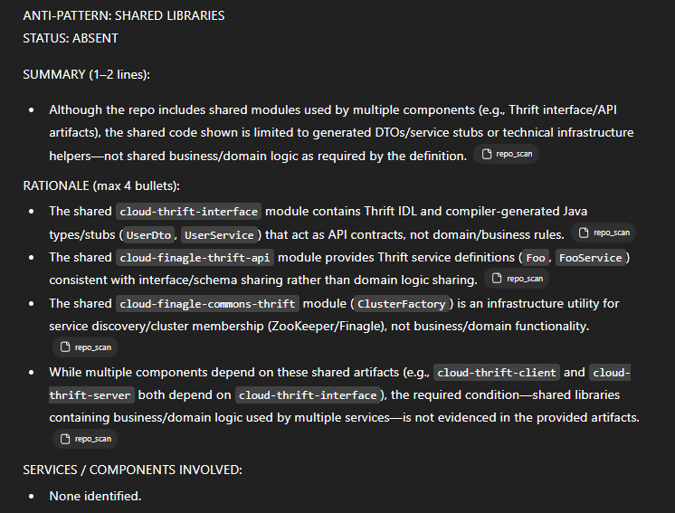
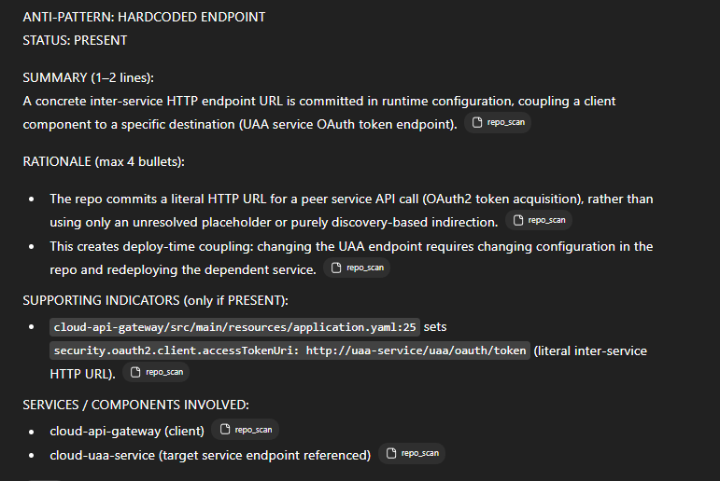

ANTI-PATTERN: MANUAL CONFIGURATION
STATUS: PRESENT
SUMMARY (1–2 lines):
- Configuration of service instances/hosts is embedded in per-service files (and some code) with hard-coded ports/URLs/hostnames, implying manual updates across services rather than automated centralized injection.
RATIONALE (max 4 bullets):
- Multiple microservices define fixed server.port and explicit service host/URL endpoints (e.g., Eureka, Zipkin) inside each service’s own config files, requiring manual edits when endpoints change.
repo_scan
- Several services hard-code the configuration-server URI (and other infra endpoints) to localhost/explicit ports, again implying manual coordination per service.
repo_scan
- Host/port configuration is also hard-coded in code for some components (e.g., ZooKeeper/Zipkin endpoints), which cannot be adjusted via centralized config without code changes.
repo_scan
- While a config server exists, the artifacts still show many runtime endpoints and ports being set directly per service, matching the anti-pattern’s “manual configuration” condition.
repo_scan
SUPPORTING INDICATORS (only if PRESENT):
- cloud-api-gateway/src/main/resources/application.yaml:2,17,39 hard-codes server.port: 8765, eureka.client.serviceUrl.defaultZone: http://localhost:8761/eureka/, and spring.zipkin.baseUrl: http://localhost:9411.
repo_scan
- cloud-dummy-service/src/main/resources/application.yml:5,8–12 hard-codes server.port: 8870 and Eureka hostname/port as localhost:8761.
repo_scan
- cloud-simple-service/src/main/resources/bootstrap.yaml:1,4,6 hard-codes config-server URI http://127.0.0.1:${config.port:8888}, Eureka URL http://localhost:8761/eureka/, and server.port: 8081.
repo_scan
- cloud-finagle-commons-thrift/src/main/java/cloud/finagle/commons/ClusterFactory.java:19–21 hard-codes ZooKeeper node new InetSocketAddress("localhost", 2181).
repo_scan
SERVICES / COMPONENTS INVOLVED:
- cloud-api-gateway
- cloud-dummy-service
- cloud-simple-service
- cloud-simple-ui
- cloud-finagle-commons-thrift (ClusterFactory / ZooKeeper endpoint)

ANTI-PATTERN: NO API GATEWAY
STATUS: ABSENT
SUMMARY (1–2 lines):
The repository includes a dedicated API gateway service that provides a centralized entry point (routing and security), so the system does not match the “no unified entry point” definition.
repo_scan
RATIONALE (max 4 bullets):
- A standalone cloud-api-gateway component exists and is configured explicitly as an API gateway/reverse proxy (Zuul).
repo_scan
- The gateway defines centralized routing rules that map external paths to underlying services, contradicting the “clients must invoke microservices directly” condition.
repo_scan
- The gateway includes centralized security configuration (OAuth2 SSO / Spring Security), indicating cross-cutting concerns are handled at the gateway.
repo_scan
SERVICES / COMPONENTS INVOLVED:
- None identified.

ANTI-PATTERN: MEGA-SERVICE
STATUS: ABSENT
SUMMARY (1–2 lines):
The provided repository is decomposed into multiple small Spring Cloud services/modules; none shows the “extreme monolithic” characteristics (very large codebase plus combined business functionalities) required by the MEGA-SERVICE definition.
repo_scan
loc
RATIONALE (max 4 bullets):
- No individual business microservice in the artifacts has a notably high number of source files/modules or very large LOC; the largest business-looking service (“cloud-simple-service”) is only 8 Java files and ~221 LOC (code).
loc
- The biggest LOC component (“cloud-thrift-interface”, ~1064 LOC code) appears to be an interface/library module (DTO/service interface + generated code), not evidence of a single deployable service implementing broad business logic.
loc
repo_scan
- High fan-in (many other services calling/dependent on one service) is a required indicator in the definition but is not directly evidenced/quantified in the provided artifacts (no complete call graph / dependency fan-in report per deployable service).
loc
- The repository structure shows multiple distinct deployables (gateway, config server, eureka, simple services, thrift client/server, UI, etc.) rather than “all functionality within a single codebase/service.”
repo_scan
SERVICES / COMPONENTS INVOLVED:
- None identified.

ANTI-PATTERN: SHARED PERSISTENCY
STATUS: ABSENT
SUMMARY (1–2 lines):
- The artifacts show database access in cloud-simple-service, but there is no concrete evidence that another microservice accesses the same database/schema/tables. Therefore, the definition/example conditions for shared persistency are not met.
RATIONALE (max 4 bullets):
- The definition requires different microservices accessing the same database/schema (often same tables/entities); the provided artifacts only show DB/table usage for one service.
repo_scan
- cloud-simple-service clearly performs SQL queries against a user table and ships a db.sql defining that table.
repo_scan
- cloud-simple-serviceB shows only a REST controller returning a static string and contains no evidenced datasource/JDBC/SQL usage in the provided artifacts.
repo_scan
- Missing/unverifiable for PRESENT: a second microservice with explicit DB connection/config pointing to the same DB/schema or explicit reads/writes to the same tables/entities.
SERVICES / COMPONENTS INVOLVED:
- None identified.

ANTI-PATTERN: NO API VERSIONING
STATUS: PRESENT
SUMMARY (1–2 lines):
- One or more services expose REST endpoints using unversioned paths (e.g., /user, /users, /) with no visible alternative versioning strategy in the provided artifacts.
RATIONALE (max 4 bullets):
- Multiple Spring MVC controllers define REST routes without a version prefix like /v1/... (matching the example pattern of unversioned paths).
- No evidence in the provided repository scan of header-based or query-parameter versioning (e.g., @RequestMapping(headers=...) / @RequestMapping(params=...) carrying version keys).
- API Gateway routes also forward to unversioned service paths, reinforcing the lack of versioned entry points.
SUPPORTING INDICATORS (only if PRESENT):
- cloud-simple-service/src/main/java/cloud/simple/service/web/UserController.java:16 defines @RequestMapping(value="/user", method=GET) (unversioned).
repo_scan
- cloud-simple-serviceB/src/main/java/cloud/simple/serviceB/controller/UserController.java:7 defines @RequestMapping(value="/user", method=GET) (unversioned).
repo_scan
- cloud-simple-ui/src/main/java/cloud/simple/web/UserController.java:14 defines @RequestMapping(value="/users") (unversioned).
repo_scan
- cloud-dummy-service/src/main/java/cloud/dummy/service/CloudDummyService.java:19–22 maps the controller to / with GET (unversioned).
repo_scan
SERVICES / COMPONENTS INVOLVED:
- cloud-simple-service
- cloud-simple-serviceB
- cloud-simple-ui
- cloud-dummy-service

ANTI-PATTERN: NO HEALTH CHECK
STATUS: ABSENT
SUMMARY (1–2 lines):
The repository does not match the “NO HEALTH CHECK” definition/example because at least some services include Spring Boot Actuator, which provides a health-check endpoint (e.g., /health) rather than having no health checks across all microservices.
repo_scan
RATIONALE (max 4 bullets):
- The anti-pattern requires that none of the microservices implement health checks; this repo includes Actuator in multiple modules, which is a direct indicator of health endpoints being available.
repo_scan
- cloud-eureka-server explicitly depends on spring-boot-starter-actuator, contradicting the “no health check anywhere” condition.
repo_scan
- cloud-thrift-client also depends on spring-boot-starter-actuator, again contradicting the definition’s required absence of health-check exposure.
repo_scan
SERVICES / COMPONENTS INVOLVED:
- None identified.

ANTI-PATTERN: INSUFFICIENT MONITORING
STATUS: ABSENT
SUMMARY (1–2 lines):
- The artifacts show explicit, centralized monitoring/observability components (Zipkin tracing + Hystrix Dashboard/Turbine), so the system does not match the “only local/simple logging with no centralized monitoring” example.
repo_scan
RATIONALE (max 4 bullets):
- A dedicated centralized tracing/monitoring service exists (cloud-zipkin with @EnableZipkinServer), contradicting the “lack a centralized monitoring system” condition.
repo_scan
- Multiple services are configured to report traces to Zipkin (spring.zipkin.baseUrl / spring.zipkin.enabled: true), indicating cross-service performance/failure tracking rather than untracked behavior.
repo_scan
- Centralized operational visibility tooling is included via Hystrix Dashboard and Turbine services in the repo and compose setup, supporting monitoring rather than “insufficient monitoring.”
repo_scan
- Docker Compose wires the monitoring components (e.g., gateway links to zipkin), demonstrating intended centralized observability deployment.
repo_scan
SERVICES / COMPONENTS INVOLVED:
- None identified.

ANTI-PATTERN: CYCLIC DEPENDENCY
STATUS: ABSENT
SUMMARY (1–2 lines):
- The provided artifacts do not show any cyclic chain of calls where two (or more) services depend on each other directly or indirectly; observed interactions are one-way (often toward infrastructural services).
spring-cloud-microservice-examp…
RATIONALE (max 4 bullets):
- No pair of services is evidenced as calling each other (A→B and B→A) in the extracted service-to-service information flows.
spring-cloud-microservice-examp…
- The only explicit bidirectional interaction is user ↔ gateway, but “user” is modeled as an external_component, not a service, so it does not satisfy the “between services” requirement in the definition/example.
spring-cloud-microservice-examp…
- Repository artifacts shown (structure + configs) do not provide concrete, citable evidence of mutual inter-service call chains forming a cycle.
repo_scan
- Missing/unverifiable from artifacts: any explicit endpoint/client code or routing evidence showing Service A depends on Service B while Service B depends (directly/indirectly) back on Service A.
spring-cloud-microservice-examp…
repo_scan
SERVICES / COMPONENTS INVOLVED:
- ABSENT: None identified.

