ANTI-PATTERN: WRONG CUTS
STATUS: PRESENT
SUMMARY (1–2 lines):
The repository structures and deploys microservices along technical layers (a dedicated web UI service and a dedicated persistence/data-access service), matching the “wrong cuts” definition of layer-based decomposition.
repo_scan
RATIONALE (max 4 bullets):
- A distinct presentation-layer microservice exists (teastore-webui), separated as its own deployable service rather than being grouped by a single business capability.
repo_scan
- A distinct data-access/persistence microservice exists (teastore-persistence), indicating a service boundary drawn around persistence concerns (a technical layer).
repo_scan
- Deployment descriptors explicitly run these layer-oriented services independently (web UI and persistence as separate services), aligning with the anti-pattern’s layer-based cut example.
repo_scan
SUPPORTING INDICATORS (only if PRESENT):
- examples/docker/docker-compose_default.yaml defines separate services persistence and webui as independently deployed components (lines 13–22 and 43–50).
repo_scan
- services/tools.descartes.teastore.webui/... contains UI servlets and JSP pages (e.g., .../servlet/*.java, .../WEB-INF/pages/*.jsp), evidencing a presentation-layer microservice boundary.
repo_scan
- services/tools.descartes.teastore.persistence/... contains repositories and persistence endpoints (e.g., .../domain/*Repository.java, .../rest/*Endpoint.java), evidencing a data-access-layer microservice boundary.
repo_scan
SERVICES / COMPONENTS INVOLVED:
- services/tools.descartes.teastore.webui (teastore-webui)
repo_scan
- services/tools.descartes.teastore.persistence (teastore-persistence)

ANTI-PATTERN: NANO-SERVICE
STATUS: ABSENT
SUMMARY (1–2 lines):
The repository shows a small set of business-oriented services (auth, image, persistence, recommender, webui), each with multiple responsibilities/endpoints and non-trivial code size, rather than extremely fine-grained “single-operation” services.
repo_scan
loc
RATIONALE (max 4 bullets):
- The system’s business services are coarse enough to cover cohesive domains (authentication/cart actions, persistence CRUD, recommendation, image handling, web UI), not one-operation-per-service as in the calculator example.
repo_scan
- Service size/complexity indicators (hundreds to thousands of LOC, dozens of classes/methods) do not match “only a few operations.”
loc
- Multiple REST components per service are present (e.g., persistence has several endpoints; recommender has multiple endpoints), contradicting “few operations.”
repo_scan
- The registry service is infrastructural (service registry) and is excluded from nano-service detection unless it implements business logic; no evidence here indicates it does.
repo_scan
loc
SERVICES / COMPONENTS INVOLVED:
- None identified.

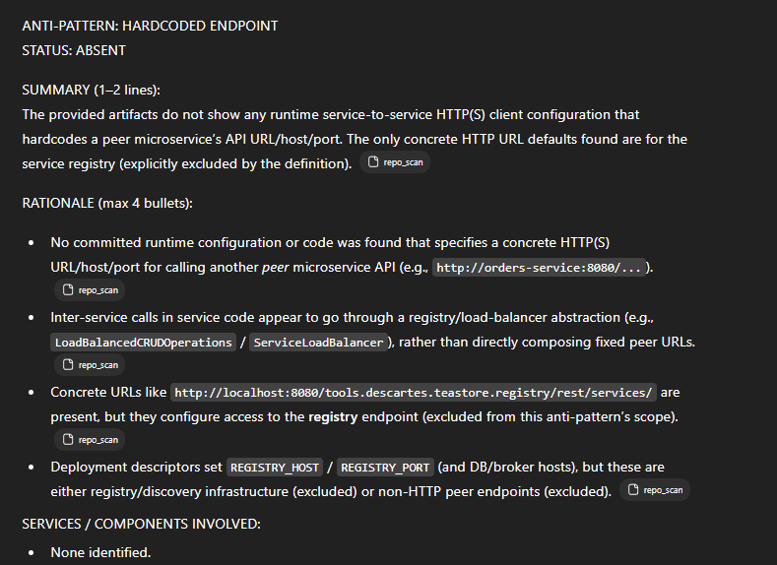
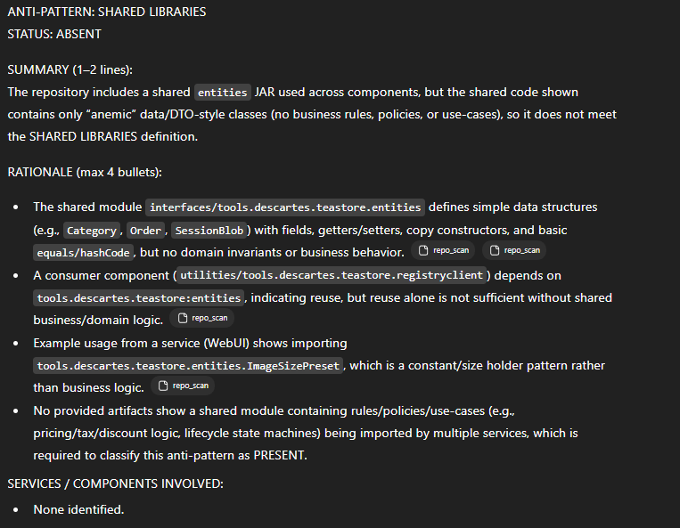

ANTI-PATTERN: MANUAL CONFIGURATION
STATUS: PRESENT
SUMMARY (1–2 lines):
The system’s service/host/port configuration is specified explicitly in deployment descriptors (e.g., Docker Compose), requiring manual edits to change endpoints like DB host/port across services.
repo_scan
RATIONALE (max 4 bullets):
- Per-service configuration (hosts, ports, registry endpoints) is hardcoded in static compose files, matching “configuration of instances, services, and hosts is done manually.”
repo_scan
- Database connectivity details (DB_HOST/DB_PORT) are manually assigned in the deployment config, aligning with the example’s “manually update a port for the database” difficulty.
repo_scan
- The artifacts show no centralized configuration server mechanism; configuration is distributed across service definitions instead.
repo_scan
SUPPORTING INDICATORS (only if PRESENT):
- examples/docker/docker-compose_default.yaml hardcodes DB host/port for the persistence service via environment variables (DB_HOST: "db", DB_PORT: "3306").
repo_scan
- examples/docker/docker-compose_default.yaml manually assigns REGISTRY_HOST and HOST_NAME per service (e.g., REGISTRY_HOST: "registry", HOST_NAME: "auth"/"image"/"recommender"/"webui").
repo_scan
- examples/docker/docker-compose_kieker.yaml repeats the same pattern and adds another manually configured dependency (RABBITMQ_HOST: "rabbitmq") across multiple services.
repo_scan
- Both compose files explicitly declare exposed/host ports (e.g., DB 3306:3306, webui 8080:8080), reinforcing manual port configuration.
repo_scan
SERVICES / COMPONENTS INVOLVED:
- registry, db, persistence, auth, image, recommender, webui, rabbitmq (kieker setup)

ANTI-PATTERN: NO API GATEWAY
STATUS: ABSENT
SUMMARY (1–2 lines):
The provided artifacts do not show clients invoking multiple microservices directly; instead, the deployment descriptors expose only a single public entry point (webui) while other services are not published to external clients.
repo_scan
RATIONALE (max 4 bullets):
- The definition requires that “clients … have to invoke its microservices directly”; the provided Docker Compose manifests publish only webui to the host, not the other microservices.
repo_scan
- Other services (auth, persistence, image, recommender, registry) are listed with expose but without host ports, which does not evidence direct external client access in these artifacts.
repo_scan
- A unified external entry point is evidenced via webui having ports: "8080:8080" in both compose variants, contradicting the “no centralized entry point” condition in the example.
repo_scan
- What’s missing to assert PRESENT: explicit evidence that external clients call multiple backend microservices directly (e.g., multiple backend services published via ports, or client code/config showing direct calls to each service).
repo_scan
SERVICES / COMPONENTS INVOLVED:
- None identified

So technically there is no API gateway component?
No dedicated “API gateway” component is visible in the provided artifacts (there’s no service/module named or configured as an API gateway).
However, the system does expose a single public entry point (webui) to external clients (Docker Compose publishes only webui on 8080:8080 while the other services are only exposed internally). That means clients are not shown (in these artifacts) to be calling multiple microservices directly—the key condition for the NO API GATEWAY anti-pattern as defined.

ANTI-PATTERN: MEGA-SERVICE
STATUS: ABSENT
SUMMARY (1–2 lines):
- The provided artifacts describe a system decomposed into multiple deployable services rather than an “extreme” single large service handling all functionality; no service is evidenced as monolithic across the whole domain.
loc
RATIONALE (max 4 bullets):
- The repository is structured as multiple microservices (e.g., auth, image, persistence, recommender, webui, registry) with separate Maven modules and Dockerfiles, which contradicts the example of “all functionality within a single codebase.”
repo_scan
- LOC and file counts per service show several mid-sized services, but nothing demonstrably “mega” in the sense of combining multiple distinct business functionalities into one monolithic service across the system.
loc
- The definition requires “high fan-in” and “high number of lines/modules/files,” but the artifacts do not provide fan-in/call graph/dependency inflow evidence to verify “high fan-in” for any single service.
loc
- No artifact explicitly indicates one service “tries to handle all functionality and business logic within a single codebase” (the given extreme example).
repo_scan
SERVICES / COMPONENTS INVOLVED:
- None identified.

ANTI-PATTERN: SHARED PERSISTENCY
STATUS: ABSENT
SUMMARY (1–2 lines):
The artifacts show a single dedicated Persistence service connecting to the MariaDB/MySQL schema (teadb), but no evidence that any other microservice directly accesses that same database/schema.
repo_scan
RATIONALE (max 4 bullets):
- The only explicit database schema and JDBC configuration shown is for the Persistence service (JPA persistence.xml points to jdbc:mysql://.../teadb).
repo_scan
- Deployment descriptors (docker-compose) pass DB_HOST/DB_PORT only to the persistence container; other services (auth/image/recommender/webui) do not receive DB connection env vars there.
repo_scan
- The database container initializes a single schema teadb, but there is no artifact showing a second microservice using JDBC/JPA or otherwise connecting to it.
repo_scan
- What’s missing to mark PRESENT: any concrete evidence (e.g., another service’s persistence.xml, JDBC URL, ORM configuration, or SQL client code) showing a second microservice accessing the same database/schema/tables.
repo_scan
SERVICES / COMPONENTS INVOLVED:
- None identified.

ANTI-PATTERN: NO API VERSIONING
STATUS: PRESENT
SUMMARY (1–2 lines):
- Multiple services expose REST endpoints using unversioned paths (e.g., /rest/services, /rest/categories, /ready/isready) with no evidence of path/header/query-based API versioning in the provided artifacts.
repo_scan
RATIONALE (max 4 bullets):
- REST resources are defined with @Path(...) values like "services", "categories", and "ready" (no /v1, /v2, etc.).
- Deployment/configuration maps Jersey under /rest/*, but does not introduce a version segment (e.g., /rest/v1/*).
repo_scan
- Repository client code adds a tracing header (KiekerTracingInfo), but nothing indicates API version negotiation via headers.
repo_scan
- Searches across the provided artifacts did not reveal versioning tokens such as /v1, X-API-Version, Accept-Version, or a version query parameter used for API version selection.
SUPPORTING INDICATORS (only if PRESENT):
- services/tools.descartes.teastore.registry/src/main/java/tools/descartes/teastore/registry/rest/RegistryREST.java line 11: @Path("services") (unversioned REST base path).
repo_scan
- services/tools.descartes.teastore.persistence/src/main/java/tools/descartes/teastore/persistence/rest/CategoryEndpoint.java line 9: @Path("categories") (unversioned REST resource).
repo_scan
- services/tools.descartes.teastore.auth/src/main/java/tools/descartes/teastore/auth/rest/ReadyRest.java line 6: @Path("ready") (unversioned REST resource).
repo_scan
- services/tools.descartes.teastore.recommender/src/main/webapp/WEB-INF/web.xml line 21: <url-pattern>/rest/*</url-pattern> (no version prefix in the REST servlet mapping).
repo_scan
SERVICES / COMPONENTS INVOLVED:
- tools.descartes.teastore.registry
- tools.descartes.teastore.persistence
- tools.descartes.teastore.auth
- tools.descartes.teastore.recommender

ANTI-PATTERN: NO HEALTH CHECK
STATUS: ABSENT
SUMMARY (1–2 lines):
The artifacts show that at least some services expose explicit readiness/health-style HTTP endpoints (e.g., /ready/isready), so the “none of the microservices implement health checks” condition from the definition/example is not satisfied.
repo_scan
RATIONALE (max 4 bullets):
- The anti-pattern requires that microservices do not expose endpoints to check health/readiness; the repository contains concrete REST endpoints explicitly named and routed for readiness.
repo_scan
- Because at least one microservice implements such a check endpoint, the system cannot match the example scenario where none of the microservices implement health checks.
repo_scan
SERVICES / COMPONENTS INVOLVED:
- None identified

ANTI-PATTERN: INSUFFICIENT MONITORING
STATUS: ABSENT
SUMMARY (1–2 lines):
The artifacts show explicit, centralized monitoring/tracing instrumentation (Kieker + Jaeger/OpenTracing) and a dedicated monitoring/log-collection component, so the system does not match the “no tracking / only simple logs” example.
repo_scan
RATIONALE (max 4 bullets):
- Central monitoring is explicitly enabled and configured (Kieker enabled=true, writers configured).
repo_scan
- Services include a request-level tracking filter that records monitoring/tracing metadata rather than relying only on ad-hoc logs.
repo_scan
- A dedicated “kieker-rabbitmq” component exists to collect/serve monitoring records, indicating a centralized monitoring setup rather than purely local logging.
repo_scan
- Distributed tracing is explicitly initialized via Jaeger/OpenTracing, which contradicts the “lack a centralized monitoring system” condition in the definition/example.
repo_scan
SERVICES / COMPONENTS INVOLVED:
- None identified.

ANTI-PATTERN: CYCLIC DEPENDENCY
STATUS: ABSENT
SUMMARY (1–2 lines):
The artifacts show multiple one-way service call dependencies (e.g., AUTH → PERSISTENCE), but no cyclic chain of calls (A → … → A) can be evidenced from the provided repository inputs.
RATIONALE (max 4 bullets):
- The extracted architecture model contains no recorded inter-service “information_flows”, so it provides no evidence of any dependency cycle.
TeaStore--e93bca7_json_architec…
- Concrete code evidence shows AUTH calling PERSISTENCE (e.g., create orders, fetch users/products), but there is no corresponding evidence of PERSISTENCE calling back into AUTH (directly or indirectly) to complete a cycle.
- Without any artifact evidence of mutual (direct) dependencies or an indirect call chain that returns to an earlier service, the definition/example requirement (“two or more services depend on each other directly or indirectly”) is not met.
- Missing/unverifiable from artifacts: any explicit outbound calls from PERSISTENCE (or other downstream services) to AUTH/WEBUI/RECOMMENDER/IMAGE that would close a dependency loop.
repo_scan
SERVICES / COMPONENTS INVOLVED:
- None identified.

So we have one-way dependencies? List them
Ragionato per 55s
Yes — there are several one-way (directed) dependencies visible in the artifacts.
Service-to-service call dependencies (REST via registryclient)
- webui → persistence (reads categories/products/users/orders via LoadBalancedCRUDOperations.getEntities/getEntity(Service.PERSISTENCE, ...))
repo_scan
repo_scan
- webui → image (fetches web images via LoadBalancedImageOperations.getWebImages/getWebImage(...))
repo_scan
- webui → recommender (calls LoadBalancedRecommenderOperations.getRecommendations(...), which load-balances to Service.RECOMMENDER)
repo_scan
repo_scan
- webui → auth (uses LoadBalancedStoreOperations.*, which load-balances to Service.AUTH)
repo_scan
repo_scan
- auth → persistence (AuthCartRest loads products via LoadBalancedCRUDOperations.getEntity(Service.PERSISTENCE, "products", ...))
repo_scan
Deployment/runtime “infrastructure” dependencies (from docker-compose / k8s)
- persistence → db (DB_HOST=db, DB_PORT=3306)
repo_scan
- auth → registry, image → registry, recommender → registry, webui → registry, persistence → registry (REGISTRY_HOST=...)
repo_scan
repo_scan
- auth → rabbitmq, image → rabbitmq, recommender → rabbitmq, webui → rabbitmq, persistence → rabbitmq (RABBITMQ_HOST=...)
repo_scan
repo_scan
_

