3. SQL PLAYBOOK — BigQuery → Redshift → Snowflake
My SQL playbook for the Lead Analytics Engineer 90-min technical round.
Every pattern shows BigQuery (my native dialect), Redshift, and Snowflake equivalents, ordered simple → medium → hard.
Companion docs: 1_GATHER_CONTEXT.md (facts), 2_FOCUS_CONTEXT.md (plan).

How to use this
- Match the interviewer's words to a pattern with the cheat sheet below, then jump to that section.
- Each pattern = What it is → BigQuery → Redshift → Gotcha (when it breaks).
- Scenarios are real-company style (Amazon, Netflix, Meta, Spotify), not toy examples.
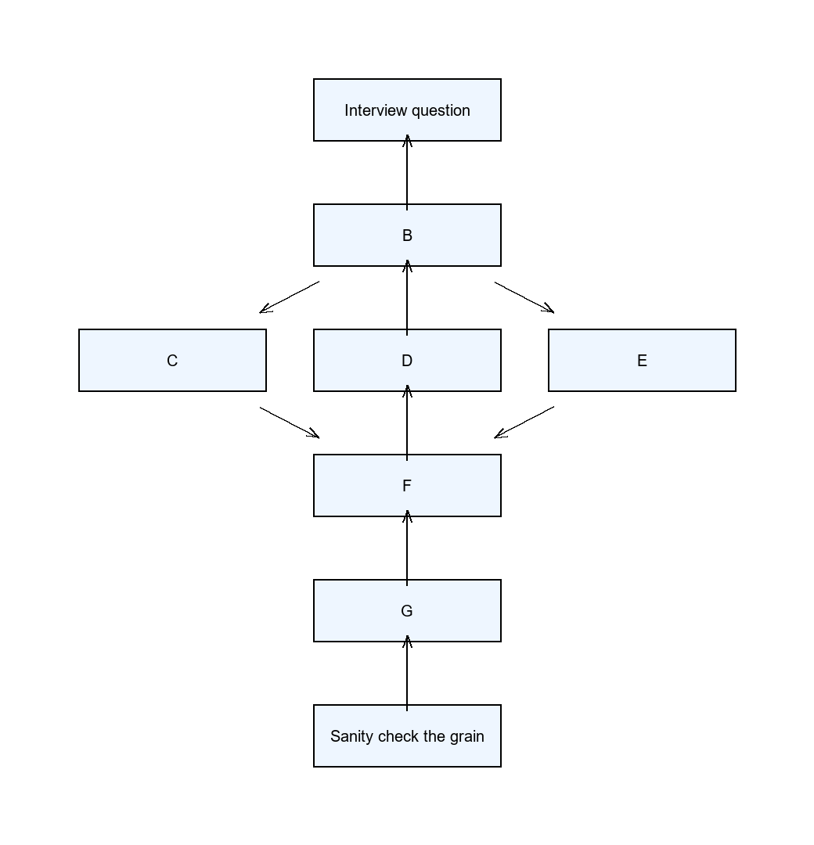

The mindset (before any query)
- Grain first — say out loud what one output row is: "one row per user per day".
- Plan out loud — "filter to completed orders, group by week, then LAG".
- Build in pieces — small CTEs, talk as you go.
- Check — does the total reconcile? Any impossible values?
- Understand before coding (1-2 min of questions), talk while you work, prefer portable ANSI SQL, fewest table scans.

Signal phrase → pattern (cheat sheet)
If the interviewer says… | Pattern | Section
"first / second / nth highest" | Window rank (DENSE_RANK) | 2.1
"top N per group / in each department" | ROW_NUMBER() OVER (PARTITION BY …) | 2.4
"rolling" / "cumulative" / "moving average" | Window frame (ROWS BETWEEN) | 2.3
"compare to previous day / week-over-week" | LAG | 2.2
"users who have no X / never did Y" | Anti-join (LEFT JOIN … IS NULL) | 1.2
"count multiple things with a condition" | COUNTIF / SUM(CASE WHEN) | 1.4
"X by country / metric by dimension" | GROUP BY | 1.1
"deduplicate / keep the latest per key" | QUALIFY ROW_NUMBER() = 1 | 2.5
"consecutive / streak / find gaps" | Gaps-and-islands | 3.1
"funnel / conversion path" | Conditional aggregation + CTE | 3.3
"retention by signup cohort" | Cohort self-join | 3.4
"nested / repeated fields" | UNNEST (BQ) / SUPER (RS) | 3.5

1. Simple patterns

1.1 Joins & grain
What it is: JOIN combines rows from two tables on a key. Grain = what one row of a table/result means (e.g. "one row per order line").
Why it matters: joining two tables at different grains double-counts rows. State the grain before you join.
Join | Keeps
INNER | only rows that match in both
LEFT | all left rows + matches from right
RIGHT | all right rows + matches from left
FULL OUTER | all rows from both
Scenario (Amazon): "Revenue by customer segment, including segments with zero orders."
-- BigQuery AND Redshift (ANSI, identical)
SELECT
s.segment,
COALESCE(SUM(o.amount), 0) AS revenue
FROM segments s
LEFT JOIN orders o ON o.segment_id = s.id
GROUP BY s.segment;
Gotcha: putting a filter on the right table in WHERE silently turns a LEFT JOIN into an INNER JOIN. Right-table filters go in the ON clause:
-- WRONG: drops segments with zero orders
LEFT JOIN orders o ON o.segment_id = s.id
WHERE o.status = 'paid'
-- RIGHT: keep the LEFT semantics
LEFT JOIN orders o ON o.segment_id = s.id AND o.status = 'paid'

1.2 Anti-join / "find missing"
What it is: rows that have no match in another table — "users who have no friends", "users who never ordered".
Three ways, in order of preference:
-- 1) BEST: LEFT JOIN + IS NULL (BigQuery AND Redshift)
SELECT u.user_id
FROM users u
LEFT JOIN friends f ON u.user_id = f.user_id
WHERE f.user_id IS NULL;
-- 2) FAST: NOT EXISTS (short-circuits on first match)
SELECT u.user_id
FROM users u
WHERE NOT EXISTS (SELECT 1 FROM friends f WHERE f.user_id = u.user_id);
-- 3) AVOID: NOT IN (breaks if the subquery returns NULL)
SELECT user_id FROM users
WHERE user_id NOT IN (SELECT user_id FROM friends);
Gotcha: NOT IN returns no rows if the subquery contains a NULL. Always prefer NOT EXISTS or LEFT JOIN … IS NULL.

1.3 CTEs (Common Table Expressions)
What it is: a WITH block = a named, temporary result you can reuse. It reads top-to-bottom and keeps big queries understandable.
-- BigQuery AND Redshift
WITH daily AS (
SELECT user_id, DATE(created_at) AS d, SUM(amount) AS revenue
FROM orders
GROUP BY 1, 2
)
SELECT d, SUM(revenue) AS total
FROM daily
GROUP BY d
ORDER BY d;
Why it matters: prefer a WITH over a nested subquery — it keeps your thought process visible to the interviewer.

1.4 Conditional aggregation — KEY BigQuery → Redshift → Snowflake difference
What it is: count or sum rows that match a condition, all in one pass (one table scan).
Scenario (Meta): "How many users liked, shared, and commented in one query?"
-- BigQuery: COUNTIF
SELECT
COUNTIF(event = 'like') AS likes,
COUNTIF(event = 'share') AS shares,
COUNTIF(event = 'comment') AS comments
FROM events;
-- Redshift: SUM(CASE WHEN ... THEN 1 ELSE 0 END)
SELECT
SUM(CASE WHEN event = 'like' THEN 1 ELSE 0 END) AS likes,
SUM(CASE WHEN event = 'share' THEN 1 ELSE 0 END) AS shares,
SUM(CASE WHEN event = 'comment' THEN 1 ELSE 0 END) AS comments
FROM events;
-- Snowflake: COUNT_IF (or SUM(IFF(cond, 1, 0)))
SELECT
COUNT_IF(event = 'like') AS likes,
COUNT_IF(event = 'share') AS shares,
COUNT_IF(event = 'comment') AS comments
FROM events;
Why it matters: one scan beats three WHERE event = … UNION ALL scans (fewest table scans).
Gotcha: BigQuery uses COUNTIF, Redshift uses SUM(CASE WHEN …), Snowflake uses COUNT_IF (or IFF). Know all three.

2. Medium patterns

2.1 Window functions — ROW_NUMBER / RANK / DENSE_RANK
What it is: a window function computes over a set of rows ("window") without collapsing them, unlike GROUP BY. PARTITION BY splits the window into groups; ORDER BY sets the order inside each.
The tie question (scores 100, 100, 90, 80):
Function | Output | Meaning
ROW_NUMBER() | 1, 2, 3, 4 | always unique, no gaps
RANK() | 1, 1, 3, 4 | ties share rank, skips numbers
DENSE_RANK() | 1, 1, 2, 3 | ties share rank, no gaps
Scenario (Meta/Amazon classic): "Second highest salary."
-- BigQuery AND Redshift (DENSE_RANK handles ties correctly)
SELECT salary
FROM (
SELECT salary, DENSE_RANK() OVER (ORDER BY salary DESC) AS rnk
FROM employees
)
WHERE rnk = 2;
-- Alternative without a window (portable ANSI):
SELECT MAX(salary) AS second_highest
FROM employees
WHERE salary < (SELECT MAX(salary) FROM employees);
Gotcha: use DENSE_RANK for "nth highest" (so two people tied at the top don't break "2nd"). Use ROW_NUMBER for a strict, unique pick (e.g. "top 1 per group").

2.2 LAG / LEAD (compare to previous / next)
What it is: LAG(col) = the value from the previous row; LEAD(col) = the next row. Use it for "day-over-day", "week-over-week", "compare to previous".
Scenario (Spotify): "Days where streams were higher than the previous day."
-- BigQuery AND Redshift
WITH daily AS (
SELECT DATE(listened_at) AS d, COUNT(*) AS streams
FROM listens
GROUP BY 1
)
SELECT d, streams
FROM (
SELECT d, streams, LAG(streams) OVER (ORDER BY d) AS prev
FROM daily
)
WHERE streams > prev;
Gotcha: LAG/LEAD need a deterministic ORDER BY; otherwise rows are unordered and the result is wrong.

2.3 Running totals & moving averages
What it is: cumulative sums / rolling averages over a time series. Signal words: "rolling", "cumulative", "moving average".
-- BigQuery AND Redshift (ROWS frame is identical)
SELECT
order_date,
daily_revenue,
SUM(daily_revenue) OVER (ORDER BY order_date
ROWS BETWEEN UNBOUNDED PRECEDING AND CURRENT ROW) AS running_total,
AVG(daily_revenue) OVER (ORDER BY order_date
ROWS BETWEEN 6 PRECEDING AND CURRENT ROW) AS ma_7day
FROM daily_revenue;
Gotcha: use ROWS BETWEEN … PRECEDING AND CURRENT ROW (not RANGE) for a fixed number of rows; RANGE groups ties and can give wrong rolling counts.

2.4 Top-N per group
What it is: "top 3 X in each group" — a ROW_NUMBER() partitioned by the group.
Scenario (Amazon): "Top 3 salaries per department."
-- BigQuery AND Redshift
SELECT department, employee_name, salary
FROM (
SELECT department, employee_name, salary,
ROW_NUMBER() OVER (PARTITION BY department ORDER BY salary DESC) AS rn
FROM employees
)
WHERE rn <= 3;
Gotcha: to keep ties (two people with the same top salary), use DENSE_RANK and <= 3; to pick exactly N rows, use ROW_NUMBER.

2.5 Deduplication (keep latest / earliest per key)
What it is: one row per key, keeping the newest (or oldest) record.
Scenario (Spotify): "Keep each user's latest subscription status."
-- BigQuery AND Redshift: both support QUALIFY
SELECT *
FROM subscriptions
QUALIFY ROW_NUMBER() OVER (PARTITION BY user_id ORDER BY updated_at DESC) = 1;
-- Portable version (works everywhere, incl. MySQL/Postgres):
SELECT *
FROM (
SELECT *, ROW_NUMBER() OVER (PARTITION BY user_id ORDER BY updated_at DESC) AS rn
FROM subscriptions
)
WHERE rn = 1;
Gotcha: QUALIFY filters on a window function after it's computed — it's not in MySQL, so in a "basic MySQL" screener, fall back to the subquery version.

2.6 Pivot (CASE WHEN)
What it is: turn values in one column into columns. Manual pivot = conditional aggregation with GROUP BY.
Scenario (Amazon): "Monthly revenue per department, months as columns."
-- BigQuery AND Redshift (manual pivot)
SELECT
department,
SUM(CASE WHEN month = 'Jan' THEN revenue ELSE 0 END) AS jan,
SUM(CASE WHEN month = 'Feb' THEN revenue ELSE 0 END) AS feb,
SUM(CASE WHEN month = 'Mar' THEN revenue ELSE 0 END) AS mar
FROM dept_revenue
GROUP BY department;
Gotcha: a manual pivot needs one CASE WHEN per output column — know the distinct values up front (or generate SQL dynamically).

2.7 Self-join
What it is: join a table to itself (give it two aliases). Classic for "compare a row to a related row in the same table".
Scenario (Amazon): "Employees earning more than their manager."
-- BigQuery AND Redshift
SELECT e.name AS employee
FROM employee e
JOIN employee m ON e.manager_id = m.id
WHERE e.salary > m.salary;
Gotcha: a self-join can also replicate LAG/LEAD (join on the previous key) — some teams demand pure ANSI SQL, so know this trick:
-- LAG/LEAD equivalent via self-join (portable ANSI)
SELECT a.d, a.value - b.value AS day_over_day
FROM daily a
LEFT JOIN daily b ON b.d = DATE_SUB(a.d, INTERVAL 1 DAY);

2.8 Approximate distinct count
What it is: a fast, approximate COUNT(DISTINCT …) for huge tables. Slightly imprecise, much cheaper.
-- BigQuery
SELECT APPROX_COUNT_DISTINCT(user_id) AS approx_users
FROM events;
-- Redshift
SELECT APPROXIMATE COUNT(DISTINCT user_id) AS approx_users
FROM events;
Gotcha: use it for exploratory/trend numbers, never for exact reconciliation or billing.

3. Hard patterns

3.1 Gaps-and-islands
What it is: group consecutive values into "islands" (runs) and find "gaps" between them. The trick: subtract a ROW_NUMBER() from the value — consecutive values get the same group id.
Scenario (Cinema, LeetCode): "Find all blocks of 2+ consecutive free seats."
-- BigQuery AND Redshift (integer arithmetic, identical)
WITH numbered AS (
SELECT seat_id,
seat_id - ROW_NUMBER() OVER (ORDER BY seat_id) AS grp
FROM cinema
WHERE free = 1
)
SELECT grp, MIN(seat_id) AS start_seat, MAX(seat_id) AS end_seat, COUNT(*) AS consecutive
FROM numbered
GROUP BY grp
HAVING COUNT(*) >= 2;
Scenario (gaming, dates): "Player sessions — a new session starts after 30 min of inactivity."
-- BigQuery (timestamp diff)
-- Redshift uses DATEDIFF(minute, prev_ts, event_timestamp) instead of TIMESTAMP_DIFF
WITH flagged AS (
SELECT user_id, event_timestamp,
LAG(event_timestamp) OVER (PARTITION BY user_id ORDER BY event_timestamp) AS prev_ts
FROM raw_events
)
SELECT user_id, event_timestamp,
SUM(CASE WHEN prev_ts IS NULL OR TIMESTAMP_DIFF(event_timestamp, prev_ts, MINUTE) > 30
THEN 1 ELSE 0 END)
OVER (PARTITION BY user_id ORDER BY event_timestamp) AS session_id
FROM flagged;
Gotcha: the subtract-ROW_NUMBER trick needs a stable sort; ties/duplicates break the grouping.

3.2 Consecutive sequences
What it is: find values that repeat N times in a row (using LAG twice).
Scenario (LeetCode 180): "Numbers that appear 3 times consecutively."
-- BigQuery AND Redshift
WITH c AS (
SELECT num,
LAG(num, 1) OVER (ORDER BY id) AS prev1,
LAG(num, 2) OVER (ORDER BY id) AS prev2
FROM logs
)
SELECT DISTINCT num
FROM c
WHERE num = prev1 AND num = prev2;

3.3 Funnel analysis
What it is: measure how many users move step-by-step through a path (view → cart → purchase).
Scenario (Netflix/Spotify): "Funnel: viewed → added to cart → purchased."
-- BigQuery (IF + COUNTIF)
WITH steps AS (
SELECT user_id,
MIN(IF(event = 'view', ts, NULL)) AS view_ts,
MIN(IF(event = 'cart', ts, NULL)) AS cart_ts,
MIN(IF(event = 'purchase', ts, NULL)) AS purchase_ts
FROM events
GROUP BY user_id
)
SELECT
COUNTIF(view_ts IS NOT NULL) AS viewed,
COUNTIF(cart_ts IS NOT NULL AND cart_ts > view_ts) AS added_to_cart,
COUNTIF(purchase_ts IS NOT NULL AND purchase_ts > cart_ts) AS purchased
FROM steps;
-- Redshift (CASE WHEN + SUM)
WITH steps AS (
SELECT user_id,
MIN(CASE WHEN event = 'view' THEN ts END) AS view_ts,
MIN(CASE WHEN event = 'cart' THEN ts END) AS cart_ts,
MIN(CASE WHEN event = 'purchase' THEN ts END) AS purchase_ts
FROM events
GROUP BY user_id
)
SELECT
SUM(CASE WHEN view_ts IS NOT NULL THEN 1 ELSE 0 END) AS viewed,
SUM(CASE WHEN cart_ts IS NOT NULL AND cart_ts > view_ts THEN 1 ELSE 0 END) AS added_to_cart,
SUM(CASE WHEN purchase_ts IS NOT NULL AND purchase_ts > cart_ts THEN 1 ELSE 0 END) AS purchased
FROM steps;
Gotcha: a sequential funnel requires timestamps to be ordered (step N after step N-1), not just present.

3.4 Cohort / retention analysis
What it is: group users by signup month, then measure how many stay active in later months.
Scenario (Spotify): "Monthly retention by signup cohort."
-- BigQuery
WITH cohorts AS (
SELECT user_id, DATE_TRUNC(signup_date, MONTH) AS cohort
FROM users
),
activity AS (
SELECT user_id, DATE_TRUNC(activity_date, MONTH) AS act_month
FROM events
GROUP BY 1, 2
)
SELECT c.cohort,
DATE_DIFF(a.act_month, c.cohort, MONTH) AS month_num,
COUNT(DISTINCT a.user_id) AS active_users
FROM cohorts c
JOIN activity a USING (user_id)
GROUP BY 1, 2
ORDER BY 1, 2;
-- Redshift: two differences
-- DATE_TRUNC('month', signup_date) (quoted unit, not MONTH)
-- DATEDIFF(month, c.cohort, a.act_month) (part first)
Gotcha: DATE_TRUNC syntax differs — BigQuery DATE_TRUNC(d, MONTH), Redshift DATE_TRUNC('month', d). And DATE_DIFF(a, b, X) (BQ) = DATEDIFF(x, b, a) (RS).

3.5 Nested data — ARRAY/STRUCT (UNNEST) → SUPER/JSON
What it is: a column can hold a list (ARRAY) or object (STRUCT) in BigQuery; Redshift stores these in a SUPER column.
-- BigQuery: flatten an array with UNNEST
SELECT t.user_id, item.product, item.price
FROM transactions t
CROSS JOIN UNNEST(t.items) AS item;
-- Redshift: SUPER type + PartiQL (comma-join flattens the array)
SELECT t.user_id, item.product, item.price
FROM transactions t, t.items AS item;
-- Redshift: JSON path extraction (from a SUPER/JSON column)
SELECT JSON_EXTRACT_PATH_TEXT(JSON_SERIALIZE(payload), 'user_id') AS user_id
FROM staging.raw_telemetry;
Gotcha: BigQuery flattens with UNNEST; Redshift flattens a SUPER array with a comma-join (PartiQL) or extracts fields with JSON_EXTRACT_PATH_TEXT.

3.6 Complex multi-step (nested CTEs)
What it is: chain several CTEs, one logical step per CTE, filtering/aggregating before each join.
-- BigQuery AND Redshift (pattern, not syntax)
WITH filtered AS (
SELECT * FROM orders WHERE order_date >= '2026-01-01' -- filter early
),
user_totals AS (
SELECT user_id, SUM(amount) AS total
FROM filtered
GROUP BY user_id -- aggregate before join
)
SELECT c.country, COUNT(r.user_id) AS buyers, SUM(r.total) AS revenue
FROM user_totals r
JOIN customers c ON c.user_id = r.user_id -- co-located join
GROUP BY c.country;
Gotcha: keep each CTE single-purpose — this is also how you hand readable, testable SQL to an AI agent or reviewer.

4. Optimization (onsite-style)
Your 90-min round is onsite-style: expect table scans, EXPLAIN, and physical-design questions — not just "write the query".

4.1 Fewest table scans
Rule: solve the question with the minimum number of passes over the table.
-- One scan (good): conditional aggregation
SELECT
COUNT(CASE WHEN status = 'completed' THEN 1 END) AS completed,
COUNT(CASE WHEN status = 'refunded' THEN 1 END) AS refunded
FROM orders;
-- Two scans (avoid): UNION ALL forces a second read
SELECT COUNT(*) FROM orders WHERE status = 'completed'
UNION ALL
SELECT COUNT(*) FROM orders WHERE status = 'refunded';

4.2 Query plans (EXPLAIN)
What it is: EXPLAIN shows how the database executes a query (scans, joins, sorts) without running it.
- Redshift has EXPLAIN and system views:
- svl_query_report — per-step rows, bytes, is_diskbased (spilled to disk).
- stl_explain — the plan; watch for DS_DIST_INNER / DS_DIST_ALL_NONE (data reshuffled across nodes = bad).
- BigQuery has no classic EXPLAIN; use bq query --dry_run to see bytes scanned, and the console execution graph.
The Redshift tuning sequence (4 steps):
1. svl_query_report → find is_diskbased = true or huge output_bytes (the bottleneck).
2. stl_explain → find DS_DIST_* steps (network shuffle).
3. Check the SORTKEY column is used in WHERE; run ANALYZE <table>.
4. Refactor CTEs to filter/aggregate before joining.

4.3 Redshift physical design — the BigQuery → Redshift shift
BigQuery auto-manages storage (partitioning/clustering, serverless). Redshift needs you to set physical layout manually:
Term | Definition (plain English)
DISTKEY | the column Redshift uses to decide which node stores a row — set it on the join column so joined rows live on the same node (no network shuffle)
SORTKEY | orders rows on disk so Redshift can skip blocks it doesn't need (block pruning) — set it on the time column you filter on
DISTSTYLE | how rows are spread: KEY (by DISTKEY), EVEN (round-robin), ALL (copy small dim to every node)
VACUUM / ANALYZE | housekeeping: VACUUM reclaims space + re-sorts, ANALYZE refreshes stats for the planner
-- Redshift: create a fact table tuned for user joins + date filters
CREATE TABLE fact_orders (
order_id BIGINT NOT NULL,
user_id BIGINT NOT NULL DISTKEY, -- co-locate by user
amount DECIMAL(18,2),
order_ts TIMESTAMP NOT NULL SORTKEY -- prune by date
);
ANALYZE fact_orders;
VACUUM SORT ONLY fact_orders;
Redshift has no B-tree indexes. "Add an index" is the wrong answer — the Redshift answer is "set DISTKEY/SORTKEY and ANALYZE/VACUUM".
Snowflake auto-manages storage in micro-partitions — there is no DISTKEY/SORTKEY and no VACUUM/ANALYZE. Instead, optionally define a clustering key on the columns you filter/join on (Snowflake re-clusters automatically):
CREATE TABLE fact_orders (...) CLUSTER BY (user_id, order_date);

Appendix: Dialect map (BigQuery → Redshift → Snowflake)
Concept | BigQuery | Redshift | Snowflake
Conditional count | COUNTIF(cond) | SUM(CASE WHEN cond THEN 1 ELSE 0 END) | COUNT_IF(cond)
Conditional value | IF(cond, a, b) | CASE WHEN cond THEN a ELSE b END | IFF(cond, a, b)
Approx distinct | APPROX_COUNT_DISTINCT(x) | APPROXIMATE COUNT(DISTINCT x) | APPROX_COUNT_DISTINCT(x)
String aggregate | STRING_AGG(x ORDER BY x) | LISTAGG(x, ', ') WITHIN GROUP (ORDER BY x) | LISTAGG(x, ', ') WITHIN GROUP (ORDER BY x)
Nested data | ARRAY / STRUCT + UNNEST | SUPER + PartiQL comma-join / JSON_EXTRACT_PATH_TEXT | VARIANT / ARRAY / OBJECT + FLATTEN
Dedup filter | QUALIFY ROW_NUMBER() … = 1 | QUALIFY ROW_NUMBER() … = 1 | QUALIFY ROW_NUMBER() … = 1
Date truncate | DATE_TRUNC(d, MONTH) | DATE_TRUNC('month', d) | DATE_TRUNC('month', d)
Date add | DATE_ADD(d, INTERVAL 7 DAY) | DATEADD(day, 7, d) | DATEADD(day, 7, d)
Date diff | DATE_DIFF(a, b, DAY) | DATEDIFF(day, b, a) | DATEDIFF(day, a, b)
Timestamp diff | TIMESTAMP_DIFF(a, b, MINUTE) | DATEDIFF(minute, b, a) | DATEDIFF(minute, a, b)
Query plan | bq query --dry_run | EXPLAIN + svl_query_report / stl_explain | EXPLAIN + QUERY_HISTORY

Practice checklist (from the 20 SQL questions)
- [ ] INNER vs LEFT vs FULL OUTER JOIN — say the difference out loud (1.1)
- [ ] Find duplicate rows; keep latest per key (2.5)
- [ ] Second/nth highest salary (2.1)
- [ ] RANK vs DENSE_RANK vs ROW_NUMBER ties (2.1)
- [ ] Pivot without PIVOT (2.6)
- [ ] EXPLAIN / query plan (4.2)
- [ ] Optimize a slow multi-join query (4.1, 4.3)
- [ ] HAVING vs WHERE (filter after vs before aggregation)
- [ ] NULLs in aggregation (COUNT skips NULLs; SUM of NULLs = NULL)
- [ ] Moving average (2.3)
- [ ] Top 3 per region (2.4)
- [ ] Correlated subquery vs regular subquery
- [ ] JOIN vs UNION (2.6)
- [ ] DELETE vs TRUNCATE vs DROP
- [ ] Detect outliers in SQL (e.g. values beyond N stddevs via window/percentiles)

5. dbt
What it is: dbt ("data build tool") turns your SQL files into tested, documented models in the warehouse. You write SELECT statements; dbt builds the tables/views and runs them in the right order.
How it works (the loop):
- Write SQL — you write SELECT statements in .sql files.
- Run dbt — dbt reads your code, builds the DAG, and runs SQL in order.
- Transform — SQL runs in the warehouse; data is transformed.
- Test & validate — dbt runs tests to check quality and consistency.
- Analyze & use — trusted data is ready for BI tools and dashboards.
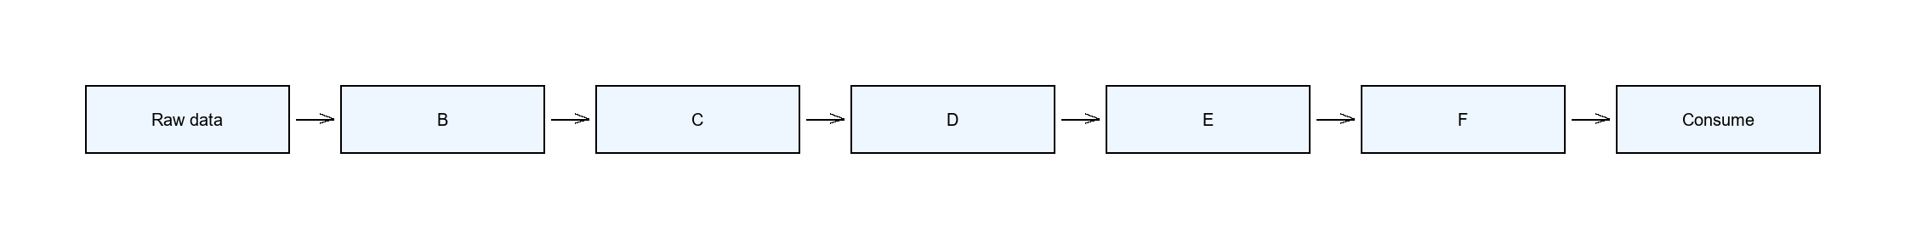
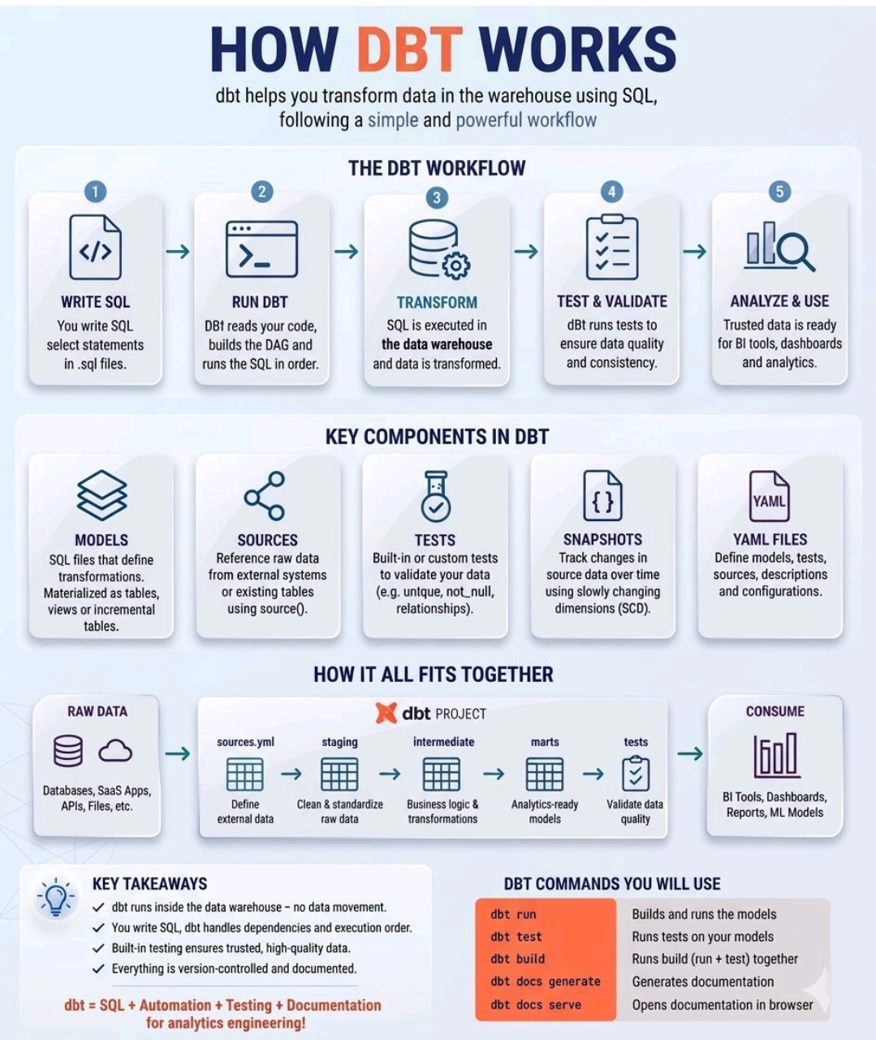

5.1 Install & setup (macOS + uv)
uv is a fast Python + package + virtual-environment manager (replaces pip + venv + pyenv).
Step | Command | What it does
Prereq: git | xcode-select --install | Install command-line tools (includes git)
Prereq: Homebrew | /bin/bash -c "$(curl -fsSL https://raw.githubusercontent.com/Homebrew/install/HEAD/install.sh)" | Package manager for macOS
Install uv | brew install uv | Install the Python/env manager
Install Python | uv python install 3.11 | Install a Python version (uv-managed)
Create env | uv venv | Create a .venv/ folder for this project
Activate | source .venv/bin/activate | Enter the environment (macOS/Linux)
Install dbt (BigQuery) | uv pip install dbt-bigquery | dbt + BigQuery adapter
Install dbt (Redshift) | uv pip install dbt-redshift | dbt + Redshift adapter
Install dbt (Snowflake) | uv pip install dbt-snowflake | dbt + Snowflake adapter
Quality tools | uv pip install dbt-checkpoint pre-commit sqlfluff sqlfluff-templater-dbt yamllint | Lint + git hooks
Init project | dbt init my_project | Scaffold dbt_project.yml, models/, macros/, seeds/
Gotcha: source .venv/bin/activate is macOS/Linux. Windows uses .venv\Scripts\activate.
Connection — ~/.dbt/profiles.yml:
# --- BigQuery ---
my_bq:
target: dev
outputs:
dev:
type: bigquery
method: oauth # or: service-account
project: my-project
dataset: my_dataset
location: US
threads: 4
# --- Redshift ---
my_rs:
target: dev
outputs:
dev:
type: redshift
host: my-cluster.redshift.amazonaws.com
port: 5439
user: my_user
password: "{{ env_var('DBT_RS_PASSWORD') }}"
dbname: my_db
schema: my_schema
threads: 4
# --- Snowflake ---
my_sf:
target: dev
outputs:
dev:
type: snowflake
account: my_account.us-east-1
user: my_user
password: "{{ env_var('DBT_SF_PASSWORD') }}"
role: my_role
warehouse: my_warehouse
database: my_db
schema: my_schema
threads: 4
Verify it works:
dbt --version # is dbt installed?
dbt debug # does the connection work?
dbt deps # install packages (e.g. dbt_utils)
dbt build # run + test everything
pre-commit install # set up git hooks

5.2 dbt commands (cheat sheet)
Command | How to run | What it does (plain English)
init | dbt init <name> | Create a new dbt project skeleton
debug | dbt debug | Test the warehouse connection
deps | dbt deps | Install packages listed in packages.yml
parse | dbt parse | Validate the project compiles (no DB access)
list | dbt list / dbt ls | List models / tests / sources
seed | dbt seed | Load CSV files from seeds/ into the warehouse
run | dbt run | Build the models (tables / views)
test | dbt test | Run the tests defined in YAML
build | dbt build | run + test + seed + snapshot in one
compile | dbt compile | Write the compiled SQL to target/ without running
snapshot | dbt snapshot | Build SCD2 snapshot tables
run-operation | dbt run-operation <macro> | Run a macro
show | dbt show -s <model> | Preview the rows a model returns
source freshness | dbt source freshness | Check if sources are stale
docs generate | dbt docs generate | Build the docs site
docs serve | dbt docs serve | Open docs locally in a browser
clean | dbt clean | Delete target/ and dbt_packages/
retry | dbt retry | Re-run only what failed last time
Selectors (run a subset):
Selector | Example | Meaning
-s | dbt run -s stg_orders | Select one model
+model | dbt run -s +stg_orders | The model + everything upstream (parents)
model+ | dbt run -s stg_orders+ | The model + everything downstream (children)
+model+ | dbt run -s +stg_orders+ | The model + both directions
@model | dbt run -s @stg_orders | Model + downstream + their upstream
2+model | dbt run -s 2+stg_orders | Limit to 2 levels upstream
tag:name | dbt run -s tag:staging | All resources with a tag
path:dir/ | dbt run -s path:models/staging/ | All resources under a path
resource_type: | dbt build --exclude resource_type:seed | Filter by node type
--exclude | dbt run --exclude stg_* | Run everything except a pattern
state:modified | dbt run -s state:modified+ --defer --state prod/ | Only what changed (Slim CI), defer unchanged refs
A few more useful flags:
Command | What it does
dbt build --full-refresh | Force incremental models to rebuild from scratch
dbt build --vars '{start_date: 2024-01-01}' | Pass run-time variables
dbt run-operation grant_select --args '{role: bi}' | Run a macro standalone (grants, admin SQL)
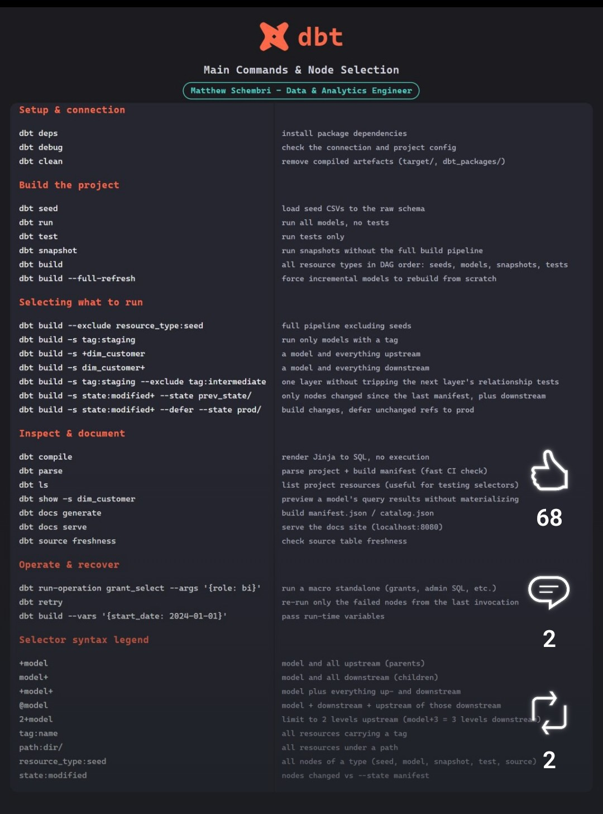

5.3 Git / terminal workflow
What it is: the branch → commit → push → rebase loop you use daily.
Task | Command | Plain English
Get latest from remote | git fetch origin | Download changes without merging
Update your main | git checkout main && git pull | Switch to main and fast-forward it
New branch (with JIRA) | git checkout -b ABC-123-add-orders-model | Create + switch to a feature branch named with the ticket
See what changed | git status / git diff | List / show uncommitted changes
Stage files | git add dbt/models/... or git add . | Mark files to commit
Commit | git commit -m "ABC-123: add stg_orders" | Save a snapshot with a message
First push | git push -u origin ABC-123-add-orders-model | Upload the branch and track it
Rebase onto main | git rebase main | Replay your commits on top of the latest main
Squash commits | git rebase -i HEAD~3 | Combine / edit the last 3 commits
Safe force-push | git push --force-with-lease | Overwrite remote only if nobody else pushed
Stash | git stash / git stash pop | Temporarily set aside / restore changes
Undo last commit | git reset --soft HEAD~1 | Undo a commit but keep the changes staged
Discard a file | git checkout -- <file> | Throw away a file's uncommitted changes
Gotcha: avoid plain git push --force (can overwrite teammates' work). Use git push --force-with-lease — it refuses if the remote changed since you last fetched.
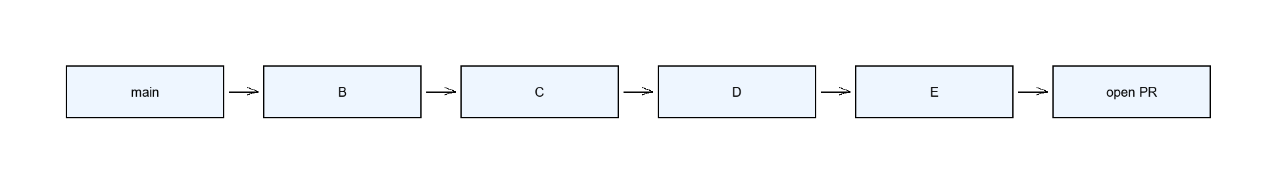

5.4 Model layers
What it is: dbt models are organized into layers. Data flows left → right, each layer adding cleanliness and meaning.
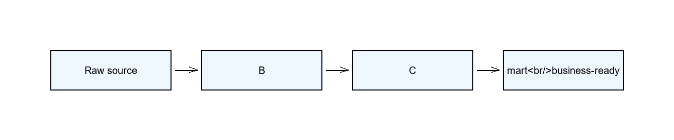
Layer | Prefix | What it does | Materialized as
Staging (dedup) | stg_<source>_<entity>s_dedup | 1:1 with raw source; remove duplicate rows | view
Staging (clean) | stg_<source>_<entity>s | Rename columns, cast types, surrogate key | incremental
Intermediate | int_<thing> | Joins + business logic across staging models | ephemeral / view
Mart | <business_name> | Business-ready tables for BI tools | table / incremental
Naming (new guidelines): do not use dim_ / fct_ prefixes. Marts are named by business purpose (e.g. orders, customer_segments), not by technical type.
Surrogate key: a single column that uniquely identifies a row, built from the natural keys:
{{ dbt_utils.generate_surrogate_key(['user_id', 'order_id']) }} AS _key_order

5.5 YAML (sources + models)
sources.yml — declare where raw data comes from:
version: 2
sources:
- name: raw_orders
database: my-project # BigQuery project (or Redshift db)
schema: raw
tables:
- name: orders
loaded_at_field: ingested_at # enables freshness checks
Model schema.yml — describe + test each model:
version: 2
models:
- name: stg_orders
description: >
Staging model for raw order data.
One row per order.
columns:
- name: _key_order
description: Surrogate primary key.
tests:
- not_null
- unique
- name: order_id
description: Source order identifier.
tests:
- not_null
- name: amount_dollars
description: Order amount rounded to 2 decimals.
Rules (from your team conventions): version: 2 at the top; minimum 2 tests per model; primary key always has not_null + unique; blank line between every column block; descriptions ≤ 150 chars per line (else use > folded style).
{% docs %} blocks (optional — for shared or long descriptions): when the same column appears in many models, or a description is long, define it once in a co-located .md file and reference it, instead of repeating the text in every model.
<!-- _orders.md -->
{% docs col_order_id %}
Unique identifier for an order. This is the grain for all order models.
{% enddocs %}
# schema.yml
columns:
- name: order_id
description: '{{ doc("col_order_id") }}'
tests:
- not_null
- unique
Why: one source of truth — update the description once and every model using {{ doc("col_order_id") }} updates with it. Works for column and table-level descriptions.

5.6 Materializations (view vs table vs incremental vs ephemeral vs raw_sql)
What it is: materialized controls how dbt stores a model in the warehouse.
Type | What happens | When to use
view | A saved query — no storage, always fresh | Staging dedup; small, cheap-to-recompute models
table | A full physical table rebuilt on every run | Marts / dimensions; medium size, needs storage speed
incremental | Only appends/updates new rows | Large fact tables; the workhorse for big data
ephemeral | Inlined as a CTE into the models that use it | Intermediate models used once — avoids a stored table
raw_sql (custom) | Runs the model's SQL verbatim — you write the CREATE/MERGE/INSERT yourself | When built-in materializations can't express the DML you need
Set it in the model's config() block:
{{ config(
materialized='incremental',
unique_key='_key_order'
) }}
Or at folder level in dbt_project.yml:
models:
my_project:
staging:
+materialized: view
marts:
+materialized: incremental
Custom materialization raw_sql (a Jinja macro — run the SQL verbatim, no auto DDL):
-- macros/materialization_raw_bq.sql
{% materialization raw_sql, adapter='bigquery' %}
{%- set identifier = model['alias'] -%}
{%- set target_relation = api.Relation.create(database=database, schema=schema, identifier=identifier) -%}
{{ run_hooks(pre_hooks) }}
{% call statement('main') -%}
{{ sql }}
{% endcall -%}
{{ run_hooks(post_hooks) }}
{{ return({'relations': [target_relation]}) }}
{% endmaterialization %}
Then use it like any materialization: {{ config(materialized='raw_sql') }}.

5.7 Incremental strategies
What it is: instead of rebuilding a huge table, only process the rows that are new or changed. dbt has 4 strategies; the two that matter for MERGE engines (BigQuery, Redshift) are delete+insert and insert_overwrite. Snowflake uses merge (default), delete+insert, or append instead of insert_overwrite.
Strategy | How it works | Use when
append | Only INSERT new rows; never touches existing rows | Append-only logs (no updates)
delete+insert | DELETE the rows being replaced (matched by unique_key), then INSERT the new versions | You need to update/overwrite existing rows (safe default)
insert_overwrite | Replace whole partitions that overlap the new data | Time-partitioned tables (cheapest, needs a partition column)
merge | One SQL MERGE (upsert) | Redshift and Snowflake default
Example 1 — delete+insert (updates existing rows, no duplicates):
{{ config(
materialized='incremental',
unique_key='_key_order',
incremental_strategy='delete+insert'
) }}
SELECT *
FROM {{ ref('stg_orders') }}
{% if is_incremental() %}
WHERE ingested_at >= (SELECT MAX(ingested_at) - INTERVAL '3 days' FROM {{ this }})
{% endif %}
- No duplicates — unique_key + delete+insert removes the old row before writing the new one.
- Late-arriving data — the - INTERVAL '3 days' lookback re-scans recent days.
- Right column — filter on ingested_at (load time), not a business-time column.
Example 2 — insert_overwrite (replace whole partitions):
{{ config(
materialized='incremental',
incremental_strategy='insert_overwrite',
partition_by={'field': 'order_date', 'data_type': 'date'}
) }}
SELECT *
FROM {{ ref('stg_orders') }}
{% if is_incremental() %}
WHERE order_date >= (SELECT MAX(order_date) - INTERVAL '3 days' FROM {{ this }})
{% endif %}
- Needs a partition column — insert_overwrite requires partition_by, or it fails.
- Late-arriving data — the lookback re-covers recent partitions.
Example 3 — advanced insert_overwrite (real production model):
{% set window_start = var('window_start_date', '') | string | trim %}
{% set start_date = modules.datetime.datetime.strptime(window_start, '%Y-%m-%d') if window_start and window_start | lower != 'none' else modules.datetime.datetime.today() %}
{% set start_date_with_healing_window = (start_date - modules.datetime.timedelta(days=var('auto_healing_window_days'))).strftime('%Y-%m-%d') %}
{{ config(
materialized = 'incremental',
incremental_strategy = 'insert_overwrite',
partition_by = {'field': '_processing_day', 'granularity': 'day', 'copy_partitions': true},
unique_key = 'order_id',
cluster_by = ['order_id']
) }}
WITH combined_orders AS (
SELECT
id AS order_id,
status AS order_status,
customer_id,
brand_flag,
dwh_modified_timestamp,
accepted_at,
DATE(_partitiontime) AS _processing_day,
CURRENT_DATETIME() AS _updated_at
FROM {{ source('order_production_append_mode_orders', 'orders') }}
WHERE status <> 'AWAITING_PAYMENT'
AND datastream_metadata.change_type <> 'DELETE'
AND DATE(_partitiontime) >= DATE('{{ start_date_with_healing_window }}')
AND DATE(_partitiontime) <= DATE('{{ var("window_end_date") }}')
UNION ALL
SELECT
id AS order_id,
status AS order_status,
customer_id,
brand_flag,
dwh_modified_timestamp,
accepted_at,
DATE(_partitiontime) AS _processing_day,
CURRENT_DATETIME() AS _updated_at
FROM {{ source('order_production_append_mode_orders', 'archive_orders') }}
WHERE DATE(_partitiontime) >= DATE('{{ start_date_with_healing_window }}')
AND DATE(_partitiontime) <= DATE('{{ var("window_end_date") }}')
)
SELECT
order_id,
order_status,
customer_id,
brand_flag,
dwh_modified_timestamp,
accepted_at,
_processing_day,
_updated_at
FROM combined_orders
WHERE combined_orders.brand_flag = 0
QUALIFY ROW_NUMBER() OVER (
PARTITION BY combined_orders.order_id
ORDER BY IF(combined_orders.dwh_modified_timestamp IS NULL, 0, 1) DESC,
combined_orders.dwh_modified_timestamp DESC,
combined_orders.order_status ASC,
IF(combined_orders.accepted_at IS NULL, 0, 1) DESC
) = 1
- Run window (Jinja) — three steps:
1. var('window_start_date') reads a run-time date (default empty).
2. strptime(..., '%Y-%m-%d') if <date passed> else datetime.today() — if a date was passed (and isn't "none"), parse it into a real date; otherwise use today. This if/else only checks "did you pass a date?" — it does not compare dates.
3. Subtract auto_healing_window_days via timedelta(days=...) to get an earlier "healing" start, then format back with strftime('%Y-%m-%d').
modules.datetime is dbt's built-in access to Python's datetime/timedelta, so all this date math happens in Jinja, not SQL.
- Heads-up — fixed vs dynamic window: a fixed window_start_date (e.g. 2024-01-01) makes every run re-read from that date onward → a growing full refresh, not incremental. For true incremental, set window_start_date and window_end_date to the run date (Airflow's {{ ds }}), so each run processes just that day + the healing lookback. Example: window_start_date = 2024-01-01, auto_healing_window_days = 60 → start_date_with_healing_window = 2023-11-02; if the start never moves, each run scans 2023-11-02 → window_end_date (growing).
Use case | window_start_date | window_end_date | What it processes
Daily incremental | {{ ds }} (run date) | {{ ds }} (run date) | just that one day (+ healing lookback)
Backfill a range | 2024-01-01 (fixed) | 2024-01-31 (fixed) | only January 2024
Open-ended (bad) | 2024-01-01 | (none) | everything from Jan 1 to "now" — grows every run
- Healing window — auto_healing_window_days re-scans N days back for late rows.
- Partition by ingestion time — DATE(_partitiontime) reads partitions directly (no MAX() scan).
- Dedup — QUALIFY ROW_NUMBER() keeps the latest row per order_id.
- CDC — datastream_metadata.change_type <> 'DELETE' drops deletes.
Diagram (the 4 strategies):
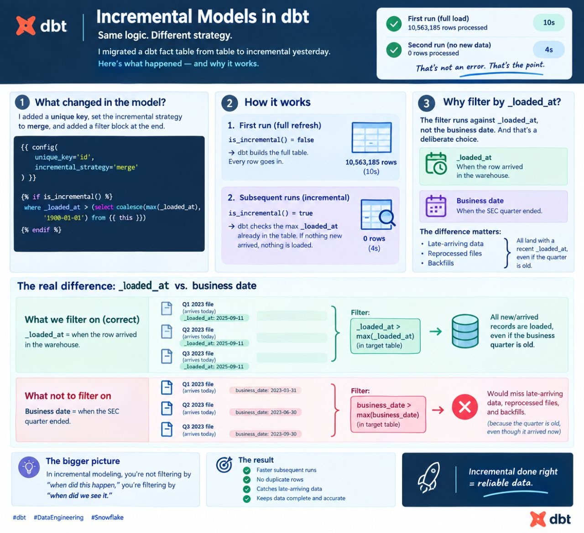
BigQuery — refresh by partition, not full scan (cost optimization):
The problem: SELECT MAX(ingested_at) FROM {{ this }} scans the whole table — expensive at 1B+ rows. BigQuery also only prunes partitions when the filter uses a literal value, not a subquery, so WHERE date >= (SELECT MAX(date) ...) scans everything anyway.
The fix: read the partition metadata (free — no data scan) instead of the data:
-- metadata only, finds which partitions changed
SELECT partition_id, last_modified_time, total_rows
FROM `project.dataset.INFORMATION_SCHEMA.PARTITIONS`
WHERE table_name = 'fct_orders'
AND last_modified_time > TIMESTAMP_SUB(CURRENT_TIMESTAMP(), INTERVAL 3 DAY);
A dbt macro injects the latest partition id as a literal:
-- macros/latest_partition.sql
{% macro latest_partition_id(relation) %}
{% set sql %}
SELECT MAX(partition_id)
FROM `{{ relation.database }}.{{ relation.schema }}.INFORMATION_SCHEMA.PARTITIONS`
WHERE table_name = '{{ relation.identifier }}'
{% endset %}
{% set result = run_query(sql) %}
{% if execute and result and result.rows | length > 0 %}
{{ return(result.rows[0][0]) }}
{% else %}
{{ return(none) }}
{% endif %}
{% endmacro %}
-- models/fct_orders.sql
{{ config(
materialized='incremental',
incremental_strategy='insert_overwrite',
partition_by={'field': 'order_date', 'data_type': 'date', 'granularity': 'day'},
require_partition_filter=true
) }}
SELECT ...
FROM {{ ref('stg_orders') }}
{% if is_incremental() %}
WHERE order_date >= '{{ latest_partition_id(this) }}'
{% endif %}
This is permanent code (not a one-off script): the macro lives in macros/ and is reused, and every dbt run executes the metadata query automatically. require_partition_filter=true makes dbt error if the partition filter is ever forgotten.
Gotcha: use the ingestion timestamp (ingested_at), not a business-time column, and always add a lookback window so late rows aren't missed.

5.8 SQL conventions (SQLFluff style)
What it is: your team's linting style, enforced by sqlfluff + pre-commit.
- 4-space indentation; SELECT, FROM, WHERE, JOIN, CAST, COALESCE in UPPERCASE.
- Identifiers lowercase; trailing commas in SELECT lists.
- CTEs over subqueries — WITH on its own line, CTE names indented 4 spaces, blank line between CTEs.
- ref() / source() only — never hardcoded table names.
- No semicolons at the end of scripts.
- Explicit AS on computed columns (SUM(amount) AS total) and table aliases (FROM {{ this }} AS source).
- Reserved words as aliases get backticks in BigQuery: day AS `date`.
- Suppress a lint rule on one line with -- noqa: L042, or all with -- noqa.
WITH
source AS (
SELECT *
FROM {{ source('raw_orders', 'orders') }}
),
renamed AS (
SELECT
order_id,
ROUND(amount / 100.0, 2) AS amount_dollars
FROM source
)
SELECT *
FROM renamed

5.9 Quality checks (run before you push)
Check | Command | What it catches
Build + test | dbt build -s "stg_orders+" | Broken SQL, failing tests
SQL lint | sqlfluff lint models/ (or sqlfluff fix) | Style violations
YAML lint | yamllint models/ | YAML formatting, long lines
Pre-commit | pre-commit run --files <file> | All hooks (dbt-checkpoint, semicolon, ref/source)
Why it matters: these are the exact gates in your CI — passing them locally means your PR won't bounce in GitHub Actions.

5.10 Advanced dbt interview scenarios (Q&A)
What it is: the real-world problems interviewers ask about, with a one-line fix for each.
# | Scenario | Simple-English solution
1 | Incremental models — load only new/changed data, no duplicates | materialized='incremental' + unique_key + an is_incremental() filter; use delete+insert so the old row is replaced (§5.7)
2 | Late-arriving data — out-of-order rows | Add a lookback window (re-scan N days) on ingested_at, not business time (§5.7)
3 | Schema evolution — renamed/removed columns | Enforce a data contract (contract.enforced + on_schema_change: fail) and alias renames in staging (§6.1)
4 | Data quality & tests — tests, thresholds, failures | Generic tests (not_null, unique, relationships, accepted_values) + custom singular tests; fail the build and alert (§6.2)
5 | Performance optimization — slow models | Partition + cluster (BQ/Snowflake) or DISTKEY/SORTKEY (Redshift); filter before joining (§4)
6 | Snapshots / CDC — track history over time | dbt snapshot with a timestamp strategy + unique_key → SCD2 (§5.2)
7 | Lineage & impact analysis — what breaks if I change X | dbt docs generate (lineage graph) + dbt ls + state:modified+ (§7.3)
8 | Macros & reusability — keep the project DRY | Write Jinja macros for repeated logic (surrogate keys, dedup, audits) (§5.5)
9 | State-aware deployments — run only what changed | dbt build -s state:modified+ --defer --state prod/ (§7.3)
10 | CI/CD & automated testing — reliable deployments | GitHub Actions runs dbt build + tests on every PR; block merge on failure (§7.3)
11 | Data contracts & docs — trust and clarity | Enforced contracts + YAML descriptions + {% docs %} blocks (§5.5, §6.1)
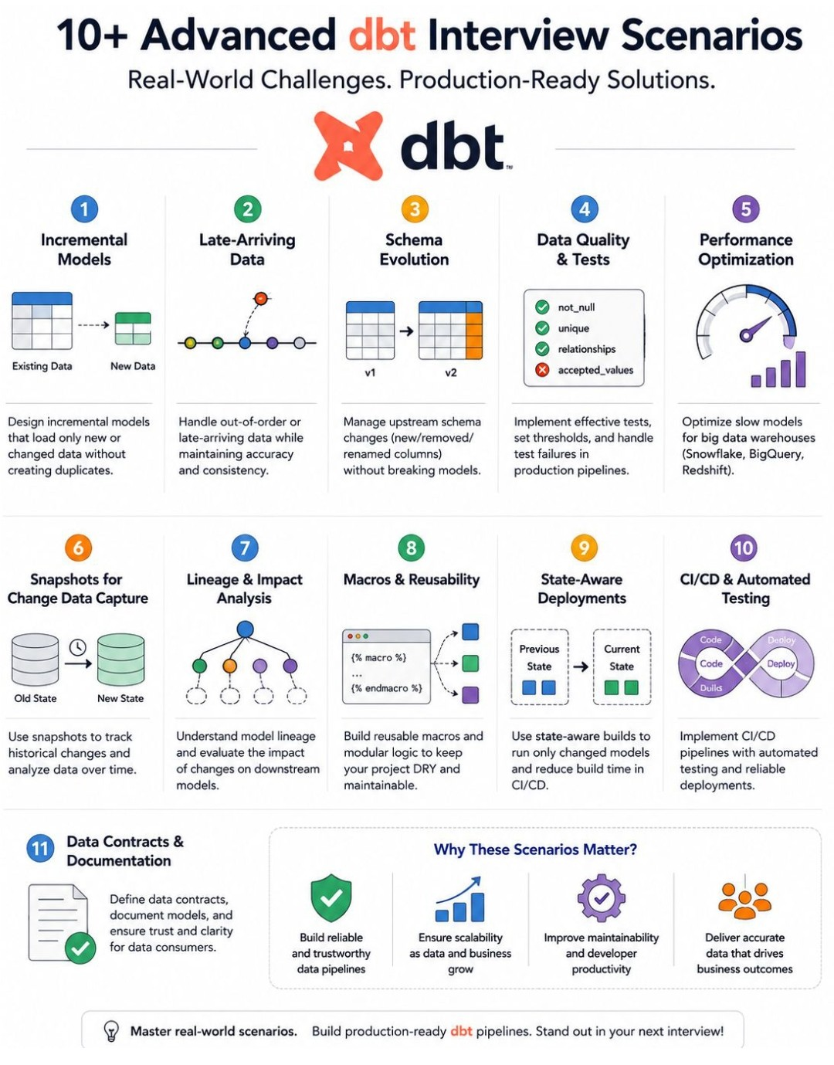

6. Data quality

6.1 Data contracts
What it is: a contract locks down a model's column names and types, so an upstream change fails the build instead of silently breaking things.
# schema.yml
models:
- name: fct_subscription_events
config:
contract:
enforced: true # check output vs these types at build time
on_schema_change: fail # fail if upstream adds/drops columns
columns:
- name: event_id
data_type: varchar(64)
tests:
- not_null
- unique
- name: amount_usd
data_type: numeric(18,2)
Why it matters: if an upstream team renames customer_id → account_id, on_schema_change: fail stops the pipeline at build time — instead of a dashboard silently showing wrong numbers.

6.2 Tests — 3 levels
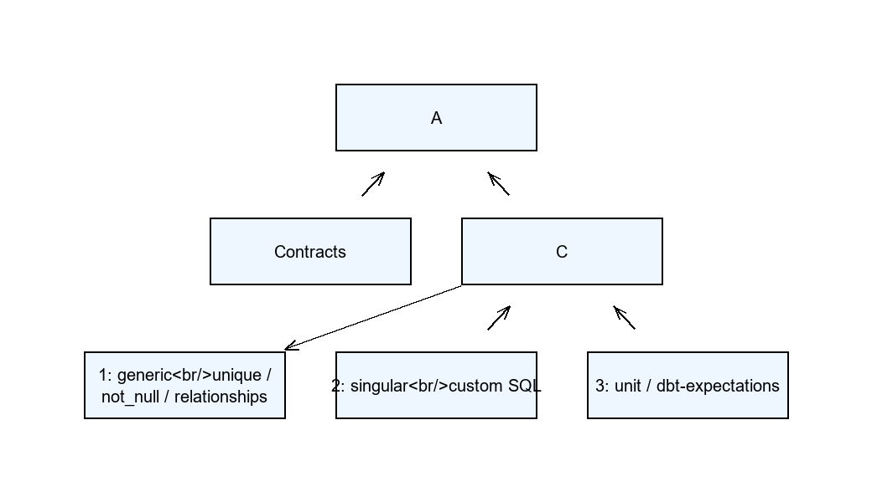
Level 1 — generic tests (built-in, declared in YAML):
columns:
- name: order_id
tests:
- not_null
- unique
- name: user_id
tests:
- relationships:
to: ref('stg_users')
field: user_id
- name: status
tests:
- accepted_values:
values: ['completed', 'refunded']
Level 2 — singular tests (custom SQL in tests/, return failing rows):
-- tests/assert_no_negative_amounts.sql
SELECT order_id
FROM {{ ref('stg_orders') }}
WHERE amount_dollars < 0
Level 3 — unit tests / dbt-expectations (richer assertions from the dbt-expectations package):
- name: amount_dollars
tests:
- dbt_expectations.expect_column_values_to_be_between:
min_value: 0
max_value: 100000
Rule of thumb: at least 2 tests per model, and the primary key always gets not_null + unique.

7. Agentic AI & CI

7.1 dbt project structure for AI agents
What it is: how to lay out a dbt repo so an AI agent (Claude Code, Cursor) can work on it safely. Your .claude folder is the template:
.claude/
agents/ # sub-agents (e.g. sql-reviewer.md — read-only reviewer)
rules/ # conventions the AI must follow
sql-conventions.md
yaml-conventions.md
dimensional-model-conventions.md
skills/ # reusable workflows (e.g. skills/develop/SKILL.md)
develop/SKILL.md
settings.json # permission allow/deny list
dbt/
models/
<domain>/
staging/dedup/
staging/clean/
intermediate/
mart/
sources.yml
dbt_project.yml
packages.yml
Why small, single-purpose models: an AI writes better SQL when each model does one thing (dedup, clean, join, aggregate) than when it must edit one giant 500-line CTE. YAML + tests give the agent "ground truth" to verify against.

7.2 Skills, agents & permissions
- Context files — CLAUDE.md (entry point) → AGENTS.md (the "brain": role, tech stack, directory structure, menu of skills).
- Skills — a SKILL.md that walks the agent through a workflow step-by-step: /develop (scaffold SQL + YAML), /test (run tests + spot-check), /deploy (commit + open PR), /check-test-failures (suggest fixes).
- Sub-agents — focused on-demand reviewers: code-reviewer (reviews SQL only), doc-reviewer (reviews YAML descriptions).
- References (lazy-loaded) — dbt-conventions.md, sql-conventions.md, yaml-conventions.md, data-warehouse.md — loaded only when the relevant task runs.
- Permissions (settings.json) — allow dbt *, sqlfluff lint/fix, yamllint, pre-commit run, git log/diff/status/branch; deny rm -rf and git push --force.
Why it matters: giving the AI explicit rules + permissions + tests means it can iterate without breaking the repo or inventing bad SQL.
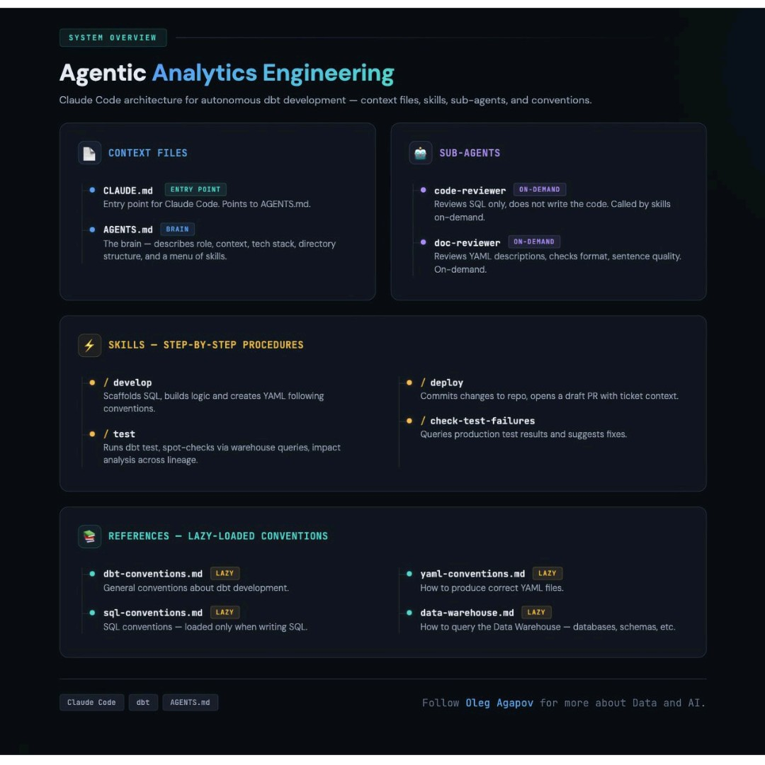

7.3 CI/CD (Slim CI)
What it is: when you open a PR, GitHub Actions runs dbt build on only the changed models (plus their downstream), against a temp schema.
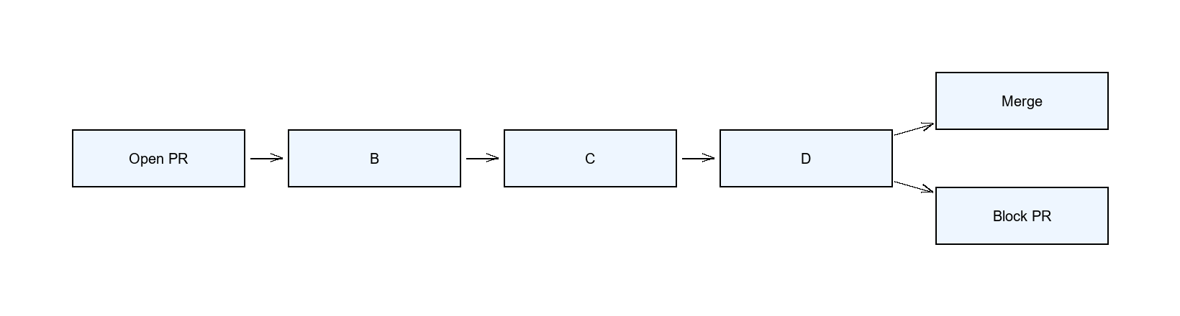
# .github/workflows/dbt_ci.yml (key steps)
- name: Run dbt Slim CI
env:
DBT_PASSWORD: ${{ secrets.DBT_PASSWORD }}
run: |
dbt deps
dbt build --target ci_schema \
--select state:modified+ \
--state ./state
Why it matters: Slim CI catches broken SQL, failing tests, and contract violations before merge — using state:modified+ so it only builds what actually changed, keeping it fast.
The full deployment flow (10 steps):
- Feature branch — create a Git branch, update models/tests/docs, run dbt build locally.
- Open a PR — trigger automated checks + peer review.
- CI kicks in — install deps, compile, run tests (pass/fail on the PR).
- Build in a PR schema — validate transformations without touching prod tables.
- Deploy to staging — validate row counts, freshness, metrics, joins.
- Reviewer approval + merge — check naming, test coverage, performance, docs.
- CD triggers prod — run dbt build in prod with state:modified+.
- Observability & alerts — track run-time spikes, freshness failures, row-count anomalies.
- Publish docs — dbt docs generate → docs site (keeps lineage updated).
- Schedule runs — hourly/daily prod jobs with SLAs and freshness expectations.
