DOCKER TUTORIALS

Run docker images
docker run hello-world.(first will search the image locally. if it is not there then will contact to docker hub and try to find out the specific image. then will download the image from hub to local machine and will create the container. post this will start the container and print the output on console.)
docker run busybox echo hi there.(it will override default command and display hi there)
docker run busybox ls.(list all floder which is present in fs snapshot image)
docker run ps.(list all running cotainer)
docker run ps --all.(list all running and stopped container)
docker run hello-world = docker create hello-world + docker start container-id
docker create hello-world. (will create the hello-wold image and return container id)
docker start -a container-id. (will start the conatiner of specific id and by -a command will return the output on terminal)
docker start container-id. (will start the container and return the container id but didnt print the output on console.)

Restart the stopped container.
first get the container-id
docker ps --all
docker start container-id (will restart the stopped container)

Removing stopped container.
docker system prune.(Will remove the all stopped container from local cache.)

Retrieving log output.
docker logs container-id.(it will print the logs of specific container-id even it is started one or stopped one.)

Stopping container.
docker stop container-id.(Will stop the conatainer. before stoppping it will try to save the file or etc with in the 10 second. if it will unable to stop the container with in 10 second then will try to kill the conatiner)

docker kill conatiner-id. (Will kill the container instantly.)

Mulit-command container or executing command with in the container.
docker run redis.(Will run the redis container)
docker exec -it container-id redis-cli.(will execute the edis-cli command on redis conatiner and will open the terminal of redis-cli)
here -it will provide the console to write the text to terminal.

docker exec -it container-id sh.(will open the terminal just like linux terminal to execute the command whatever we want to execute on container.)

Starting the container with shell.
docker run -it redis sh.(will run the conatiner and open the shell terminal to execute the command)

Create Docker image
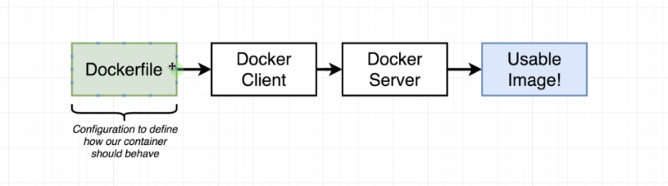
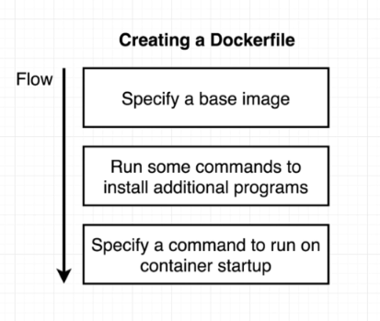

Building a Docker File
Goal :
Create an image that run redis-server.
Create the directory.
mkdir redis-image
cd redis-image
create the file name dockerFile
add the text in file as below.
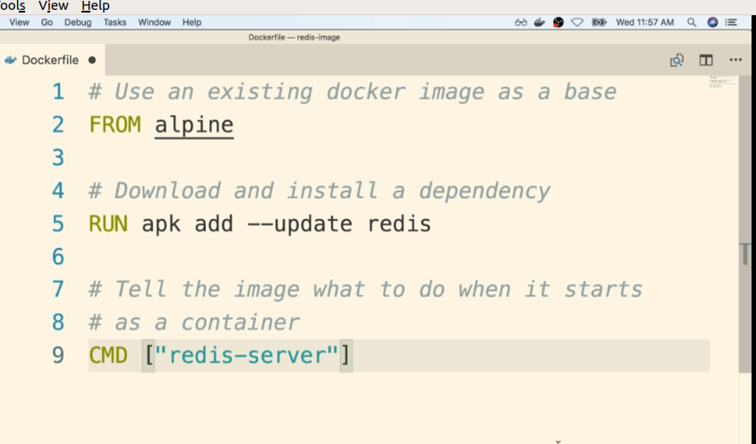

Then save the file.
Go to the directory again. Open the terminal and execute the following cmd.
Docker build .
It will build the docker image and will retur the id.
Then execute the cmd
docker run id_number

What is Base image
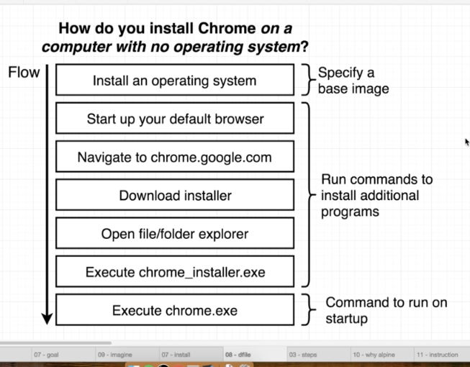

The Build process :

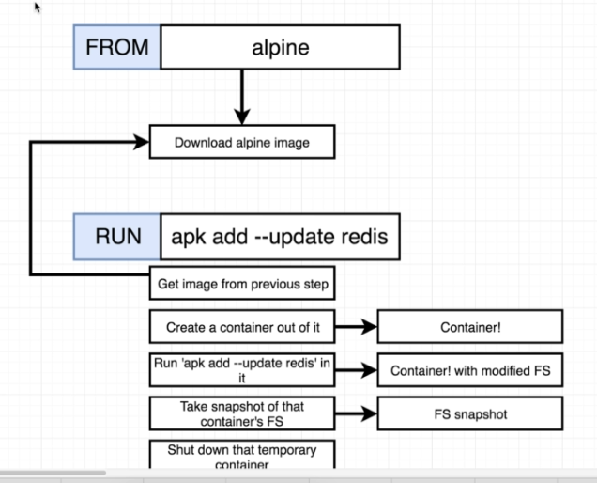

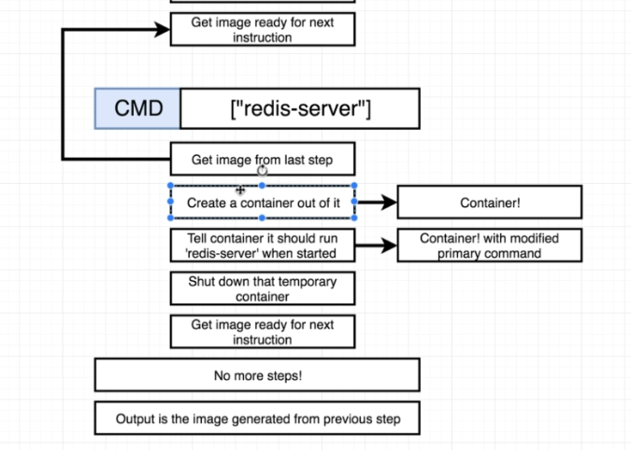

Tagging and image(Customized name of image id which is return while build process)
docker build -t dockerName/projectName:Version .
Above command will build the Dockerfile and will return the image name instead of id.
Example : sudo docker -t antique/redis:latest
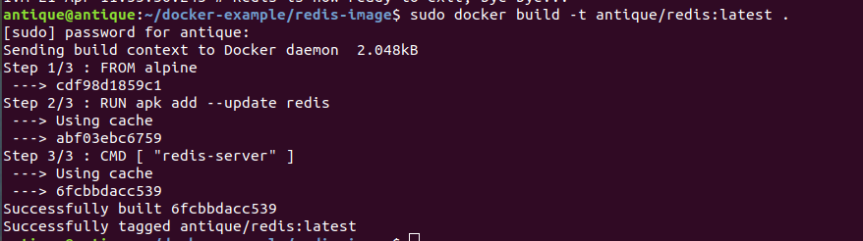

Then run the image by following cmd:
sudo docker run antique/redis

Manual Image Generation wiith Docker commit :
run the following cmd
sudo docker run -it alpine sh ENTER
apk add –update redis
it willl run the alpine container
open the other terminal
get the id of alpine by run the cmd
sudo docker ps
docker commit -c ‘CMD [“redis-server”]’ container-id
will list the image id let say abcdedf
sudo docker run abcdedf
will start the redis-server.

Deploying project with docker :
Go to project directory or Open the project with Visual studio or any ide tool.
Create the file named Dockerfile
add the following in file
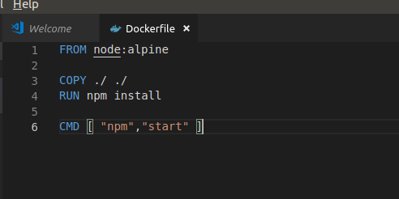

Open the terminal and execute the following cmd

sudo docker build -t antique/projectName:Version .
It will start to build the docker image with id and tagging image name.

Sudo docker run -p 8080:3000 image-id/image-name
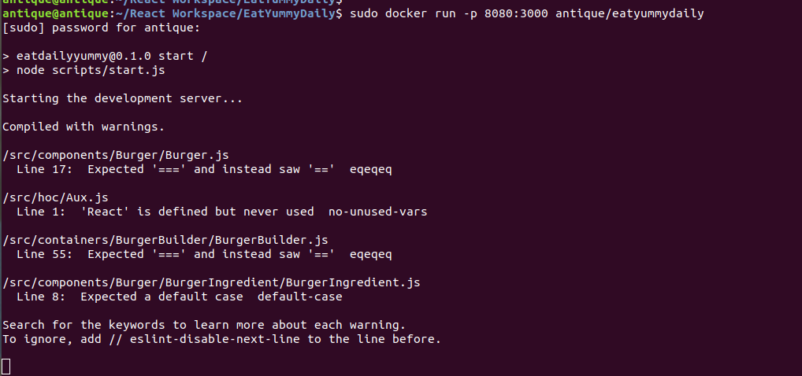

the above cmd will map the port 3000 on which project got deployed in container with the machine port 8080.
it will start the deployment on port 8080.
go to browser and call localhost:8080 will redirect to container pot on which project has deployed.

