Draft guidance on transition from GTS to WIS2

2023-09-26

|  |
| --- |
|  |
| **World Meteorological Organization** |
| Date: 2023-09-26 |
| Version: 2.0.0alpha1 |
| Document location: <https://community.wmo.int/wis2-transition-guide> |
| Standing Committee on Information Management and Technology (SC-IMT)[1] |
| Commission for Observation, Infrastructure and Information Systems (INFCOM)[2] |
| Copyright © 2023 World Meteorological Organization (WMO) |

# Preamble

## Purpose

The purpose of this document is to provide technical guidance and additional information for members to transition from GTS to WIS2, in implementing the practices, procedures, and specifications defined in the Manual on WIS (WMO No. 1060), Vol II.

## Audience

This draft guidance document is provided primarily for GTS data producers, data consumers, and service providers.

## Status of this document

This draft guidance is as an informal document. The content will be updated, modified and improved throughout the WIS2 transition phase as detailed specifications and procedures are validated through testing. The information provided herein will be consolidated into a new version of the Guide to WIS (WMO No. 1061) upon completion of the pilot phase. (TODO: validate)

# Introduction

The WMO Information System 2.0 (WIS2) will be implemented according to the schedule provided in Figure 1. A one-year pilot phase will start at the end of 2022, with several countries collaborating in building the WIS2 infrastructure. Each Country will have a different role in the WIS2 framework and will implement a specific component.

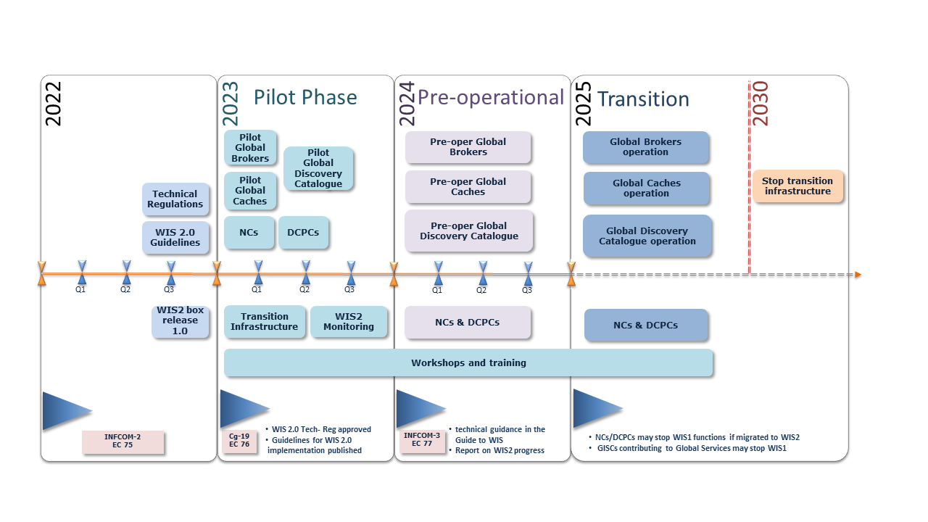

WIS2 implementation timeline

According to the WIS2 implementation plan (see figure 1), the Global Telecommunication System (GTS) will be decommissioned by 2030, and National Meteorological and Hydrological Services NMHSs will use the WIS2 platform for data exchange. During the transition period, there will be a mix of centers operating WIS2 and WIS/GTS. Some of them will be running both data-sharing frameworks simultaneously, with the difficulties associated with maintaining two operational systems for the same purpose. Therefore, a transition plan will be developed during the pilot phase, taking into account the time necessary for Members to migrate to the new systems and reducing, at the minimum, the time of parallel operation of both systems for a Member.

# Principles

The following principles are appropriate for the transition:

**Principle**1: Each NMHS will be able to make the migration during the agreed period 2025-2030:

* Considering the fact that not all centers have the same skills and facilities, and the operational aspects of WIS and the risks involved in a big-bang approach, the WIS node implementation would not be fully implemented at the same time

**Principle 2**: No GTS data loss during the transition:

* During the pilot phase, and in coordination with the regional associations and GISCs, WIS2 infrastructure will be established in order to avoid data loss during the transition. The aim of this infrastructure is to ensure that data sent on the GTS can be received by a site having migrated on WIS2, and data, previously sent on the GTS, sent on WIS2 can be received by a site still on the GTS

**Principle 3**: Each Centre will decide when decommissioning the WIS1 and GTS:

* Decommissioning WIS1 services, as well as GTS ones, will be the decision of each NC/DCPC/GISC when they will consider that their and their user’s migration is completed
* After migration to WIS2, It is not required to run an MSS to receive or send data from Centers not having made the transition. The Center will decide when and if they want to stop their Message Switching System MSS. They can also stop the data dissemination to GTS

**Principle 4**: New data (eg. GBON, Climate, Hydrology, Cryosphere) will be exchanged solely on WIS2:

* WIS2 is designed to to enable the WMO Unified Data Policy, and to support the WMO Global Basic Observing Network. The new data will be available on WIS2. A center not having made the migration to WIS2 will not receive the new data. This data will not have a GTS headers TTAAii and will not be exchanged over the GTS

# GTS to WIS2 Gateway

The Executive Council, with resolution 34 (EC-76), endorsed the WMO Information System 2 (WIS2) implementation plan and recognized the importance of establishing a pilot phase to develop the WIS2 infrastructure and begin testing it in order to be ready for a preoperational phase in 2024, and then for the transition starting on 2025. According to the WIS2 implementation plan, the Global Telecommunication System (GTS) will be decommissioned by 2030, and National Meteorological and Hydrological Services NMHSs will use the WIS2 platform for data exchange.

During the transition period, in order to avoid some WIS centres being forced to run both data-sharing frameworks simultaneously WIS2 and GTS, with the challenges associated with maintaining two operational systems for the same purpose, a gateway from GTS to WIS2 is designed, taking into account the time required for Members to migrate to the new systems and minimizing the time a member has to operate both systems in parallel.

## Purpose

The purpose of the GTS to WIS2 gateway is to enable members who have migrated to WIS2 and have stopped their GTS systems to continue receiving GTS data from WIS2. This gateway also enables users who are not connected to GTS to access GTS data, during the transition phase, from WIS2.

## GTS to WIS2 Gateway provider

The gateway will be provided by Germany’s Deutscher Wetterdienst (DWD). The Japanese Meteorological Agency (JMA) may provide a second gateway for increased sustainability and resilience.

## Technical requirements

* GTS headers SHALL be used in the WIS2 Topic Hierarchy (WTH)
* The TH for GTS data on the Global Cache (GC) SHALL be as follows:
  + cache/a/wis2/xxg/gts_to_wis2_GC-name/TTAAii
  + e.g for DWD: cache/a/wis2/xxg/gts_to_wis2_dwd/TTAAii

# WIS2 to GTS Gateway

The Executive Council, with resolution 34 (EC-76), endorsed the WMO Information System 2.0 (WIS2) implementation plan and recognized the importance of establishing a pilot phase to develop the WIS2 infrastructure and begin testing it in order to be ready for a preoperational phase in 2024, and then for the transition starting on 2025. According to the WIS2 implementation plan, the Global Telecommunication System (GTS) will be decommissioned by 2030, and National Meteorological and Hydrological Services (NMHSs) will use the WIS2 platform for data exchange.

During the transition period, in order to avoid some WIS centres being forced to run both data sharing frameworks simultaneously for WIS2 and GTS, with the challenges associated with maintaining two operational systems for the same purpose, a gateway from WIS2 to GTS will be designed during the WIS2 pilot phase, taking into account the time required for Members to migrate to the new systems and minimizing the time a member has to operate both systems in parallel.

## Purpose

The purpose of this gateway is to enable GTS members who have not yet migrated to WIS2 to continue to receive GTS data from GTS members who have migrated to WIS2 and stopped their GTS systems.

**Note**: Only data that have been already published in GTS are concerned by this gateway, New data will be available **only** on WIS2.

## WIS2 to GTS Gateway provider

The gateway will be provided by the Regional Telecommunication Hubs (RTH)

## Technical requirements

To enable the Gateway, providers to do the mapping from WIS2 to GTS, and data providers shall include in the WIS2 Notification Message (WNM) a GTS property as follows:

"properties": {  
 …  
 "gts": {  
 "ttaaii": "FTAE31",  
 "cccc": "whatever"  
 }

# References

## Normative

* WMO: Manual on WIS (WMO No. 1060), Vol II. WIS 2.0
* WMO: WMO Core Metadata Profile version 2 (WCMP2) [3]
* WMO: WIS2 Topic Hierarchy (WTH) [4]
* WMO: WIS2 Notification Message (WNM) format [5]
* WMO: WIS2 Metric Hierarchy (WMH) [6]

## Informative

* WMO: WMO Information System 2.0 Strategy (WMO No. 1213) [7]
* WMO: WMO Guidelines on Emerging Data Issues (WMO No. 1239) [8]

1. <https://community.wmo.int/governance/commission-membership/commission-observation-infrastructures-and-information-systems-infcom/commission-infrastructure-officers/infcom-management-group/standing-committee-information-management-and-technology-sc-imt>
2. <https://community.wmo.int/governance/commission-membership/infcom>
3. <https://wmo-im.github.io/wcmp2>
4. <https://github.com/wmo-im/wis2-topic-hierarchy>
5. <https://wmo-im.github.io/wis2-notification-message>
6. <https://github.com/wmo-im/wis2-metric-hierarchy>
7. <https://library.wmo.int/index.php?lvl=notice_display&id=20422>
8. <https://library.wmo.int/index.php?lvl=notice_display&id=21644>