get values 1
LOok up table for stable states 1
Physical parameters 1
Run Matlab simulation in 10 steps 2
Plot one time step simulation results: 4
Same plots for Simulink simulations 5
Plot results from closed loop simulation 7
Load data from OL simulation 8

get values
clear;
close all;
addpath(fullfile(fileparts(pwd),'dataIn'));
initModel5MWNRELBianchi;
load('workSpace.mat')
load('OutDataSweep.mat');
OutTable = array2table(OutData,'VariableNames', OutList);
idxWind = contains(OutList, 'Wind');
vectWind = OutTable{:,idxWind};
vectAmpWind = sqrt(sum((vectWind.^2),2));

LOok up table for stable states
LUT_V = 4:25;
LUT_omega = [0.4815, 0.6017,0.7217,0.8413,0.9603,1.0786,1.1949, repmat(1.2671,1,15)];
LUT_beta = [zeros(1,8),0.0642 0.1126 0.1493 0.1808 0.2093 0.2356 0.2602...
0.2833 0.3054 0.3269 0.3477 0.3676 0.3868 0.4056];
LUT_torque = [5.0870 7.9450 11.4300 15.5300 20.2400 25.5200 31.3500 ,...
repmat(43.0900,1,15)];

Physical parameters
Out: omegaG, Tg States: ThetaS, omegaR, omegaG, Tg In: beta_ref, Tg_ref; Scheduling param rho: V, beta_ref, omegaG/Ng (as approximation of omegaR)
Vbar = 4;
rb = 63; % m blade radius
G = 97;
omegabar = interp1(LUT_V,LUT_omega,Vbar);
Lambda_bar = omegabar*rb/Vbar;
beta_bar = interp1(LUT_V,LUT_beta,Vbar)/pi*180;
schedParam = [omegabar, beta_bar/180* pi, Vbar];
r(1) = interp1(LUT_V,LUT_omega,Vbar) * Ng; %
r(2) = interp1(LUT_V,LUT_torque,Vbar) * 1000;
xk = [r(1), r(2), zeros(1,4)]';
nu = 2;
N = 40;
Xko = kron(ones(N,1),xk);
mu_old = zeros(2*N*nu,1);
Rotor_cQ = Rotor_cQ(:,1:size(Rotor_Lambda,1)); lambdaVec = Rotor_Lambda;
pitchVec = Rotor_Pitch;
U = zeros(2*N,1);
cQ = Rotor_cQ;
% Test function
[u,Xko,Unew,mu,us,tictoc]= qLPVMPC_WECS_matlab(r,xk,Xko,mu_old,lambdaVec,pitchVec,cQ,schedParam,U,DT);
fprintf('Reference value from steady state r: '); fprintf('%2.3f ',r); fprintf('\n');
fprintf('Calculated input beta [rad] %2.3f\n',u(1));
fprintf('Calculated input T_g [Nm] %2.3f\n',u(2));
fprintf('Estimated states: '); fprintf('%2.3f ', Xko(1:6)); fprintf('\n');
fprintf('Estimated states next step: '); fprintf('%2.3f ', Xko((1:6) +6)); fprintf('\n');
Reference value from steady state r: 46.706 5087.000
Calculated input beta [rad] 0.000
Calculated input T_g [Nm] 5087.000
Estimated states: 46.706 5087.000 0.000 0.000 0.000 0.000
Estimated states next step: 46.706 5087.000 0.000 0.000 0.000 0.000

Run Matlab simulation in 10 steps
Call the Matlab simulation 10 times with constant scheduling parameters
% Initialize vectors and matrices for simulation
Nsim = 10;
U = zeros(2*N,1);
xDdot_Ve = NaN(Nsim+1,6);
uvec = NaN(Nsim+1,2);
Uvec = NaN(Nsim+1,80);
% Values at time 0 for simulation
xDdot_Ve(1,:) = xk;
Uvec(1,:) = U;
uvec(1,:) = [schedParam(2), Xko(2)];
nxa = length(xk);
for i = 1:Nsim
[u,Xko,U,mu,us,tictoc]= qLPVMPC_WECS_matlab(r,xk,Xko,mu_old,lambdaVec,pitchVec,cQ,schedParam,U,DT);
xk = Xko(nxa+1:2*nxa);
xDdot_Ve(i+1,:) = xk;
Uvec(i+1,:) = U;
uvec(i+1,:) = u;
end
fprintf('Calculated input beta [rad] %2.3f\n',u(1));
fprintf('Calculated input T_g [Nm] %2.3f\n',u(2));
time = 0: DT:(Nsim -1)*DT;
titleStr1 = 'Input Udot Matlab Simulation';
titleStr2 = ['State Estimates Matlab Simulation, const speed ',num2str(Vbar)];
nrPlot1 = 1;
plotInputStateTrajectories(Uvec,xDdot_Ve,time, titleStr1, titleStr2,nrPlot1);
Calculated input beta [rad] 0.000
Calculated input T_g [Nm] 5087.000
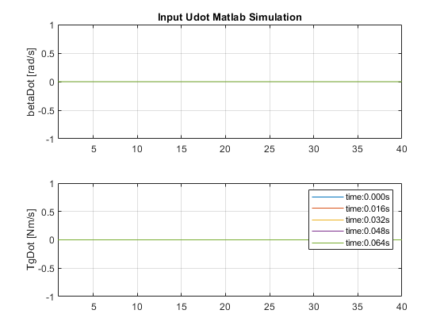
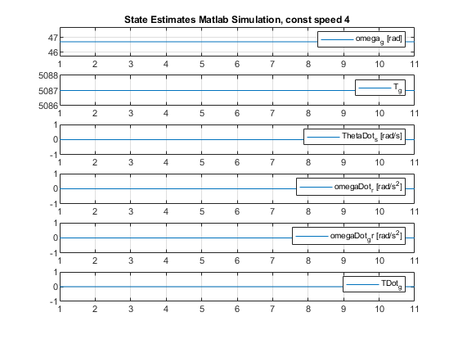

Plot one time step simulation results:
load('OutDataTestCL_LPV_01', 'xDot06','OutDataTestOL_LPV','xk06', 'u','uDot','A','B');
load('testVar','r','xk','Xk','mu_old','lambdaVec','pitchVec','cQ','schedParam','DT');
fprintf('Reference value from Simulink r: '); fprintf('%2.3f ',r); fprintf('\n');
% Initialize vectors and matrices for simulation
Nsim = 10;
U = zeros(2*N,1);
xDdot_Ve = NaN(Nsim+1,6);
uvec = NaN(Nsim+1,2);
Uvec = NaN(Nsim+1,80);
% Values at time 0 for simulation
xDdot_Ve(1,:) = xk;
Uvec(1,:) = U;
uvec(1,:) = [schedParam(2), Xk(2)];
for i = 1:Nsim
[u,Xk,U,mu,us,tictoc]= qLPVMPC_WECS_matlab(r,xk,Xk,mu_old,lambdaVec,pitchVec,cQ,schedParam,U,DT);
xk = Xk(nxa+1:2*nxa);
xDdot_Ve(i+1,:) = xk;
Uvec(i+1,:) = U;
uvec(i+1,:) = u;
end
fprintf('Calculated input beta [rad] %2.3f\n',u(1));
fprintf('Calculated input T_g [Nm] %2.3f\n',u(2));
time = 0: DT:(Nsim -1)*DT;
titleStr1 = 'Input Udot Matlab Simulation';
titleStr2 = ['State Estimates Matlab Simulation, const speed ',num2str(Vbar)];
nrPlot1 = 3;
plotInputStateTrajectories(Uvec,xDdot_Ve,time, titleStr1, titleStr2,nrPlot1);
Reference value from Simulink r: 49.668 5812.935
Calculated input beta [rad] -0.035
Calculated input T_g [Nm] 5304.659
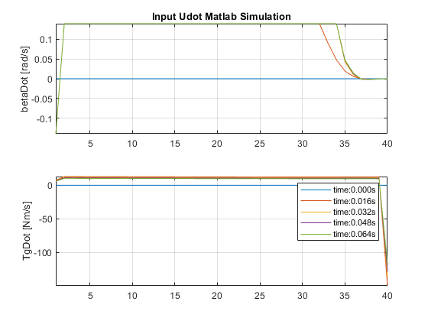
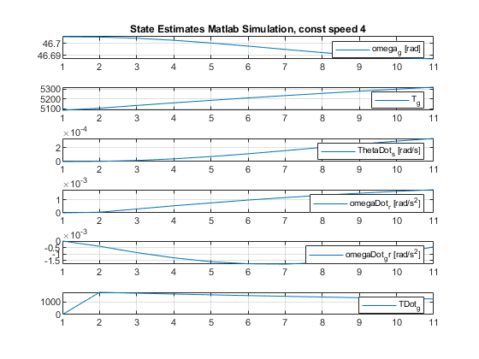

Same plots for Simulink simulations
load('OutDataTestCL_LPV_05', 'xDot06','OutDataTestOL_LPV','xk06', 'u','uDot','A','B','UVecSim','XVecSim','u_uss','tictoc_LPVMPC','q_','r_','p');
nrPlot1 = 5;
Uvec = UVecSim;
xDdot_Ve = xk06;
Nsim = length(u_uss);
time = OutTable.Time(1: Nsim);
plotInputStateTrajectories(Uvec,xDdot_Ve,time, titleStr1, titleStr2,nrPlot1);
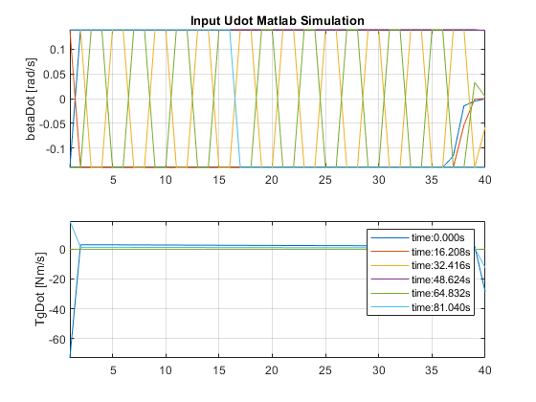
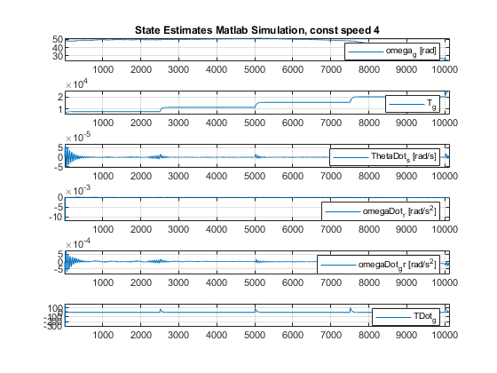

Plot results from closed loop simulation
%load('OutDataTestCL_LPV_01', 'xDot06','OutDataTestOL_LPV','xk06', 'u','uDot','A','B','UVecSim','XVecSim','u_uss','tictoc_LPVMPC','q_','r_','p');
u_uss_plot = squeeze(u_uss);
u_uss_plot = diag([180/pi,1,180/pi,1]) * u_uss_plot';
u1Cell = {'beta[deg]','T_g [Nm]'};
wind = vectAmpWind;
timeEnd = Nsim;
Nsim = length(u_uss);
time = OutTable.Time(1: length(u_uss));
qVec = deblank(sprintf('%d ',q_));
rVec = deblank(sprintf('%d ', r_));
pVec = deblank(sprintf('%d', p));
figure(11);
subplot(3,1,1);
plot(time(1:timeEnd), wind(1:timeEnd))
ylabel('wind [m/s]')
title({'Simulation run with weights', ...
['q_ = [', qVec,'], r = [',rVec,'], p = ',pVec,'* q']})
R_ = kron(eye(N),diag([1,100]));
axis tight; grid on;
for idx = 1:2
subplot(3,1,idx+1);
plot(time(1:timeEnd), u_uss_plot(idx,1:timeEnd)); hold on;
plot(time(1:timeEnd), u_uss_plot(idx+2,1:timeEnd));
axis tight; grid on;
ylabel(u1Cell{idx});
end
legend('u_{opt}','u');
hold off
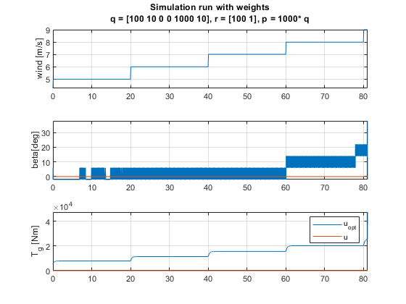

Load data from OL simulation
load('OutDataTestOL_LPV', 'xDot06','OutDataTestOL_LPV','xk06', 'u','uDot','A','B');
% Plot input
time = OutTable.Time(1: length(uDot));
figure;
subplot(4,1,1); plot(time, uDot(:,1)); axis tight; grid on;
ylabel('betaDot [rad/s]')
title('Simulink OL Input u_{dot}')
subplot(4,1,2); plot(time, u(:,1)); axis tight; grid on;
ylabel('beta [rad]')
subplot(4,1,3); plot(time, uDot(:,2)); axis tight; grid on;
ylabel('TgDot_{ref} [Nm/s]'),
subplot(4,1,4); plot(time, u(:,2)); axis tight; grid on;
ylabel('Tg_{ref} [Nm]'), xlabel('Time')
print('input_udot_u_OL', '-dpng');
% Table for state plots
xCellTable = {'omega_g', 'T_g', 'ThetaDot_s','omegaDot_r',...
'omegaDot_g','TDot_g'};
tableTestLPVxDot06 = array2table(xDot06,'VariableNames', xCellTable);
tableTestLPV = array2table(OutDataTestOL_LPV,'VariableNames', xCellTable);
% Output of linear model
figure;
subplot(2,1,1);
plot(time, tableTestLPVxDot06.omega_g,time,tableTestLPV.omega_g,'--');
axis tight; grid on;
ylabel('GenSpeed omegaG [rad/s]')
title('Output LPV model: Generator Speed \omega_g and Torque T_g')
subplot(2,1,2);
plot(time, tableTestLPVxDot06.T_g, time, tableTestLPV.T_g,'--'); hold on
%plot(time, xk06(:,2))
legend('Discrete LPV x(t+\Delta t)','Discrete LPV x(t)')
axis tight; grid on;
ylabel('GenTorque T_G [Nm]')
print('output_y_OL', '-dpng');
% Output of linear and non linear model
figure;
subplot(2,1,1);
plot(time, tableTestLPVxDot06.omega_g, time, tableTestLPV.omega_g,'--',...
time,xk06(:,1),'k-.')
axis tight; grid on;
ylabel('GenSpeed omegaG [rad/s]')
title('Output LPV model: Generator Speed \omega_g and Torque T_g')
subplot(2,1,2);
plot(time, tableTestLPVxDot06.T_g, time, tableTestLPV.T_g,'--',time, xk06(:,2),'k-.')
legend('Discrete LPV x(t+\Delta t)','Discrete LPV x(t)', 'Nonlinear x(t)')
axis tight; grid on;
ylabel('GenTorque T_G [Nm]')
print('output_udotNonLin_OL', '-dpng');
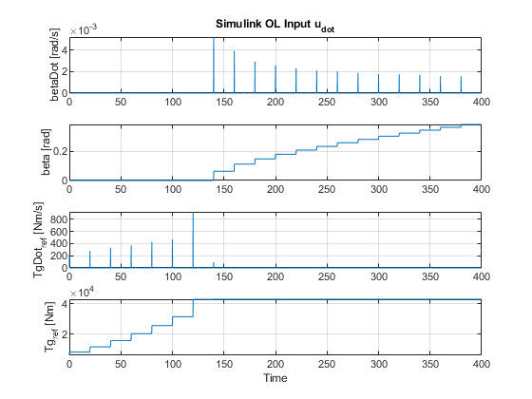
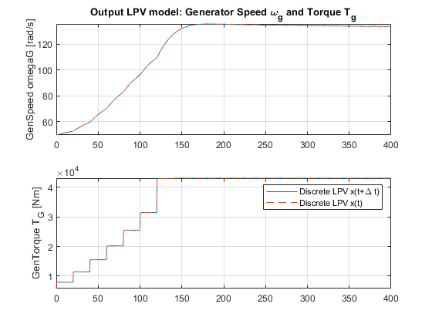
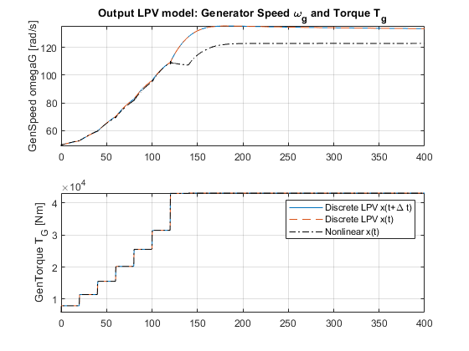
Published with MATLAB® R2019a

