get values 1
LOok up table for stable states 1
Physical parameters 1
Load data from OL simulation 6

get values
clear;
close all;
initModel5MWNRELBianchi;
addpath(fullfile(fileparts(pwd),'datain'));
load('workSpace.mat')
load('OutDataSweep.mat');
OutTable = array2table(OutData,'VariableNames', OutList);
idxWind = contains(OutList, 'Wind');
vectWind = OutTable{:,idxWind};
vectAmpWind = sqrt(sum((vectWind.^2),2));

LOok up table for stable states
LUT_V = 4:25;
LUT_omega = [0.4815, 0.6017,0.7217,0.8413,0.9603,1.0786,1.1949, repmat(1.2671,1,15)];
LUT_beta = [zeros(1,8),0.0642 0.1126 0.1493 0.1808 0.2093 0.2356 0.2602...
0.2833 0.3054 0.3269 0.3477 0.3676 0.3868 0.4056];
LUT_torque = [5.0870 7.9450 11.4300 15.5300 20.2400 25.5200 31.3500 ,...
repmat(43.0900,1,15)];

Physical parameters
Out: omegaG, Tg States: ThetaS, omegaR, omegaG, Tg In: beta_ref, Tg_ref; Scheduling param rho: V, beta_ref, omegaG/Ng (as approximation of omegaR)
Vbar = 4;
rb = 63; % m blade radius
G = 97;
omegabar = interp1(LUT_V,LUT_omega,Vbar);
Lambda_bar = omegabar*rb/Vbar;
beta_bar = interp1(LUT_V,LUT_beta,Vbar)/pi*180;
schedParam = [omegabar, beta_bar/180* pi, Vbar];
r(1) = interp1(LUT_V,LUT_omega,Vbar) * Ng; %
r(2) = interp1(LUT_V,LUT_torque,Vbar) * 1000;
xk = [r(1), r(2), zeros(1,4)]';
nu = 2;
N = 40;
Xko = kron(ones(N,1),xk);
mu_old = zeros(2*N*nu,1);
% Vbar = rho(3);
% omegabar = rho(1)/Ng; % OmegaG/Ng as approximation of omegaR
% beta_bar = rho(2)/pi*180;
Rotor_cQ = Rotor_cQ(:,1:size(Rotor_Lambda,1));
lambdaVec = Rotor_Lambda;
pitchVec = Rotor_Pitch;
U = zeros(2*N,1);
cQ = Rotor_cQ;
[u,Xko,Unew,mu,us,tictoc]= qLPVMPC_WECS_matlab(r,xk,Xko,mu_old,lambdaVec,pitchVec,cQ,schedParam,U,DT);
load('testVar','r','xk','Xk','mu_old','lambdaVec','pitchVec','cQ','schedParam','DT');
%[u,Xk,U,mu,us,tictoc]= qLPVMPC_WECS_matlab(r,xk,Xk,mu_old,lambdaVec,pitchVec,cQ,schedParam,U);
Nsim = 10;
U = zeros(2*N,1);
xDdot_Ve = NaN(Nsim+1,6);
Uvec = NaN(Nsim+1,80);
xDdot_Ve(1,:) = xk;
Uvec(1,:) = U;
for i = 1:Nsim
[u,Xk,U,mu,us,tictoc]= qLPVMPC_WECS_matlab(r,xk,Xk,mu_old,lambdaVec,pitchVec,cQ,schedParam,U,DT);
xDdot_Ve(i+1,:) = xk;
Uvec(i+1,:) = U;
end
xest = xDdot_Ve;
xCell = {'omega_g [rad]','T_g','ThetaDot_s [rad]','omegaDot_r [rad]',...
'omegaDot_gr [rad]','TDot_g'}; %'V_dot'
uCell = {'betaDot [rad/s]','TgDot [Nm/s]'}; %'V_dot'
figure(1);
for idx = 1:2
for idx1 = 1:100:Nsim
subplot(2,1,idx);
plot(Uvec(idx1,idx:2:end)); hold on;
end
if idx == 1
title('Input Udot Matlab Simulation')
end
axis tight; grid on;
ylabel(uCell{idx});
end
figure(2);
for idx = 1:6
subplot(6,1,idx);
plot(xest(:,idx))
axis tight; grid on;
legend(xCell{idx});
if idx == 1
title(['State Estimates Matlab Simulation, const speed ',num2str(Vbar)])
end
end
load('SimResultsOL', 'UVecSim','OutDataTestOL','u_uss','XVecSim');
Nsim = size(UVecSim,1);
DtPlot = round(Nsim/5);
Uvec = UVecSim;
figure(3);
for idx = 1:2
for idx1 = 1:DtPlot:Nsim
subplot(2,1,idx);
plot(Uvec(idx1,idx:2:end)); hold on;
end
legend;
axis tight; grid on;
ylabel(uCell{idx});
if idx == 1
title(['Input Trajectories at different time steps',num2str(Vbar)])
end
end
xvecsim = XVecSim(end,:);
figure(4);
for idx = 1:3
subplot(3,1,idx);
plot(xvecsim(idx:6:end))
axis tight; grid on;
ylabel(xCell{idx});
end
figure(5);
for idx = 1:3
subplot(3,1,idx);
plot(xvecsim(idx+3:6:end))
axis tight; grid on;
ylabel(xCell{idx+3})
end
u_uss_plot = squeeze(u_uss);
u_uss_plot = diag([180/pi,1,1,1]) * u_uss_plot;
u1Cell = {'beta[deg]','T_g [Nm]'};
time = OutTable.Time(1: length(u_uss_plot));
wind = vectAmpWind;
timeEnd = Nsim;
figure(11);
subplot(3,1,1);
plot(time(1:timeEnd), wind(1:timeEnd))
ylabel('wind [m/s]')
axis tight; grid on;
for idx = 1:2
subplot(3,1,idx+1);
plot(time(1:timeEnd), u_uss_plot(idx,1:timeEnd)); hold on;
axis tight; grid on;
ylabel(u1Cell{idx});
end
hold off
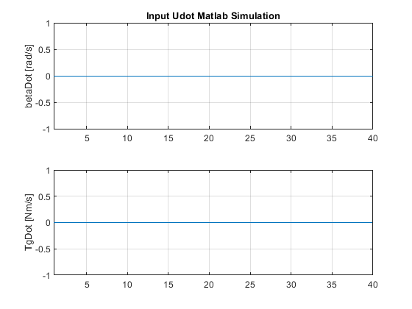
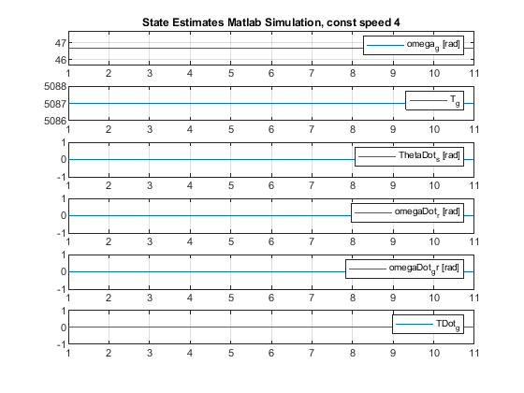
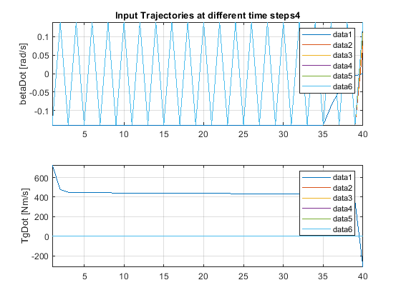
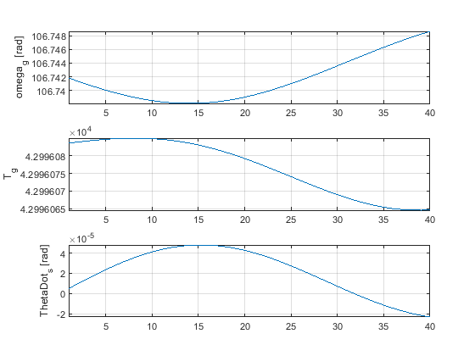
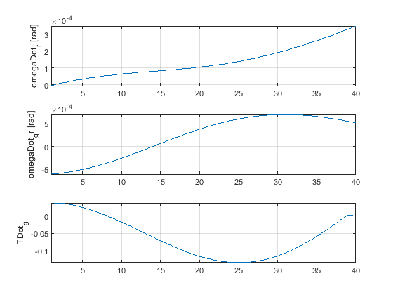
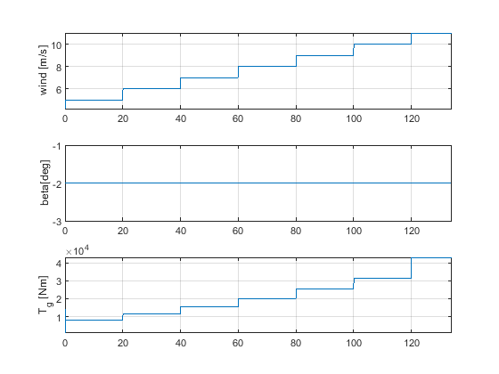

Load data from OL simulation
load('OutDataTestOL_LPV', 'xDot06','OutDataTestOL_LPV','xk06', 'u','uDot','A','B');
% Plot input
time = OutTable.Time(1: length(uDot));
figure;
subplot(4,1,1); plot(time, uDot(:,1)); axis tight; grid on;
ylabel('betaDot [rad/s]')
title('Simulink OL Input u_{dot}')
subplot(4,1,2); plot(time, u(:,1)); axis tight; grid on;
ylabel('beta [rad]')
subplot(4,1,3); plot(time, uDot(:,2)); axis tight; grid on;
ylabel('TgDot_{ref} [Nm/s]'),
subplot(4,1,4); plot(time, u(:,2)); axis tight; grid on;
ylabel('Tg_{ref} [Nm]'), xlabel('Time')
print('input_udot_u_OL', '-dpng');
% Table for state plots
xCellTable = {'omega_g', 'T_g', 'ThetaDot_s','omegaDot_r',...
'omegaDot_g','TDot_g'};
tableTestLPVxDot06 = array2table(xDot06,'VariableNames', xCellTable);
tableTestLPV = array2table(OutDataTestOL_LPV,'VariableNames', xCellTable);
% Output of linear model
figure;
subplot(2,1,1);
plot(time, tableTestLPVxDot06.omega_g); hold on
plot(time, tableTestLPV.omega_g,'--'); hold on
%plot(time, xk06(:,1))
axis tight; grid on;
ylabel('GenSpeed omegaG [rad/s]')
title('Output LPV model: Generator Speed \omega_g and Torque T_g')
subplot(2,1,2);
plot(time, tableTestLPVxDot06.T_g); hold on
plot(time, tableTestLPV.T_g,'--'); hold on
%plot(time, xk06(:,2))
legend('Discrete LPV x(t+\Delta t)','Discrete LPV x(t)')
axis tight; grid on;
ylabel('GenTorque T_G [Nm]')
print('output_y_OL', '-dpng');
% Output of linear and non linear model
figure;
subplot(2,1,1);
plot(time, tableTestLPVxDot06.omega_g); hold on
plot(time, tableTestLPV.omega_g,'--'); hold on
plot(time, xk06(:,1))
axis tight; grid on;
ylabel('GenSpeed omegaG [rad/s]')
title('Output LPV model: Generator Speed \omega_g and Torque T_g')
subplot(2,1,2);
plot(time, tableTestLPVxDot06.T_g); hold on
plot(time, tableTestLPV.T_g,'--'); hold on
plot(time, xk06(:,2))
legend('Discrete LPV x(t+\Delta t)','Discrete LPV x(t)', 'Nonlinear x(t)')
axis tight; grid on;
ylabel('GenTorque T_G [Nm]')
print('output_udotNonLin_OL', '-dpng');
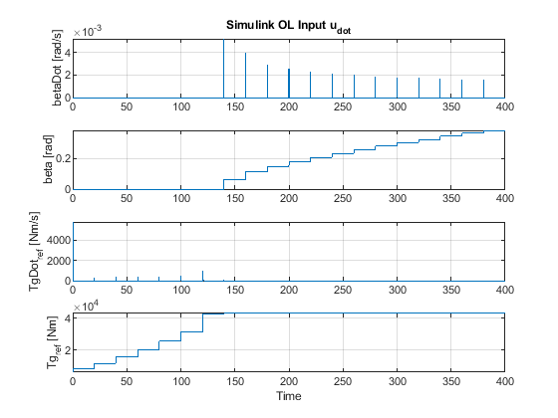
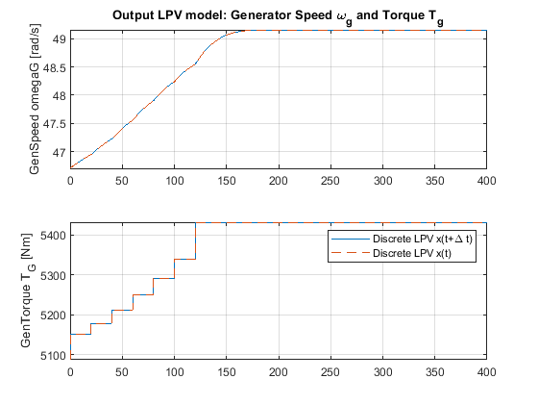
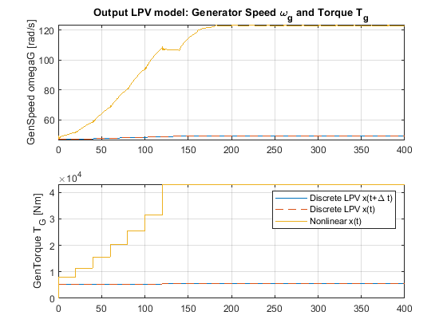
Published with MATLAB® R2019a

