Initialize workspace and path 1
Load data from FAST run 2
Run simulations or load data 3
Create output plots 4
Figure for paper 7
Get incremental torque characteristic TheadG = B 10
plot measured x = [y,xdot] 11
function runCompareModels(strWindType,loadData,yAxCell)
% runCompareModels compares two Simulink models (Mdl1(5 states) and Mdl2 (8
% states) with
if ~nargin || isempty(strWindType)
strWindType = 'Sweep';
end
if nargin < 2 || isempty(loadData)
loadData = 0; %load simulation output data if available;
end
if nargin < 3 || isempty(yAxCell)
yAxCell = {'wind V [m/s]', 'GenTq T_g [kNm]', 'Pitch \beta [°]', 'RotSpd \omega_r [rpm]',...
'GenPwr P_g [MW]','Twr_{FA} y_t [m/s^2]'};
end

Initialize workspace and path
%lear; clc; close all;
% bdclose all;
% Set path to inputdata directory
mainDir = fullfile(pwd);
dataInDir = fullfile(fileparts(pwd),'dataIn');
addpath(dataInDir);
% Set path to figure directory
%figDir = fileparts(mainDir); %'html','figDir');
figDir = fullfile(fileparts(mainDir),'figDir');
if ~isfolder(figDir)
mkdir(figDir)
end
% Set path to data output directory
dataDirOut = 'dataOut';
if ~isfolder(dataDirOut)
mkdir(dataDirOut)
end
% Provide names of FAST simulation data to be loaded
%'NTW18';%'Sweep'; %normal turbulance
% Provide names of Simulink models to be run
simMdlname1 = 'test_SimulinkMdl1_Baseline'; %
%simMdlname2 = 'test_SimulinkMdl3LPV_Baseline';
simMdlname2 = 'test_SimulinkMdl2_Baseline';
if strcmp(strWindType,'Sweep') == 1
% sweep from 4 to 25 in steps
%workspaceSimulationMat = 'workSpace.mat';
outDataSimulationMat = 'OutDataSweep.mat';
strFig = '';
testCaseStr = 'Wind Sweep';
else
% wind with average 18 m/s
%workspaceSimulationMat = 'workSpace18NTM.mat';
outDataSimulationMat = 'OutDataWind18NTM.mat';
strFig = 'NTW18';
testCaseStr = 'Wind, mean 18 m/s';
end

Load data from FAST run
%load(fullfile(dataInDir,workspaceSimulationMat)) %#ok<LOAD> ADi ToDo: Clean this up later: Only load variables needed for simulation
DT = 0.008;
load(outDataSimulationMat ,'OutTable');%#ok<NASGU>
% LUT tables loaded have these values
% LUT_torque2 = [5.0066 8.8294 13.5530 18.9143 23.8603 29.5200 36.9452,...
% repmat(43.5290,1,15)];
% LUT_omega2 = [0.7776 0.8209 0.8742 0.9348 1.0430 1.1600 ...
% 1.2369 1.2555 1.2548 1.2546 1.2546 1.2545 1.2546 1.2545 1.2545 1.2545 1.2545 ...
% 1.2545 1.2545 1.2545 1.2545 1.2545];
% Assign data from FAST to variables
% OutTable = array2table(OutData,'VariableNames', OutList);
idxTime = 1: height(OutTable);
OutTable = OutTable(idxTime,:);
% OutTable.BlPitch1 = NaN(height(OutTable),1);
% OutTable.BldPitch1(1:3:end) = pitch(:,1); %#ok<NODEF> Loaded in Matfile
OutTable.BldPitch1 = OutTable.BlPitch1;
% OutTable.Torque = NaN(height(OutTable),1);
% OutTable.Torque(1:3:end) = Torque;
OutTable.Torque = OutTable.GenTq;
idxWind = contains(OutTable.Properties.VariableNames, 'Wind');
vectWind = OutTable{:,idxWind};
vectAmpWind = sqrt(sum((vectWind.^2),2));
% assign data for LPV model
%initModel5MWNREL;
% idxWind_11to14 = vectAmpWind > 10 & 14 > vectAmpWind;
% vectAmpWind_11to14 = vectAmpWind(idxWind_11to14);
% time_11to14 = 0:DT: DT*length(vectAmpWind_11to14)-DT;
% Initialize constants for Simulink model
% param;
%initModel5MWNREL;
% Lin_points.RSpeed = LUT_omega2;
% Lin_points.Torque = LUT_torque2;
varnames = {'Wind', 'RotSpeed', 'GenPwr', 'BlPitch1', 'GenTq', ...
'NcIMUTAxs', 'NcIMUTAys'}; %%'Tower FA acc', 'Tower SS acc'};

Run simulations or load data
Run simulation for two models or load mat files if available
matFileOutTableTest1 = fullfile(dataDirOut,['OutTableTest1',strFig,'.mat']);
if exist(matFileOutTableTest1,'file') == 2 && loadData
load(matFileOutTableTest1,'OutTableTest1');
else
WS = 'base';
assignin(WS,'DT',DT)
assignin(WS,'OutTable',OutTable)
open_system(simMdlname1);
%Ng = wecs.Ng;
out1 = sim(simMdlname1,'SrcWorkspace',WS);
OutTableTest1 = array2table(out1.OutDataTest,'VariableNames',varnames);
save(matFileOutTableTest1,'OutTableTest1');
end
matFileOutTableTest2 = fullfile(dataDirOut,['OutTableTest2',strFig,'.mat']);
if exist(matFileOutTableTest2,'file') == 2 && loadData
load(matFileOutTableTest2,'OutTableTest2');
else
open_system(simMdlname2);
out2 = sim(simMdlname2,'SrcWorkspace',WS);
if size(out2.OutDataTest,2) == 9 % Pitch commands of all actuators
out2OutDataTest = out2.OutDataTest(:,[1:4,7:9]);
else
out2OutDataTest = out2.OutDataTest;
end
OutTableTest2 = array2table(out2OutDataTest,'VariableNames',varnames);
save(matFileOutTableTest2,'OutTableTest2');
end
% Get actuator block to test influence
% actuatorBlock = find_system(simMdelname,'Name','Actuators');
% Commented: 'through'/'off'
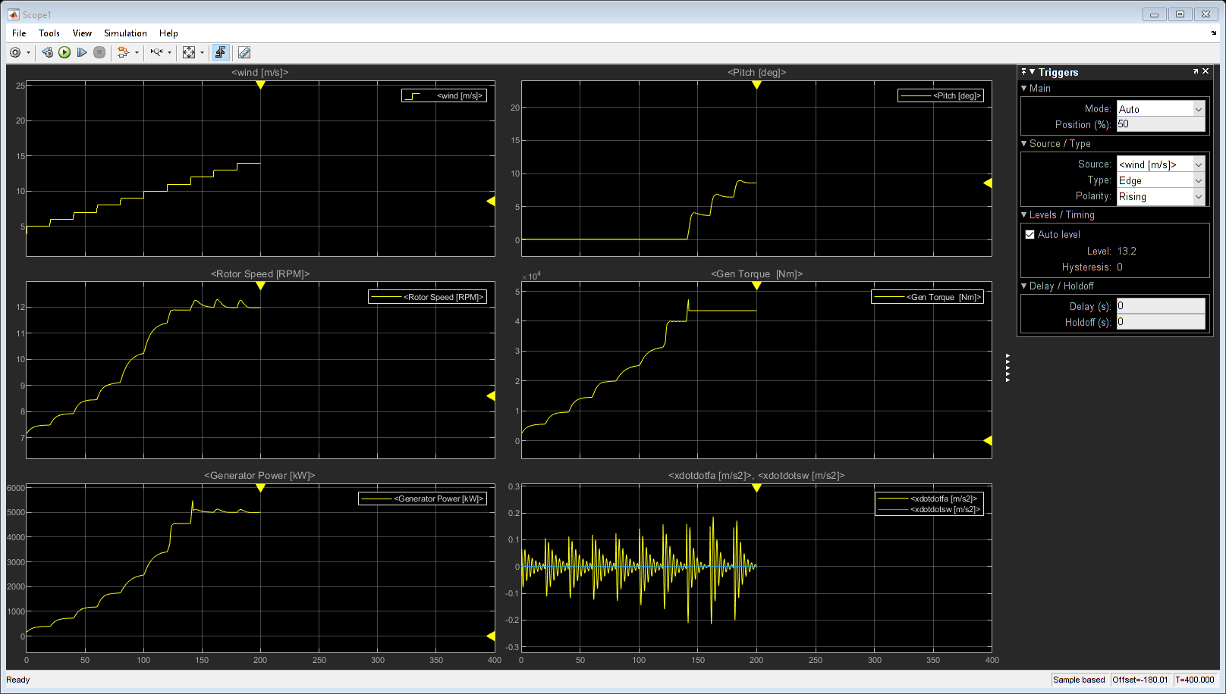

Create output plots
%Prepare data for plots
% Calculate wind amplitude
%cellChannelWind = {'Wind1Vel'};
%OutList = OutTable.Properties.VariableNames;
%vectAmpWindTest = sqrt(sum((vectWind.^2),2));
% Get color map for 'title legends'
cl = colormap('lines');
titleStr = [testCaseStr,': Mdl1: Rot+Twr {\color[rgb]{',num2str(cl(1,:)),'}Mdl2: Rot,Twr,Bld+Act ',...
'\color[rgb]{',num2str(cl(2,:)),'}FAST} '];
%Create output plots
figNo1 = 1; figNo2 = 2;
idxTime = 1: min([length(idxTime), height(OutTableTest1),height(OutTableTest2)]);
time = OutTable.Time(idxTime);
idxTime = time > 15;
time = time(idxTime);
% defaultLineWidth = get(groot,'defaultLineLineWidth');
% set(groot,'defaultLineLineWidth',1);
% set(groot,'defaultLineLineWidth',defaultLineWidth );
figure(figNo1);
axPlot(1) = subplot(3,1,1);
plot(time,vectAmpWind(idxTime),time,OutTableTest1.Wind(idxTime),'--');
axis tight; grid on;
ylabel('wind [m/s]')
title(titleStr);
axPlot(2) = subplot(3,1,2);
plot(time,OutTableTest2.RotSpeed(idxTime), time,OutTable.RotSpeed(idxTime),time,OutTableTest1.RotSpeed(idxTime),'k--');
axis tight; grid on;
ylabel('RotSpd \omega_r [rpm]')
axPlot(3) = subplot(3,1,3);
plot(time,OutTableTest2.GenPwr(idxTime)/1000,time,OutTable.GenPwr(idxTime)/1000,time,OutTableTest1.GenPwr(idxTime)/1000,'k--');
axis tight; grid on;
ylabel('GenPwr P_g [MW]')
xlabel('time [s]')
linkaxes(axPlot,'x');
set(findall(gcf,'-property','FontSize'),'FontSize',11)
print(fullfile(figDir,['cmpTimeDomain_Wind',strFig]), '-dpng');
figure(figNo2)
axPlot2(1) = subplot(3,1,1);
plot(time,OutTableTest2.BlPitch1(idxTime),time,OutTable.BlPitch1(idxTime),time,OutTableTest1.BlPitch1(idxTime),'k--');
axis tight; grid on;
ylabel('BldPitch1 \beta [rad]')
title(titleStr);
axPlot2(2) = subplot(3,1,2);
plot(time,OutTableTest2.GenTq(idxTime)/10^3,time,OutTable.GenTq(idxTime),time,OutTableTest1.GenTq(idxTime)/10^3,'k--');
axis tight; grid on;
ylabel('GenTq T_g [Nm]')
axPlot2(3) = subplot(3,1,3);
plot(time,OutTableTest2.NcIMUTAxs(idxTime),time,OutTable.NcIMUTAxs(idxTime),time,OutTableTest1.NcIMUTAxs(idxTime),'k--');
axis tight; grid on;
ylabel('Twr_{FA} y_t[m/s^2]')
xlabel('time [s]')
set(findall(gcf,'-property','FontSize'),'FontSize',11)
print(fullfile(figDir,['cmpTimeDomain_BlPitchTqTwr',strFig]), '-dpng');
linkaxes(axPlot2,'x');

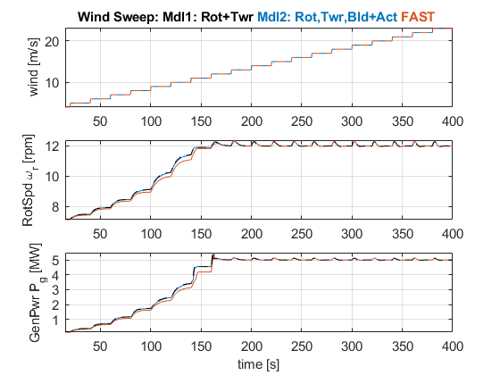
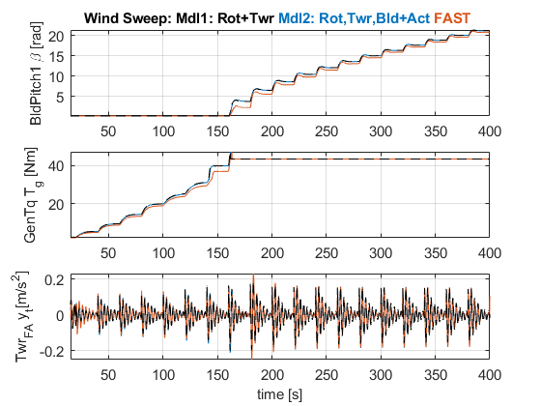

Figure for paper
figure(figNo2+1)
axPlotAll(1) = subplot(6,1,1);
plot(time,vectAmpWind(idxTime),time,OutTableTest1.Wind(idxTime),'--');
axis tight; grid on;
ylabel(yAxCell{1}); %'wind [m/s]')
title(titleStr);
axPlotAll(4) = subplot(6,1,4);
plot(time,OutTableTest2.RotSpeed(idxTime), time,OutTable.RotSpeed(idxTime),time,OutTableTest1.RotSpeed(idxTime),'k--');
axis tight; grid on;
ylabel(yAxCell{4}); %'RotSpd \omega_r [rpm]')
axPlotAll(2) = subplot(6,1,2);
plot(time,OutTableTest2.GenTq(idxTime)/10^3,time,OutTable.GenTq(idxTime),time,OutTableTest1.GenTq(idxTime)/10^3,'k--');
axis tight;
posAxis = axis;
axis([posAxis(1:2), min(43,posAxis(3)), 44]);
ylabel(yAxCell{3}); %'T_g [kNm]')
grid on; % axis tight;
%grid on;
ylabel(yAxCell{2}); %'GenTq T_g [Nm]')
axPlotAll(3) = subplot(6,1,3);
plot(time,OutTableTest2.BlPitch1(idxTime),time,OutTable.BlPitch1(idxTime),time,OutTableTest1.BlPitch1(idxTime),'k--');
axis tight; grid on;
ylabel(yAxCell{3}); %'Pitch \beta [°]')
axPlotAll(5) = subplot(6,1,5);
plot(time,OutTableTest2.NcIMUTAxs(idxTime),time,OutTable.NcIMUTAxs(idxTime),time,OutTableTest1.NcIMUTAxs(idxTime),'k--');
axis tight; grid on;
ylabel(yAxCell{6}); %'Twr_{FA} y_t[m/s^2]')
axPlotAll(6) = subplot(6,1,6);
plot(time,OutTableTest2.GenPwr(idxTime)/1000,time,OutTable.GenPwr(idxTime)/1000,time,OutTableTest1.GenPwr(idxTime)/1000,'k--');
axis tight; grid on;
ylabel(yAxCell{5}); %'GenPwr P_g [MW]')
xlabel('time [s]')
linkaxes(axPlotAll,'x');
posDefault = get(gcf, 'position');
set(gcf, 'position', [posDefault(1:3),posDefault(4)*1.5]);
print(fullfile(figDir,['cmpTimeDomain_All',strFig]), '-dpng');
print(fullfile(figDir,['cmpTimeDomain_All',strFig]), '-depsc');
% axPlot2(4) = subplot(4,1,4);
% plot(time,OutTableTest2.NcIMUTAys(idxTime),time,OutTable.NcIMUTAys(idxTime),time,OutTableTest1.NcIMUTAys(idxTime),'k--');
% axis tight; grid on;
% ylabel('Twr_{SW} x_t (m/s^2)')
% xlabel('time (s)')
% linkaxes(axPlot2,'x');
% set(groot,'defaultLineLineWidth',defaultLineWidth);
return;
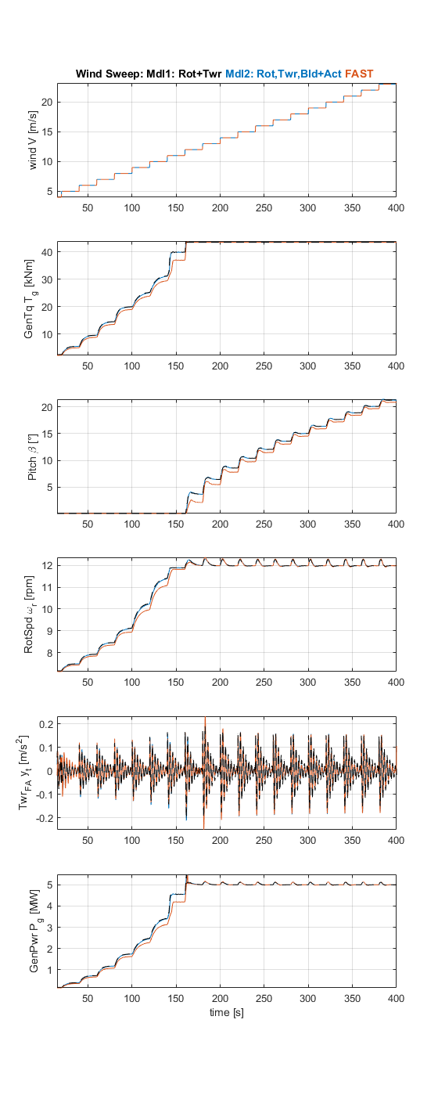

Get incremental torque characteristic TheadG = B
lengthWindSteps = 5:24; %#ok<UNRCH> This was used for debugging - ADi ToDo delete or move to another file
vecIdx = (2500:2500:length(idxTime))- 50;
%vecIdx = (2500:2500: height(OutTable)) -100
wind_Vec = round(vectAmpWind(vecIdx));
genSpeed_rad_s = OutTable.GenSpeed(vecIdx) * pi/30;
genTq_kNm = OutTable.GenTq(vecIdx);
genPwr_kNm = OutTable.GenPwr(vecIdx);
genSpeed_rad_s_Mdl1 = OutTableTest1.RotSpeed(vecIdx) *pi/30 * 97;
genTq_kNm_Mdl1 = OutTableTest1.GenTq(vecIdx)/1000;
genSpeed_rad_s_Mdl2 = OutTableTest2.RotSpeed(vecIdx) *pi/30 * 97;
genTq_kNm_Mdl2 = OutTableTest2.GenTq(vecIdx)/1000;
try
LUT_Torque = interp1(Lin.V, Lin.Torque, wind_Vec);
catch
return
end
LUT_GenSpeed = interp1(Lin.V, Lin.RSpeed, wind_Vec) * 97;
figure(figNo2+1)
subplot(3,1,1)
plot(wind_Vec,LUT_GenSpeed,'o', wind_Vec,genSpeed_rad_s,'*', wind_Vec,genSpeed_rad_s_Mdl2,'kx')
title('Reference Values: Steady-state Generator Speed and Torque')
ylabel('GenSpeed \omega_g [rad/s]')
axis tight; grid on;
subplot(3,1,2)
plot(wind_Vec,LUT_Torque,'o', wind_Vec,genTq_kNm,'*', wind_Vec,genTq_kNm_Mdl2,'kx')
ylabel('GenTq T_g [kNm]')
axis tight; grid on;
subplot(3,1,3)
plot(wind_Vec,LUT_Torque .* LUT_GenSpeed,'o', ...
wind_Vec,genTq_kNm .* genSpeed_rad_s,'*', ...
wind_Vec,genSpeed_rad_s_Mdl2 .* genTq_kNm_Mdl2,'kx')
ylabel('GenPwr P_g [kW]')
xlabel('Wind speed V [m/s]')
axis tight; grid on;
legend('FAST LUT','FAST Sim','Simulink MDL2 Sim', 'Location','SouthEast')
print(fullfile(figDir,['cmpReferences_LUT_FAST_Simulink',strFig]), '-dpng');
%ratioGenTqSpeed = genTq_kNm ./ genSpeed_rad_s;
figure(figNo2+2)
subplot(2,2,1); plot(OutTable.GenSpeed,OutTable.GenTq);
ylabel('GenTq T_{g,ref} [kNm]');
grid on; axis tight;
subplot(2,2,3); plot(OutTable.GenSpeed,OutTable.BlPitch1);
ylabel('Pitch \beta_ref [kNm]');
xlabel('GenSpeed \omega_g [rpm]')
grid on; axis tight;
subplot(2,2,2); plot(vectAmpWind,OutTable.GenTq);
grid on; axis tight;
subplot(2,2,4); plot(vectAmpWind,OutTable.BlPitch1);
grid on; axis tight;
xlabel('Wind Speed V [m/s]')
%title('genTq_{kNm}/genSpeed_{rad,s}')
%[ratioGenTqSpeed(1:20),(5:24)']
Be_5To14 = [0.0664, 0.1109,0.1598,0.2086,0.2358,0.2623,0.3079,0.3574,0.3576,0.3577];

plot measured x = [y,xdot]
if ~exist('xk','var')==1
return
end
if min(size(xk)) == 1
return;
end
xest = xk;
xCell = {'ThetaDot_s [rad]','omegaDot_r [rad]',...
'omegaDot_g [rad]','TDot_g','BetaDot_r','V_dot'}; %'V_dot'
figure(4);
subplot(3,1,1); plot(xest(:,1))
grid on; axis tight
legend('omega_g [rad/s]')
subplot(3,1,2);
plot(xest(:,3)); hold on; plot(xest(:,4),'k')
grid on; axis tight
legend('beta [deg]','V [m/s]');
subplot(3,1,3); plot(xest(:,2));legend('T_g [Nm]');
grid on; axis tight
figure(5);
for idx = 1:3
subplot(3,1,idx);
plot(xest(:,idx+4))
axis tight; grid on;
ylabel(xCell{idx});
end
figure(6);
for idx = 1:3
subplot(3,1,idx);
plot(xest(:,idx+4+3))
axis tight; grid on;
ylabel(xCell{idx+3})
end
Published with MATLAB® R2019b

