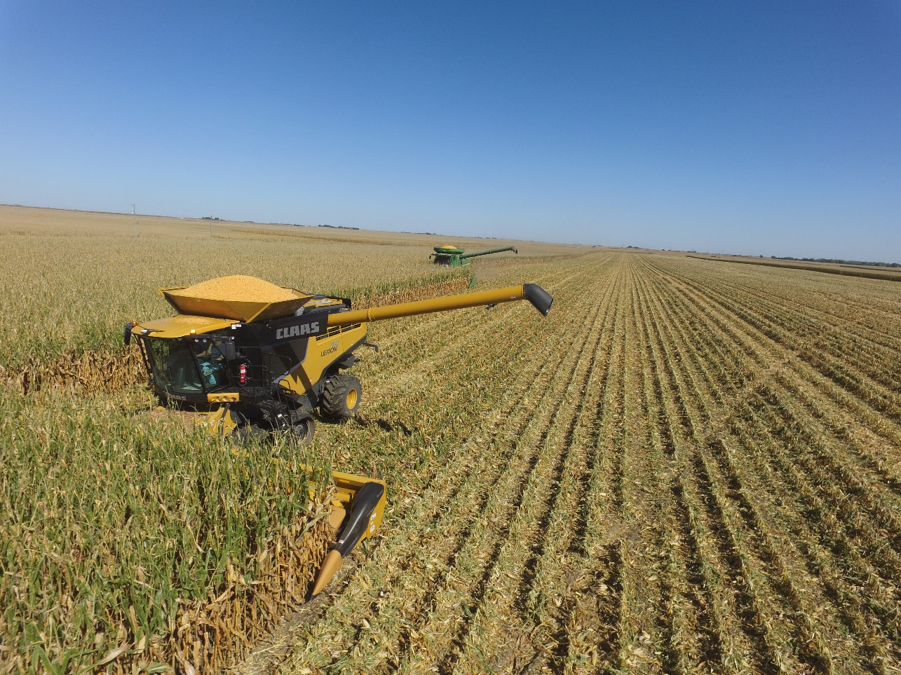

Value calculator   
user guide

CLAAS of america | 8401 s 132nd street, Omaha, NE 68138

online value calculator help

Jacobsen, Nick

2017

# Preliminary information

The most important aspect of a good demonstration and value calculator is getting the correct information. This means the first two sections of the value calculator where the name, dealer and crop information is entered, as shown below.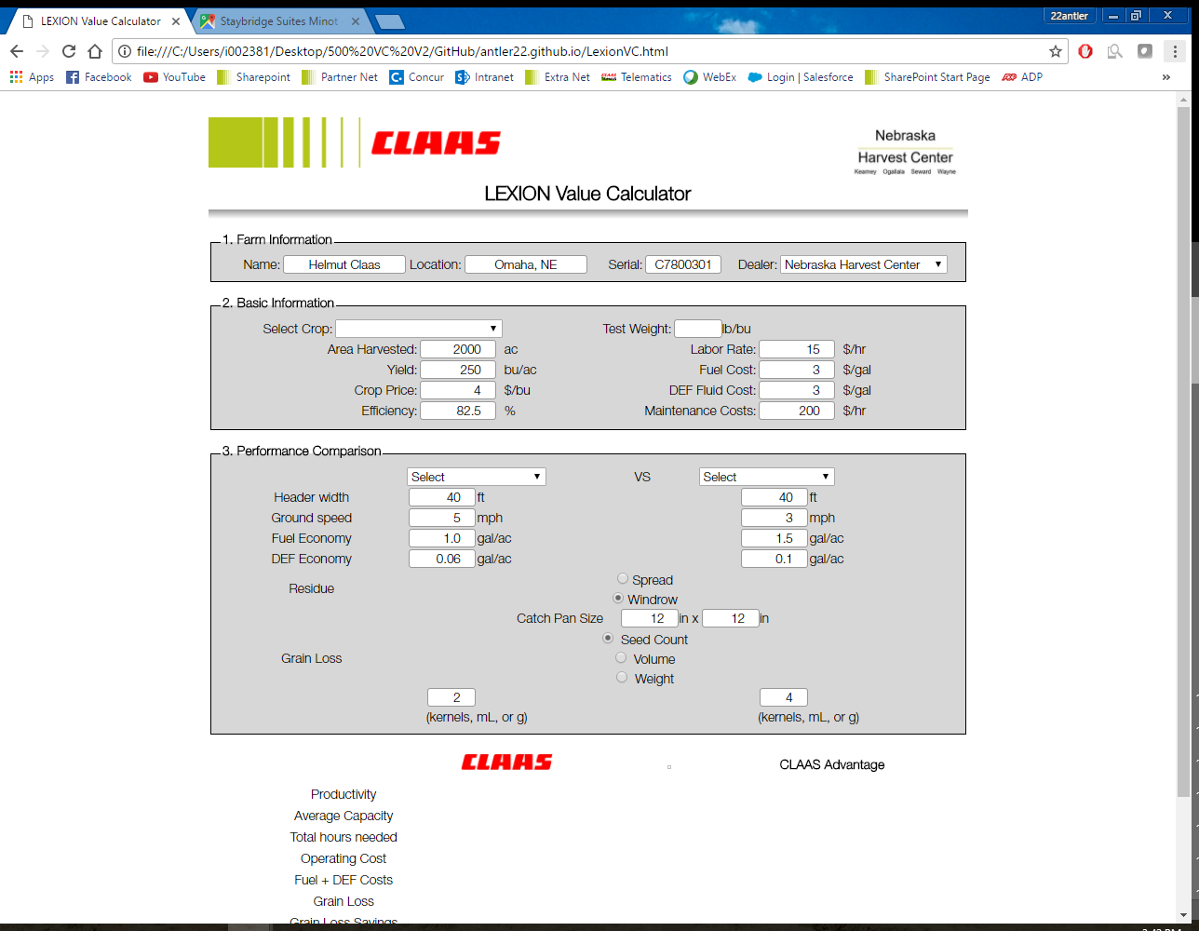

Professionalism is key on this document, especially when the customer is using this tool to make a purchasing decision. So, even something as small as a misspelled farm name could have a significant impact. In the *Basic Information* section, all the values entered are used to make the necessary calculations, so accuracy is important. Skipping fields here can lead to errors or overgenerous results later on.

# Performance comparison

The majority of the information here must be completed in the field. The prospect should be involved in the data collection process, to ensure accuracy of the comparison in the eyes of both the sales team and the prospect.

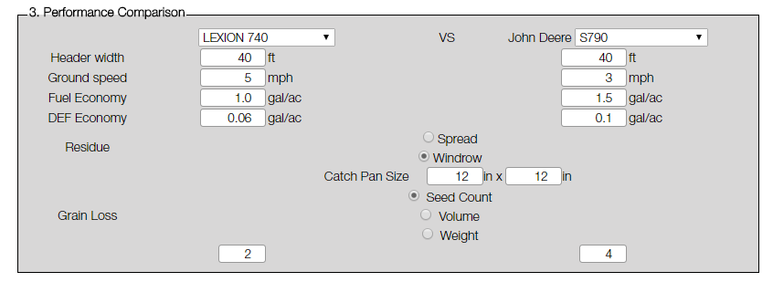

If you need more info on any item in the value calculator, you can either hover your mouse over the label, or use the info icons as shown below:

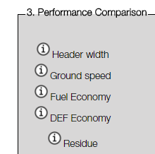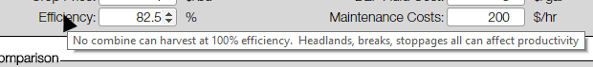

# Results

The results will be displayed on the bottom of the page. This will detail each aspect of value that the CLAAS product brings over the competition. If any line items say “NaN” or are zeroed out, there was information that was missed when filling out the form.

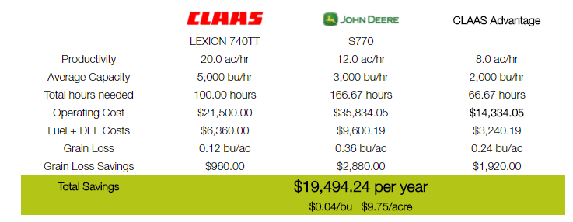

# Importance of grain loss

Overview

The LEXION combine brings value to producers in three major areas: productivity, grain loss, and fuel economy. The value calculator intends to point this out during the demo process in order to show the money that can be saved by using this machine for harvest.

productivity

Covering more acres in less time can mean savings in many different ways. By completing harvest days earlier than normal, you reduce field losses, wage payments, and machine depreciation.

As the season progresses, crops dry out and are more susceptible to pre-harvest losses. Wind, rain, and other weather events are more likely to cause ear drop or head shatter before the combine can get to the field. Once that crop hits the ground, it can be nearly impossible to recover. Even if it remains on the plant, it can be a challenge to pick it back up with a combine.

With harvest done days earlier, a producer can reduce the time his workers are needed to run equipment. This means they can be used in other areas of the operation, making the whole farm more productive.

All machines depreciate in value the more “hours” it is used. If harvest is completed in fewer hours than normal, the machines can hold their value for longer. This can reduce maintenance costs, but also can cause the machine to retain a better trade-in value when the farm is ready to trade again.

grain loss

Mechanical losses from the combine directly steal profit from a farm. This can be especially frustrating when the producer has invest a season’s-worth of time, money and effort to grow a great crop only to see some of it left in the field.

Harvest losses of 10 percent or more are not unusual[1], but even the 2-4% range can mean money left in the field. Depending on the crop, losses can be limited to under 0.1% of the total yield by properly adjusting the combine. To ensure the combine is adjusted, it is helpful to check behind the combine regularly. When conditions change, machine performance can as well. Checking the ground is the only sure way to know what your combine is leaving in the field.

Because of variability throughout the field, the best way to check a combine’s grain loss is to have the combine in windrow mode. This concentrates the crop coming out of the combine, so that winds and processor type do not affect where losses are found. By windrowing, you can also isolate header and processor losses, as shown below:

[‎7/‎27/‎2017 1:47 PM] Christian Soseman:

How's the value calc coming?

[‎7/‎27/‎2017 1:48 PM] Jacobsen, Nick:

hey i was just thinking about emailing you yesterday.  ive been working on it a little recent since my fieldwork has slowed down.

I have lots of good ideas on how to improve the front-end, but I really want to get a back-end established first.  I am really struggling with getting a back-end connected at the moment though

[‎7/‎27/‎2017 1:49 PM] Jacobsen, Nick:

A buddy recommended MongoDB as a database service.  I can get some low-end specs for free to get me started.  I think it's still beyond my understanding how to get the front-end and back-end looking at each other though

PHP and SQL are making sense to me.  I just can't make the "first step" to actually test my PHP and SQL.  I even have a schema written and ready to create my database

[‎7/‎27/‎2017 1:51 PM] Christian Soseman:

Have you been using MySQL for testing?

[‎7/‎27/‎2017 1:52 PM] Christian Soseman:

PHP has PDO to interact with most SQL database like MSSQL, MySQL, Oracle, etc.

If you go the Mongo route it's a NoSQL Database so you'd have to interact with the data a bit differently with PHP.

[‎7/‎27/‎2017 1:56 PM] Jacobsen, Nick:

But, I can't use mySQL or similar alone.  I still need a SQL database to start.  What would you recommend to get something rough put together?

[‎7/‎27/‎2017 1:57 PM] Christian Soseman:

It depends on how your going to host it really. Do you have your front end hosted anywhere?

you're**

What do you mean by can't use MySQL alone?

[‎7/‎27/‎2017 1:58 PM] Jacobsen, Nick:

just GitHub.  which limits my options.  But, I'm willing to host it elsewhere

I can use mySQL to manipulate/work with my database.  Create tables, organize data, etc.  But the database itself still has to exist somewhere..

[‎7/‎27/‎2017 1:59 PM] Christian Soseman:

Gotcha...So usually hosting sites will allow you to start up a MySQL instance if you're already hosting a PHP site.

They would give you a connection string once you create the instance with a hostname, username, password, db name, etc.

[‎7/‎27/‎2017 2:00 PM] Jacobsen, Nick:

Okay.  so it could be as easy as finding a different host.. and then its essentially all-in-one

[‎7/‎27/‎2017 2:00 PM] Christian Soseman:

Yes...but....

[‎7/‎27/‎2017 2:02 PM] Christian Soseman:

You also have to be cognizant of the security controls on that database instance. A lot of the time the hosting sites don't fully disclose they're security protocols for shared instances/database so if you have sensitive data just be aware of that.

[‎7/‎27/‎2017 2:03 PM] Christian Soseman:

And, also, when you are looking for hosts, try to look for a host that uses Apache as their web server and that they allow use of a .htaccess file. That will grant you a bit more control as far as settings are concerned.

[‎7/‎27/‎2017 2:03 PM] Jacobsen, Nick:

ok.  especially for testing/creation, the data is NOT sensitive at all.  even the scripting is just math that others already know about.

Is there anything that comes to mind that you would recommend?

[‎7/‎27/‎2017 2:03 PM] Christian Soseman:

Perfect!

[‎7/‎27/‎2017 2:05 PM] Christian Soseman:

I don't use shared hosting mostly for security reasons. I use AWS or Google Cloud Compute to build an entire virtual server from scratch or use a container service.

I can't speak for the security aspect of it but I know GoDaddy does offer hosting plans with mysql included.

[‎7/‎27/‎2017 2:09 PM] Christian Soseman:

It's pretty basic though

[‎7/‎27/‎2017 2:09 PM] Jacobsen, Nick:

Basic is what I'm looking for at this point.  I learn best by trial and error and getting fluid front-back end communication is my big speed bump right now

If we decide to polish this up, is it likely that we integrate this into existing claas domain/servers?

[‎7/‎27/‎2017 2:12 PM] Christian Soseman:

We'd just have to build a virtual server to your project specs and move the data

[‎7/‎27/‎2017 2:12 PM] Jacobsen, Nick:

gotcha.  okay.  I'll check out GoDaddy and see where that gets me.

thanks Christian!

[‎7/‎27/‎2017 2:13 PM] Christian Soseman:

No problem! It's been about 10 years since I've touched GoDaddy for anything other than domains but if you get stuck, hit me up!

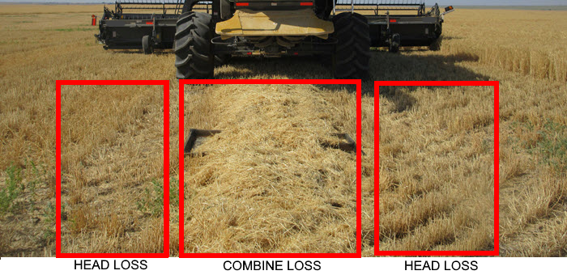

fuel economy

1. Sumner, Paul E. Measuring Field Losses from Grain Combines. Publication no. 973. University of Georgia Extension, 11 May 2012. Web. 10 Jan. 2017. <http://extension.uga.edu/publications/detail.html?number=B973>.