Name: Antonio Lopez

CHM236LL

**Triphenylmethanol and Benzoic Acid Lab Assignment**

a.

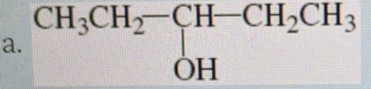

Method:

1. Prepare Grignard reagent by adding bromoethane to magnesium in a flask with diethyl ether.

2. React Grignard reagent with propanal.

3. Add water to hydrolyze molecule and form alcohol.

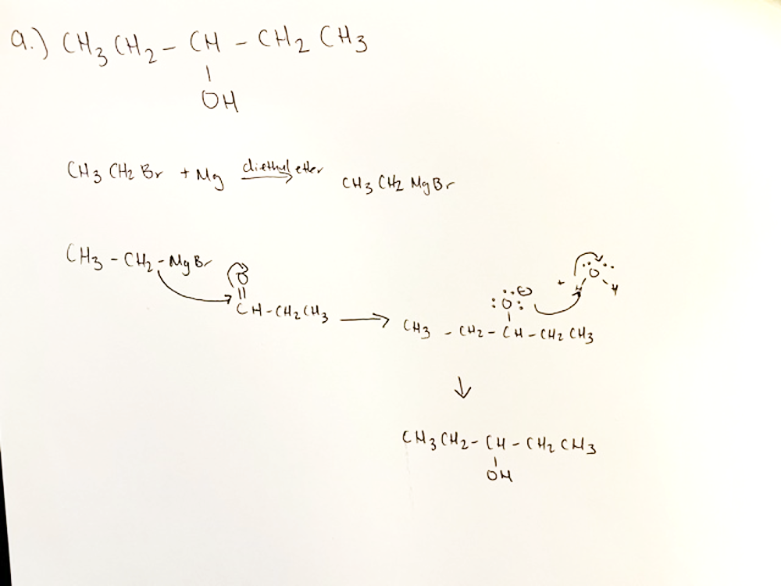

b.

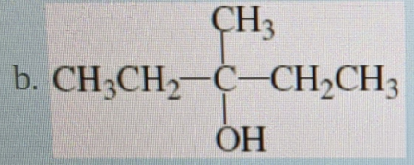

Method:

1. Prepare Grignard reagent by adding bromoethane to magnesium in a flask with diethyl ether.

2. React Grignard reagent with butanone.

3. Add water to hydrolyze molecule and form alcohol.

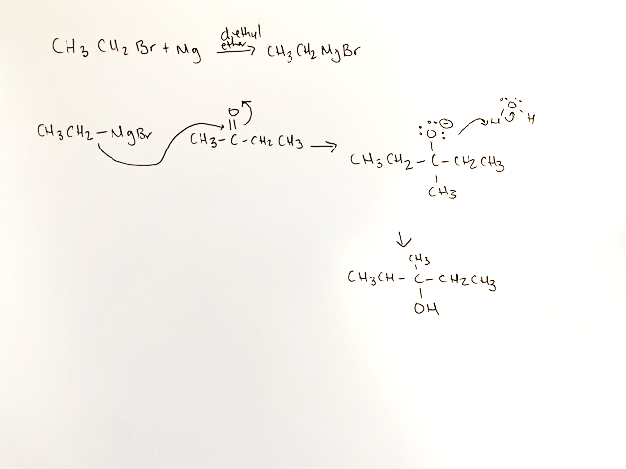

c.

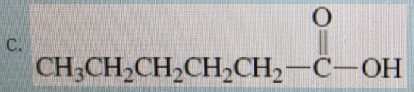

Method:

1. Prepare Grignard reagent by adding 1-bromopentane to magnesium in a flask with diethyl ether.

2. React Grignard reagent with carbon dioxide or dry ice.

3. Add water to hydrolyze molecule and form alcohol.

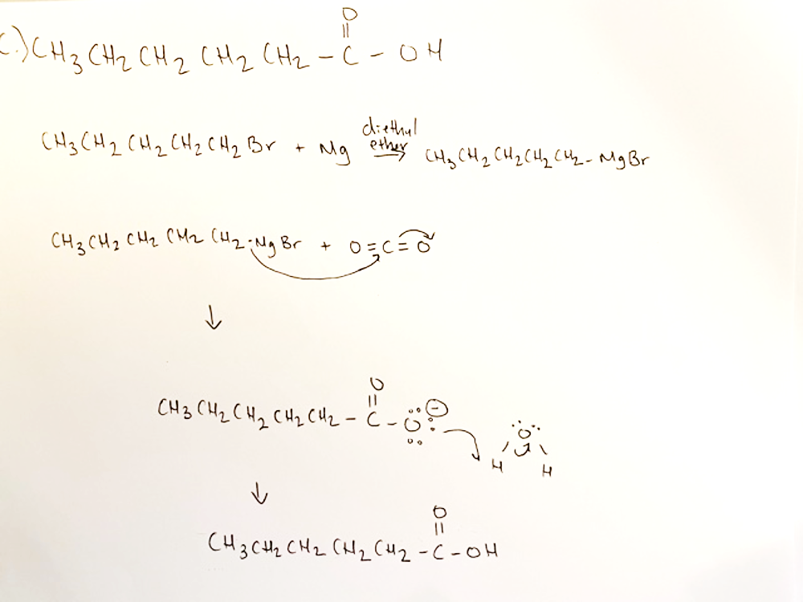

d.

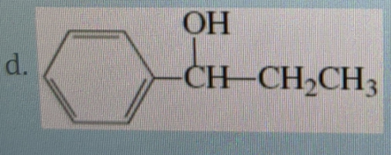

Method:

1. Prepare Grignard reagent by adding bromobenzene to magnesium in a flask with diethyl ether.

2. React Grignard reagent with propanal.

3. Add water to hydrolyze molecule and form alcohol.

