Maven Customized Structure

1. Create below pom.xml. This pom is used to define the archetype structure.



1. Create below archetype.xml. This xml is used as Archetype descriptor.



1. Create below pom.xml. It is used as the prototype pom and different from the pom created in step1.



1. Below files are the App.java and AppTest.java

 

1. Create below file structure.

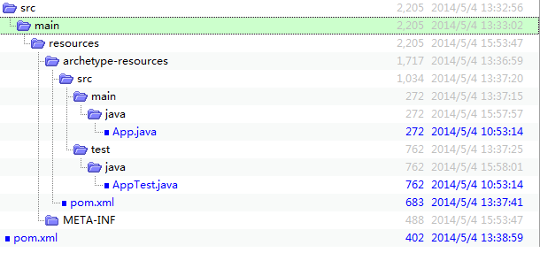

1. Execute **mvn install** command to install the archetype in repository.

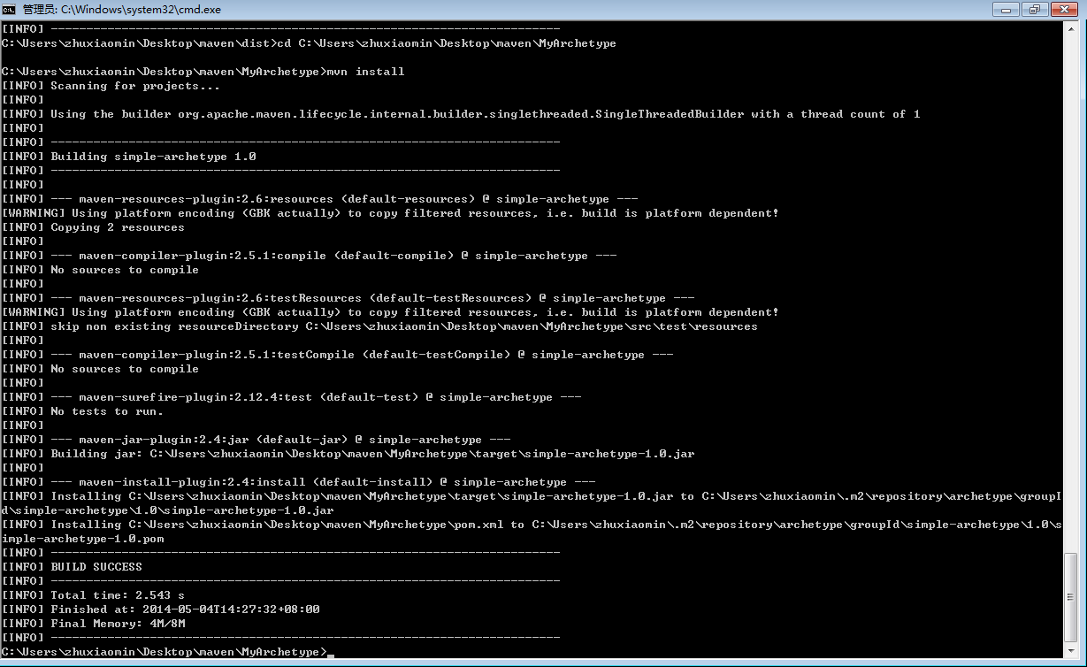

1. Execute below command to invoke the generate archetype for new structure creation.

mvn archetype:generate -DgroupId=com.mycompany.app -DartifactId=my-app -DinteractiveMode=false -DarchetypeArtifactId=simple-archetype -DarchetypeGroupId=archetype.groupId -DarchetypeVersion=1.0 -DarchetypeCatalog=local

Below screenshot shows the generated file structure.

