Rational rose practical tips
VERSION: 1.0

SAI K MUPHARAPHU
DESIKAN SANTHANAM
YEZDI PARVEZ

PURPOSE: To help get started quickly on using the tool, with out re-inventing the wheel.

1) Are there any special setups required before you start the object modeling using Rose?

If the goal is to generate code using the tool and the implementation language has been decided, set this language as the Model’s default language. It is important that this is done before starting to model because setting the default language does not affect existing classes or components.
If most or all of the classes and components your are creating in your model will be Java classes, you may want to set your model’s default language to Java. When you do this, each class and component you create will be a Java class or component by default. To set the default language to Java:

Verify that the Java Add-In is active by selecting Add-In Manager from the Add-Ins menu. Activate it, if it is not currently active.

Click Tools > Model Properties >Edit.

Click the Notation Tab in the Model Properties dialog.

Select Java from the Default Language list.

- What is the difference between an Association and an Aggregation?

Association represents the ability of one instance to send a message to another instance. This is typically implemented with a pointer or reference instance variable, although it might also be implemented as a method argument, or the creation of a local variable.
[Example:]
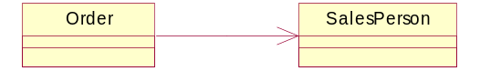

class Order
{
private SalesPerson salesPerson;
};

Aggregation is the typical whole/part relationship. This is exactly the same as an association with the exception that instances cannot have cyclic aggregation relationships (i.e. a part cannot contain its whole).
[Example:]

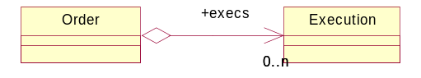

class Order
{

private SalesPerson salesPerson;
private Execution[] execs;
};

Note that the role specified for the Execution in the aggregation relation becomes the name of the data member in the Order class, during code generation.

- What are the guidelines on Naming Conventions?

Naming Convention Guidelines

- Class Naming Convention

The naming of the class should adhere to the following conventions:
- Class Name should be a noun. Verbal names should not be used.
- Class Names should be related to business objects. For example, ‘Trade’ class represents the business object Trade.
- For Interfaces the name of the class should be an Adjective. For example, Runnable, MessageListener, ActionListener, ChargeEligible, etc. Now if charges are applied to the class Order and it implements interface ChargeEligible then we can say that an Order is a ChargeEligible Order.

- Attribute Naming Convention
- The attribute name should the preceded by an ‘m_’ to denote that it’s a member variable of the class.
- The attribute name should start with a lower case for the first word after the m_ pre-tag. For example, the attribute buy/sell code in the class ‘Order’ should be declared as ‘m_buySellCode’ and not as ‘m_BuySellCode’. If the attribute has a single word for example quantity of the order in the class ‘Order’ it should be declared as ‘m_quantity’ and not as ‘m_Quantity’.
- The attribute name should be precise and informative. For example, to specify the attribute ‘id’ in the Order class the attribute should be ‘m_id’ (this is what my thinking is, instead of m_orderId). The same goes for any other class say Execution that will also have an attribute ‘id’ should be named as ‘m_id’ and not m_executionId. This is the most common practice that developers follow to include the class name in the attribute, though it is not needed. This explains the preciseness part of the attribute. As far as the information aspect goes the attribute name should be full and not an acronym. For example the Account Mnemonic in class Account should be declared as m_mnemonic and not m_mnc. If the same is in the case of class Order then it should be declared as m_accountMnemonic and not m_actMnc.

- Method Naming Convention

- Member Functions should be named using a full English description, using mixed case with the first letter of any non-initial word capitalized. It is also common practice for the first word of a member function name to be a strong, active verb. e.g.
openAccount()
printMailingLabel()
save()
delete()

- Accessor and Mutator functions.

Accessors are member functions that return the value of a field. You should prefix the word ‘get’ to the name of the field, unless it is a Boolean field and then you prefix ‘is’ to the name of the field instead of ‘get’. For example:
getFirstName()
getAccountNumber()
isPersistent()

Mutators are member functions that modify the values of a field. You should prefix the word ‘set’ to the name of the field, regardless of the field type.
setFirstName(String aName)
setAccountNumber(int anAccountNumber)
setPersistent(boolean isPersistent)

Here is a sample Trade class that shows all the conventions.

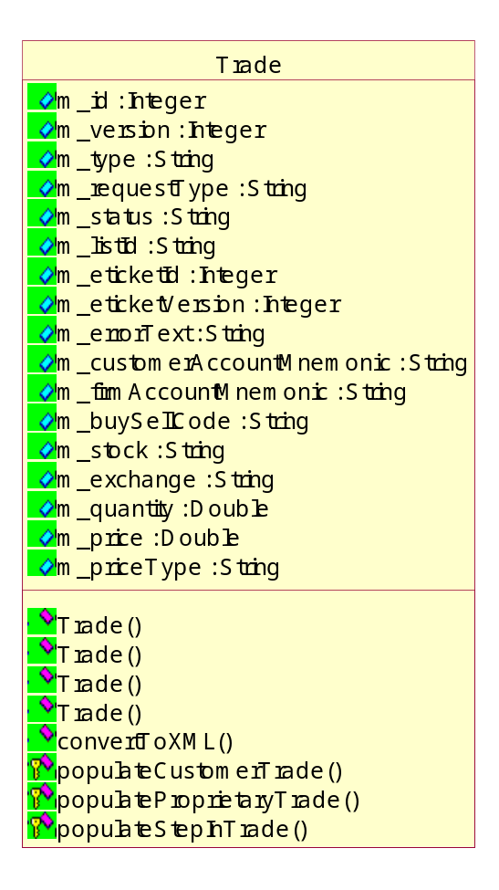

4) How to put in numbering for the calls in a sequence diagram?

Click on TOOLS/OPTIONS/DIAGRAM and check the sequence numbering checklist box to on.
This provides a better understanding of the calls in the sequence diagram

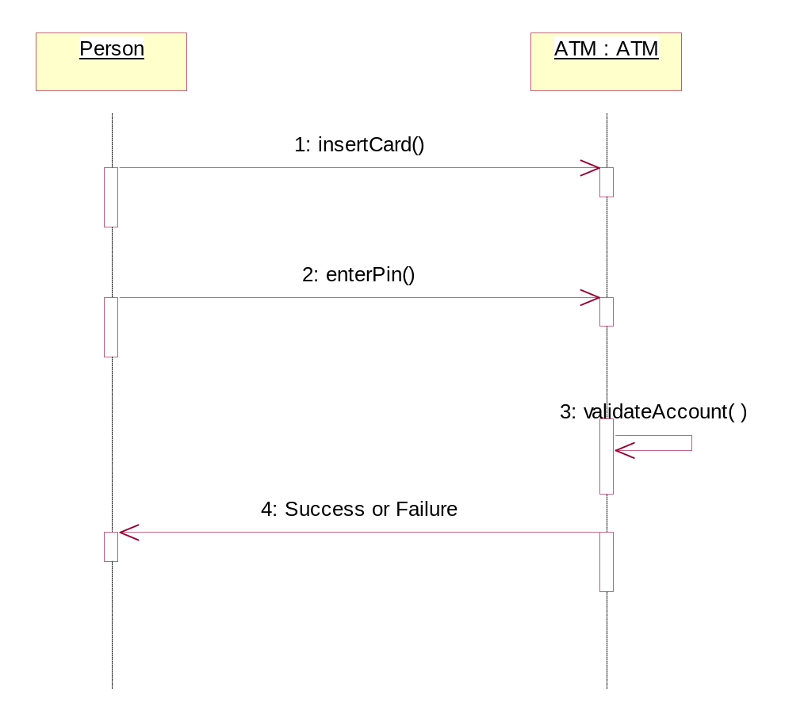

5) How to load Java Units in to the Model

Click on File/Import to load the units

Select the path of J:\apps_pub\rosj0210\rational\Rose\framework\frameworks\ShareComponents and pick the category file that you want to load.

Change Control

Version | Description | Change Authors | Reviewed By | Date
1.0 | Practical Tips | Desikan, Yezdi, Sai | Sridhar Patoori | 07/22/2002

