Node.js and Express.js Part 1: Sample Project Install
CIS237-01 Advanced Web Programming | Digenova
Step 1: Verify Node.js and npm are installed (node -v and npm -v)
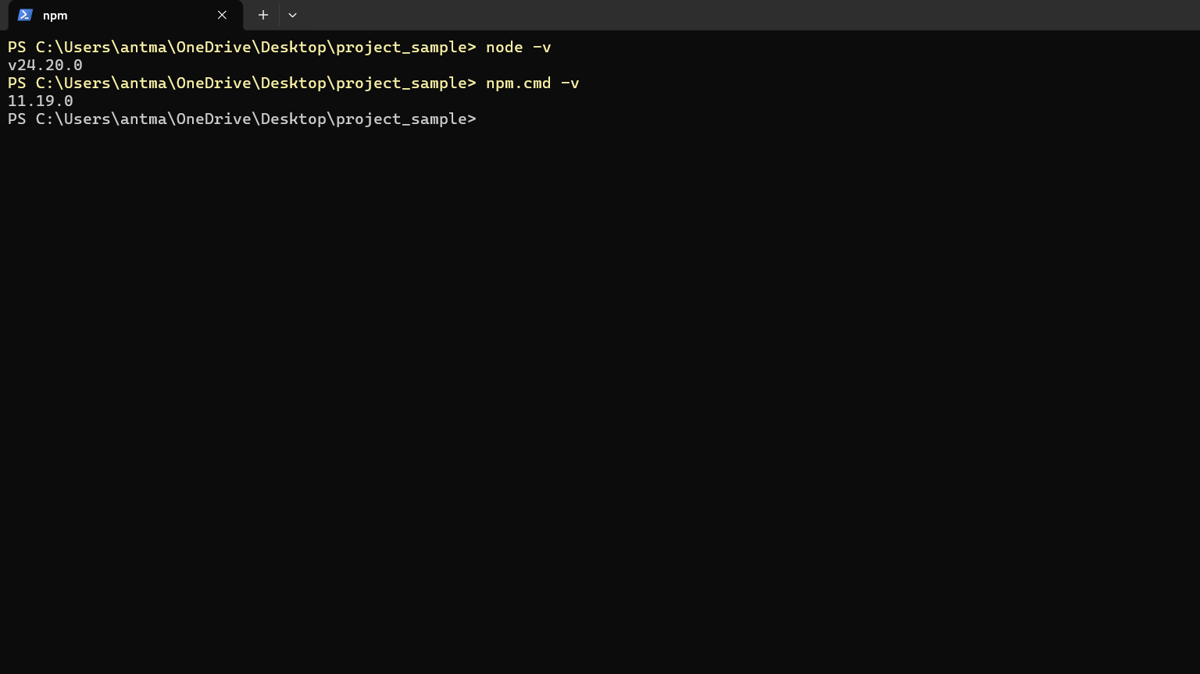
Step 2: Create package.json in the sample project with npm init -y
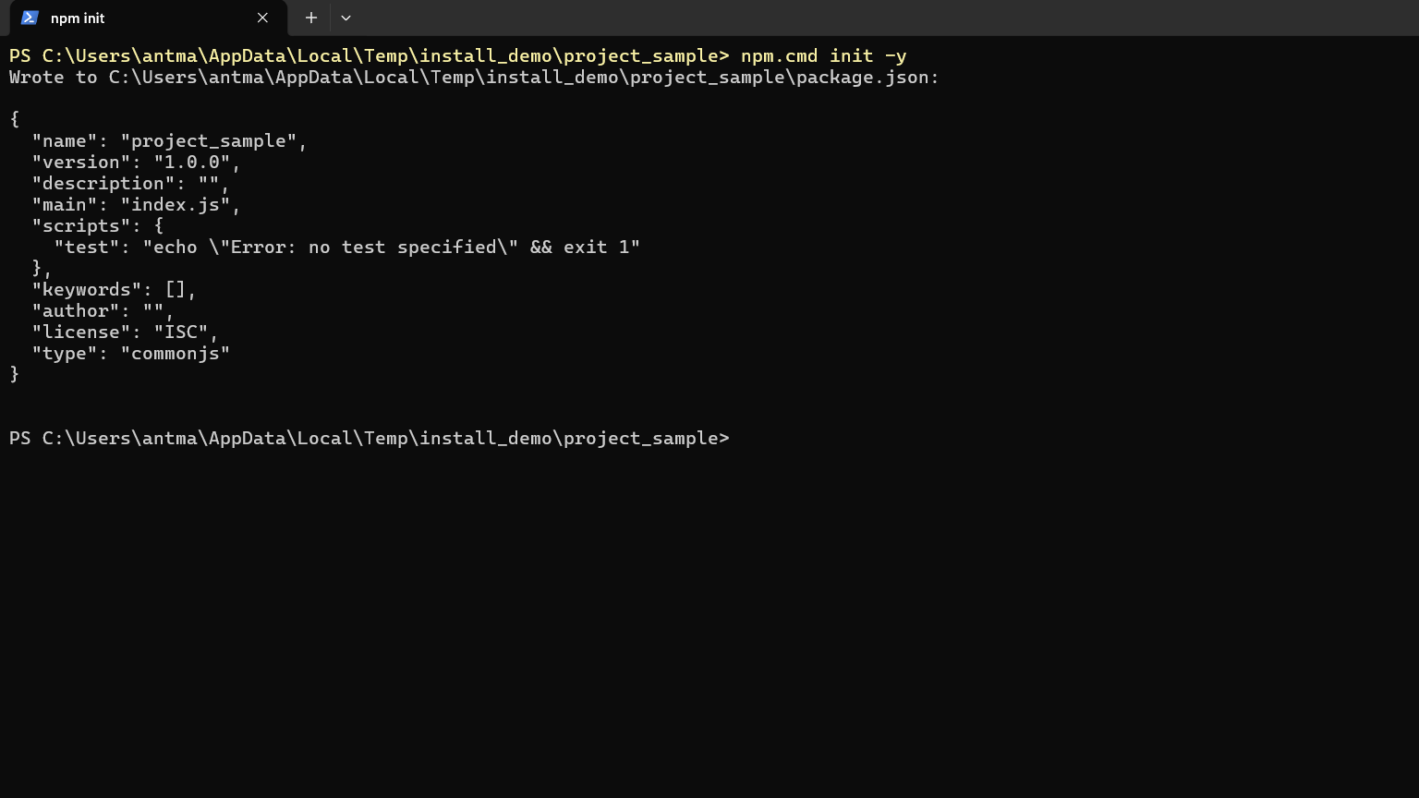

Step 3: Confirm the new package.json file exists and view its default template
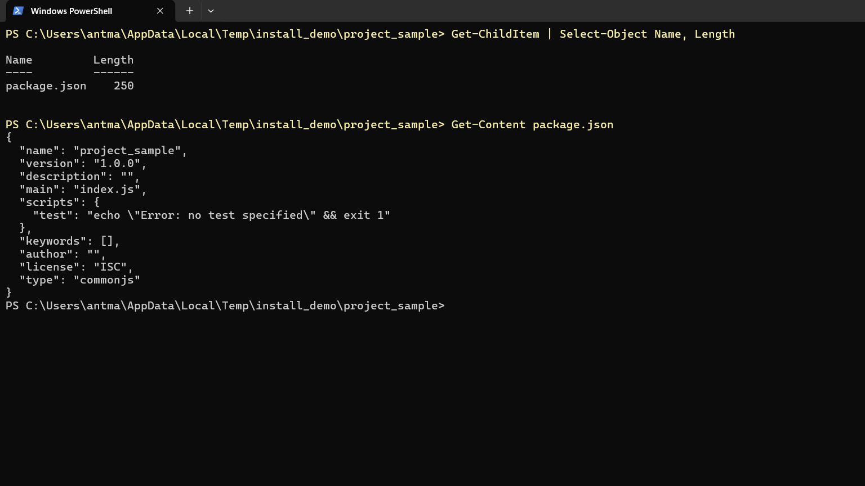
Step 4: Install the Express web server framework with npm install express
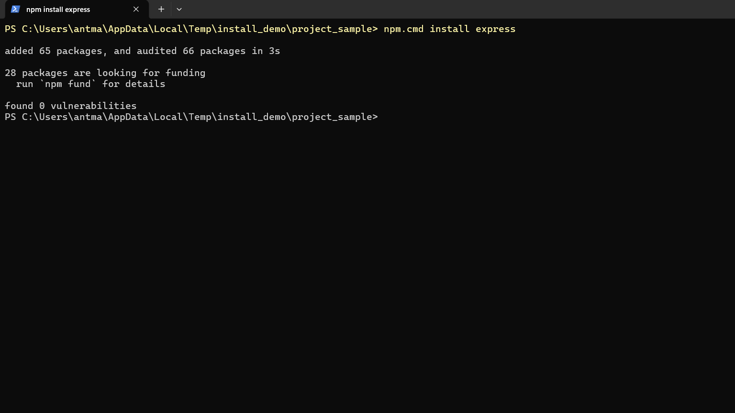

Step 5: package.json now lists Express under dependencies
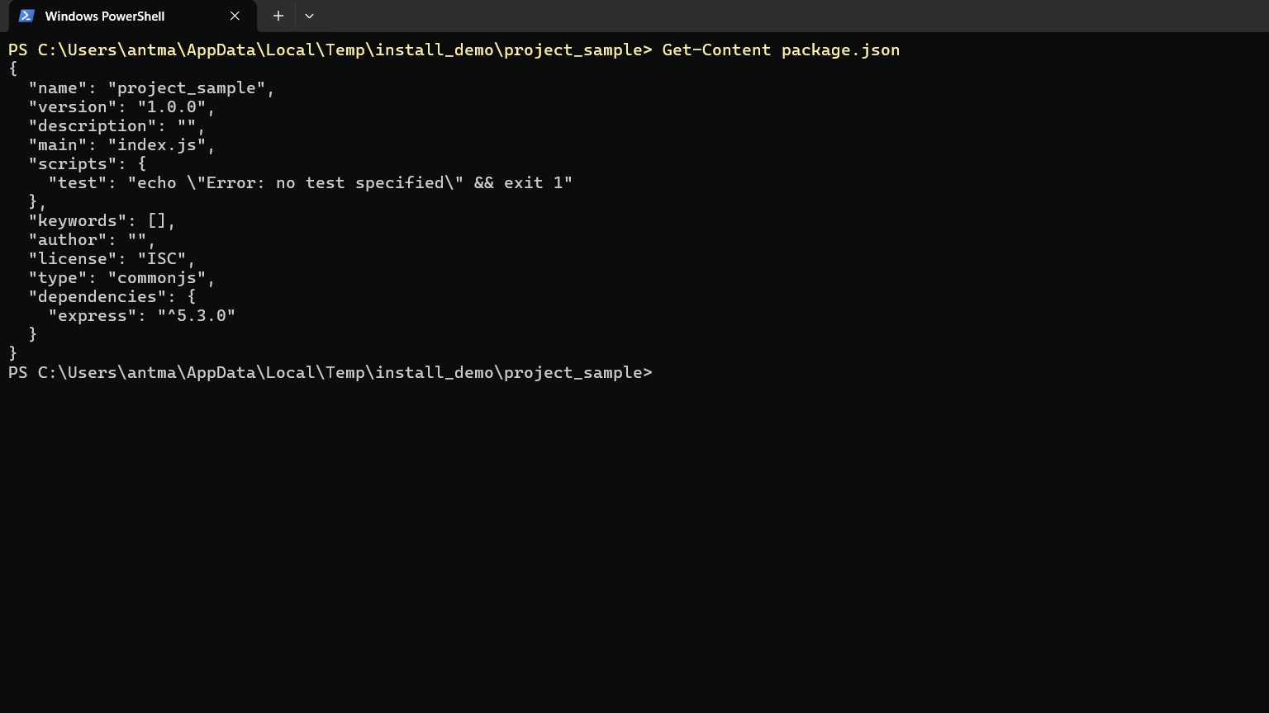
Step 6: Project directory structure (index.html, css, js, assets, package.json, server.js)
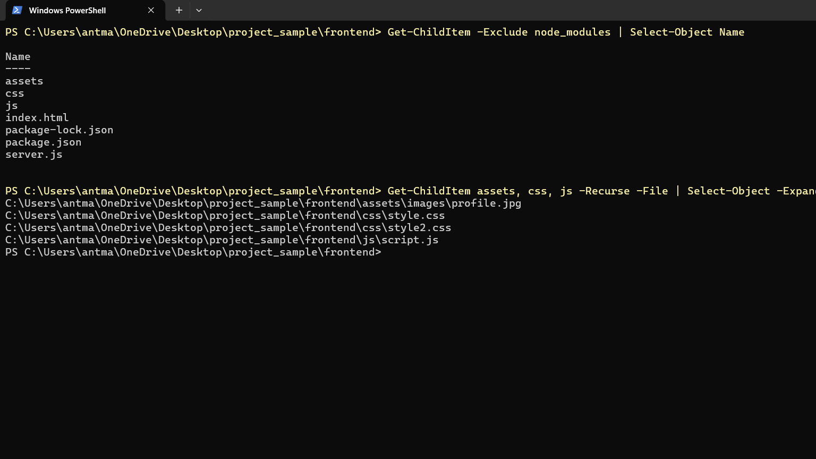

Step 7: package.json configuration with Express, nodemon, and the start/dev scripts
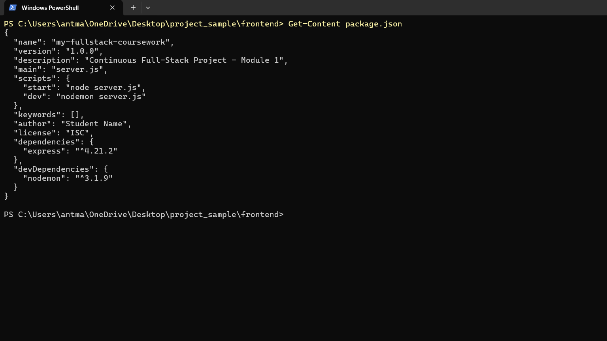
Step 8: Install the project dependencies with npm install
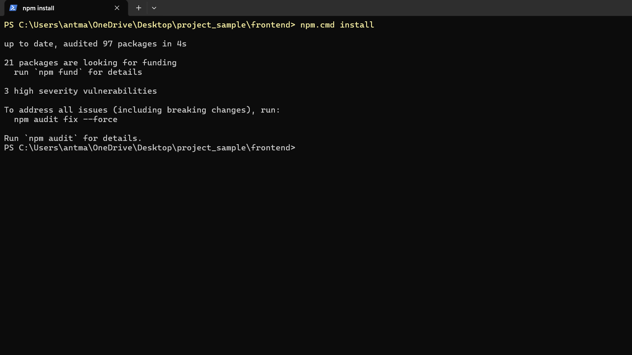

Step 9: The server.js file that serves the project with Express
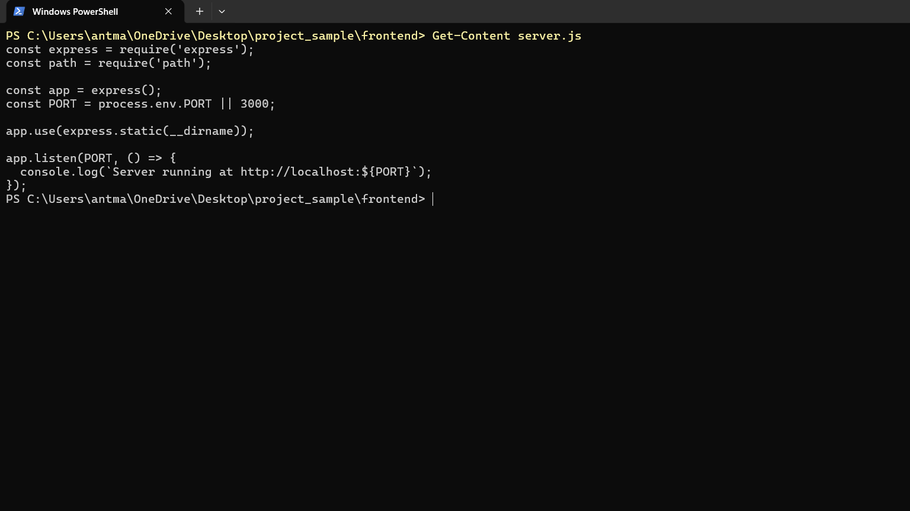
Step 10: Start the server with node server.js (running on http://localhost:3000)
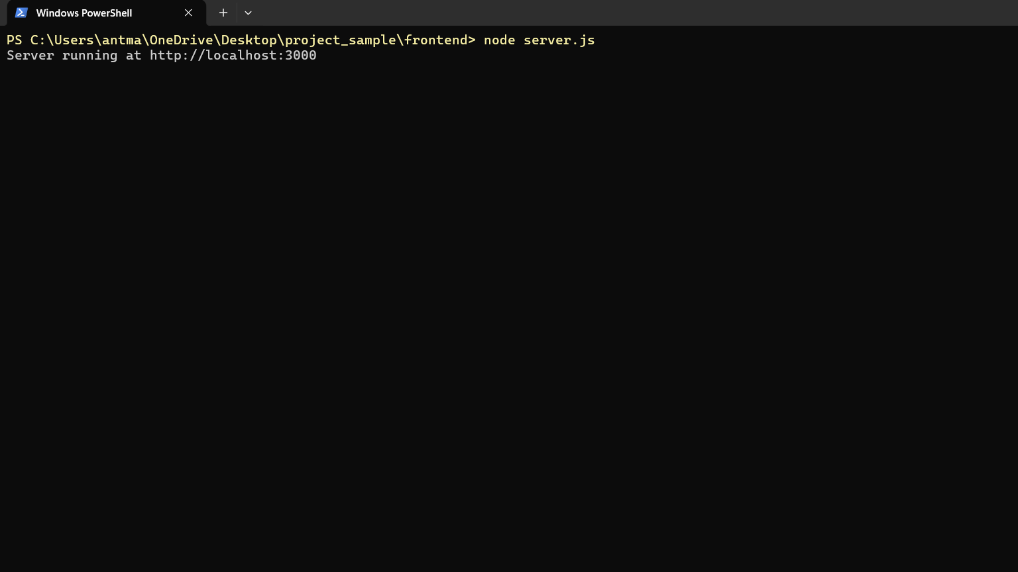

Step 11: The sample project page served in the browser at http://localhost:3000
