**Data Visualization Lecture Preparation**

**AHEaD Program 2021**

Instructor: Margaret Antonio antmarge@stanford.edu

For the Data Visualization Lecture, you will need to do the following:

1. Install R
2. Install Rstudio
3. Inside of Rstudio, install package: tidyverse

*Before the installation instructions, read through these frequently asked questions!*

**What is R and what is Rstudio?**

R is the programming language we will be using. You may be familiar with other programming languages, such as python and java. Rstudio is a graphical user interface (GUI) for coding in R. It has a nice user interface where you can see your code, plots, search for functions, etc. Rstudio uses R.

**What do I need to download R and Rstudio?**  
You’ll need a laptop or computer that allows you to download software.

**I can’t download software on my device (E.g. I’m using a shared computer or a tablet**)

That’s fine! If you have access to an internet browser, you can use the rstudio cloud server online for free <https://rstudio.cloud>. Make an account, create a workspace, and start a new project. You should see a window like the screenshot below.

**The instructions below are not detailed enough. Where do I find more detailed instructions about downloading R and Rstudio?**

Here is a much more detailed explanation of how to download R and Rstudio for Mac, Windows, and Linux operating systems: <https://rstudio-education.github.io/hopr/starting.html>

**Something is not working. What do I do?**

1. For R and Rstudio installation, first[check the link above](https://rstudio-education.github.io/hopr/starting.html) to see if there are any more details that might be helpful.
2. For the tidyverse library installation, check that everything is spelled correctly.
3. Search any error messages or problems online to see what you can do
4. Contact me for help (or skip to #5)
5. Use [Rstudio server online](https://rstudio.cloud/) (mentioned in the beginning of this document)
6. Worst case scenario, we will be working in groups so you can still participate if you didn’t get the installation working in time.

Installation Instructions

1. **To download R**
   1. Go to this link: <https://cran.r-project.org>
   2. Click on the one corresponding to your operating system. E.g. if you’re using a Mac then click on [Download R for macOS](https://cran.r-project.org/bin/macosx/)
   3. Follow the directions to download the appropriate version for your operating system version. Click on the package link that corresponds to the version of your operating system. For mac: to figure out what your operating system version is, click on the apple logo in the top left of your window and select “About this Mac”. The version should be something like MacOS 10.xx. *For more detailed instructions for Mac, Windows, Linux, read this:* [*https://rstudio-education.github.io/hopr/starting.html*](https://rstudio-education.github.io/hopr/starting.html)
   4. Follow the installer package instructions
   5. If the install is successful, you should be able to open an “R” window as you would for any other software program / application (see screenshot below). Type 2+2 and press enter.

1. **To download Rstudio**
   1. Go [here](https://www.rstudio.com/products/rstudio/download/#download) and click the download link corresponding to your operating system: <https://www.rstudio.com/products/rstudio/download/#download> (note this is the free desktop version)
   2. Follow the install instructions. Should be similar to installing other software.
   3. Open Rstudio. It should look like the screenshot below (Image source: [here](https://rstudio-education.github.io/hopr/starting.html))
   4. Type 2+2 in the windowpane that says “Console”. Press enter. This Console pane should look like the R window we opened earlier. However, note that in Rstudio, there are other panes for Files, Plots, History, Etc.

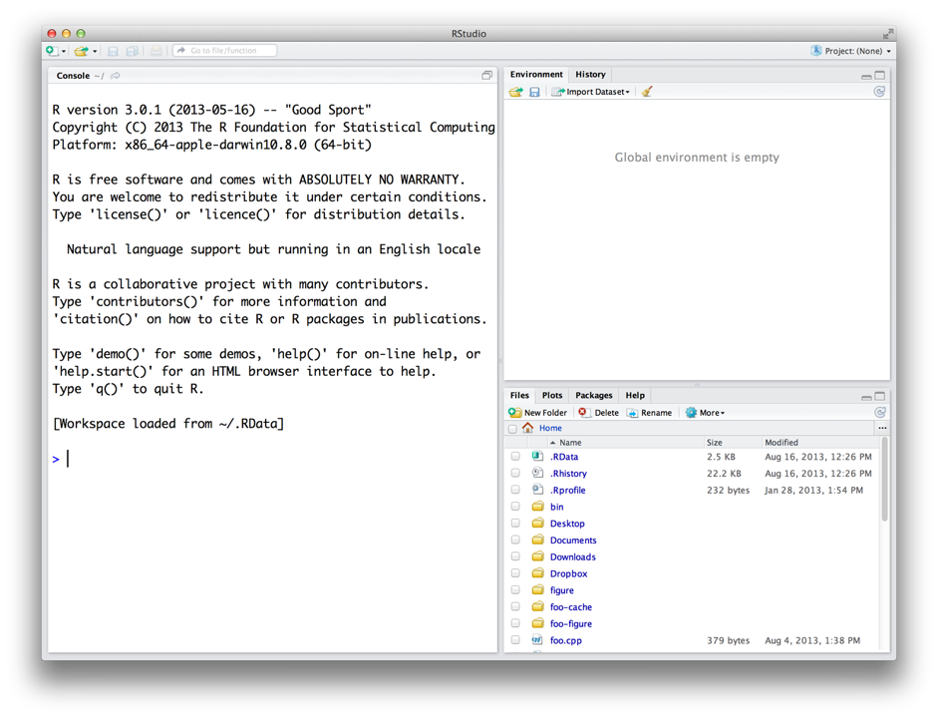

1. **Download R packages inside of Rstudio**
   1. **What are packages?** Packages are like extensions or expansions of the basic R programming language. They can contain many different things from statistical functions to preset color palettes.
   2. In Rstudio: navigate to the windowpane that says “Console” at the top. There should be a “>”. This is the prompt. It means it’s ready to accept a command. (If there is a “+” then clear it by pressing escape or Ctrl-C)
   3. Install the tidyverse package (<https://tidyverse.tidyverse.org>) by entering **install.packages(‘tidyverse’)** at the prompt. Check the spelling carefully. If you copy-paste from this document, you may need to remove and reinsert the quotation marks (single or double works).
   4. **What are these messages?** It should output a lot of messages detailing the installation process. This is fine. It’s also ok if it says there are conflicts. Warning messages are ok. Error messages mean the install did not work. Copy the Error message and search it in Google and see what’s suggested.
   5. Once it’s done installing, load the tidyverse library by entering **library(tidyverse)** on the prompt line. Again, it’s ok if it lists conflicts. If it says there is no library called tidyverse, check the spelling carefully and check that the install did complete without any Error messages.