

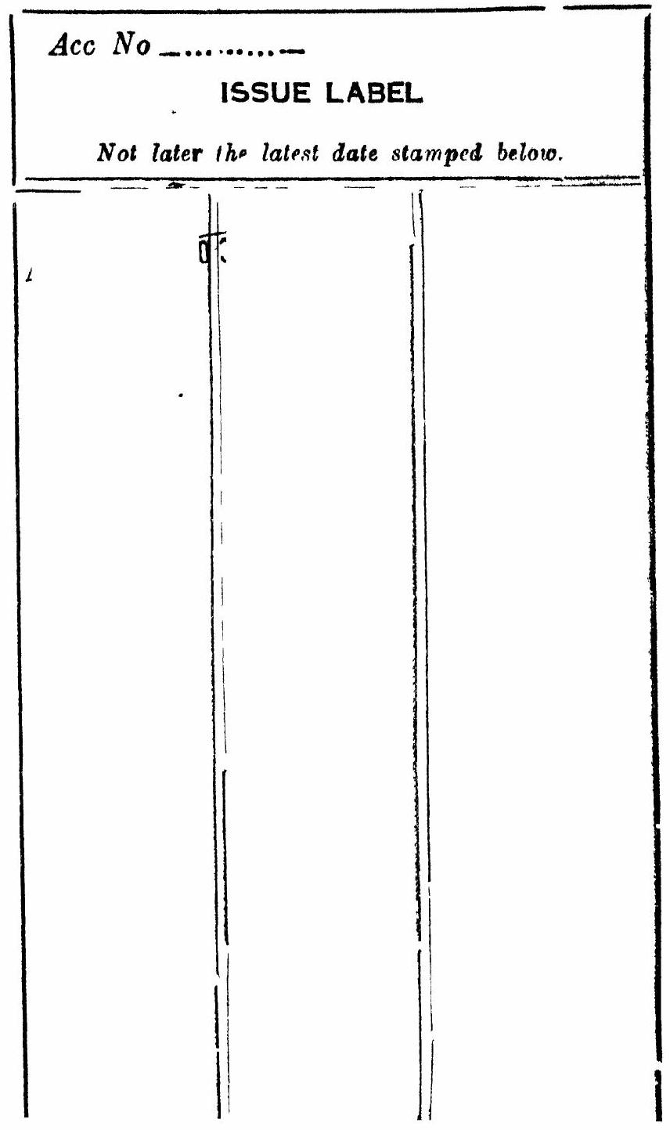
A TREATISE
ON
\title{ ELECTRICITY AND MAGNETISM
}
MAXWELL
VOL. I.
A TREATISE
ON
ELECTRICITY AND MAGNETISM
BY
JAMES CLERK MAXWELL, M.A.
LL.D. EDIN., D.C.L., F.R.SS. LONDON AND EDINBURGH
HONORARY FELLOW OF TRINITY COLLEGE
AND LATE PROFESSOR OF EXPERIMENTAL PHYSICS IN THE UNIVERSITY OF CAMBRIDGE
VOL. I
THIRD EDITION
First Edition 1873
Second Edition 1881
Tuird Edition 1892 ; Reprinted 1904
Reprinter? photographically in Great Britain in 1937, 1946 by LOWE & BRY DONE, PRINTERS, LTD., LONDON, from sheets of the third edition
PREFACE TO THE FIRST EDITION
THE fact that certain bodies, after being rubbed, appear to attract other bodies, was known to the ancients. In modern times, a great variety of other phenomena have been observed, and have been found to be related to these phenomena of attraction. They have been classed under the name of Electric phenomena, amber, ήλεκτρον, having been the substance in which they were first described.
Other bodies, particularly the loadstone, and pieces of iron and steel which have been subjected to certain processes, have also been long known to exhibit phenomena of action at a distance. These phenomena, with others related to them, were found to differ from the electric phenomena, and have been classed under the name of Magnetic phenomena, the loadstone, μάγνης, being found in the Thessalian Magnesia.
These two classes of phenomena have since been found to be related to each other, and the relations between the various phenomena of both classes, so far as they are known, constitute the science of Electromagnetism.
In the following Treatise I propose to describe the most important of these phenomena, to shew how they may be subjected to measurement, and to trace the mathematical connexions of the quantities measured. Having thus obtained the data for a mathematical theory of electromagnetism, and
having shewn how this theory may be applied to the calculation of phenomena, I shall endeavour to place in as clear a light as I can the relations between the mathematical form of this theory and that of the fundamental science of Dynamics, in order that we may be in some degree prepared to determine the kind of dynamical phenomena among which we are to look for illustrations or explanations of the electromagnetic phenomena.
In describing the phenomena, I shall select those which most clearly illustrate the fundamental ideas of the theory, omitting others, or reserving them till the reader is more advanced.
The most important aspect of any phenomenon from a mathematical point of view is that of a measurable quantity. I shall therefore consider electrical phenomena chiefly with a view to their measurement, describing the methods of measurement, and defining the standards on which they depend.
In the application of mathematics to the calculation of electrical quantities, I shall endeavour in the first place to deduce the most general conclusions from the data at our disposal, and in the next place to apply the results to the simplest cases that can be chosen. I shall avoid, as much as I can. those questions which, though they have elicited the skill of mathematicians, have not enlarged our knowledge of science.
The internal relations of the different branches of the science which we have to study are more numerous and complex than those of any other science hitherto developed. Its external relations, on the one hand to dynamics, and on the other to heat, light, chemical action, and the constitution of bodies, seem to indicate the special importance of electrical science as an aid to the interpretation of nature.
It appears to me, therefore, that the study of electromagnetism in all its extent has now become of the first importance as a means of promoting the progress of science.
The mathematical laws of the different classes of phenomena have been to a great extent satisfactorily made out.
The connexions between the different classes of phenomena have also been investigated, and the probability of the rigorous exactness of the experimental laws have been greatly strengthened by a more extended knowledge of their relations to each other.
Finally, some progress has been made in the reduction of electromagnetism to a dynamical science, by shewing that no electromagnetic phenomenon is contradictory to the supposition that it depends on purely dynamical action.
What has been hitherto done, however, has by no means exhausted the field of electrical research. It has rather opened up that field, by pointing out subjects of enquiry, and furnishing us with means of investigation.
It is hardly necessary to enlarge upon the beneficial results of magnetic research on navigation, and the importance of a knowledge of the true direction of the compass, and of the effect of the iron in a ship. But the labours of those who have endeavoured to render navigation more secure by means of magnetic observations have at the same time greatly advanced the progress of pure science.
Gauss, as a member of the German Magnetic Union, brought his powerful intellect to bear on the theory of magnetism, and on the methods of observing it, and he not only added greatly to our knowledge of the theory of attractions, but reconstructed the whole of magnetic science as regards the instruments used, the methods of observation, and the calculation of the results, so that his memoirs on Terrestrial Magnetism may be taken as models of physical research by all those who are engaged in the measurement of any of the forces in nature.
The important applications of electromagnetism to telegraphy have also reacted on pure science by giving a commercial value to accurate electrical measurements, and by affording to electricians the use of apparatus on a scale which greatly transcends that of any ordinary laboratory. The consequences of this demand for electrical knowledge, and of these experimental opportunities for acquiring it, have been already very great, both in stimulating the energies of ad-

