Functions of Several Variables
Functions of Several Variables
A function of two variables is a rule which assigns for each ( $x,y$ ) in a domain $D⊂R^{2}$ a real number $z=f(x,y)$.
A function of two variables can be given by a formula, a graph or a table.
Formula: $f(x,y)=x^{2}+y^{2}$
Graph: $\{(x,y,z)∣(x,y)∈D$ and $z=f(x,y)\}$
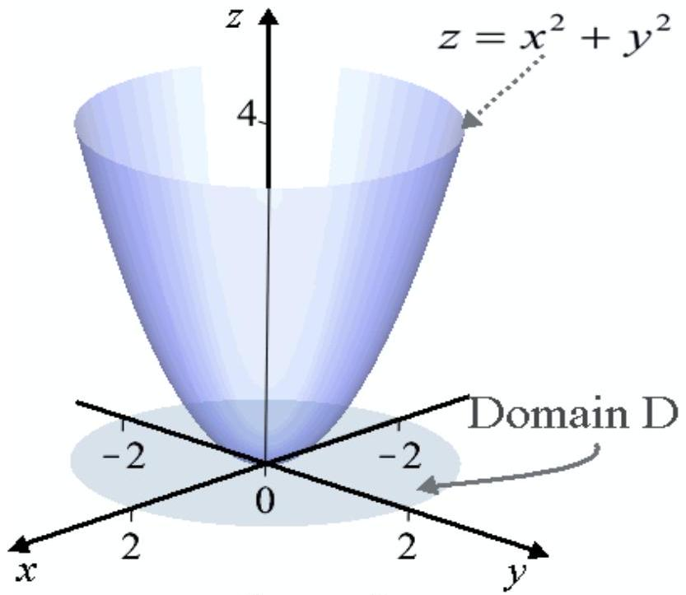
Graph of $z=x^{2}+y^{2}$ in the domain
$$D=\left\{(x,y)∣x^{2}+y^{2}≤4\right\}$$
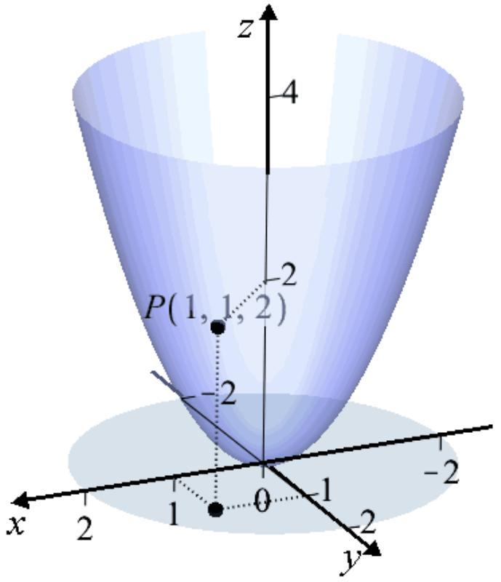
Since $f(1,1)=2$, the point $P(1,1,2)$ is on the graph of $f$.
Functions of Several Variables
Table: $f(x,y)=x^{2}+y^{2}$
$$yx$$ | $$1$$ | $$2$$ | $$3$$ | $$4$$
$$−2$$ | 5 | 8 | 13 | 20
$$1$$ | 2 | 5 | 10 | 17
$$4$$ | 17 | 20 | 25 | 32

$$\begin{matrix}f(1,−2)=1^{2}+(−2)^{2}=5 \\ f(2,4)=2^{2}+4^{2}=20\end{matrix}$$
Functions of Several Variables
The Level Curves of the function are the curves with equation $f(x,y)=k$ projected down on the $xy$-plane. The graph of the level curves is called the contour plot
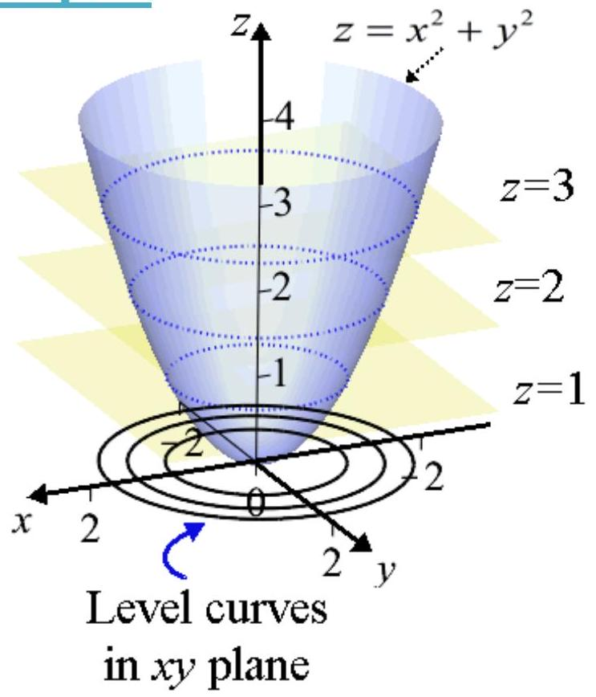
View from the top
Contour plot
of the function
$$f(x,y)=x^{2}+y^{2}$$
View from the top
Contour plot
of the function
$$f(x,y)=x^{2}+y^{2}$$
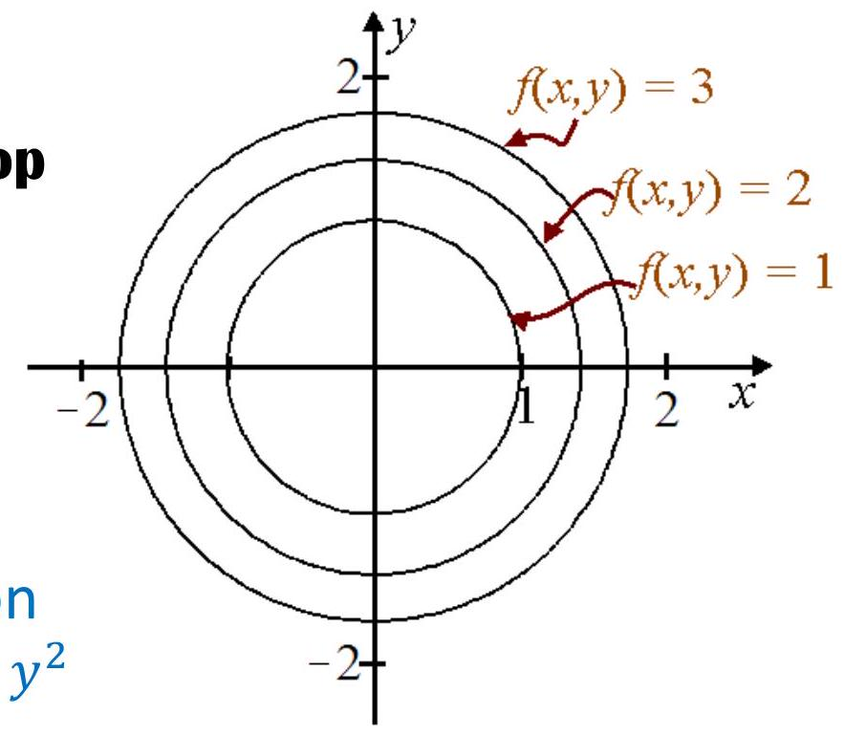
The level curves are the traces of the graph of $f$ in the horizontal planes $z=k$ projected in the $xy$-plane
$$f(x,y)=k− \begin{matrix}k=1: & \text{ circle } \\ k=2: & x^{2}+y^{2}=1 \\ k=3: & \text{ circle } \\ k=2 & x^{2}+y^{2}=2 \\ x^{2}+y^{2}=3\end{matrix}$$
Functions of Several Variables
Example of surface $z=f(x,y)$ with traces on the planes $z=k$ projected down in the $xy$-plane.
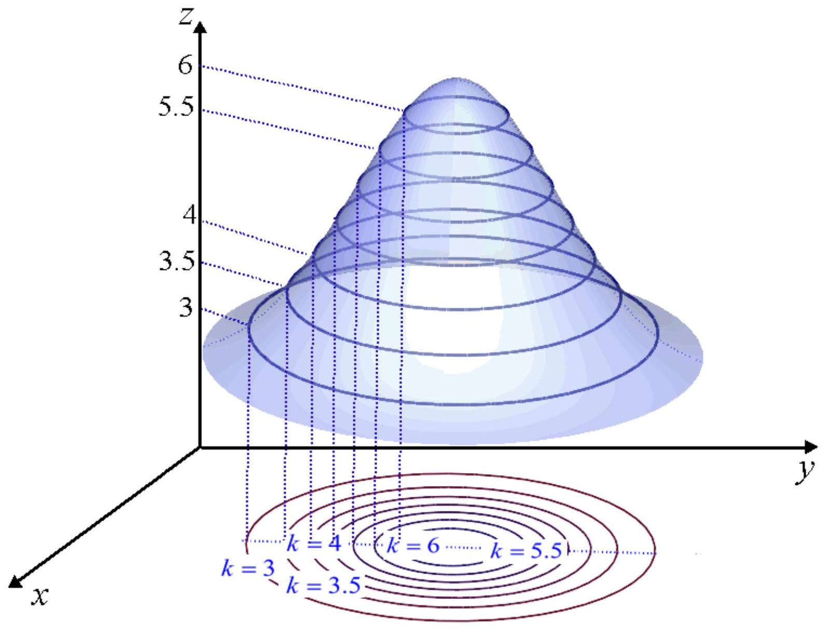
Functions of Several Variables
More Examples of contour plots:
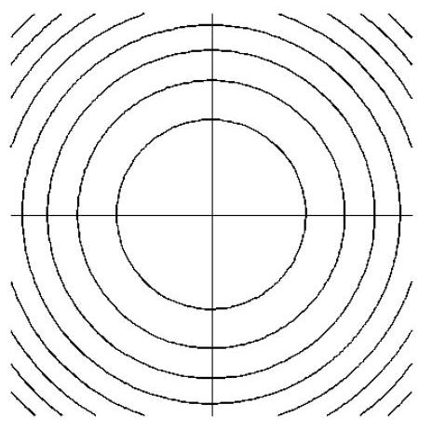

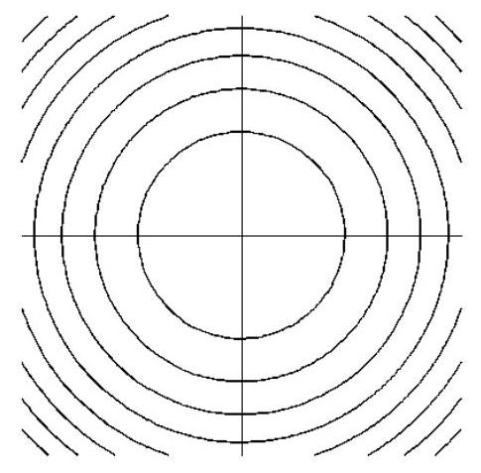

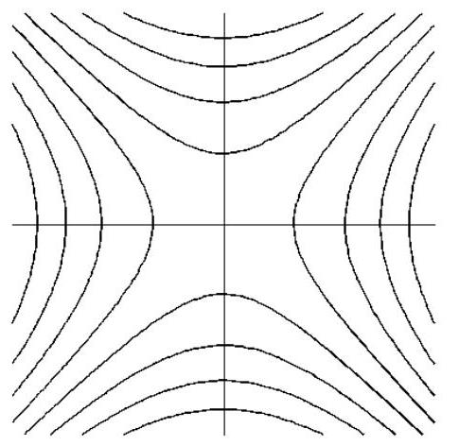

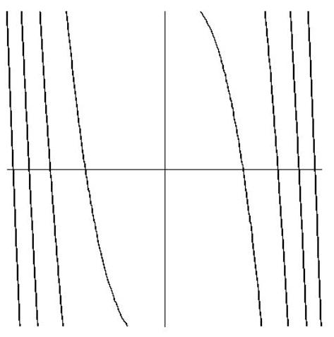

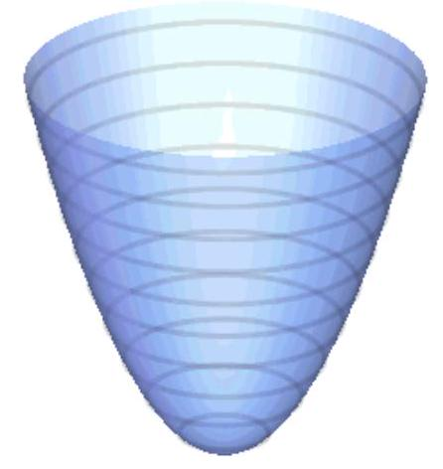
Concentric circles (ellipses): minimum
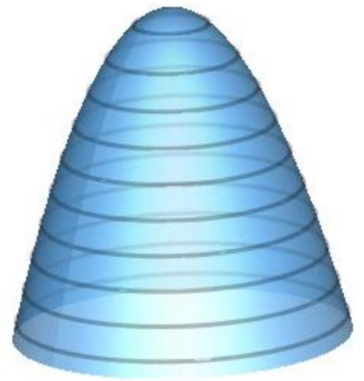
Concentric circles (ellipses): maximum
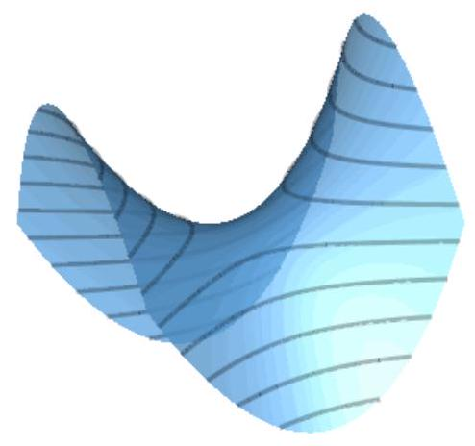
Hyperbolas: saddle point
Closely spaced contours: steep slope in 3D. Widely spaced contours: flat 3D surface.
Functions of Several Variables
Hyperbolic paraboloid (Saddle) $z=x^{2}−y^{2}$
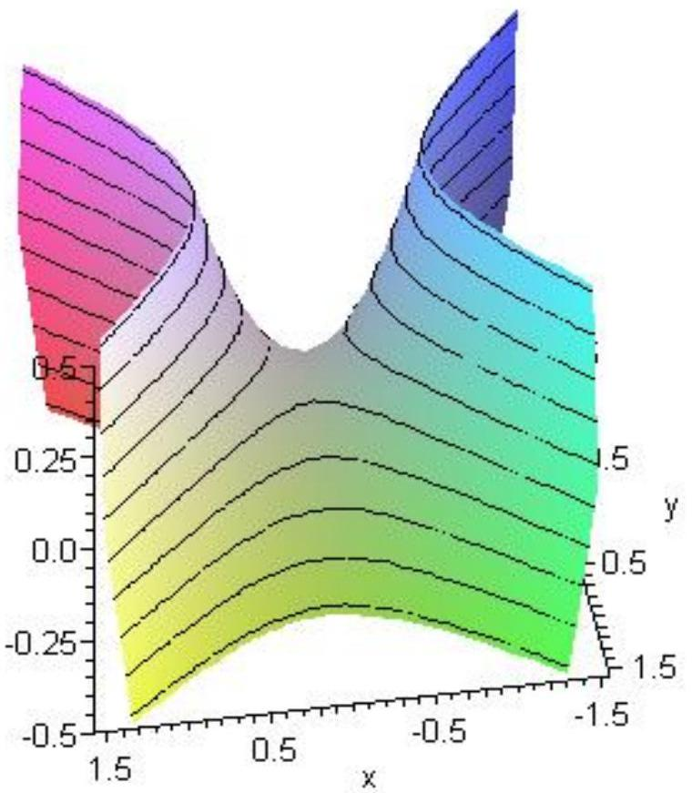
Level curves: $x^{2}−y^{2}=k$
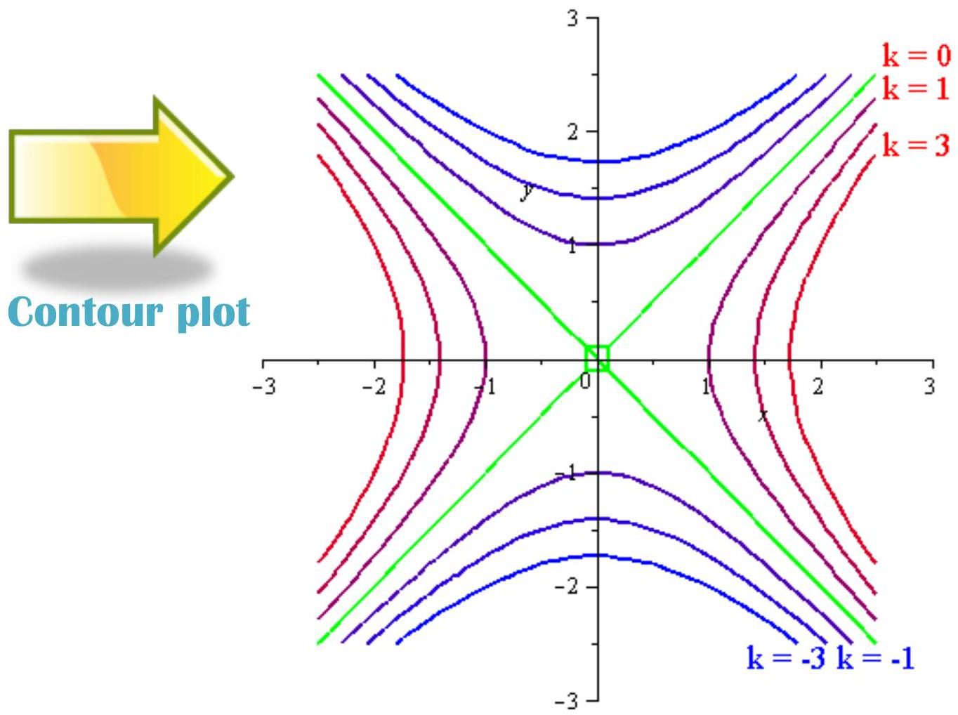
$k=0$ gives the asymptotes: $y=x$ and $y=−x$.
For all the other values of $k$ we get hyperbolas.
Note that the values of $k$ decrease as we approach the origin from the $x$-axis and they increase as we approach the origin from the $y$-axis.
Functions of Several Variables
Use the contour plot to identify maximum, minimum and saddle points of of the function
$$z=3(1−x)^{2}e^{−x^{2}−(y+1)^{2}}−10\left(\frac{x}{5}−x^{3}−y^{5}\right)e^{−x^{2}−y^{2}}−\frac{1}{3}e^{−(x+1)^{2}−y^{2}}+10$$
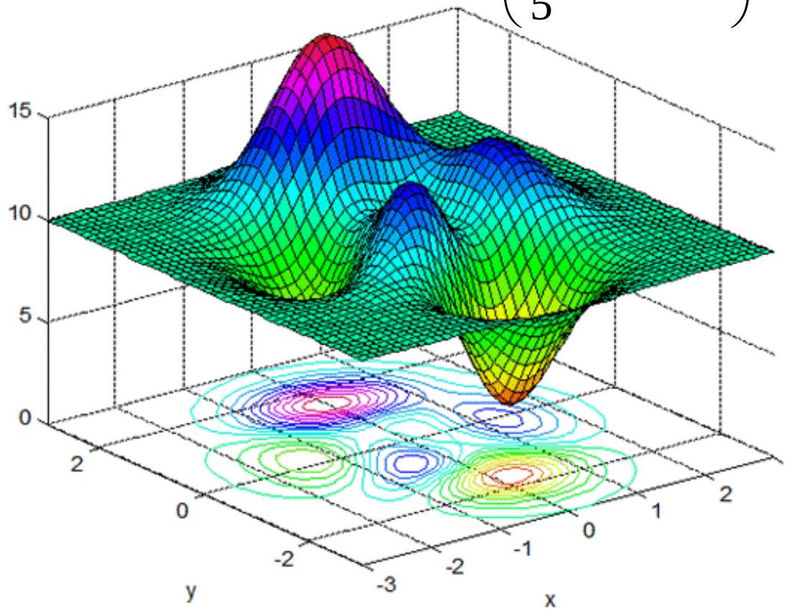
Local maxima:
$$(1.3,−0.005),(−.46,−.63),(−0.01,1.6)$$
Local minima:
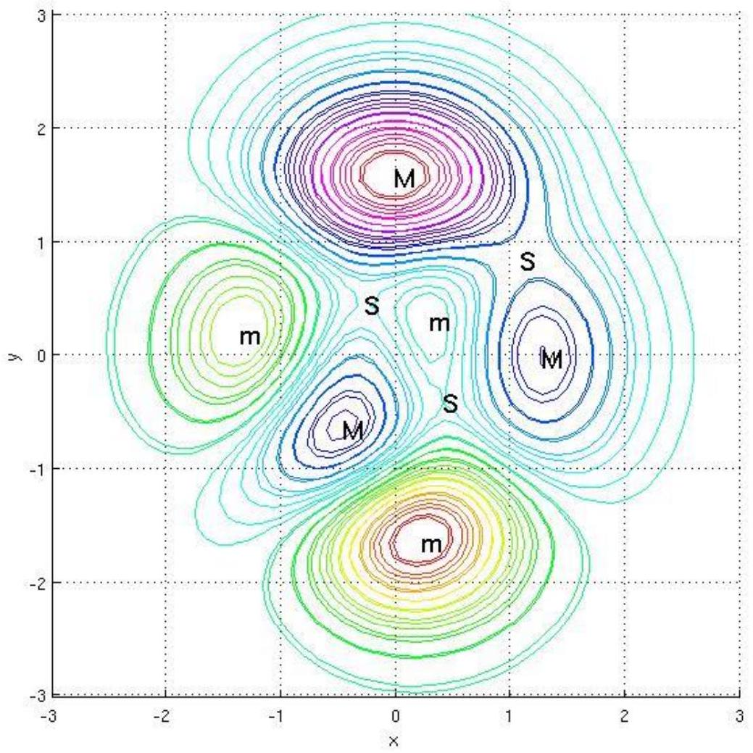
(.23,-1.6), (-1.3,.20), (.3,.3)
Saddle points:
(-.27,.47), (.42,-.39), (1.1,.85)
Functions of Several Variables
Unless otherwise specified, the Domain of the function $f(x,y)$ is the set of all points $(x,y)$ for which $f(x,y)$ is a well defined real number.
The Range of the function $f(x,y)$ is the set $\{z∣z=f(x,y)$ with $(x,y)∈$ Domain $\}$
Example: Find the domain: $f(x,y)=\frac{\sqrt{x−y+3}}{x+2}$
The function is defined when $x−y+3≥0$ and $x+2≠0$
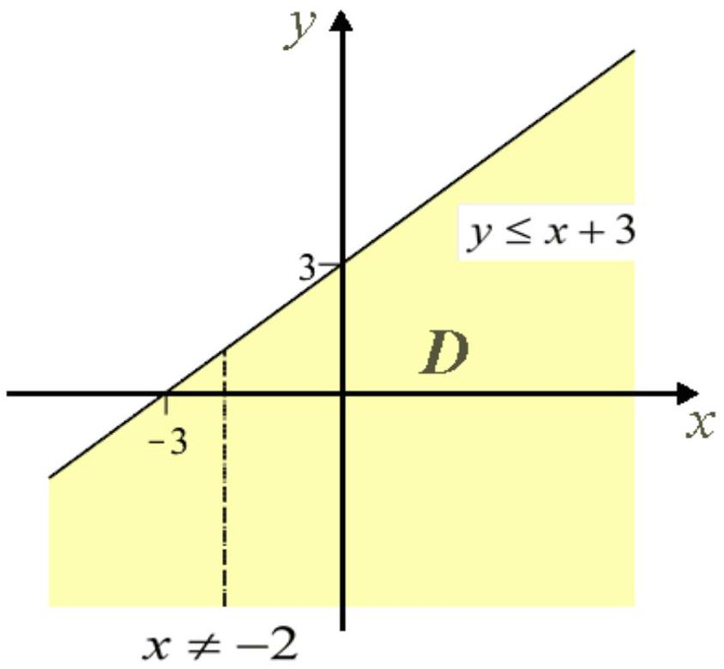
Functions of Several Variables
Example: Find domain and range: $f(x,y)=\sqrt{4−x^{2}−y^{2}}$
Domain:
$$4−x^{2}−y^{2}≥0⇒x^{2}+y^{2}≤4$$
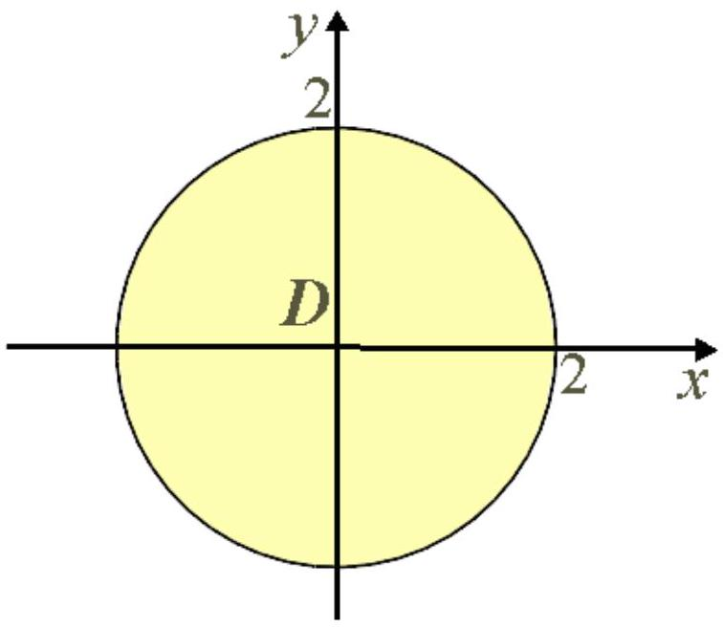
The surface is the top half of the sphere of radius 2 :
$$x^{2}+y^{2}+z^{2}=4$$
Range:
The largest value of $z$ is $\sqrt{4}=2$, obtained when $x=0$ and $y=0$.
On the other hand, the square root is always non negative, thus $z≥0$ and the range is the interval $[0,2]$
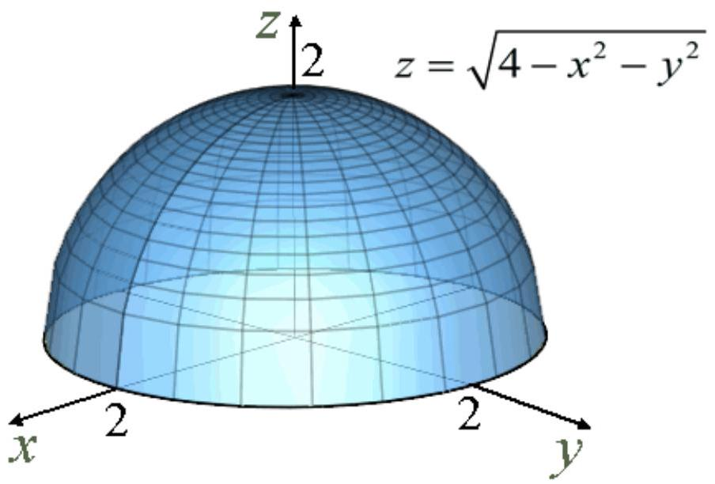
Function of Several Variables
A function of $n$ variables assigns a number $z=f\left(x_{1},x_{2},…,x_{n}\right)$ to an $n$-tuple $\left(x_{1},x_{2},…,x_{n}\right)$
Example: Consider the function of three variable $f(x,y,z)=x^{2}ln⁡(x−y+z)$
a) Evaluate $f(3,6,4)$
$$f(3,6,4)=3^{2}ln⁡(3−6+4)=9ln⁡(1)=0$$
b) Find the domain of $f$
$$D=\{(x,y,z)∣x−y+z>0\}$$
The plane $x−y+z=0$ divides the space in two parts. The part of space above the plane constitutes the domain of the function.
c) Find the range of $f$
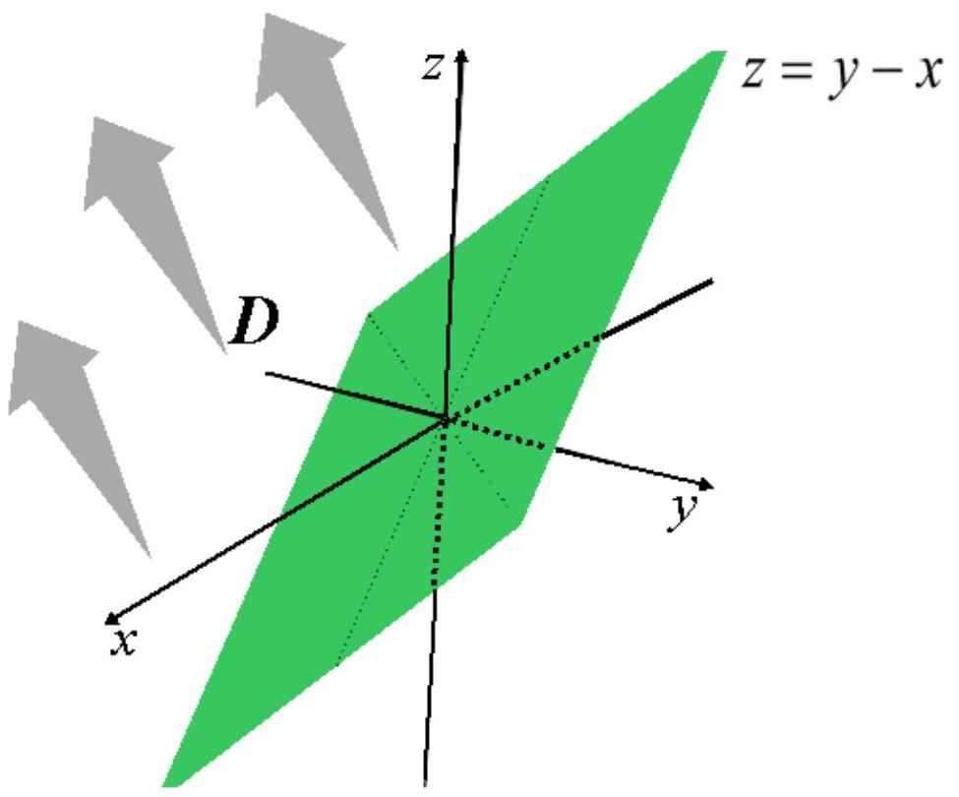
Since the natural logarithmic function takes on all possible real values, the domain of the function is $(−∞,∞)$
Function of Several Variables
Example: The temperature in a region where there is a heat source at the origin is given by
$$T=\frac{1000}{x^{2}+y^{2}+z^{2}}\text{ for }x^{2}+y^{2}+z^{2}≥1$$
We cannot graph this "surface" because we would need four dimensions, but if we set $T(x,y,z)=k$ with $k$ constant, we obtain level surfaces which in this context are isotherms.
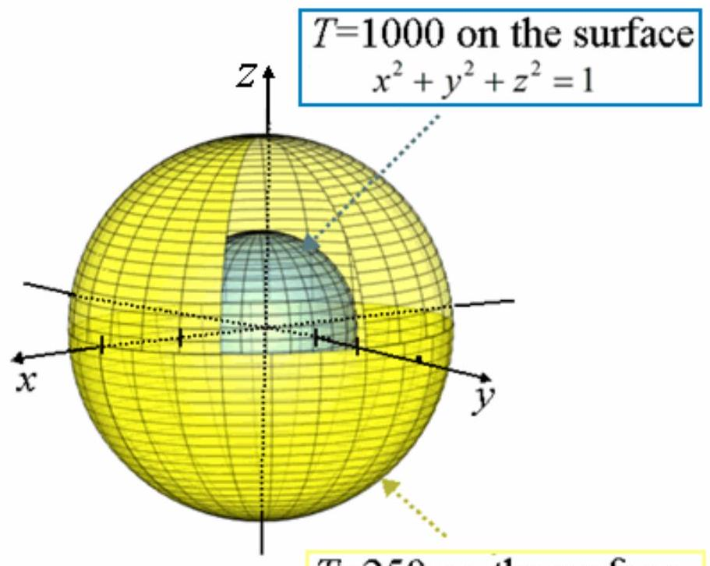
$T=250$ on the surface
$$x^{2}+y^{2}+z^{2}=4$$
$$\frac{1000}{x^{2}+y^{2}+z^{2}}=k$$
We can pick arbitrary values for $k$.
Let's pick $k=1000$ and $k=250$
$$\begin{matrix} & k=1000⇒\frac{1000}{x^{2}+y^{2}+z^{2}}=1000⇒x^{2}+y^{2}+z^{2}=1 \\ & k=250⇒\frac{1000}{x^{2}+y^{2}+z^{2}}=250⇒x^{2}+y^{2}+z^{2}=4\end{matrix}$$

