Calculation
The key is 64 bit long.
32 bits fixed and 32 bits variable.
Ignoring the initial combinations like “00 00 12 23 or 00 01 22 33”, the possible 2^32- 2^24 approx. 4billion.
Problem Statement (Formalized)
- Total possible combinations:
( N = 4,000,000,000 ) (≈ 4 billion)
- Valid passwords within that space:
( K = 65,000 ) : Assuming that newly commissioned system.
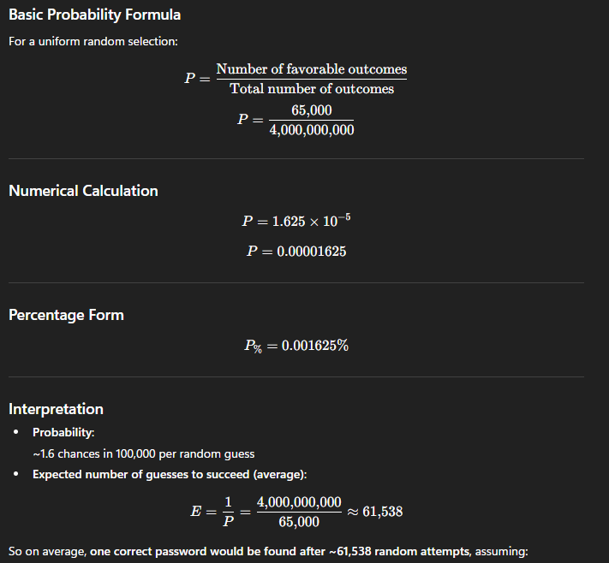

With the TI CC1101 Transceiver, 3 possible passwords per second is possible.
Considering 180 Passwords in a minute and 10,800 passwords per hour.
Possibility to unlock the system in around 6 hours.

