Spring IOC & Beans

Q1. You are tasked to create a product catalog system where user can add a product and display a product catalog. Design a Spring Data JPA entity for a product catalog. Include attributes for product name, price, and category. Implement a repository method to fetch all products of a specific category.

Steps:

The first restful URI. should display the html page where Two option should be there i.e. 1. Add product 2 Display product. where user can choose.

\* If a user clicks on Add product then should display the html page (product Info form )where user can enter name, price and category and users can click one submit button.

If a user clicks on Display product All product information should Display on webpage in tabular format

\* In backend use Spring Data JPA to create the necessary entity, repository, and service classes to store product information in a database.

Home Page:

'http://localhost:8080/'

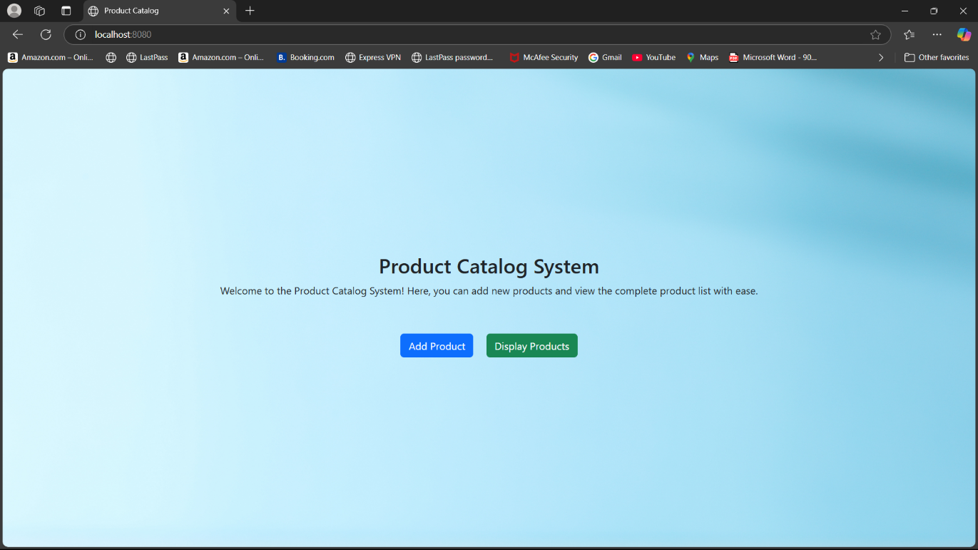

Add Product:

'/add-product'

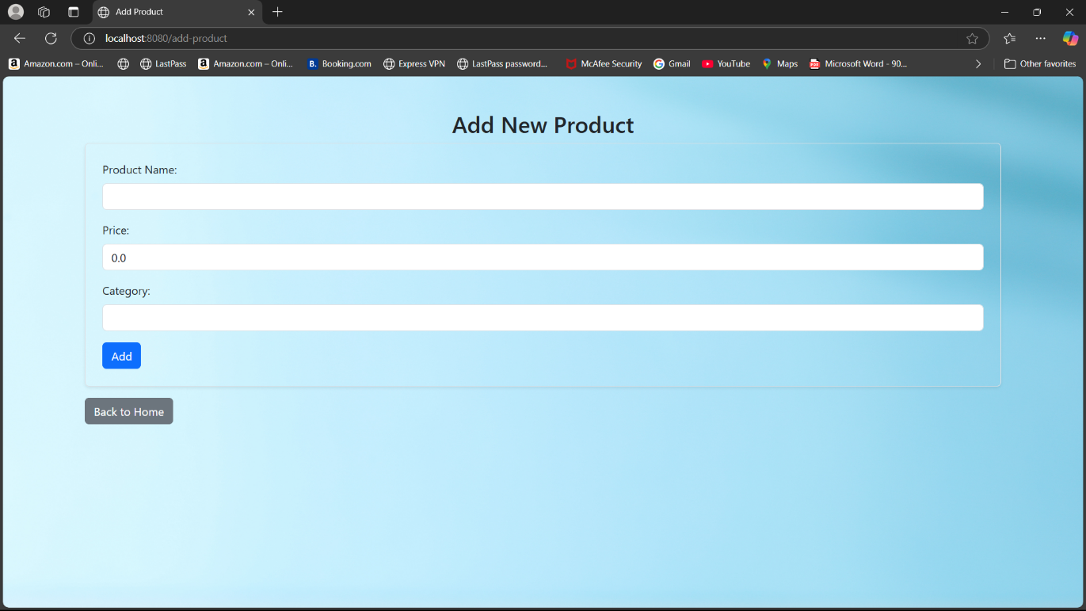

Product Catalog:

'/display-products'

