# Branching & Looping statements

1. Write a program to print the numbers from 10 to 50 using for loop/while loop.

public class Solution01 {  
 public static void main(String[] args) {   
 // main method-this is where java program begins its execution

for(int i=10;i<=50;i++){   
 // for-loop starts with i=10 and continues as long as i<= 50.  
 // i will be incremented by 1 after each iteration

System.*out*.print(i + " ");   
 // print i value with space in same line  
 }  
 }  
}

Output:

1. Write a program that find a given number is negative or positive.

import java.util.Scanner;  
  
public class Solution02 {  
 public static void main(String[] args) {  
 Scanner obj=new Scanner(System.*in*);  
 //Scanner class object to get user input  
  
 int givenNumber=obj.nextInt();  
  
 if(givenNumber>0){  
 // checks givenNumber greater than zero  
 System.*out*.println(givenNumber + " is a positive number.");  
 }else if(givenNumber<0){  
 // checks givenNumber less than zero  
 System.*out*.println(givenNumber + " is a negative number.");  
 }else{  
 // executes if the above conditions are false  
 // therefore givenNumber is zero  
 System.*out*.println(givenNumber + " is neither a positive nor a negative");  
 }  
 obj.close(); // close Scanner class object  
 }  
}

Output :

1. Write down the program to reverse the given number using loops.

Input = 876

Output-678

import java.util.Scanner;  
  
public class Solution03 {  
 public static void main(String[] args) {  
 Scanner obj=new Scanner(System.*in*);  
 //Scanner class object to get user input  
 int givenNumber=obj.nextInt();  
 //reads input int value  
  
 int revNumber=0;  
  
 // Loop to reverse the digits of the number  
 while (givenNumber > 0) {  
 // Extract the last digit of the number using modulus operator  
 revNumber = revNumber * 10 + givenNumber % 10;  
  
 // Remove the last digit from the given number by dividing it by 10  
 givenNumber /=10;  
  
 }  
 System.*out*.println(revNumber);  
 obj.close();// close Scanner class object  
 }  
}

Output :

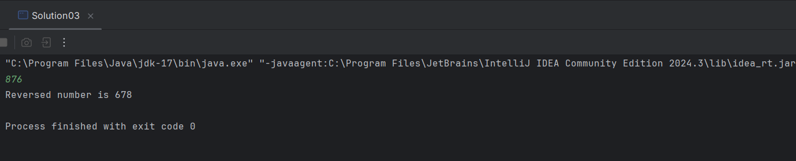

1. Write a java program to Find the smallest number among three numbers.

import java.util.Scanner;  
  
public class Solution04 {  
 public static void main(String[] args) {  
 Scanner obj=new Scanner(System.*in*);  
 //Scanner class object to get user input  
   
 int num1=obj.nextInt(); // reads num1 int value  
 int num2=obj.nextInt(); // reads num2 int value  
 int num3=obj.nextInt(); // reads num3 int value  
  
 if(num1<num2 & num1<num3){ //checks whether num1 is smaller  
 System.*out*.println(num1 + " is the smallest number");  
 }else if(num2<num1 & num2<num3) { //checks whether num2 is smaller  
 System.*out*.println(num2 + " is the smallest number");  
 }else{   
 // print num3 is smaller if previous conditions are false  
 System.*out*.println(num3 + " is the smallest number");  
 }  
 obj.close();  
 // close Scanner class object  
 }  
}

Output:

1. Write a Java program that takes the purchase amount as input and calculates the final payable amount after applying the discount.

a. If the purchase amount is less than 500, no discount is applied.

b. If the purchase amount is between 500 and 1000, a 10% discount is applied.

c. If the purchase amount is greater than 1000 a 20% discount is applied.

import java.util.Scanner;  
  
public class Solution05 {  
 public static void main(String[] args) {  
 Scanner obj=new Scanner(System.*in*);  
 //Scanner class object to get user input  
   
 double purchaseAmount = obj.nextDouble(); // reads user input as type double  
 double discount=0; // initializing discount as 0.  
 if(purchaseAmount<500){

// checks purchaseAmount is less than 500   
 discount=0;; // discount will be 0.

}else if(purchaseAmount>=500 & purchaseAmount<=1000){  
 // checks purchaseAmount is between 500 and 1000  
 discount=purchaseAmount*0.10;

// mutiply purchaseAmount with 0.10 to find 10% discount

}else{  
 //executes if previous conditions failed -> purchaseAmount above 1000  
 discount=purchaseAmount*0.20;

// mutiply purchaseAmount with 0.10 to find 10% discount

}

// subtracting purchaseAmount and discount to find final payable amount.  
 double finalAmount=purchaseAmount-discount;  
   
 // print with two decimal points  
 System.*out*.printf("The final payable amount is %.2f",finalAmount);  
 obj.close(); // close Scanner class object   
 }  
}

Output:

1. Write a java program to print bellowed pattern ->i and j and k=>5

55555

54444

54333

54322

54321

import java.util.Scanner;  
  
public class Solution06 {  
 public static void main(String[] args) {  
 Scanner obj= new Scanner(System.*in*); // Scanner class object to get user input  
 int n = obj.nextInt(); // Reads user input as int variable  
  
 for (int i=0; i<n; i++) { // Outer loop for rows  
 for (int j=n; j>n-i; j--) { // Inner loop for decreasing numbers  
 System.*out*.print(j); // Print decreasing numbers  
 }  
 for (int k=0; k <n-i; k++) { //Inner loop for repeated numbers  
 System.*out*.print(n-i); // Print repeated numbers  
 }  
 System.*out*.println(); // Move to the next row  
 }

obj.close(); // close Scanner class object

}

}

Output:

