Global Services Technology

MDEx Gen3
InSite2 Platform (Devise Side) SI Guide

IS THIS THE LATEST REVISION OF THIS DOCUMENT?
Before using this document, make sure it is the latest revision. For hardcopy document, you should consult the program LPI or quality representative, for electronic document, access eLibrary to verify the current revision. If you do not have access to, or are unfamiliar with eLibrary, you should consult the Program LPI or GST quality representative.

Approval Name:

Approval Signature: Date:
Table of Contents
1. Introduction 3
1.1 Overview 3
1.2 Scope 3
2. Cookie Monster 3
2.1 Overview 3
2.2 Step to Start/Stop/Probe Cookie Monster 3
3. Common Service Desktop 4
3.1 Overview 4
3.2 CSD Customization 4
4. Agent Config Tool 5
4.1 Overview 5
4.2 Agent Configuration using Config Tool 5
4.3 Role Management for Config Tool 8
5. Agent Custom Configuration 9
5.1 Contact GE Agent HTML Extension (With UI) 9
5.2 Contact GE Command Line Application (Without UI) 13
5.3 Multi Tunnel 14
5.4 Remote Service Mode 16
5.5 File Transfer Command Line Application 20
5.6 ConnectToGE 21
6. Glossary of Terms 22
Appendix A: MultiTunnel Configuration in QSS Application 23
Appendix B: RSM Configuration is QSS Application 30

Introduction

Overview
This guide, the InSite2 Platform System Integrator guide, is intended to provide the information about the custom extensions of Questra Service Agent and other capabilities provided as part of MDEx Gen3 release. This document gives the integration points for the modalities about these extensions. This includes the overview of component, configuration required for that component, dependencies, component response in different error scenario, supported platform and usage example.
The Insite2.0 platform contains three components namely the Cookie Monster (CKM), Questra Service Agent (QSA) and Common Service Desktop (CSD). The CKM provides a web infrastructure platform with the servers like Tomcat and Apache. It also hosts the web applications that are needed to be run by the modalities. QSA is a service agent for tunneling and to submit the service requests and QSA itself is a service agent platform. CSD provides the framework for modalities to deploy their web applications.
The following Agent extensions are released as part of MDEx Gen3:
- ContactGE html extension (With UI)
- ContactGE command application
- Multitunnel data source
- Remote Service Mode
- File Transfer command application
- Connect To GE command application

Scope
This document only talks about the QSA configuration for that component. It could be possible that some Insite2.0 enterprise configuration is also requires for that component. This document does not talk about those configurations. Even some of the enterprise configuration is mentioned in Appendix of this document.
This document is not a user manual. So, There is no “How To Use” section in this document. But each component is having section called usage example, which talks about how to use that component (if applicable).

Cookie Monster

Overview
The CKM provides a web infrastructure platform with the servers like Tomcat and Apache. It also hosts the web applications that are needed to be run by the modalities.

Step to Start/Stop/Probe Cookie Monster
- Go to ckm directory.
- Start CookieMonster using ./CookieMonster.sh start.
- Execute command - chmod +x tomcat/webapps/modality-csd/cgi-bin/* (only at the installation time).
- Open dsp/ckm/Apache/conf/httpd.conf file and include the following line at the end: PassEnv DSP_HOME.
- Open a browser and go to url http://localhost/modality-csd/
- Stop CookieMonster using ./CookieMonster.sh stop.

Common Service Desktop

Overview
CSD platform will provide business partners with the following functionality:
- A common UI as the framework, in which business partners will be able to integrate their applications.
- A security authorization scheme in which business partners will provide their own means of checking for security. Based on the security levels, business partners can show different applications.
- A caching mechanism, which will help to improve performance. Business partners will be able to turn caching on/off as desired.
- XML menu files where business partners can specify the content of the application tree.
- Access level configuration where business partners will be able to customized to fit their needs. This will change in the future once the standard access levels are established among all modalities.

CSD Customization
Get CSD war file from Insite2 package and customize CSD as described below:
Main feature that modalities customize is, the left frame in the CSD. CSD provides XML files in which modalities has to specify their web application. CSD provide template XML files where modalities can give the name of their Web Applications and command to invoke those web applications. To each tab in the CSD, corresponding XML files should be there in the configured xml directory.
XML Template
<?xml version="1.0" encoding="UTF-8" ?>
<!DOCTYPE SRV_MENU SYSTEM "http://localhost/modality-csd/java/srv_menu.dtd" >
<SRV_MENU SRV_NAME = "%menu name%">
<SRV_SUBMENU_LINK SRV_SUBMENU_FILE = "%imported sub-folder filename%" />
<SRV_SUBMENU SRV_NAM="%sub-fold name%" >
<SRV_APPLICATION SRV_NAME = "%application name%"
SRV_FRAME = "BASE"
SRV_COMMAND = "%command to launch application%"
SRV_ICON = "%image filename%" />
</SRV_SUBMENU>
< SRV_APPLICATION SRV_NAME = "%application name%" SRV_FRAME = "BLANK" SRV_COMMAND = "%command to launch application%"
SRV_ICON = "%image filename%" />
</SRV_MENU>

Here is the link to know about How to change CSD xml:
https://openge.ge.com/cgi-bin/cvsweb.cgi/InSite2Development/Service%20Agent%20Configuration%20Utilities/Windows%20dotNET%20Utility/5.2%20Agent/Linux/CSD%20XML%20Examples.doc?cvsroot=insite2sadev

Agent Config Tool

Overview
The Agent Configuration Tool provides the capability to configure the agent quickly and effectively once it is successfully installed on the device. Next section will describe the step to configure the Agent using Agent Configuration Tool.

Agent Configuration using Config Tool
Before using Agent Config Tool, please make sure following three steps has been done.
- InSite2.0 agent has been installed on the machine.
- Cookie monster has been installed properly.
- “gencfg” command has been executed as part of Agent installation.
Now, Following step should be followed to configure the Agent using Agent Config Tool:
- Start Cookiemonster and open the Home page of CSD using link.
- Click on Configuration tab.
- Click on left side “Insite2ConfigTool” link.
- Initially Tool will be on Device_Information tab, here according to the permissions you will be able to change the Device name and Serial Number.
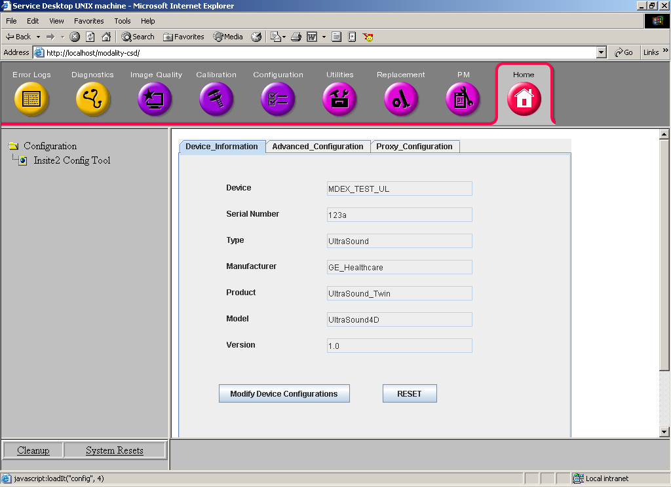

- Second tab is Adavanced_Configuration tab and you can change the Server Type, InSite2.0 Server URL, InSite2.0 Ent. Tunnel URL, File Repository Directory, Log-Level according to your permissions.
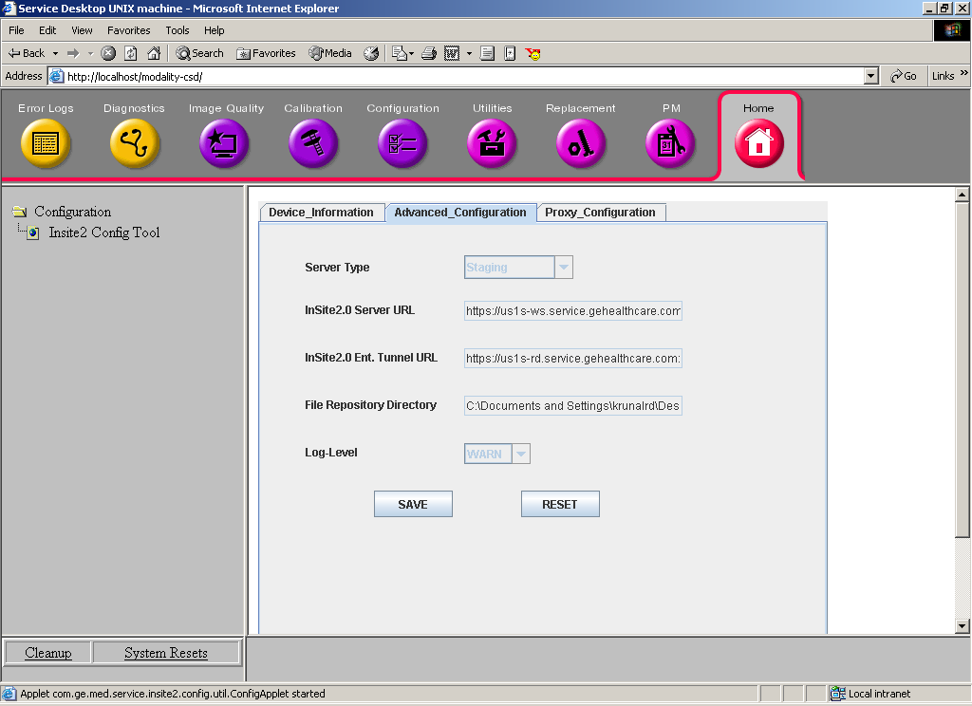

- Third tab is Proxy_Configuration tab, here you can change Proxy Server, Authentication and Authentication Scheme according to your permissions.
- Your permissions are set into the permission.xml file and your role is passed to the Applet as a init parameter from the Config_Tool.html. (Please see the more information given below)
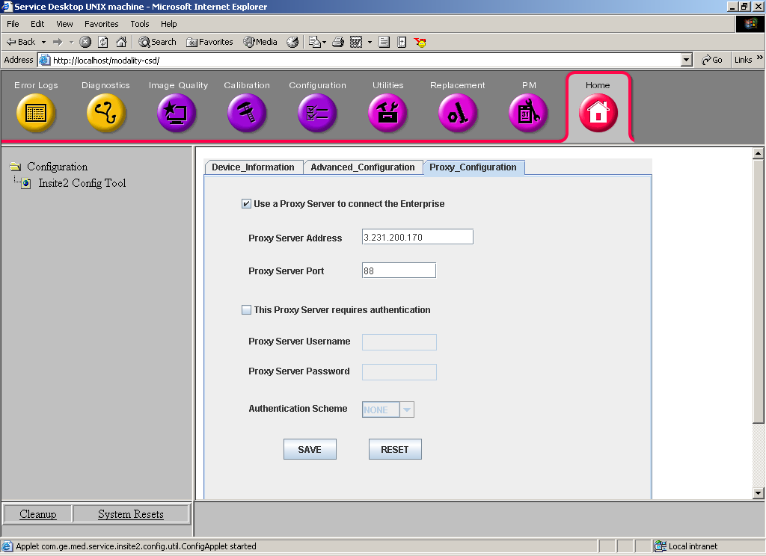

Role Management for Config Tool
To manage the Role of user for Config Tool modality will have to provide the html as follows and should set the parameter name “userRole” with the value of user logged in for the configuration. In this example we have considered, as “Customer” is the user who logged in for configuration.
Note: This value should be present in the Permissions.xml file. UserRoles cas be Customer or ServiceEngineer.
<html>
<applet codebase="." ARCHIVE="InSite2ConfigToolApplet.jar"
code="com.ge.med.service.insite2.config.util.ConfigApplet.class" height=550 width=600>
<param name="userRole" value=Customer>
</applet>
</html>

Agent Custom Configuration

Contact GE Agent HTML Extension (With UI)

Component Overview
ContactGE is an application, which is built on agent UI framework, which leverages HTML extension. The UI has html pages, which can be customized by the adopting programs to match their look and feel. A standard html page would be provided to match the Look and Feel of the ContactGE application, which exists today for DI. Once the RFS is successfully created, ContactGE application invokes the RSM to increase the polling rate of the agent.

ContactGE QSA Configuration
This section talks about what are the configuration Questra Service Agent required for this component. MDEx Gen3 release is having this entire configuration in QSA configuration file. This section is just for information to adopting programs that are using this release. Below is the configuration for ContactGE HTML Extension:
- Go to the “etc” directory under your Questra service agent installed directory. In this case, it is <questra_root_dir>/etc.
- Open the qsaconfig.xml file.
- The below snippet should be under <ServiceAgent> tag.
<Extension>
<SharedLib>__INSTALL_DIR__\bin\htmlext.dll</SharedLib>
<InitParam>__INSTALL_DIR__\etc\ContactGEUIExt.xml</InitParam>
<StartupFuncName>A2BStartupHtmlServer</StartupFuncName>
<ShutdownFuncName>A2BShutdownHtmlServer</ShutdownFuncName>
</Extension>

- <InitParam> tag in the above snippet should have ContactGE HTML extension xml file (ContactGEUIExt.xml).
- The following snippet should be there in ContactGE HTML extension xml file (ContactGEUIExt.xml).
<?xml version="1.0"?>
<HtmlServer xmlns="urn:questra-a2b:HTMLServerExt_v1_0">
<HttpAuthEnabled>FALSE</HttpAuthEnabled>
<Users>
<User name="anonymous" password=""/>
</Users>
<Protocol>http</Protocol>
<HttpPort>8020</HttpPort>
<RootDir>__INSTALL_DIR__\ContactGEwebapp</RootDir>
<DefaultPage>ContactGEForm.html</DefaultPage>
<SessionTimeout>600</SessionTimeout>
<MaxSessions>5</MaxSessions>
<RawPages>
<Page uri="/logo.gif" ctype="image/gif"/>
<Page uri="/images/contact_ge.gif" ctype="image/gif"/>
<Page uri="/content.css" ctype="text/css"/>
</RawPages>
<HandlerSource>
<SharedLib>__INSTALL_DIR__\bin\ContactGE.dll</SharedLib>
<StartupFuncName>ContactGEUIHtmlHandlerStartup</StartupFuncName>
<ShutdownFuncName>ContactGEUIHtmlHandlerShutdown
</ShutdownFuncName>
<InitParam>AlokAsset51</InitParam>
<PostHandlerEx action="/submitContactGE" f="SubmitContactGE"/>
<MarkupHandlerEx tag="GetProblemCategory" f="GetProblemCategory"/>
<MarkupHandlerEx tag="GetRFSNumber" f="GetRFSNumber"/>
<MarkupHandlerEx tag="NextOpeningHour" f="NextOpeningHour"/>
<MarkupHandlerEx tag="NextWorkingDate" f="NextWorkingDate"/>
<MarkupHandlerEx tag="PhoneNumbers" f="PhoneNumbers"/>
<MarkupHandlerEx tag="GetResponseException"
f="GetResponseException"/>
<MarkupHandlerEx tag="ReasonForContactingGE"
f="ReasonForContactingGE"/>
<MarkupHandlerEx tag="SystemProblem" f="SystemProblem"/>
<MarkupHandlerEx tag="AppsQuestion" f="AppsQuestion"/>
<MarkupHandlerEx tag="SystemID" f="SystemID"/>
<MarkupHandlerEx tag="ThisSystem" f="ThisSystem"/>
<MarkupHandlerEx tag="Other" f="Other"/>
<MarkupHandlerEx tag="ProblemArea" f="ProblemArea"/>
<MarkupHandlerEx tag="Submitter" f="Submitter"/>
<MarkupHandlerEx tag="Phone" f="Phone"/>
<MarkupHandlerEx tag="Image" f="Image"/>
<MarkupHandlerEx tag="exam_mnemonic" f="exam_mnemonic"/>
<MarkupHandlerEx tag="series_mnemonic" f="series_mnemonic"/>
<MarkupHandlerEx tag="image_mnemonic" f="image_mnemonic"/>
<MarkupHandlerEx tag="ProblemDescription" f="ProblemDescription"/>
<MarkupHandlerEx tag="DateandTimeofProblem"
f="DateandTimeofProblem"/>
<MarkupHandlerEx tag="SendtoGE" f="SendtoGE"/>

<MarkupHandlerEx tag="ProblemTypeAlert" f="ProblemTypeAlert"/>
<MarkupHandlerEx tag="SystemIdAlert" f="SystemIdAlert"/>
<MarkupHandlerEx tag="OtherSystemIdAlert" f="OtherSystemIdAlert"/>
<MarkupHandlerEx tag="InvalidSystemIdAlert"
f="InvalidSystemIdAlert"/>
<MarkupHandlerEx tag="InvalidPhoneNumberAlert"
f="InvalidPhoneNumberAlert"/>
<MarkupHandlerEx tag="EmptyFormAlert" f="EmptyFormAlert"/>

<MarkupHandlerEx tag="RequestSubmittedMSG"
f="RequestSubmittedMSG"/>
<MarkupHandlerEx tag="YourReferenceNumberMSG"
f="YourReferenceNumberMSG"/>
<MarkupHandlerEx tag="EnginnerWillCallMSG"
f="EnginnerWillCallMSG"/>
<MarkupHandlerEx tag="InformationSubmittedMSG"
f="InformationSubmittedMSG"/>
<MarkupHandlerEx tag="GetRequestParameter"
f="GetRequestParameter"/>
<MarkupHandlerEx tag="RequestFailedMSG" f="RequestFailedMSG"/>
<MarkupHandlerEx tag="RequestNotProcessedMSG"
f="RequestNotProcessedMSG"/>
<MarkupHandlerEx tag="TryAgainMSG" f="TryAgainMSG"/>
<MarkupHandlerEx tag="AfterHourMSG1" f="AfterHourMSG1"/>
<MarkupHandlerEx tag="AfterHourMSG2" f="AfterHourMSG2"/>
<MarkupHandlerEx tag="AfterHourMSG3" f="AfterHourMSG3"/>
</HandlerSource>
</HtmlServer>

ContactGE Customization
Modalities can customize the ContactGE application according to their need. There is ContactGE_Customization.xml file, which should be there in Agent’s etc directory. The structure of this configuration file should look like this:
<?xml version="1.0"?>
<ContactGESettings>
<ProblemCategory>
<Category>prescription</Category>
<Category>acquisition</Category>
<Category>image_quality</Category>
<Category>archival</Category>
<Category>filming</Category>
<Category>display</Category>
<Category>networking</Category>
<Category>other</Category>
</ProblemCategory>

<Preprocessor commandPath="c:\test"/>

<WorkflowList>
<Workflow requestType="ServiceRequest">
<Step action="pre-processor"/>
<Step action="CreateRFS"/>
<Step action="ConnectToGE"/>
</Workflow>
<Workflow requestType="Application">
<Step action="CreateRFS"/>
<Step action="ConnectToGE"/>
</Workflow>
</WorkflowList>

<InSite2Agent>
<ForcePollPeriod>10</ForcePollPeriod>
<ForcePollDuration>120</ForcePollDuration>
</InSite2Agent>

<InSite2DeviceLanguage envVariableName="LANG">
<SupportedLanguage language="en_US"/>
<SupportedLanguage language="fr_FR"/>
<SupportedLanguage language="it_IT"/>
<SupportedLanguage language="pt_BR"/>
<SupportedLanguage language="de_DE"/>
<SupportedLanguage language="es_MX"/>
<SupportedLanguage language="ja_JP"/>
<SupportedLanguage language="zh_CN"/>
</InSite2DeviceLanguage>

</ContactGESettings>

- ProblemCategory element defines the type of problems, which comes on ContactGE UI. If you want to add one more category on ContactGE UI, you need to generate resource file for different languages supported by ContactGE. To generate the resource file you have to use ICU genrb tool packaged with QSA. Step to generate resource file:
  - Go to <AGENT_ROOT_DIR>\ContactGEwebapp\i18n\resourcebundle directory.
  - Open ContactGEi18n_en_US.txt file and add the key/value pair for new problem category.
  - Save and close the file.
  - Go to <AGENT_ROOT_DIR>\bin directory and run the following command:
genrb -v -s <AGENT_ROOT_DIR>\ContactGEwebapp\i18n\resourcebundle -p ContactGEi18n ContactGEi18n_en_US.txt
The above command will generate ContactGEi18n_en_US.res resource file.
  - Replace the existing resource file with generated resource file in <AGENT_ROOT_DIR>\ContactGEwebapp\i18n\resourcebundle directory.
  - Now, restart the agent.
- Path to modality specific pre-processor command needs to be set in Preprocessor command.
- WorkflowList captures the set of actions that are taken. CreateRFS and ConnectToGE are mostly needed. If a modality does not have a pre-processor, then it can be commented out.
- InSite2Agent elements provide information about ForcePoll.
- InSite2DeviceLanguage element gives the information about what are the languages ContactGE is supporting. And the environment variable name on device side that will have language of device.

Dependencies
- QSA needs to be configured correctly and QSA shall be running.
- After installation of service agent, product team has to restart the machine or set the environment variable “INSITE2_ROOT_DIR” as agent directory.
- Device language should be set as environment variable “LANG”. Eg. en_US
- Agent needs to be configured with ContactGE related configuration and Html files. Also a ContactGEwebapp directory needs to be there, which contains all the HTML/CSS/resource files for ContactGE application.
- SerialNumber field in agent configuration file shall be set to SystemId (in case of DI/Ultrasounds). SystemId must be in GSCC database.

Error Handling
- If the agent is not running, then the UI for the ContactGE will not come up.
- If the agent is running, and ContactGE request is submitted but there is problem in creating RFS, ContactGE error page will come up with appropriate message.
- ContactGE error message will log on console itself. Some of the error message will be logged into a log file also. Please refer RSM component for Agent logging.

Supported Platforms
Supported on windows XP/2000, RH Linux 7.1/9.1, CTT Linux 4.x.x & CTT Linux 5.x.x

Usage Example
- Run the QSA and open the link http://localhost:8020/
- This will open the ContactGE UI.
- Fill the form and click on Send To GE button.
- It will create RFS and will give you RFS number.
- If there is any error it will display error message on ContactGE error page.

Contact GE Command Line Application (Without UI)

Component Overview
There would be some platforms, which will have their own ContactGE UI, OR their UI can be as simple as single button “Submit ContactGE” which takes predefined values for problem description, problem category and other fields and submits ContactGE request. In that case they can use this component to create RFS. This component is just a command line application which takes an xml file as input parameter and that xml file will be having all the required fields required to create RFS.
An RFS can be created from device to appropriate CRM by using below command –
ContactGE [<absolute path of request xml file>]

ContactGE Command QSA Configuration
- The QSA configuration file (qsaconfig.xml) should have following configuration:
<Extension>
<SharedLib>__INSTALL_DIR__/bin/wsext.dll</SharedLib>
<InitParam>__INSTALL_DIR__/etc/InSite2ServicesExtn.xml</InitParam>
<StartupFuncName>A2BStartupWsExt</StartupFuncName>
<ShutdownFuncName>A2BShutdownWsExt</ShutdownFuncName>
</Extension>

- There should be a file "InSite2ServicesExten.xml" file in Agent's etc directory. Which will have following entry under <WebServicesExt> element.
<WebServiceSource name="ContactGE">
<SharedLib>__INSTALL_DIR__\bin\ContactGEWSExtn.dll</SharedLib>
<InitParam/>
<StartupExFuncName>WSEStartup</StartupExFuncName>
<ShutdownFuncName>WSEShutdown</ShutdownFuncName>
<CreateServiceFuncName>WSECreateService</CreateServiceFuncName>
<DestroyServiceFuncName>WSEDestroyService</DestroyServiceFuncName>
</WebServiceSource>

<WebService>
<Protocol>http</Protocol>
<Binding>lan</Binding>
<ServiceUri>/a2b/ContactGEWS</ServiceUri>
<WebServiceSource ref="ContactGE"/>
</WebService>

- The ContactGE command request input file should have following structure:
<?xml version="1.0"?>
<createRFS>
<SystemID>ILINQTEST1</SystemID>
<OtherSystemID>ILINQTEST2</OtherSystemID>
<ProblemType>System</ProblemType>
<ProblemArea/>
<ContactDetail>
<FirstName>Alok</FirstName>
<LastName>Ojha</LastName>
<ContactPhone>250-334-0345</ContactPhone>
<ContactEmail>alok.ojha@ge.com</ContactEmail>
</ContactDetail>
<ExamNumber>5</ExamNumber>
<SeriesNumber>3</SeriesNumber>
<ImageNumber>2</ImageNumber>
<ProblemDescription>This is a test case please ignore1. This is a test </ProblemDescription>
<RequestSource>ContactGE</RequestSource>
</createRFS>

Dependencies
- Questra agent needs to be configured correctly and Questra agent shall be running.

Error Handling
- If the RFS creation fails, it will append the appropriate error message in request xml file.
- If the entire mandatory field is not defined in request xml file then it will give appropriate message on console itself.

Supported Platforms
Supported on windows XP/2000

Usage Example
ContactGE C:\ContactGERequest.xml

Multi Tunnel

Component Overview
The following provides configuration instruction setup an insite2 multitunnel feature at both the Questra service agent and the Questra Smart Service. For instruction of using multitunnel, please refer to Questra Enterprise user guide - Questra TotalAccess.

MultiTunnel QSA Configuration
Before you perform the following configuration, it is assume that the service agent has been installed. In this guideline, we use <questra_root_dir> to represent the service agent installed directory. You should know the location your installed Questra service agent. Afterward, please follow the following steps.
- Go to the “etc” directory under your Questra service agent installed directory. In this case, it is <questra_root_dir>/etc.
- Open the qsaconfig.xml file.
- Now, copy the following snippet into your configuration file. The snippet should go under <ServiceAgent> tag. The __INSTALL_DIR__ should be replaced with the <questra_root_dir>.
<RADataSource name="mtds">
<SharedLib>__INSTALL_DIR__/lib/libMultiTunnelDS.so</SharedLib>
<InitParam>__INSTALL_DIR__/etc/mtds.xml</InitParam>
<StartupFuncName>A2BMultiTunnelDSStartup</StartupFuncName>
<ShutdownFuncName>A2BMultiTunnelDSShutdown</ShutdownFuncName>
<GetFuncName>A2BMultiTunnelDSGet</GetFuncName>
<SetFuncName>A2BMultiTunnelDSSet</SetFuncName>
<ExecuteFuncName>A2BMultiTunnelDSExecute</ExecuteFuncName>
<DestroyResponseFuncName>
A2BMultiTunnelDSDestroyResponse
</DestroyResponseFuncName>
<DestroyPropertyListFuncName>
A2BMultiTunnelDSDestroyPropList
</DestroyPropertyListFuncName>
</RADataSource>

- Add the following snippet inside the <RATD> tag. The <RATD> tag is within the <ServiceAgentProfile> tag.

<RADataSource ref="MultiTunnelDataSource"/>

- Create/open the file specified in the <InitParam> tag in the above snippet.
- Verify the following snippet is in your file. If it does not, insert them into the file.

<MultiTunnelDS>
<Asset name="__SA_ASSET_NAME__" password="__SA_ASSET_PASSWORD__">
<Connection>
<Name>__TUNNEL_NAME__</Name>
<InitiateProperty>MTHttpInitiate</InitiateProperty>
<StateProperty>MTHttpState</StateProperty>
<EnterpriseTunnelURL>http://ins2d.med.ge.com:9009</EnterpriseTunnelURL>
<ServerSocketAddress>localhost:5900</ServerSocketAddress>
<ProxyServerAddress>3.87.248.6:88</ProxyServerAddress>
<PollInterval>10</PollInterval>
<ConnectionTimeout>1800</ConnectionTimeout>
<ConnectionType>__CONNECTION_TYPE__</ConnectionType>
<SocketConnectionTimeOut>60</SocketConnectionTimeOut>
<TransportTunnelCfg>
<BufSize>4096</BufSize>
<InactivityTO>300</InactivityTO>
</TransportTunnelCfg>
</Connection>
</Asset>
</MultiTunnelDS>

- Modify the configuration setting with your insite2 configuration. The MultiTunnel configuration complies to the Questra service agent tunneling data source configuration with the addition of attributes. Therefore, unless those are particular specified below, please refer to the Questra Service Agent System Integration Guide for configuration detail.
SocketConnectionTimeOut – The number of seconds that the application will wait for socket to successfully connect.
InactivityTO – The number of seconds to wait for the tunnel to switch connection to MultiTunnel protocol. The prefer value is 30 seconds.

Dependencies
The service agent and enterprise multitunnel configuration has to be completely done in order for the multitunnel works properly.
When a new multitunnel connection entry is added or the configuration is changed in mtds.xml file, the service agent must be restarted to take effect.

Error Handling
If the multitunnel does not work, please check the service agent log and/or MTWrapper log file.

Supported Platforms
The multitunnel component supports on both Linux and Windows (2000/XP) platform.

Usage Example

Please refer to Questra Enterprise user guide - Questra TotalAccess.

Remote Service Mode

Component Overview
Remote Service Mode application provides mechanisms for forcing agent to poll in a fast frequency as long as it is remotely accessed and notifying the agent’s RSM status on BO. When agent will be forced into RSM this component will push extended property with information of RSM start time (GMT), initial RSM period and polling frequency.
Remote Service Mode application provides mechanisms for scheduling RSM for agent. From a BO, it provides mechanism for forcing agent from RSM to normal mode. This application will be used by ISD to schedule RSM for device. ISD will pass RSM start time (GMT), RSM stop time (GMT), and polling frequency to Schedule Remote Service Mode. This component will use this information to format a command and will assign “execute command” task for agent. On the agent side when agent will get this command it will pass this command to DS Extension, which will use this command to schedule RSM for agent.
This component provide ConnectToGE command line application to invoke the web service, web service extension to put the agent in force poll mode, Tunnel Listener to listen for any remote activity and to run modality script on the same and Remote Detection to detect for any remote activity and to keep agent into Force poll mode till the remote activity is there.
This component doesn’t provide windows event logging.

RSM QSA Configuration
This section talks about what are the configuration Questra Service Agent required for this component. MDEx Gen3 release is having this entire configuration in QSA configuration file. This section is just for information to adopting programs that are using this release. In this guideline, we use <questra_root_dir> to represent the service agent installed directory. You should know the location your installed Questra service agent.
- Go to the “etc” directory under your Questra service agent installed directory. In this case, it is <questra_root_dir>/etc.
- Open the qsaconfig.xml file.
- The below snippet should be under <ServiceAgent> tag. The __INSTALL_DIR__ should be replaced with the <questra_root_dir>.

<RADataSource name="RSMDataSource">
<SharedLib>__INSTALL_DIR__/bin/InSite2RSMLogger.dll</SharedLib>
<InitParam>__INSTALL_DIR__/etc/ScheduleRSM.txt</InitParam>
<StartupFuncName>IS2RSMDSStartup</StartupFuncName>
<ShutdownFuncName>IS2RSMDSShutdown</ShutdownFuncName>
<GetFuncName>IS2RSMDSGet</GetFuncName>
<SetFuncName>IS2RSMDSSet</SetFuncName>
<ExecuteFuncName>IS2RSMDSExectue</ExecuteFuncName>
<DestroyResponseFuncName>IS2RSMDSDestoryResponse</DestroyResponseFuncName>
<DestroyPropertyListFuncName>IS2RSMDSDestroyPropList</DestroyPropertyListFuncName>
</RADataSource>
<Extension>
<SharedLib>__INSTALL_DIR__/bin/InSite2RSMLogger.dll</SharedLib>
<InitParam>__INSTALL_DIR__/etc/ InSite2CustomLogger.xml</InitParam>
<StartupFuncName>I2RSMExtnStartup</StartupFuncName>
<ShutdownFuncName>I2RSMExtnShutdown</ShutdownFuncName>
</Extension>
<Extension>
<SharedLib>__INSTALL_DIR__/bin/wsext.dll</SharedLib>
<InitParam>__INSTALL_DIR__/etc/InSite2ServicesExtn.xml</InitParam>
<StartupFuncName>A2BStartupWsExt</StartupFuncName>
<ShutdownFuncName>A2BShutdownWsExt</ShutdownFuncName>
</Extension>

- The below snippet should be inside the <RATD> tag. The <RATD> tag is within the <ServiceAgentProfile> tag.

<RADataSource ref="RSMDataSource"/>

- The below snippet should be inside the < ServiceAgentProfile > tag. The < ServiceAgentProfile > tag is within the < ContactInfo > tag.

<Property name="RSM_MODE" value="NOT_ACTIVE" action="update"/>
<Property name="RSM_START_TIME" value="0" action="update"/>
<Property name="RSM_MODE_START_TIME" value="0" action="update"/>
<Property name="RSM_GRACE_PERIOD" value="0" action="update"/>
<Property name="RSM_FORCED_POLLING_RATE" value="0" action="update"/>
<Property name="RSM_DELAY_PROFILE_START_TIME" value="0" action="update"/>

<Property name="RSM_DELAY_PROFILE_FORCED_POLLING_RATE" value="0" action="update"/>
<Property name="RSM_DELAY_PROFILE_GRACE_PERIOD" value="0" action="update"/>
- The below snippet should be inside the < ContactInfo > tag. The < ContactInfo > tag is within the < ServiceAgent > tag.

<IpcListenPort>8081</IpcListenPort>

- “InSite2CustomLogger.xml” file should be present in <questra_root_dir>/etc directory with following configuration

<?xml version="1.0"?>
<InSite2CustomLogger>
<FileLogging>
<LoggerConfigProp>__INSTALL_DIR__\etc\log-config.txt</LoggerConfigProp>
</FileLogging>
<Script>dir</Script>
<FileMessages>
<OpenMessage>
<Message>File Listing started</Message>
<Message>File Upload started</Message>
<Message>File Download started</Message>
</OpenMessage>
<CloseMessage>
<Message>File Upload completed</Message>
<Message>File Download completed</Message>
<Message>File Listing completed</Message>
<Message>File Listing failed</Message>
<Message>File Upload failed</Message>
<Message>File Download failed</Message>
</CloseMessage>
</FileMessages>
<TunnelMessags>
<OpenMessage>
<Message>Connection Established</Message>
</OpenMessage>
<CloseMessage>
<Message>Connection Closed (session complete or abort)</Message>
</CloseMessage>
<AbortMessage>Tunnels Aborted</AbortMessage>
</TunnelMessags>
<ListnerSet>
<RDListner>RemoteDetection</RDListner>
<TunnelListner>TunnelListner</TunnelListner>
<FileListner>FileLogging</FileListner>
</ListnerSet>
<RSMResumeStatusFile>__INSTALL_DIR__\etc\RsmResume.xml</RSMResumeStatusFile>
</InSite2CustomLogger>
- Modify the configuration setting as per modality requirement. You can put < Script> which modality want to run on detection of remote connection.
- “InSite2ServicesExtn.xml” file should be present in <questra_root_dir>/etc directory with following

<?xml version="1.0"?>
<WebServicesExt xmlns="urn:questra-a2b:WebServicesExt_v1_0">

<WebServiceSource name="connectToGE">
<SharedLib>__INSTALL_DIR__/bin/InSite2RSMLogger.dll</SharedLib>
<InitParam/>
<StartupExFuncName>IS2RSMWSStartup</StartupExFuncName>
<ShutdownFuncName>IS2RSMWSShutdown</ShutdownFuncName>
<CreateServiceFuncName>IS2RSMWSCreateService</CreateServiceFuncName>
<DestroyServiceFuncName>IS2RSMWSDestroyService</DestroyServiceFuncName>
</WebServiceSource>

<WebService>
<Protocol>http</Protocol>
<Binding>lan</Binding>
<ServiceUri>/a2b/InSite2Services</ServiceUri>
<WebServiceSource ref="connectToGE"/>
</WebService>

<WebServiceSource name=" reference of other web service, If present">

</WebServiceSource>

<WebService>
<Protocol>http</Protocol>
<Binding>lan</Binding>
<ServiceUri>URI of other web service</ServiceUri>
<WebServiceSource ref="refernce of other web service, if present "/>
</WebService>

</WebServicesExt>
- “log-config.txt” file should be present in <questra_root_dir>/etc directory with following configuration

file-size=5000
no_of_days=30
LogLevel=info
STDOUT=file
log-file-path=D:\\OLD_G\\Agent5.1\\GeHealthcare\\Agent\\log\\mdex-logs.xml
Here file size is in bytes. Log level is for logging into the file and “log-file-path” is path where log files should be created.

Dependencies
- QSA needs to be configured correctly and QSA shall be running.
- After installation of service agent, product team has to restart the machine or set the environment variable “INSITE2_ROOT_DIR” as agent directory.
- Agent needs to be configured with RSM related configuration files, which are given in the section 3.4.2.

Error Handling
- If the agent is not running, then the web service extension of RSM will not work.
- If the agent is running, but if the device does not have connectivity, RSM will not work properly. It will handle request from ConnectToGE and ContactGE but force polling will not work.
- RSM error messages will be logged on console itself and if configured it will log into file.

Supported Platforms
Supported on windows XP/2000, RH Linux 7.1/9.1, CTT Linux 4.x.x & CTT Linux 5.x.x

Usage Example
Please refer to Questra Enterprise user guide - Questra TotalAccess.

File Transfer Command Line Application

Component Overview
This is a command line application, which takes file name as parameter and upload the file from device to enterprise regardless of Agent is running or not. A file can be uploaded from the device to the InSite2.0 BO using the below command:
InSite2FileTransfer [–f <FileName>] [-type <FileTransferType>] [-args <Parameter1>=<value>] [-args <Parameter2>=<value>]

File Transfer QSA Configuration
File Transfer command line application reads some configuration values from FileTransferConfig.xml file, which should be available into Agent’s etc directory.
The content of FileTransferConfig.xml file should look like this:
<?xml version="1.0"?>
<ConfigurationParam>
<LogLevel>ERROR</LogLevel>
<NumRetries>3</NumRetries>
<RetryInterval>60</RetryInterval>
<ConfigFile>/\etc\/qsaconfig.xml</ConfigFile>
</ConfigurationParam>

Dependencies
- QSA configuration file should be configured properly.

Error Handling
- If the device side file transfer component can’t transfer the file successfully, the command reports the error and exits.
- On the back-office, once the file is transferred, if any post-processing is defined for the corresponding file transfer type and if it fails, the corresponding error message will not be displayed on the device side.

Supported Platforms
Supported on windows XP/2000, RH Linux 7.1/9.1, CTT Linux 4.x.x & CTT Linux 5.x.x

Uses Example
A file can be uploaded from the device to the InSite2.0 BO using the below command.
InSite2FileTransfer [–f <FileName>] [-type <FileTransferType>] [-args <Parameter1>=<value>] [-args <Parameter2>=<value>]
- -f <FileName>: Mandatory argument. Pass the file name that needs to be transferred to back-office.
- -type <FileTransferType>: It is optional. It identifies the file transfer type. Based on the file transfer type, back-office component takes different actions such as ftp’ing the file to a different server (For ISD, MR-IBIS) or copying it into a different folder (For DS) and also can send JMS message to a queue, for which other programs can subscribe to. If this field is not set, then no action is taken and file will be retained in InSite2.0 BO.
- -args <Parameter1>=<value> & -args <Parameter2>=<value>: These are optional arguments. If a file transfer type requires additional fields to be sent from the client side, then those arguments can be passed here. These extra arguments can be used for defining the actions to be taken in the post processing that happens in the back-office. Eg:-In case of DS, if a file needs to be associated with a RFS number while storing in BO, then RFS number can be passed as part of Parameter1 and back-office component would associate with the RFS number passed. Also systemid can be sent as an argument. Parameter1 & Parameter 2 would be consist of KEY=VALUE format. E.g: -args RFSNO=ST001.Please refer examples for details.
Example:
InSite2FileTranfer -f c:\opt.txt -type ISD -args SID=ILINQ -args RFS=ST01

ConnectToGE

Component Overview

Connect To GE is a feature at the device side to increase the polling rate based on a polling duration when there are service requests. On a service request from field the remote service engineer will request the customer to initiate ConnectToGE, which would increase the polling rate. This enables the remote service engineer to connect to the device for service immediately.

ConnectToGE QSA Configuration
RSM should be configured properly for ConnectToGE to work properly. Please refer to section 3.4.2 for configuration of RSM.

Dependencies
- Agent needs to be configured with RSM related configuration files, which are given in the section 3.4.2.

Error Handling
- If the agent is not running, then ConnectToGE will show error and will try for 3 times each after 5 seconds gap.
- If the agent is not configured properly for web service extension (part of RSM) then ConnectToGE will log messages to console.

Supported Platforms
Supported on windows XP/2000, RH Linux 7.1/9.1, CTT Linux 4.x.x & CTT Linux 5.x.x

Uses Example
ConnectToGE commands are as follows
1. Default Force polling of every 60 second for 30 min
Ex: ConnectToGE
2. Force Polling of every "10" second for "30" min
Ex: ConnectToGE -f 10 -t 30
3. Stopping Force Polling of Agent
Ex: ConnectToGE -disconnect

Glossary of Terms
GST | Global Services Technology
GUI | Graphical User Interface
IPP | Integrated Program Plan
OLC | On-Line Center
PPP | Product Program Proposal
SSO | Single Sign-On
UCD | User Centered Design
QSA | Questra Service Agent
MDEx | Machine Data Exchange
RSM | Remote Service Mode
QSS | Questra Smart Service

Appendix A: MultiTunnel Configuration in QSS Application
This section illustrates a high-level configuration instruction of how to set up a MultiTunnel client in the QSS. It is assumed that the reader is fully understand the usage of the QSS application and has right permission to perform the configuration.
The following instructions are based on Questra Smart Server 5.1 and 5.2.
Step 1: Logon to the QSS application, select configuration tab and then “Manage connection types”.
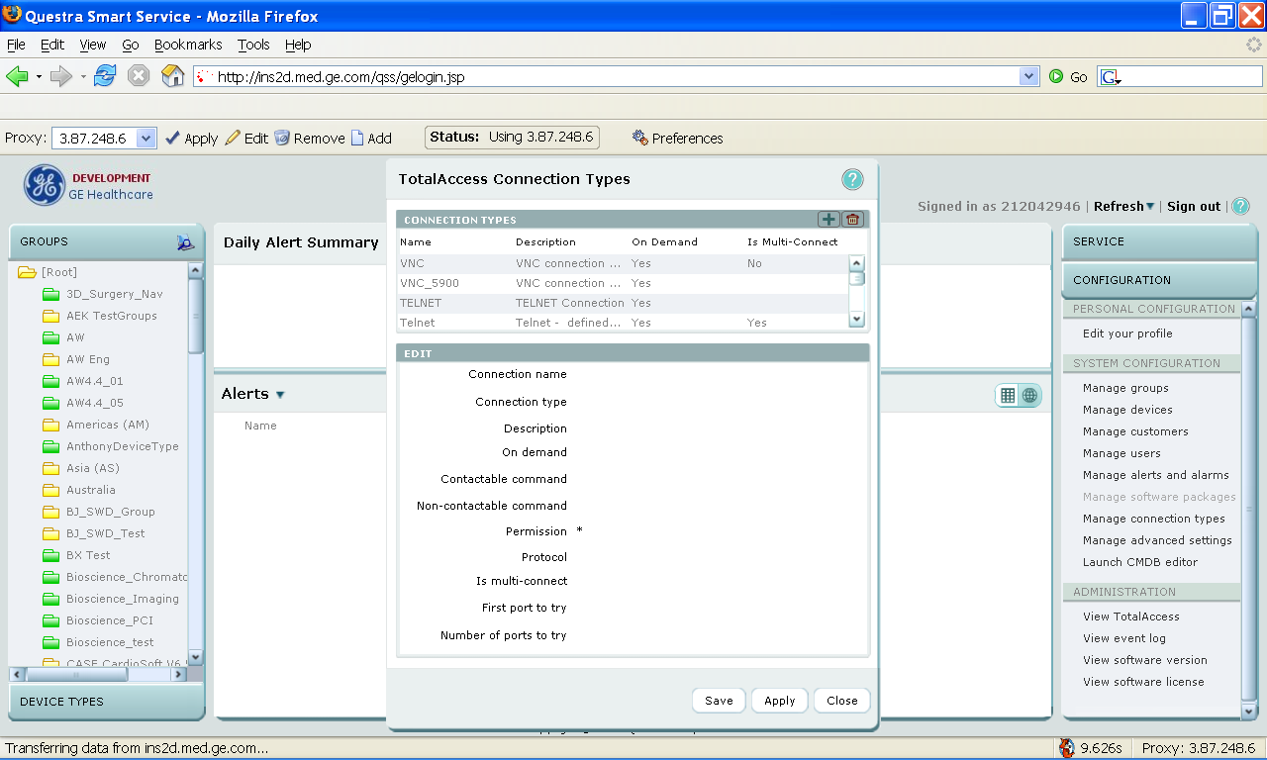

Step 2: In the Connection Types window, click the add icon and then fill out the fields as below. Please change the parameter accordingly to fit your need. Click “Add” and then “Save”.
Note: The “Connection Name” should match the connection name in your MultiTunnel service agent configuration file.
In terms of the command, please use the following:
VNC: [TA:DownloadDir]/MTWrapper -T localhost:[TA:Port] -d localhost:5902 -l 9091 -log 21 -s 4096 -exec \"'[TA:DownloadDir]\vncviewer.exe' -quickoption 4 localhost:[MT:port]/\"

Telnet:: [TA:DownloadDir]/MTWrapper.exe -T localhost:[TA:Port] -d localhost:23 -l 9090 -s 4096 -log 30 -exec \"'c:\windows\system32\cmd.exe' /k telnet.exe localhost MT:port/\"

Http: [TA:DownloadDir]/MTWrapper.exe -T localhost:[TA:Port] -d localhost:80 -l 9092 -s 4096 -log 30 -exec \"'c:\windows\iexplore.exe' localhost MT:port/\"
You need to configure the port according to the network configuration and here is the help:
MTWrapper Usage:
MTWrapper
-help
-T <host>:<port> Tunnel address (HCC)
-d <host>:<port> Destination address on scanner
-l <listen port> port to listen for local client
-I <seconds> Idle timeout in seconds
-a <seconds> Keep alive frequency in seconds
-s <buffer size> Buffer size in bytes
-exec <client application>
-log <log Level>
-t <second> Time out for socket connect
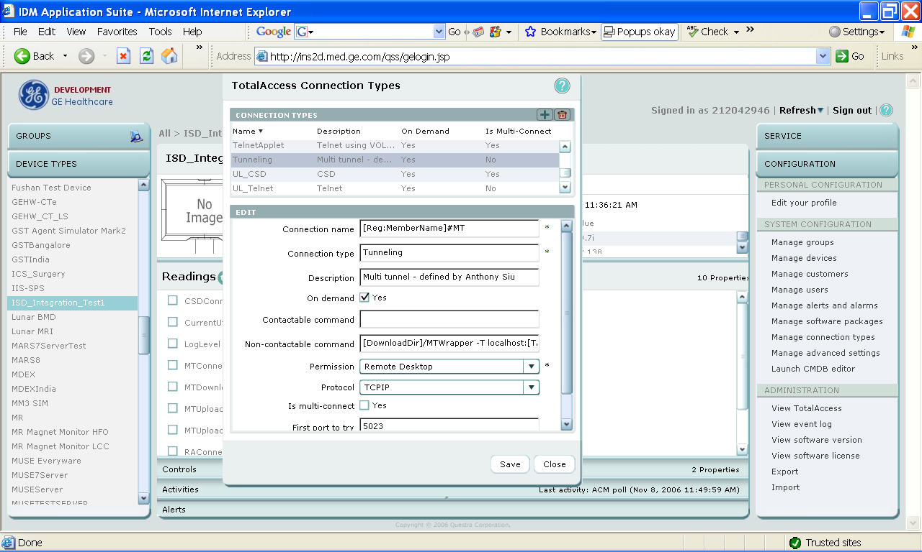

Step 3: Select “Manage devices”. When the devices window pops up, select the device type and click the edit icon.
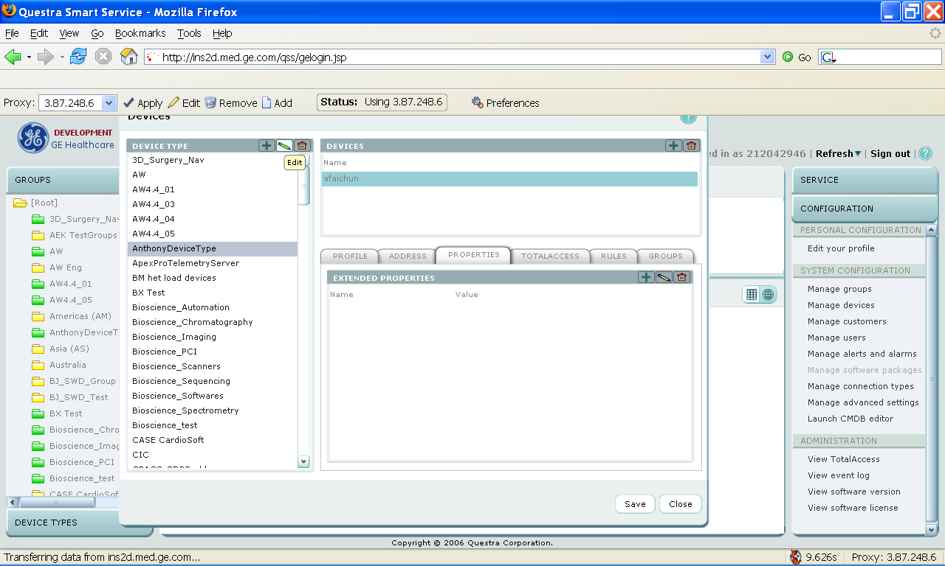

Step 4: On the device type window, click the property tab. Click the add icon.
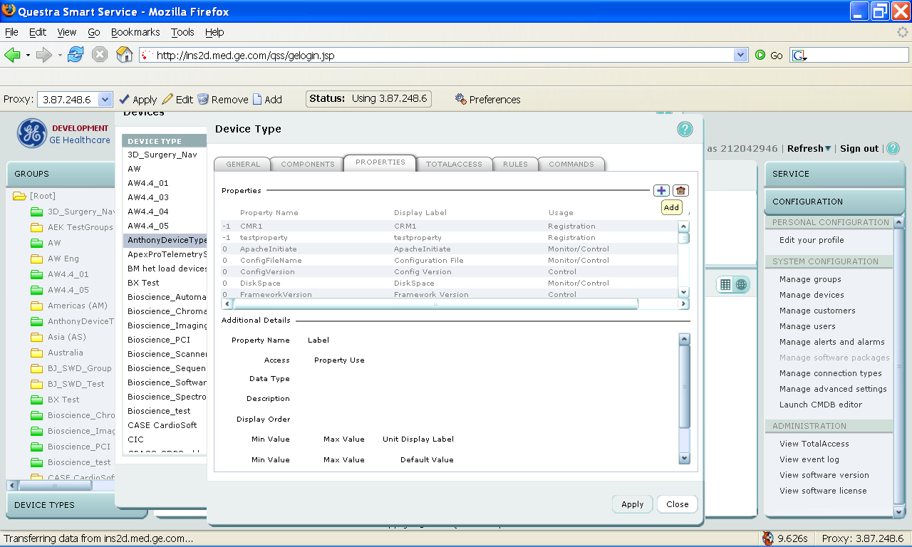
Step 5: On the property window, fill out the field as displayed in the follow to add the property to initiate the MultiTunnel. Click “Add”.
Note: The “Property Name” value being used here must match the property name being configured in the service agent configuration file. For example, if you set the InitialProperty value to MTHttpInitiate in the service agent, then you should create a property with identical name here.
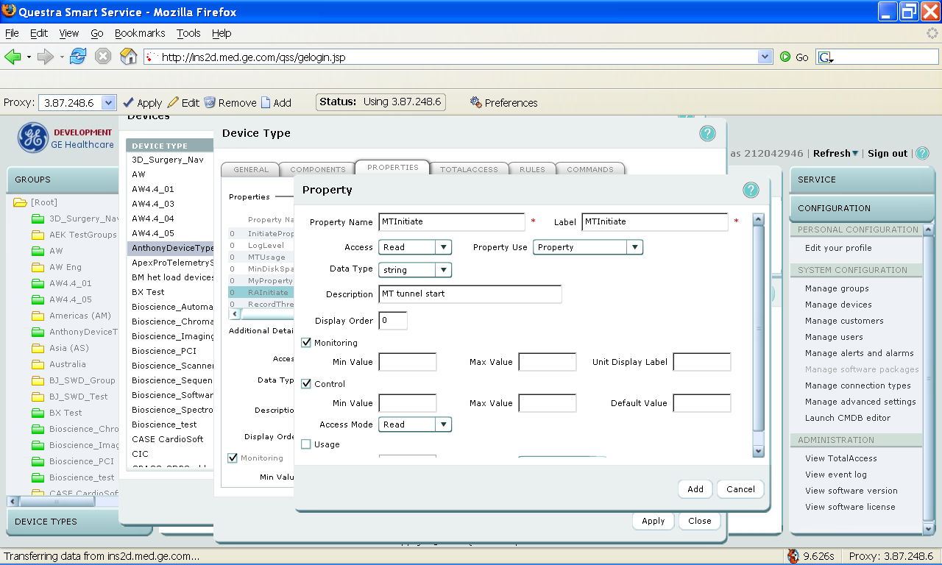

Step 6: Add another property for the multi tunnel connection state. Click “Add” and then “Apply”.
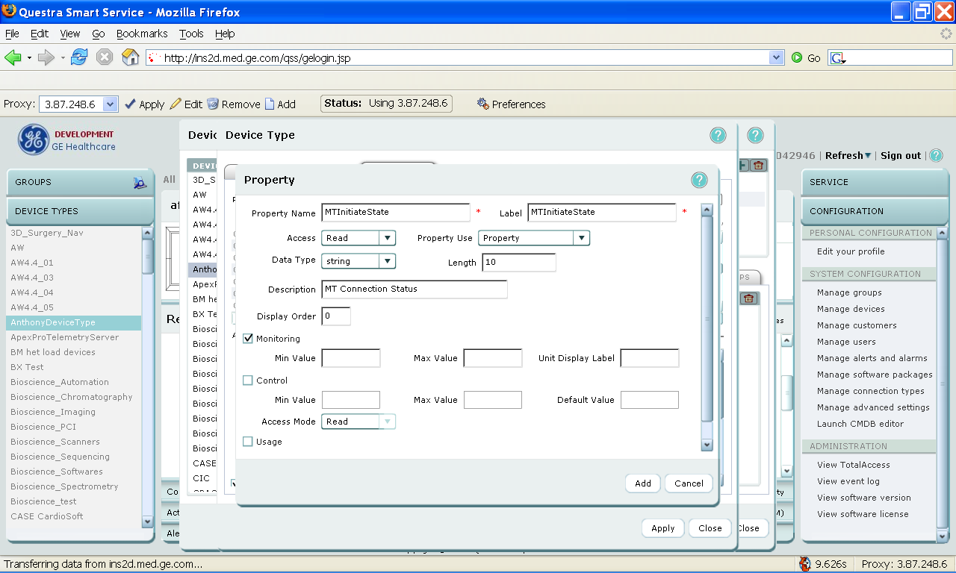

Step 7: Next, select the “TOTALACCESS” tab and click the add icon.
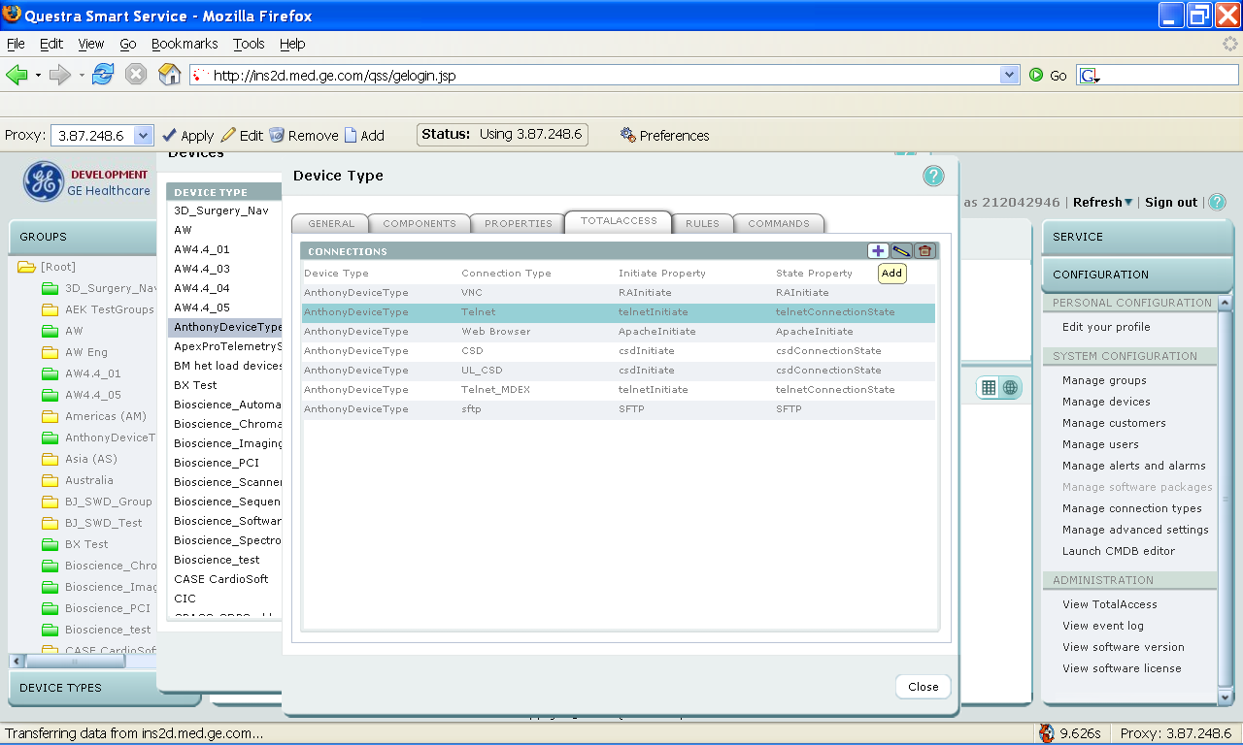

Step 8: Select the connection type your created previously (“Tunneling” in this example”) and enter the properties that you added previously. Click “Add” and then “Close”.
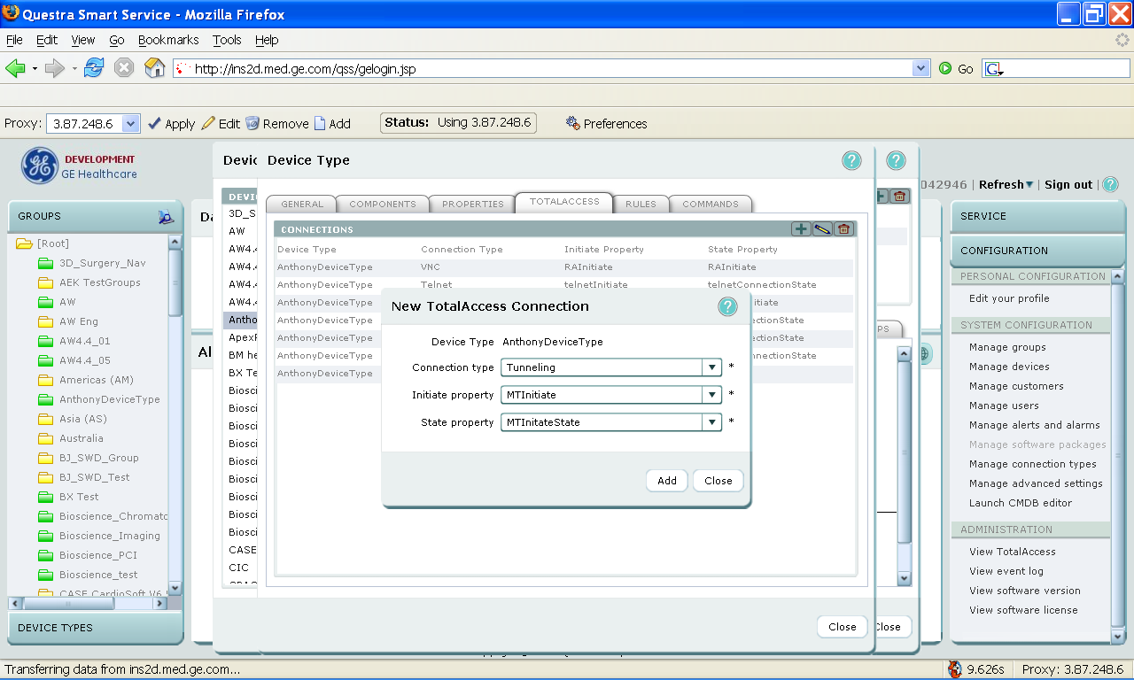

Step 9: Click “Save” and then “Close”.

Appendix B: RSM Configuration is QSS Application
This section illustrates a high-level configuration instruction of how to set up a Remote Service Mode client in the QSS. It is assumed that the reader is fully understand the usage of the QSS application and has right permission to perform the configuration.
The following instructions are based on Questra Smart Server 5.1 and 5.2.
Step 1: Logon to the QSS application, select configuration tab and then “Manage Devices”.
Step 2: Select your device type and click on edit.
Step 3: Select Properties tab from Device Type panel.
Step 4: Add following properties.
Registration Properties are as follows.
RSM_DELAY_PROFILE_FORCED_POLLING_RATE
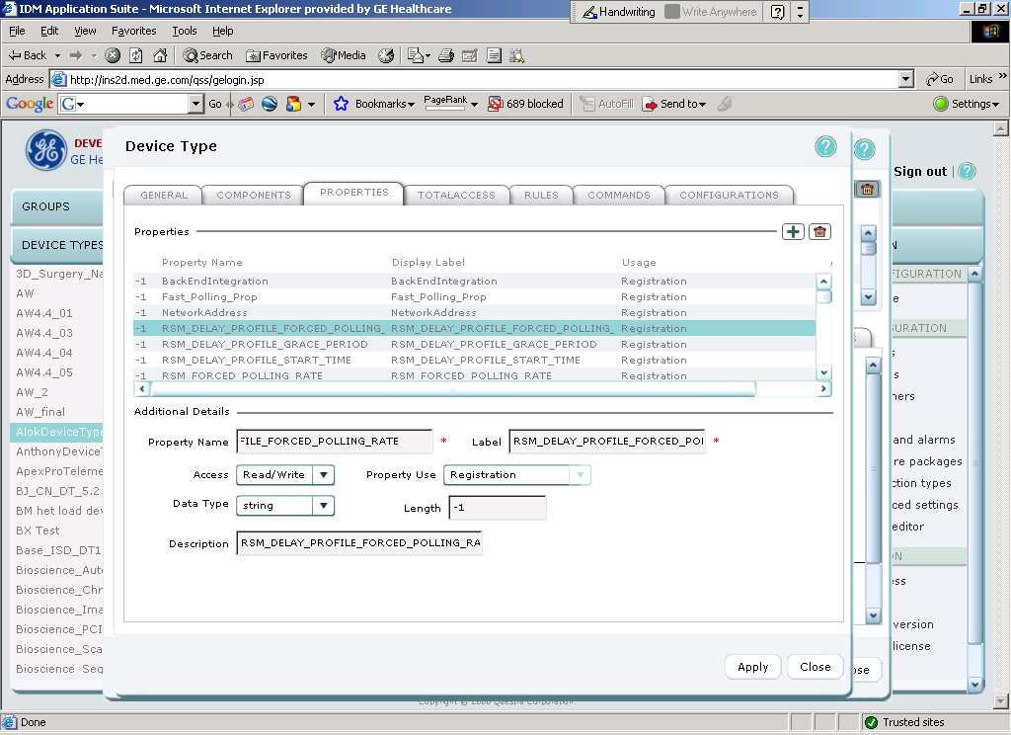

RSM_DELAY_PROFILE_GRACE_PERIOD
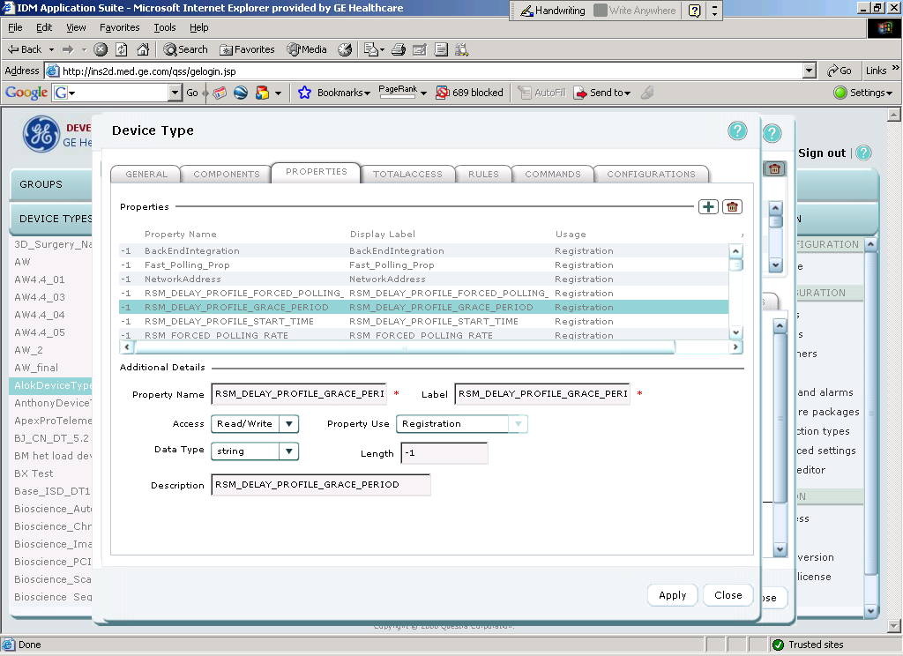

RSM_DELAY_PROFILE_START_TIME
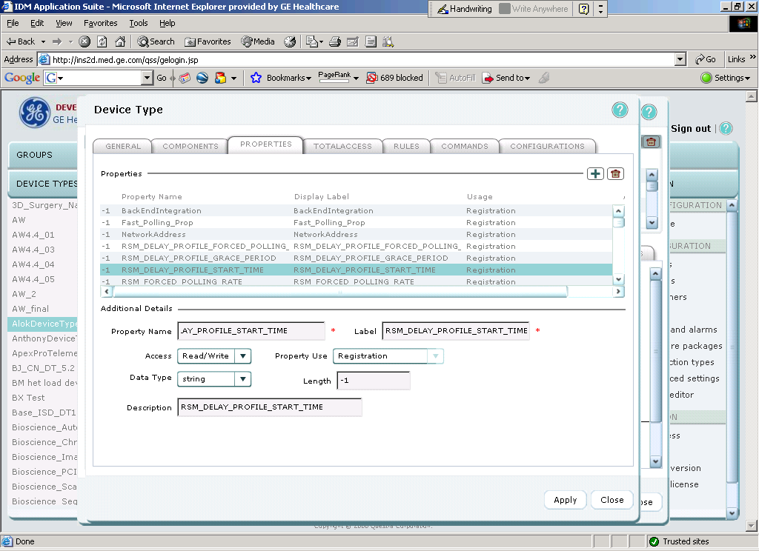

RSM_FORCED_POLLING_RATE
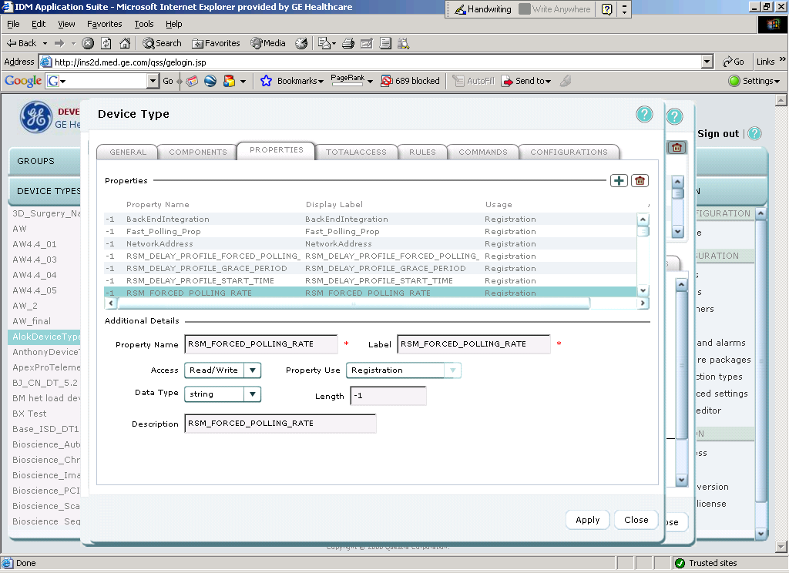

RSM_GRACE_PERIOD
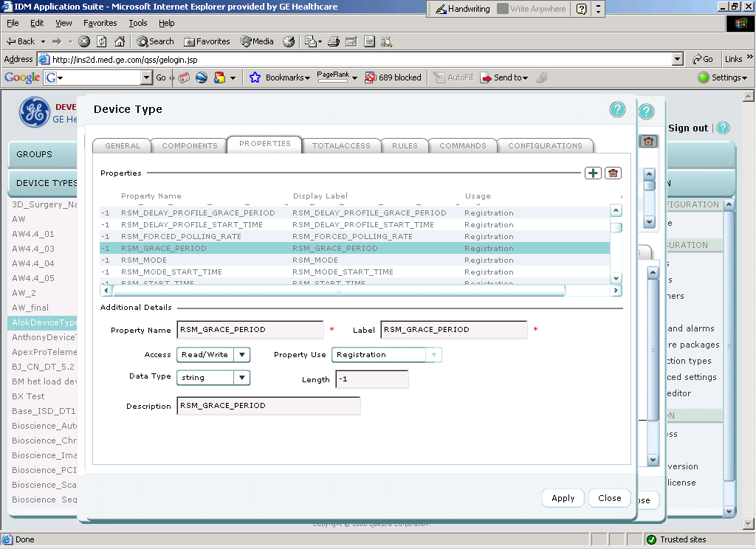

RSM_MODE
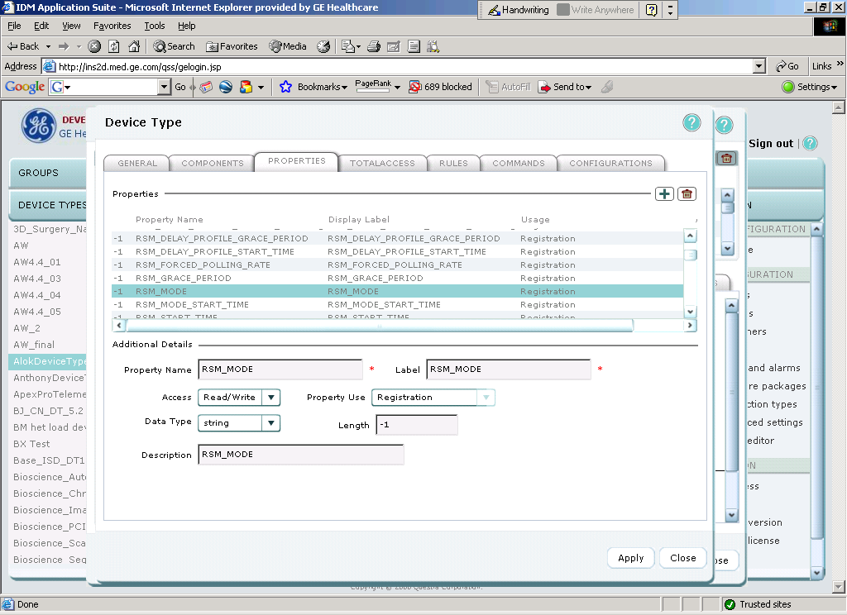

RSM_MODE_START_TIME
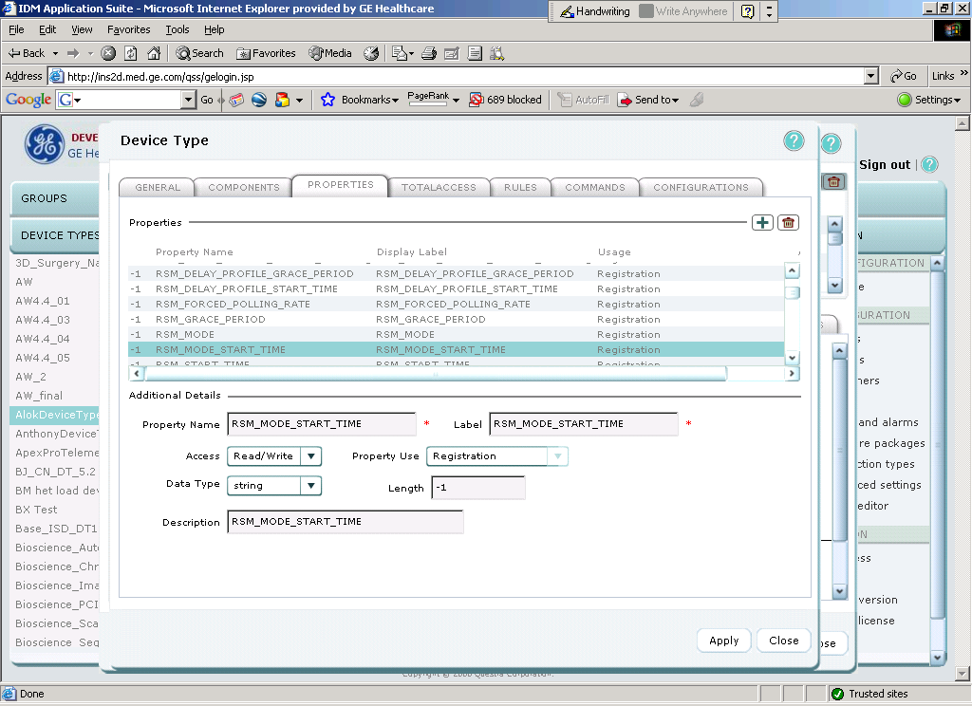

RSM_START_TIME
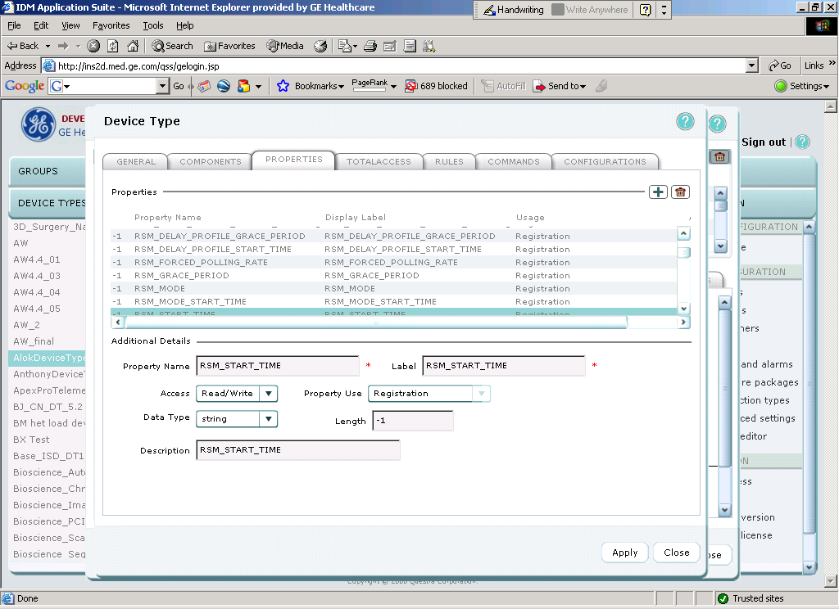

Command Argument Properties are as follows:
GracePeriod: Data Type – Integer
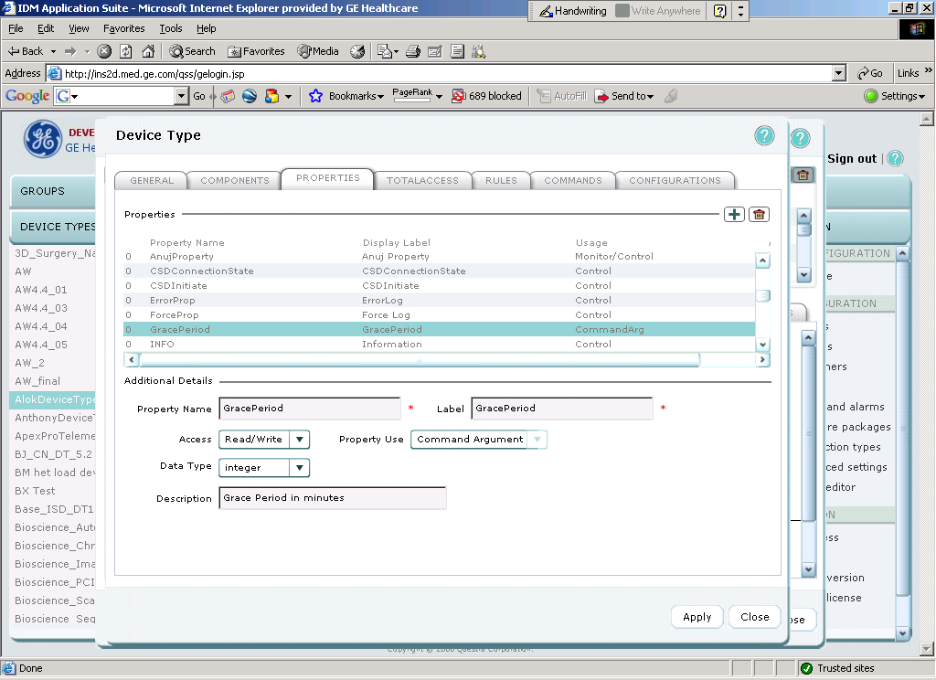

PollingRate : Data Type – Integer
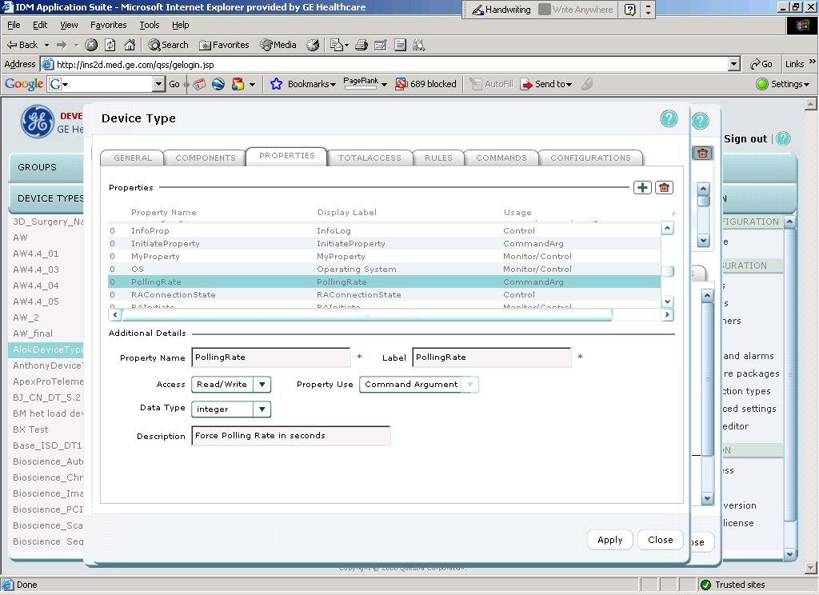

RSMEndDate : Data Type – String
Format: "yyyy-mm-dd" / "anytime"
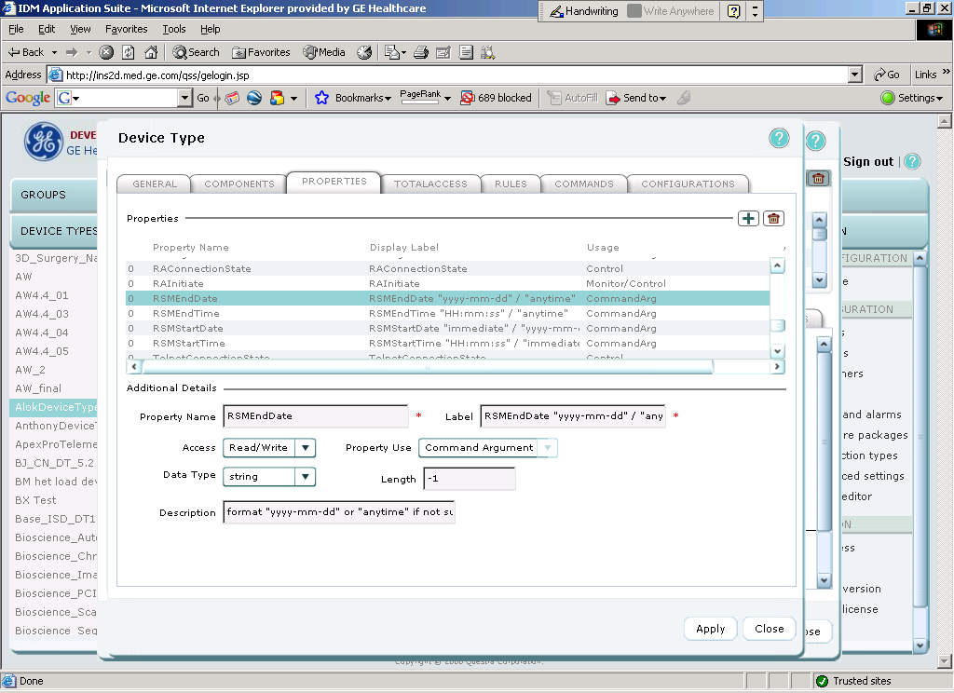

RSMEndTime : Data Type – String
Format: "HH:mm:ss" / "anytime"
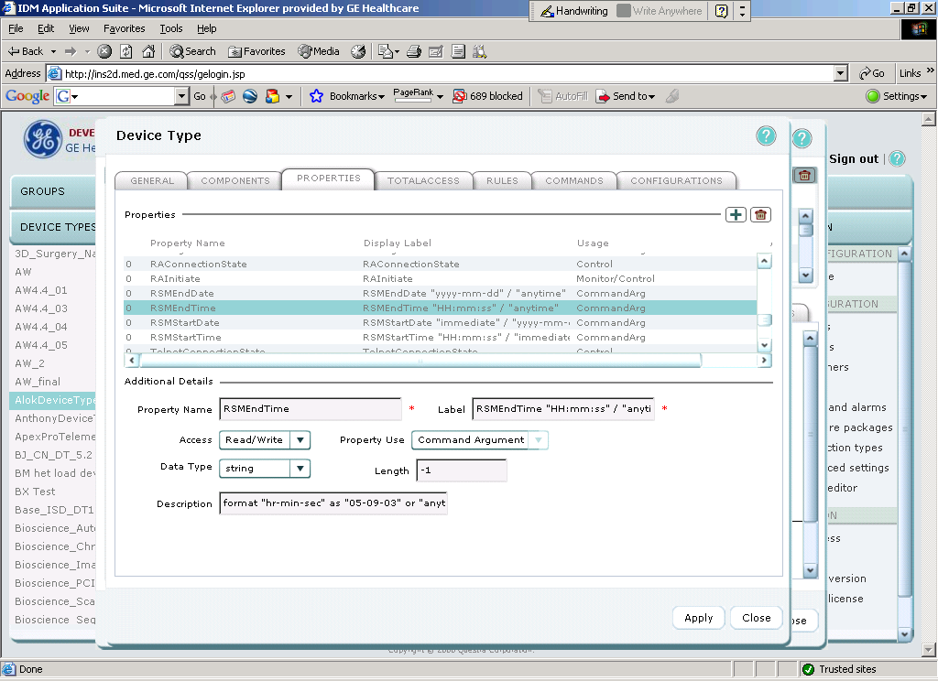

RSMStartDate : Data Type – String
Format: "immediate" / "yyyy-mm-dd"
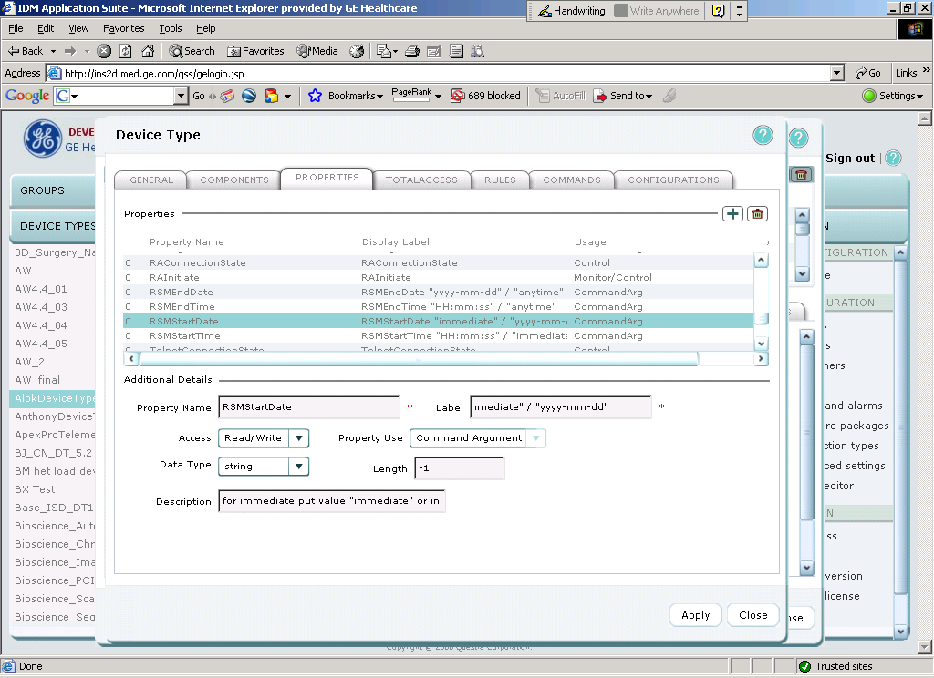

RSMStartTime : Data Type – String
Format: "HH:mm:ss" / "immediate"
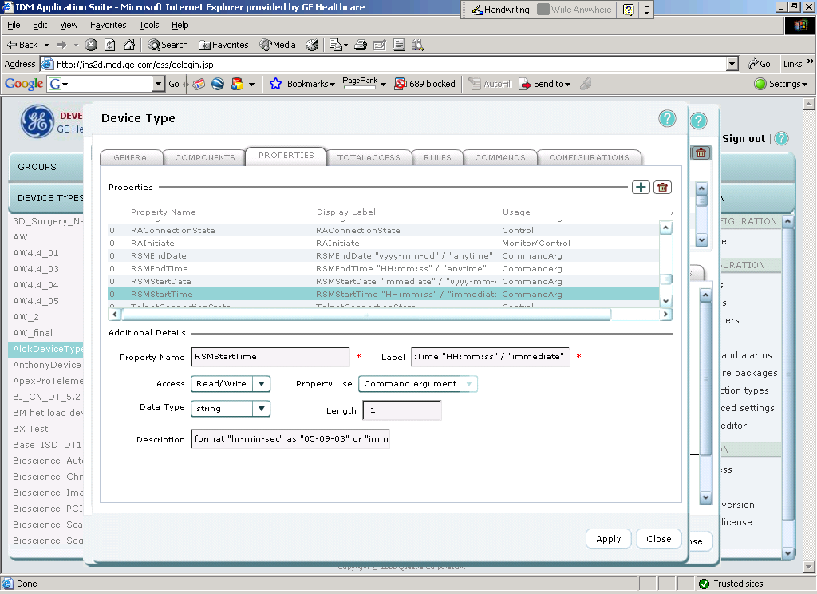

Step 5: Click on COMMANDS tab of Device Type panel.
Step 6: Click “add” and then configure command as follows:
Command: ScheduleRSM
Display label: ScheduleRSM
Description: To force agent to RSM
Execution Time: 10
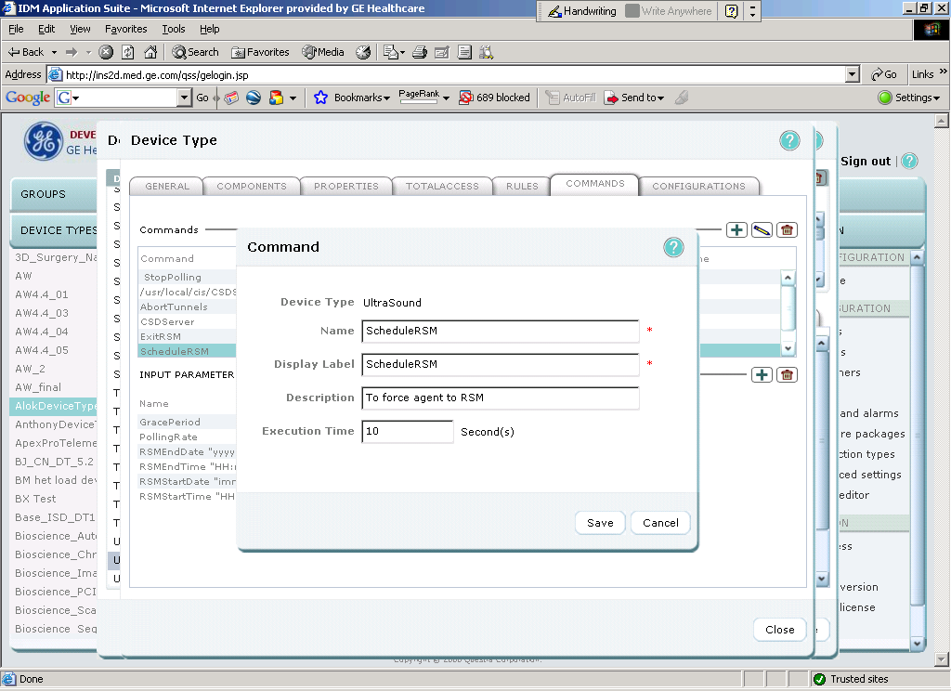

Click on “Save” button.
Click “add” to configure new command
Command: ExitRSM
Display label: ExitRSM
Description: To force agent to Exit RSM
Execution Time: 10

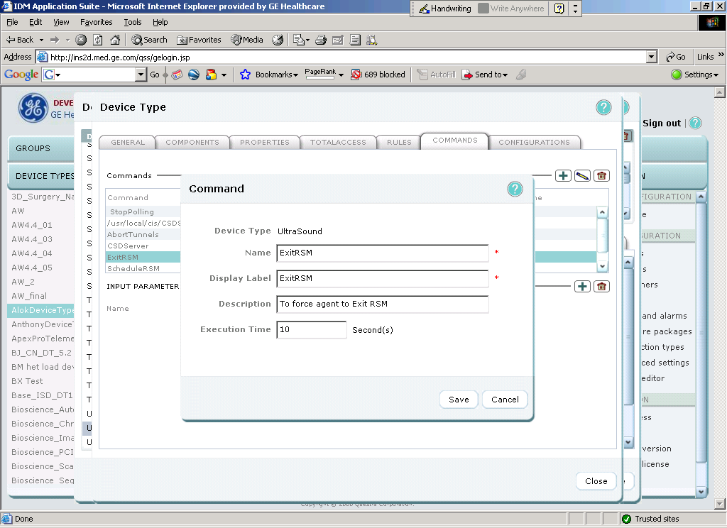

Click on “Save” button.
Step 7: From “Commands” Tab select “ScheduleRSM” command.
Step 8: Click “add” of input parameters and select parameter as “GracePeriod” and click on “Save” button.
Step 9: Click “add” of input parameters and select parameter as “PollingRate” and click on “Save” button.
Step 10: Click “add” of input parameters and select parameter as “RSMEndDate” and click on “Save” button.
Step 11: Click “add” of input parameters and select parameter as “RSMEndTime” and click on “Save” button.
Step 12: Click “add” of input parameters and select parameter as “RSMStartDate” and click on “Save” button.
Step 13: Click “add” of input parameters and select parameter as “RSMStartTime” and click on “Save” button.
Step 14: Click on “Close” button of Device Type panel.
Step 15: Click on “Close” button of Devices panel.

