SOFTWARE ENGINEERING
Testing Environment
The UteroCare AI application was tested using automated testing with the Pytest framework.
- Testing framework: Pytest
- Programming language: Python
- API testing library: Requests
- Test folder: pytest_tests/
- Test files: test_uterocare_api.py and test_boundary.py
- Execution command: python -m pytest -v pytest_tests
The application was run locally, and the test cases were executed against its API endpoints.
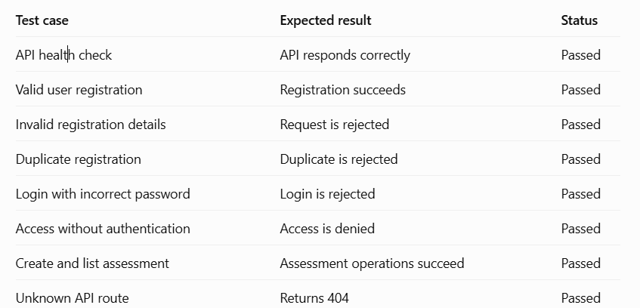
Test Execution Results
The automated test cases were executed using the Pytest framework. The tests checked API availability, user registration, authentication, input validation, assessment operations, and error handling.
Total test cases executed: 13
Execution time: 1.60 seconds
Result: All 13 test cases passed successfully, with no failures reported.
The results confirm that the tested API functionalities behaved as expected under the conditions covered by the test cases.
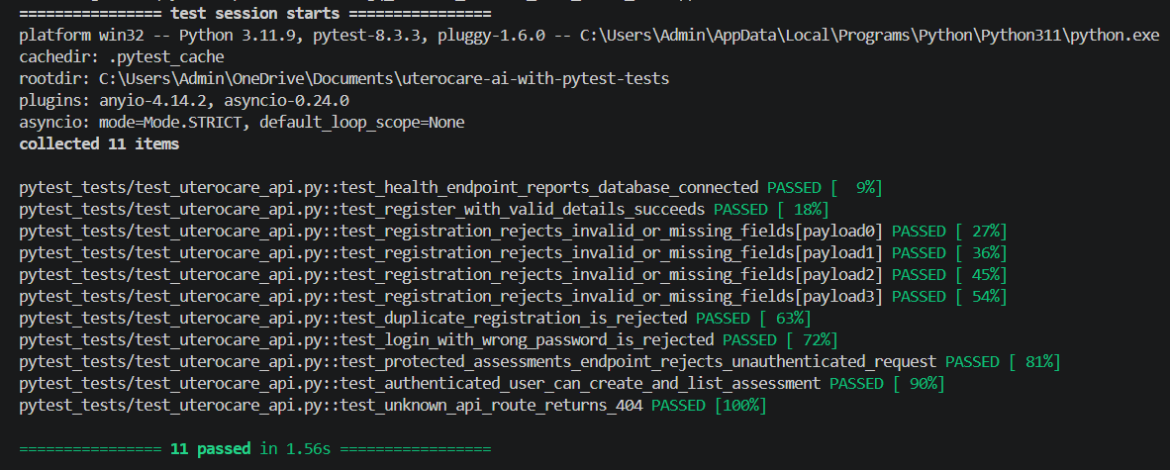
Test Execution Results
The automated test cases were executed using the Pytest framework. The tests checked API availability, user registration, authentication, input validation, assessment operations, and error handling.
Total test cases executed: 13
Execution time: 1.60 seconds
Result: All 13 test cases passed successfully, with no failures reported.
The results confirm that the tested API functionalities behaved as expected under the conditions covered by the test cases.
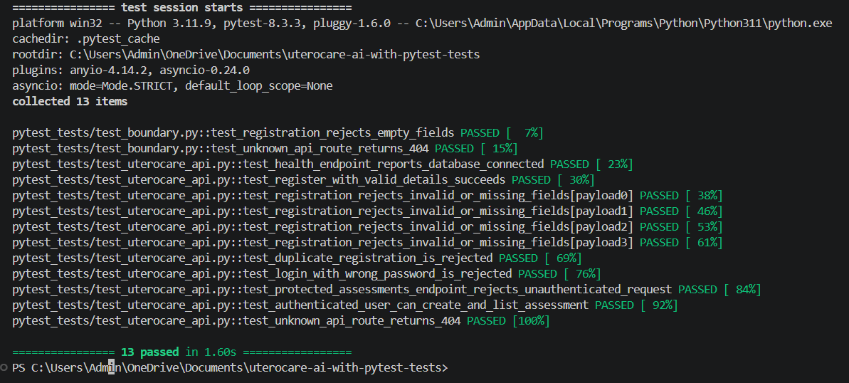
Conclusion
Automated testing of the UteroCare AI application was completed successfully using Pytest. All 13 executed test cases passed. The testing process verified selected API functionalities, including registration, authentication, assessment operations, and error handling. Further manual and integration testing is required to validate the remaining application features.

