SHEWHART CONTROL CHARTS AND FUNNEL PLOTS: A USER GUIDE TO BUILD THE TOOLS

I – The Shewhart control chart
A Shewhart control chart is a statistical process monitoring tool used to assess the stability of a process over time and to distinguish between routine variation and meaningful changes in performance^{1,2}. Originally developed by Walter A. Shewhart in the 1920s for industrial quality control, control charts are now widely used in healthcare to monitor clinical outcomes, evaluate provider performance, and support quality improvement initiatives³. The underlying principle is that all processes exhibit natural variability. Therefore, the purpose of a control chart is therefore not to eliminate variation, but rather to determine whether the observed variation is consistent with the expected behaviour of a stable process or reflects the influence of an assignable cause. By providing ongoing surveillance of performance, control charts facilitate the early detection of deterioration or improvement and enable timely investigation of potential changes in practice^{4,5}.
A control chart displays sequential observations collected over time together with a central line representing the expected level of performance and upper and lower control limits that define the range of variation anticipated under stable operating conditions. These limits are derived from statistical theory and are typically set at three standard deviations from the central line. Consequently, when the process is in statistical control, approximately 99.73% of observations are expected to fall within the control limits, with only 0.27% occurring outside them by chance alone⁶.
For monitoring binary outcomes such as postoperative mortality, complications, or readmissions, the p-chart is one of the most commonly used Shewhart charts. In a p-chart, individual observations are aggregated over predefined time intervals (e.g., months, quarters, or years), and the observed event proportion is plotted over time. The central line corresponds to the expected event rate, which may be fixed in unadjusted analyses or allowed to vary over time to account for changes in patient case-mix through risk adjustment, as shown in our example. Interpretation of the chart is straightforward. Observations that remain within the control limits and exhibit no systematic pattern are consistent with common-cause variation and indicate that the process is operating as expected. In contrast, observations falling outside the control limits suggest the presence of special-cause variation. These signals indicate that the underlying process may have changed and warrant further investigation to identify potential causes and guide corrective action where appropriate.
II – The funnel plot
A funnel plot is a graphical benchmarking tool used to compare the performance of multiple healthcare providers, hospitals, surgeons, or other organisational units⁷. Unlike statistical process control charts, which monitor changes in performance within a single entity over time, funnel plots provide a cross-sectional comparison of performance across entities during a specified period ⁸. As such, they are widely used in healthcare quality assessment, public reporting, and pay-for-performance programmes to identify providers whose outcomes differ from those of their peers. The principle of a funnel plot is to compare the observed performance of each entity with a reference value, typically the overall average performance across all entities under study. Each entity is represented by a single point, allowing direct visual comparison of outcomes between providers. Entities located above or below the reference line are interpreted as performing worse or better than average, depending on the outcome being evaluated.
A key feature of the funnel plot is that it explicitly accounts for differences in sample size. Smaller providers tend to exhibit greater random variation in their outcome estimates than larger providers, whose estimates are generally more precise. To accommodate this phenomenon, statistical control limits are constructed around the reference value. These limits are wide for low-volume providers and progressively narrow as sample size increases, producing the characteristic funnel-shaped appearance from which the method derives its name.
Interpretation of funnel plots is also simple. Entities located within the control limits are considered to have outcomes consistent with the variation expected by chance alone. In contrast, entities falling outside the control limits are identified as statistical outliers, suggesting performance that differs significantly from the reference value and may warrant further investigation. As in control charts, control limits are commonly displayed at the 95% and 99.73% confidence levels, corresponding to warning and control thresholds, respectively. Despite their intuitive visual appeal, funnel plots should be interpreted with caution. Comparisons are highly dependent on the adequacy of risk adjustment and the quality of the underlying data. Differences in patient case-mix, coding practices, or data completeness may create apparent performance differences that do not reflect true differences in quality of care. Consequently, identification of an outlier should be viewed as a signal for further investigation rather than definitive evidence of superior or inferior performance.

III – Examples using simulated data
In order to illustrate the codes that were used to build the tools, we simulated a dataset comprising digestive surgery interventions carried out in multiple hospitals. The dataset (dataset.sas7bdat) contains the following variables:
Variable | Format | Description
id_patient | Num | Patient identifiant
eta | Char  - etab01  - …  - etab10 | Hospital identifiant
date | Date | Date of procedure
urg | Char :  - 0 (no)  - 1 (yes) | Emergency admission
sex | Char :  - F (female)  - M (male) | Patient sex
age | Char :  - 18-59  - 60-74  - 75+ | Patient age
cha | Char :  - Charlson 0-1  - Charlson 2-3  - Charlson >=4 | Charlson comorbidity index
event | Char :  - 0 (no)  - 1 (yes) | Event occurence

Control charts and funnel plots can be readily generated using the provided SAS scripts:
- example.sas:
  - Reads and describes the dataset, fits a generalized estimating equations (GEE) model accounting for within-hospital clustering, stores the fitted model and the estimated intraclass correlation coefficient (ICC), and generates patient-level predicted probabilities.
  - For simplicity, the subsequent examples use predictions derived from the same dataset used for model fitting. However, for optimal risk adjustment and to avoid potential overfitting, it is recommended to estimate the adjustment model using a separate dataset from the one used to construct the monitoring charts.
- control_chart_macro.sas:
  - Requires as input a dataset containing patient-level predicted probabilities, the hospital to be monitored, the start and end dates of the monitoring period, the ICC (optional, when a GEE model is used and the user wishes to specify it manually), graphical output scales, any observations to be excluded, and additional formatting options.
  - Control limits are computed using the exact binomial distribution. The centerline corresponds to the expected outcome rate for the hospital at each time point, recalibrated according to the hospital’s overall observed rate across the entire dataset.
  - This recalibration avoids interpretations driven by benchmarking effects and enables performance assessment relative to the hospital’s own baseline rather than to other institutions.
- funnel_plot_macro.sas:
  - Requires as input a dataset containing patient-level predicted probabilities, the selected time unit, the ICC (optional, when a GEE model is used and the user wishes to specify it manually), control-limit smoothing parameters, and axis scaling options.
  - The centerline corresponds to the average outcome rate across hospitals for the selected time unit. Control limits are computed using the exact binomial distribution.
The example below illustrates the control chart for hospital « etab07 » over the period 2020-2024.
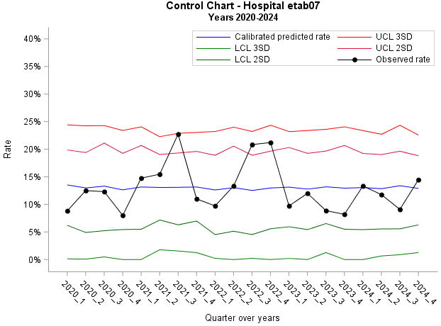
The black curve represents the observed event rates for each quarter. The blue curve (central line) corresponds to the predicted event rates, while the surrounding control limits are set at ±2 and ±3 standard deviations (SDs). Applying the Standard Electric detection rules⁹, namely the occurrence of a single point beyond the 3-SD control limits or two points out of 36 consecutive observations beyond the 2-SD limits, signals of unusual performance variation are identified in the third quarter of 2021 and the fourth quarter of 2022.

The following example illustrates the funnel plot of all hospitals for the fourth quarter of 2022 :
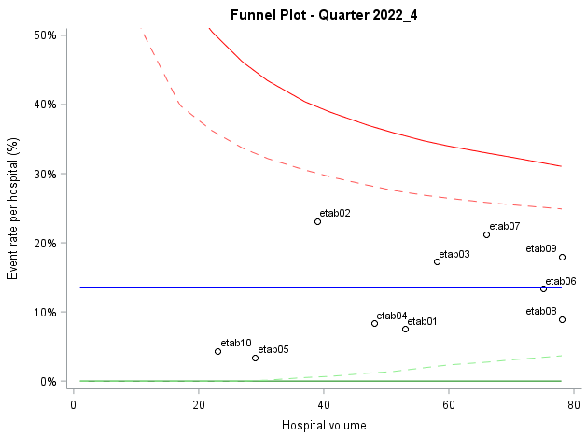
Standardized event rates were calculated for each hospital and plotted against their corresponding volume. The blue curve (central line) represents the overall event rate across all hospitals during the fourth quarter of 2022. Given the relatively low volumes and event rates observed across hospitals, the funnel plot provides limited power to identify hospitals with performance that differs significantly from that of the overall cohort.

References
(1) Thor, J.; Lundberg, J.; Ask, J.; Olsson, J.; Carli, C.; Härenstam, K. P.; Brommels, M. Application of Statistical Process Control in Healthcare Improvement: Systematic Review. Qual. Saf. Health Care 2007, 16 (5), 387–399. https://doi.org/10.1136/qshc.2006.022194.
(2) Le Thien, M.-A.; Cordier, Q.; Lifante, J.-C.; Carty, M. J.; Duclos, A. Control Charts Usage for Monitoring Performance in Surgery: A Systematic Review. J. Patient Saf. 2023, 19 (2), 110–116. https://doi.org/10.1097/PTS.0000000000001103.
(3) Shewhart WA. Economic Control of Quality of Manufactured Product; New York: D. Van Nostrand Company, Inc, 1931.
(4) Duclos, A.; Touzet, S.; Soardo, P.; Colin, C.; Peix, J. L.; Lifante, J. C. Quality Monitoring in Thyroid Surgery Using the Shewhart Control Chart. Br. J. Surg. 2009, 96 (2), 171–174. https://doi.org/10.1002/bjs.6418.
(5) Duclos, A.; Chollet, F.; Pascal, L.; Ormando, H.; Carty, M. J.; Polazzi, S.; Lifante, J.-C.; SHEWHART Trial Group. Effect of Monitoring Surgical Outcomes Using Control Charts to Reduce Major Adverse Events in Patients: Cluster Randomised Trial. BMJ 2020, 371, m3840. https://doi.org/10.1136/bmj.m3840.
(6) Duclos, A.; Voirin, N. The P-Control Chart: A Tool for Care Improvement. Int. J. Qual. Health Care J. Int. Soc. Qual. Health Care 2010, 22 (5), 402–407. https://doi.org/10.1093/intqhc/mzq037.
(7) Spiegelhalter, D. J. Funnel Plots for Comparing Institutional Performance. Stat. Med. 2005, 24 (8), 1185–1202. https://doi.org/10.1002/sim.1970.
(8) Duclos, A.; Polazzi, S.; Lipsitz, S. R.; Couray-Targe, S.; Gawande, A. A.; Colin, C.; Berry, W.; Ayanian, J. Z.; Carty, M. J. Temporal Variation in Surgical Mortality within French Hospitals. Med. Care 2013, 51 (12), 1085–1093. https://doi.org/10.1097/MLR.0b013e3182a97c54.
(9) Champ, C. W.; Woodall, W. H. Exact Results for Shewhart Control Charts With Supplementary Runs Rules. Technometrics 1987, 29 (4), 393–399. https://doi.org/10.1080/00401706.1987.10488266.

